Tag No. «Name» - «Description»
Subsystem: «ProcessBreakdownIdentifier» - «ProcessBreakdownName»
Manufacturer. | «ManufacturerName» | Model No. | «OEMPartNumber»
Field to record Serial No. | «SerialNumber»
Drawing No. | «DocumentList» | Task No. |  | «TaskName»
Additional Information: | «Comments»

Item | Description | OK | N/A | Punch
 | Tag nameplate (or stamping) is clear, legible, of correct material and securely fitted to the equipment.
 | Inspect all components for damage, contamination, corrosion or poor quality.
 | Confirm installation location is in accordance with the design and physical device installation is in accordance with MA-0000-M-1051.
 | Confirm lanyard auxiliary guides, anchors and tensioning components are installed in accordance with standard drawing MA-0000-M-1051.
 | Confirm device and lanyard installation structural clearances are in accordance with MA-0000-1051.
 | Confirm pull wire lanyard tension has been achieved.
 | Confirm pull wire lanyard turnbuckles are no more than 30% through range of adjustment for correct tension.
Confirm the lanyard has been installed as straight as practicle with direction changes not to exceed 5 degrees in any plane with standard fittings. Where this cannot be achieved direction changes of up 15 degrees may be allowed with the use of guide pulleys.
(Note: When assessing direction changes or the use of guide pulleys then the pull wire switch must still operate within standard operating parameters. Standard operating parameters include a lanyard rope deflection no greater than 400mm in any one plane (90 degree test) using a recommended applied force of 70N as per the manufacturers recommendations.
 | Confirm Pull wire switch and auxiliary hardware mounting is secure and ensure that all nuts, washers and spring washers are in place.
 | Check pull wire switch cable terminations are ferruled, numbered, firmly tightened with one wire per terminal
 | All spare cores are terminated and ferruled as spare.
 | Confirm equipment earth bonding is connected as per applicable drawings.
 | Confirm all unused cable entries are plugged with suitable blanks.
 | All gaskets, seals and sight glasses are intact.
 | Confirm protective cover is intact and suitable protects the pull wire switch operating mechanism
 | Confirm Circuit left safe and ready for energisation.

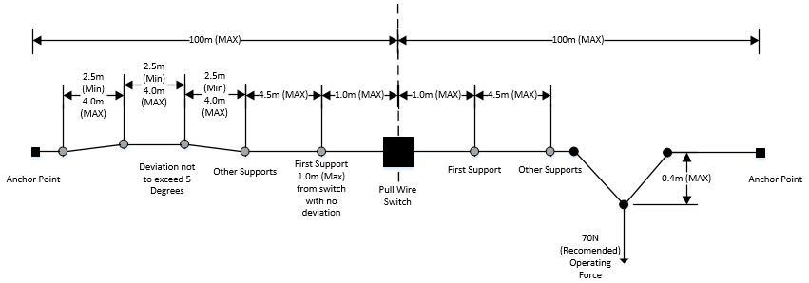

COMPLETIONS & CLIENT ACCEPTANCE REQUIREMENTS – CONTRACTOR CHECK LIST
 | Item |  |  |  | Initial | N/A | Comments
1 | All site modifications correctly marked up on master drawings as per project procedures.
2 | All Punchlist items noted on a separate Punchlist form and submitted.
3 | This form must be completed by an Authorised Electrical Worker.
COMMENTS, OBSERVATIONS & ATTACHMENTS
(Complete a Punch List Form and attach if any of the checks above marked as “Punch”)
COMPLETED
I hereby confirm the work has been completed in accordance with Contract specified drawings, specifications & standards.
PERFORMED BY CONTRACTOR: |  |  | REVIEW BY SUPERVISOR/LEAD ENGINEER: |  |  |  |  | EPCM ACCEPTED BY:
Signature: |  |  | Signature: |  |  |  |  | Signature:
Name: |  |  | Name: |  |  |  |  | Name:
Licence No: |  |  | Title: |  |  |  |  | Title:
Date: |  |  | Date: |  |  |  |  | Date:

