Tag No. «Name» - «Description»
Subsystem: «ProcessBreakdownIdentifier» - «ProcessBreakdownName»
Manufacturer. | «ManufacturerName» | Model No. | «OEMPartNumber»
Field to record Serial No. | «SerialNumber»
Drawing No. | «DocumentList» | Task No. |  | «TaskName»
Additional Information: | «Comments»

Item | Description |  |  |  |  | OK | N/A | Punch
- 1 | Tag nameplate (or stamping) is clear, legible, of correct material and securely fitted to the equipment.
- 2 | Inspect all components for damage, contamination, corrosion or poor quality.
- 3 | Confirm Instrument location, orientation and type is as design and installation is as per standard drawing MA-0000-M-1052 & MA-0000-M-1050.
- 4 | If applicable confirm device mounting allows suitable mechanical adjustment for alignment and orientation.
 | If applicable confirm the instrument mechanical protection is fitted correctly to installations exposed to dust and contamination.
 | Confirm sensing distance between sensor and sensing plate is not greater than 20mm
- 6 | Inspect the field location of the installation to ensure sensor and mounting components are accessible for maintenance.
 | Confirm cable service loops are sufficient for the full range of instrument adjustment.
- 7 | Check mountings to ensure that all nuts, washers and spring washers are in place and tensioned correctly.
- 6 | Confirm all unused cable entries are plugged with suitable blanks.
- 7 | Confirm all cable terminations are correct as per the drawings
- 8 | Confirm all spare cores are terminated and ferruled as spare.
- 9 | Terminals are numbered, firmly tightened with one wire per terminal.
 | Circuit left safe and ready for energisation.
 | Standard drawing MA-0000-M-1052 & MA-0000-M-1050.
 | 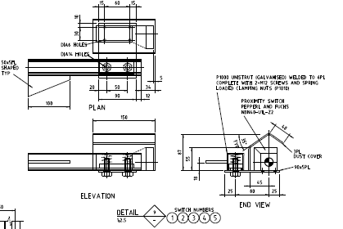
 | 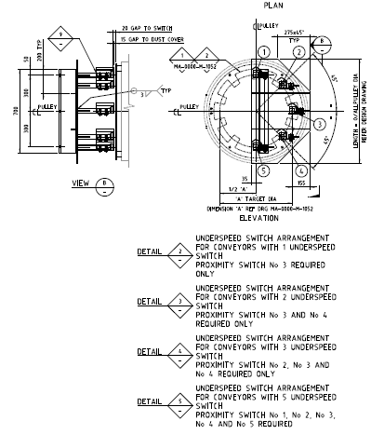
COMPLETIONS & CLIENT ACCEPTANCE REQUIREMENTS – CONTRACTOR CHECK LIST
 |  | Item | Initial | N/A | Comments
1 |  | All site modifications correctly marked up on master drawings as per project procedures.
2 |  | All Punchlist items noted on a separate Punchlist form and submitted for.
3 |  | This form must be completed by an Authorised Electrical Worker.

COMMENTS, OBSERVATIONS & ATTACHMENTS
(Complete a Punch List Form and attach if any of the checks above marked as “Punch”)
COMPLETED
I hereby confirm the work has been completed in accordance with Contract specified drawings, specifications & standards.
PERFORMED BY CONTRACTOR: |  | REVIEW BY SUPERVISOR/LEAD ENGINEER: |  | EPCM ACCEPTED BY:
Signature: |  | Signature: |  | Signature:
Name: |  | Name: |  | Name:
Licence No: |  | Title: |  | Title:
Date: |  | Date: |  | Date:

