PULLEY DATA
Centre Distance
Driver / Driven *
Driver / Driven *

 | Driver |  |  | Driven |  |  | Tensioning Idler
OD |  |  | mm |  |  | mm |  | mm
Section
PCD * | R |  | mm | N |  | mm |  | mm
Number of Grooves
Bore Diameter
Keyway
Key
Boss Type
Speed
Pulleys Correctly Secured
* Table for calculation of PCD for standard pulleys

Belt | Sections |  |  | OD-PCD (mm)
Z | SPZ | 3V | α | 1
A | SPA |  |  | 7.5
B | SPB | 5V | β | 9
C | SPC |  |  | 12
D |  |  |  | 16.2
Ratio | $$\frac{PCD Driven}{PCD Driver}= \frac{N}{R}$$ |  | =
 | Note: Ratio should not exceed 3:1 unless special provisions have been allowed for in the design criteria.
Above data complies with the design specifications (specify) …………………………………………………………………..

BELT DATA
Motor Power: |  | kW | Number of Belts:
Centre Distance: |  | mm | Belt Size(section - length):
Type of Belt:

INSPECTION ITEMS |  | YES | NO | N/A | REMARKS | SIGN OFF
 |  |  |  |  |  | CIVMEC | CLIENT
1 | All belts matched set | ☐ | ☐ | ☐
2 | Belts tensioned correctly | ☐ | ☐ | ☐
3 | Guard has provision to allow for further adjustment | ☐ | ☐ | ☐
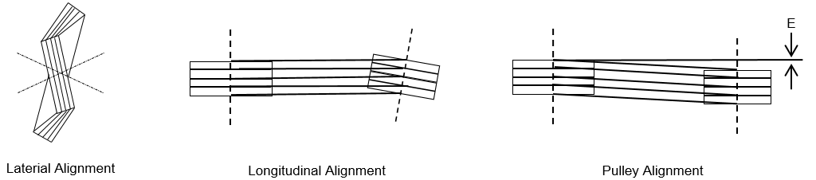
4 | Belts have adequate running clearance | ☐ | ☐ | ☐
5 | Drive is adequately protected from being sprayed by water, oil or any other liquids or solids | ☐ | ☐ | ☐
6 | Drive is free to rotate | ☐ | ☐ | ☐
7 | Run-out value E checked and acceptable | ☐ | ☐ | ☐
8 | Drive elements / sheaves are clean, free from dust and foreign particles | ☐ | ☐ | ☐
 | Commissioning
9 | Belts do not squeal or flick unduly | ☐ | ☐ | ☐
10 | Deceleration is smooth | ☐ | ☐ | ☐
11 | No excessive noise | ☐ | ☐ | ☐
12 | Run drive loaded for 30 minutes | ☐ | ☐ | ☐ | Temperature:__________°C
13 | Tension is correct | ☐ | ☐ | ☐

COMMENTS:

CIVMEC | Name | Signed | Date
CLIENT | Name | Signed | Date

