Tag No. «Name» - «Description»
Subsystem: «ProcessBreakdownIdentifier» - «ProcessBreakdownName»
Drawing No. | «DocumentList» | Task No. | «TaskName»
Additional Information: | «Comments»

Item | Description | OK | N/A | Punch
 | Confirm materials of construction are as per specifications and design drawings.
 | Confirm support structure complete, level and accepted.
 | Confirm all welding works completed and tested as required.
 | Confirm all bolted connections and fixing systems including hold down, flange and liner are tensioned and marked correctly.
 | Confirm all supporting structure and dust covers are secure and all bolts tensioned/ wedges fitted.
 | Confirm all roll out chutes are aligned, rails and wheels are installed as per specifications and drawings and chutes roll freely on rails. (survey attached)
 | Confirm all inspection doors and openings are correctly fabricated and installed in accordance with the drawings and locking mechanism freely operate and both doors close & seal correctly.
 | Confirm protective coatings applied to suit SS-P118 and RVS-0000-SPE-S-003 and all touch-up painting has been completed.
 | Confirm inner inspection doors and other guarding painted safety yellow Y14 as per SS-P118 and AS2700.
 | Confirm feed chutes are aligned with equipment receiving feed, in accordance with standards and specifications and survey(s) attached.
 | Confirm impact plates have been installed and set up in accordance with the design drawings.
 | Confirm impact plate spray bars installed as per drawing or blanking covers installed if N/A.
 | Confirm blocked chute devices and doors installed and freely operate, safety chain installed and counterweight (if applicable) with shackles moused.
 | Confirm scaff plug liners installed as per drawing/ liner requirements.
 | Confirm liners and required packers are installed as per design drawing and bolts are tight. Joint gaps as per standard drawing MA-0000-M-1114.
 | Confirm adjustable rock box moves through full range of motion without contacting chute, pulley, cutter etc
 | Confirm turn buckle and slide bar move freely through full range of motion, once confirmed, turn buckle and all slide bar nuts have been tightened, turn buckle and bolts/nuts have been denso taped and rock box is left in correct location as per design.
 | Confirm construction and installation is as per MA-0000-M-1099, MA-0000-M-1100, MA-0000-M-1101 and MA-0000-M-1102.
 | Confirm all guarding and handrails installed.
 | Confirm signage & equipment labelling installed as per design drawings and specifications.
 | Confirm all scaffold, debris and waste material removed and remedial surface treatment completed as per specification.
TYPICAL SURVEY TEMPLATE
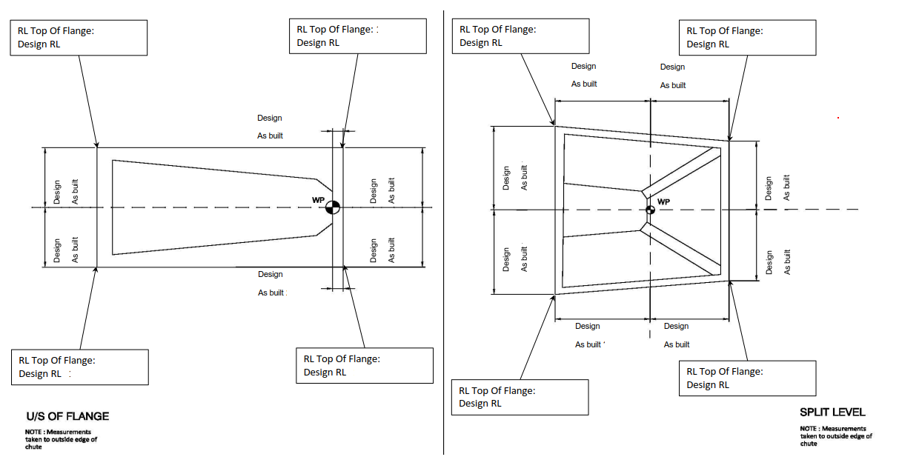
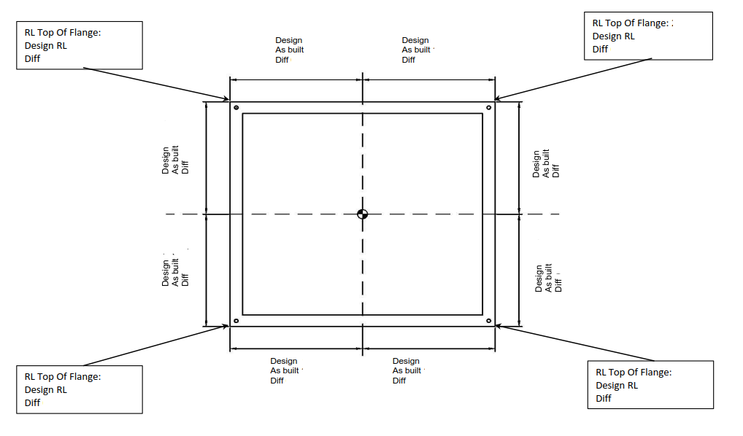

COMMENTS, OBSERVATIONS & ATTACHMENTS
(Complete a Punchlist Form and attach if any of the checks above marked as “Punch”)
COMPLETED
I hereby confirm the work has been completed in accordance with Contract specified drawings, specifications & standards.
PERFORMED BY CONTRACTOR: |  | REVIEW BY SUPERVISOR/LEAD ENGINEER: |  | EPCM ACCEPTED BY:
Signature: |  | Signature: |  | Signature:
Name: |  | Name: |  | Name:
Title: |  | Title: |  | Title:
Date: |  | Date: |  | Date:

