Tag No. «Name» - «Description»
Subsystem: «ProcessBreakdownIdentifier» - «ProcessBreakdownName»
Manufacturer. | «ManufacturerName» | Model No. |  | «OEMPartNumber»
Field to record Serial No. | «SerialNumber»
Drawing No. | «DocumentList» | Task No. | «TaskName»
Additional Information: | «Comments»

Item | Description | OK | N/A | Punch
 | Confirm materials of construction are as per specifications and drawings.
 | Confirm support structure complete, level and accepted.
 | Confirm all welding works completed and tested as required. (non rubber lined items only)
 | Confirm all bolted connections and fixing systems including hold down, flange and liner are tensioned and marked correctly.
 | Confirm all supporting structure and covers are secure and all bolts tensioned/ wedges fitted.
 | Confirm all inspection doors and openings, including seal arrangements are correctly fabricated and installed in accordance with the drawings and locking mechanism freely operate and both doors close & seal correctly.
 | Confirm protective coatings applied to suit SS-P118 and all touch-up painting completed.
 | Confirm feed chutes are aligned with equipment receiving feed, in accordance with standards and specifications and survey(s) attached.
 | Confirm all impact plates and wear items have been installed and set up in accordance with the design drawings.
 | Confirm all protective rubber liners have been installed, no damage is evident and chutes are marked “NO WELDING – RUBBER LINED” as per SS-M158. (where required)
 | Confirm spray bars installed as per drawing.
 | Confirm blocked chute devices and level devices installed as per design drawings.
 | Confirm all feed spouts and chutes are installed as per design drawings.
 | Confirm signage & equipment labelling is installed as per design drawings and specifications.
 | Confirm all scaffold, debris and waste material removed and remedial surface treatment completed as per specification.

TYPICAL SURVEY TEMPLATE
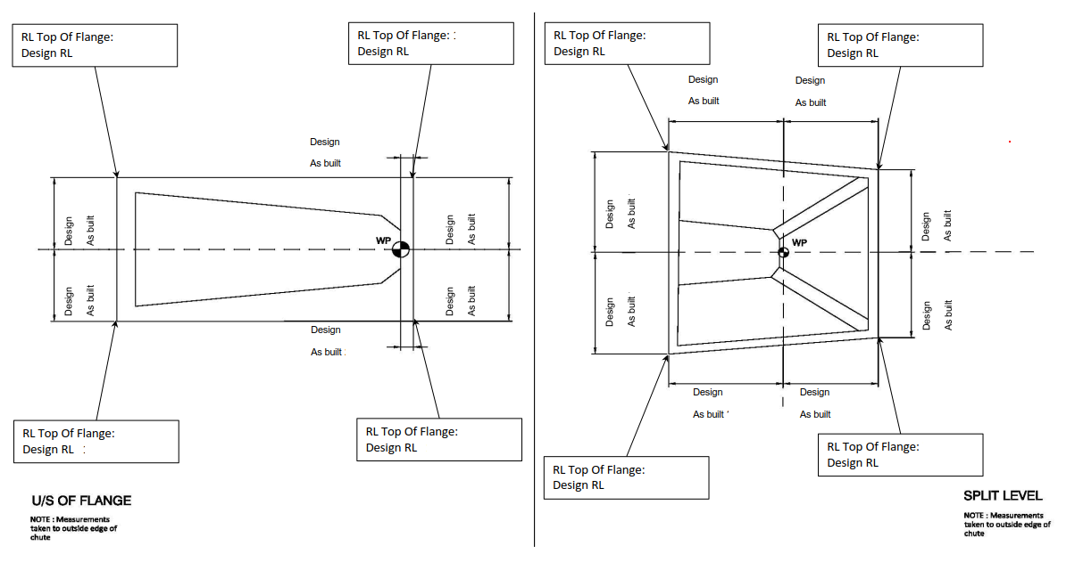
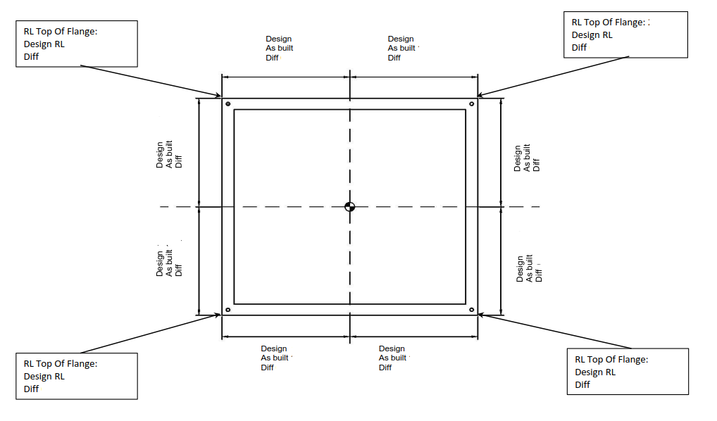

COMMENTS, OBSERVATIONS & ATTACHMENTS
(Complete a Punchlist Form and attach if any of the checks above marked as “Punch”)
COMPLETED
I hereby confirm the work has been completed in accordance with Contract specified drawings, specifications & standards.
PERFORMED BY CONTRACTOR: |  | REVIEW BY SUPERVISOR/LEAD ENGINEER: |  | EPCM ACCEPTED BY:
Signature: |  | Signature: |  | Signature:
Name: |  | Name: |  | Name:
Title: |  | Title: |  | Title:
Date: |  | Date: |  | Date:

