Tag No. «Name» - «Description»
Subsystem: «ProcessBreakdownIdentifier» - «ProcessBreakdownName»
Manufacturer. | «ManufacturerName» | Model No. |  | «OEMPartNumber»
Field to record Serial No. | «SerialNumber»
Drawing No. | «DocumentList» | Task No. | «TaskName»
Additional Information: | «Comments»

PULLEY LAYOUT & NUMBERING (taken from Profile and Data drawing)

Item | Description | OK | N/A | Punch
 | Inspect all components and confirm they are free from damage.
 | Confirm installed pulley and bearing housings matches the Profile and Data and Manufacturers Data Sheet.
 | Confirm pulley lagging and shell for damage.
 | Confirm pulley lagging protection removed prior to installation at height.
 | Confirm pulley lagging grooves are free of obstructions.
 | Confirm bearing housings identified with fixed and floating.
 | Confirm tacho ring installed as per design location with correct number of flags.
 | Confirm sole plate surveys conducted & attached & comply with Standard Specification SS-M118 19.2.3.
 | Confirm all pulleys checked for free movement of floating bearing prior to installation.
 | Confirm surface/ corrosion protection removed from bearing housing mounting face prior to install.
 | Confirm hold down bolts torqued and adjusting bolts locked and Denso taped.
 | Confirm all pulley types are correctly positioned and checked against drawings and surveys completed and attached.
 | Confirm housings are aligned in accordance with GN-M004 and IOM.
 | Confirm pulley rotates freely by hand.
 | Confirm shims installed in line with SS-M116 & MA-0000-M-1004.
 | Confirm accelerometers fitted where specified on the drawings.
 | Confirm remote grease lines installed as per MA-0000-M-1081 and lines have been pigged and purged with Shell Gadus S3 V220 2.
 | Confirm all grease lines are clearly marked with their greasing locations.
 | Confirm all guards are in place and secure.
 | Confirm all identification and signage is installed as per design drawings and project specifications.

BEARING CHECKS (multiples of this sheet may be required to cover all bearings identified on previous layout drawing)
P&D Pulley No.
Pulley ID/Serial No.
Bearing No.
Shaft Diameter
End Float
Remote grease lines fitted & purged
Pulley bearings greased & labyrinth seals purged
Grease type
Cap bolts tensioned correctly
Jacking bolt lock nuts tightened
Hold down bolts tensioned correctly

BEARING LAYOUT & NUMBERING
LABEL PULLEY e.g. Tail, Bend etc., complete with P&D Number & identify floating bearing for each
Install pulleys as per AS-0000-M-00264.
Drives shall have the plummer block housing with axially fixed bearing on the drive side, unless otherwise required by design considerations.
Drive Pulley

Typical Survey Report Templates For Sole Plates & Pulley

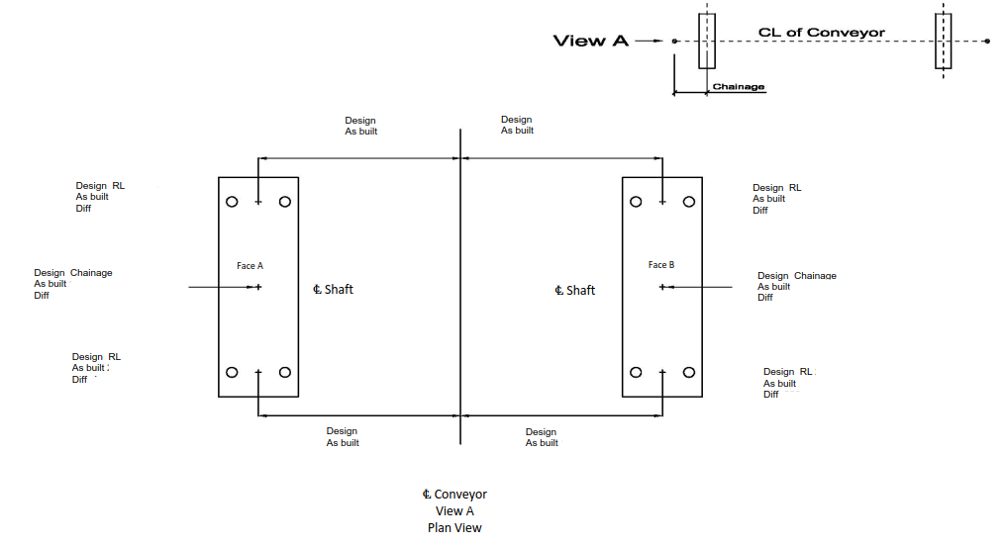
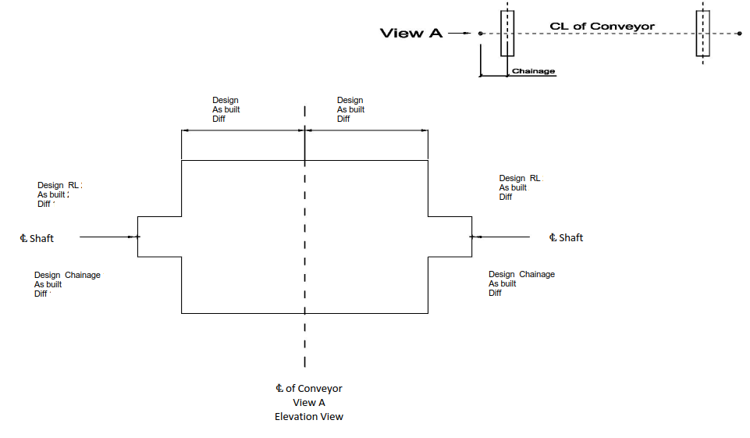

Measurement of pulley bearing housings shall be by one of the following methods as appropriate to the installation only:
- Labyrinth seal clearance check;
- Dial gauge method bearing housing alignment;
- Straight edge method bearing housing alignment

- LABYRINTH SEAL CLEARANCE CHECK
LABYRINTH SEAL CLEARANCES
INNER- FIXED |  |  | OUTER- FIXED |  |  |  | INNER- FLOATING |  |  |  | OUTER- FLOATING
A  B  C  D |  |  | E  F  G  H |  |  |  | I  J  K  L |  |  |  | M  N  O  P
 | PULLEY NUMBER
 | 1 | 2 |  | 3 | 4 | 5 |  | 6 | 7 | 8 |  | 9 | 10
A
B
C
D
E
F
G
H
I
J
K
L
M
N
O
P

- ALIGNMENT OF BEARING HOUSINGS (DIAL GAUGE METHOD)
 | 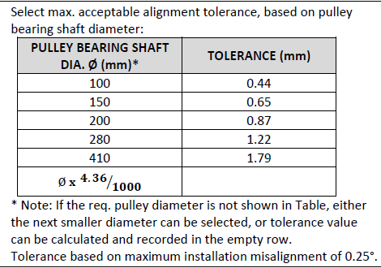
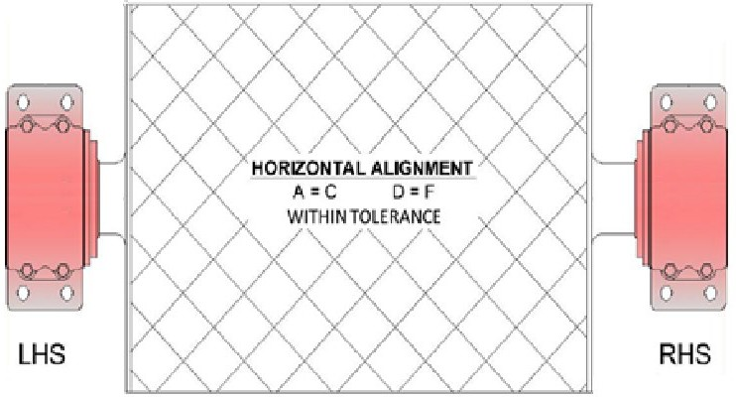  A  D  C  F  Angular measurements – Parallel to base direction | 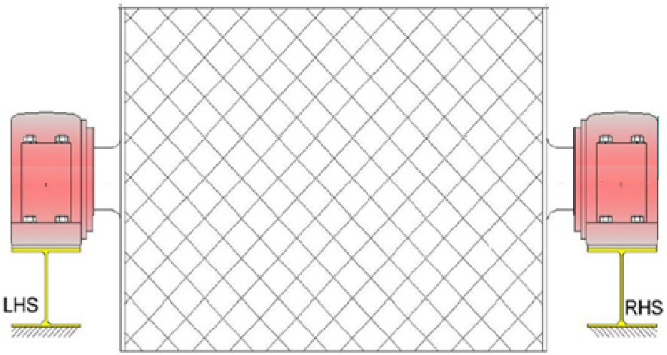  E2  B2  E1  B1  Angular measurements – Perpendicular to base direction

Description | OK | N/A | Punch

21. Select max. acceptable alignment tolerance, based on pulley bearing shaft diameter:    * Note: If the req. pulley diameter is not shown in Table, either the next smaller diameter can be selected, or tolerance value can be calculated and recorded in the empty row.  Tolerance based on maximum installation misalignment of 0.25°. | □ | □ | □ | Tolerance: mm
22. Record the final alignment dimensions, as per Dial Gauge Method: | □ | □ | □ | A =  B1 =  C =  D =  E1 = |  | B2 =  E2 = | _
a. Is |A-C| within tolerance? | □ | □ | □ | |A-C| | =
b. Is |B1-B2| within tolerance? | □ | □ | □ | |B1-B2| | =
c. Is |D-F| within tolerance? | □ | □ | □ | |D-F| | =
d. Is |E1-E2| within tolerance? | □ | □ | □ | |E1-E2| | =

- STRAIGHT EDGE METHOD BEARING HOUSING ALIGNMENT
This method can only be performed on pulleys that have closed bearing housings on both ends.

Please refer to Figure 4.1 whilst executing the following steps:
1. Place a Straight Edge on the back of the Housing, in direction parallel to base.
2. Measure the distance between the Straight Edge and the outer edge of the machined face surface of the pulley shell (ie A and C on the LHS and D and F on the RHS).
3. Adjust the housings until A = C on the LHS and D = F on the RHS. See checksheet (Section 4.3) for tolerances. The tolerances are based on pulley diameter and achieving a installation misalignment of 0.25°.
4. Set housing position with jacking screws or packers.
5. Record the final values in the checksheet (Section 4.3).
Please refer to Figure 4.2 whilst executing the following steps:
1. Rotate the Straight Edge so that it is pointing in a direction perpendicular to base, on the back of the housing.
2. Measure the distance between the Straight Edge and the outer edge of the machined face of the pulley shell (ie B on the LHS and E on the RHS).
3. Record the final values in the checksheet (Section 4.3).
4. If values are out of tolerance, then notify the site representative. The first step should be to confirm pulley alignment.
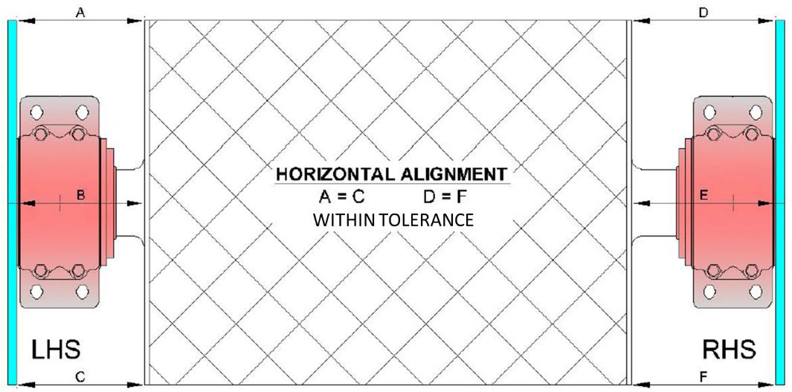  Figure 4.1: Angular measurements – Parallel to base direction | 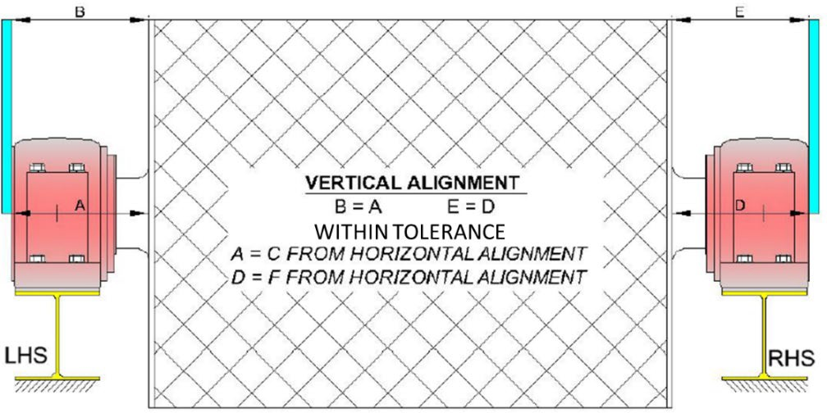  Figure 4.2: Angular measurements – Perpendicular to base direction

Description |  | OK | N/A |  | Punch
 | 23. Select max. acceptable alignment tolerance, based on pulley diameter:  PULLEY DIA. Ø (mm)* TOLERANCE (mm)  315 1.4  630 2.7  800 3.5  1000 4.4  2200 9.6  Ø x 4.36/1000  * Note: If the req. pulley diameter is not shown in Table, either the next smaller diameter can be selected, or tolerance value can be calculated and recorded in the empty row.  Tolerance based on maximum installation misalignment of 0.25°. | □ |  | □ | □ | Tolerance: mm
 | 24. Record the final alignment dimensions, as per Straight Edge and Ruler Method: | □ |  | □ | □ | A = B = _ C = _ D = E = F =
 | a. Is |A-C| within tolerance? | □ |  | □ | □ | |A-C| =
 | b. Is |A-B| within tolerance? | □ |  | □ | □ | |A-B| =
 | c. Is |D-F| within tolerance? | □ |  | □ | □ | |D-F| =
 | d. Is |D-E| within tolerance? | □ |  | □ | □ | |D-E| =

COMMENTS, OBSERVATIONS & ATTACHMENTS
(Complete a Punchlist Form and attach if any of the checks above marked as “Punch”)
COMPLETED
I hereby confirm the work has been completed in accordance with Contract specified drawings, specifications & standards.
PERFORMED BY CONTRACTOR: |  | REVIEW BY SUPERVISOR/LEAD ENGINEER: |  | EPCM ACCEPTED BY:
Signature: |  | Signature: |  | Signature:
Name: |  | Name: |  | Name:
Title: |  | Title: |  | Title:
Date: |  | Date: |  | Date:

