Tag No. «Name» - «Description»
Subsystem: «ProcessBreakdownIdentifier» - «ProcessBreakdownName»
Manufacturer. | «ManufacturerName» | Model No. |  | «OEMPartNumber»
Field to record Serial No. | «SerialNumber»
Drawing No. | «DocumentList» | Task No. | «TaskName»
Additional Information: | «Comments»

Item | Description |  |  |  |  |  |  |  |  | OK |  | N/A | Punch
SCREEN
 | Inspect all components and confirm they are free from damage.
 | Confirm screen has been installed in accordance with the design drawings & manufacturer’s instructions and survey attached.
 | Confirm all screen deck protection panels removed and all panels seated properly.
 | Confirm deck retention bolts checked for tension after transit.
 | Confirm deck locking strips seated correctly & deflectors point towards feed end.
 | Confirm all spring centre measurements checked to drawing specifications.
 | Confirm measured length between spring base plate centres within ±3 mm.
 | Confirm measured width between spring base plate centres within ±3 mm.
 | Confirm Spring base plate centres are square – diagonals within ±3 mm.
 | Confirm heights of spring base plates are within ±3 mm. (survey report attached)
 | Confirm all spring base plate bolts have been tensioned in accordance with the manufacturer’s instructions.
 | Confirm all bolts installed with self-locking nuts.
 | Confirm spring verticality (sag) has been measured & is no greater than 5 mm for ALL springs (use level placed on side of springs).
 | Confirm Static Inclination Of Deck: Horizontal (within 4 mm).
Confirm Static Inclination Of Deck: Longitudinal (as nominated on drawing):
- Horizontal (within 4 mm) mm
- Longitudinal (as nominated on drawing) mm
 | Confirm all beam protection covers are installed and not damaged.
 | Confirm screen media panel apertures are installed correctly as per deck assembly drawings.
 | Confirm all dust covers and seals installed correctly.
 | Confirm all signage & equipment labelling correct & complete as per design drawings and project specifications.
SPRING HEIGHTS (measure and record spring length at centre of spring pack, length must be equal within 4 mm side to side)
Flow
 |  | Feeder | Isolation Frame |  | DISCHARGE  FEED |  |  | Feeder |  | Isolation Frame
LHD |  | mm | mm |  |  |  | RHD | mm |  | mm
LHF |  | mm | mm |  |  |  | RHF | mm |  | mm
Item | Description |  |  |  |  |  |  |  |  | OK |  | N/A | Punch
ISOLATION FRAME
 | Confirm each side frame is level within ±2 mm.
 | Confirm assembly is square in Plan View – diagonals within ±3 mm.
 | Confirm assembly is square in End View – diagonals within ±3 mm.
 | Confirm measured length between spring base plate centres within ±3 mm.
 | Confirm measured width between spring base plate centres within ±3 mm.
 | Confirm spring base plate centres are square – diagonals within ±3 mm.
 | Confirm heights of spring base plates are within ±3 mm.
 | Confirm spring verticality (sag) has been measured & is no greater than 5 mm for ALL springs (use level placed on side of springs).
 | Confirm all bolts have been tensioned in accordance with manufacturer’s instructions.
 | Confirm all bolts installed with self-locking nuts.
 | Confirm dampers installed & bolts tensioned.
 | Confirm screen installed on isolation frame and survey attached.
CLEARANCES

Clearances on Structure- general as per design and OEM drawings/specifications
Clearance Description |  |  |  | Corner Location |  | Vertical (mm) |  |  | Longitudinal (mm) |  | Transverse (mm)
Isolation Frame Clearance Between Structures  (Front is discharge of screen)  (LH & RH are respective to the material flow direction) |  |  |  | Rear LH
 |  |  |  | Rear RH
 |  |  |  | Front LH
 |  |  |  | Front RH
Clearance Between Screen and Discharge Chute |  |  |  | Rear LH
 |  |  |  | Rear RH
 |  |  |  | Front LH
 |  |  |  | Front RH
Clearance Between Screen and Feeder |  |  |  | Rear LH
 |  |  |  | Rear RH
 |  |  |  | Front LH
 |  |  |  | Front RH
Clearance Between Screen and Dust Cover Fixed Structures |  |  |  | Rear LH
 |  |  |  | Rear RH
 |  |  |  | Front LH
 |  |  |  | Front RH

Typical Example of Screen Clearances
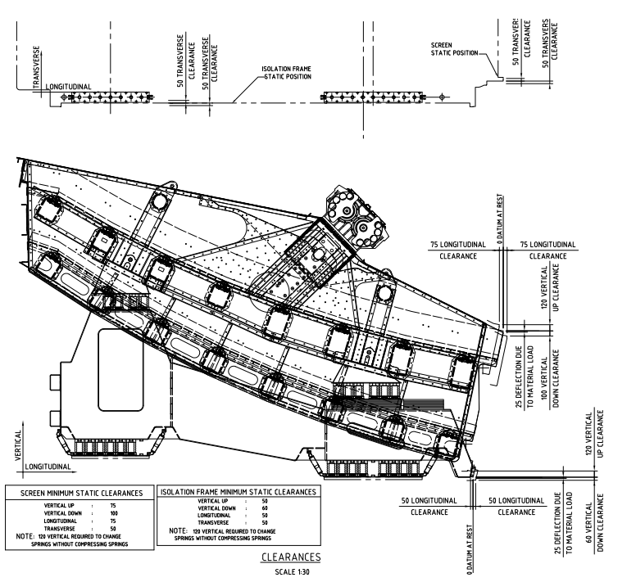
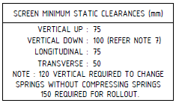
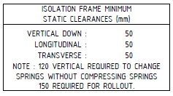

EXCITER MODEL No. |  | SERIAL No. DE |  | SERIAL No. NDE

Item | Description | OK | N/A | Punch
EXCITERS & DRIVE UNIT
 | Confirm motor hold down bolts tensioned correctly and no soft foot evident.
 | Confirm exciter transport protection removed.
 | Confirm exciter bolts with nut and washer outside beam, so nut fits into the machined spot face.
 | Confirm exciters aligned, phase and weight configuration has been set correctly for design amplitude/throw and all plugs are affixed.
Confirm exciter hold down bolts tensioned correctly- required to check tension after transport:
Torque (Nm)
 | Confirm breathers correctly installed and protective seals removed.
 | Confirm condition monitoring equipment installed as per design requirements.
 | Confirm layshaft bearing hold down bolts tensioned correctly.
 | Confirm Horizontal Axis: lay shaft axis is BELOW exciter shaft axis as per nominated measurement on vendor drawing (±5 mm).
 | Confirm Vertical Axis: lay shaft axis is in alignment with exciter shaft axis as per nominated measurement on vendor drawing (±5 mm).
Confirm drive shaft couplings secured & aligned and torqued correctly _________Nm.
Attach alignment report.
 | Confirm all first fills have been completed, samples taken and results attached.
 | Confirm direction of rotation physically checked for both drive & gearbox and marked.
 | Confirm all guarding installed with use of self-locking nuts or the use of thread locker where tapped holes are used. (if required by vendor)
 | Confirm all identification and signage is installed as per design drawings and project specifications.
ROLL OUT UNITS AND RAIL
 | Confirm all rails are aligned and installed as per specifications and drawings and survey is attached.
 | Confirm all roll out drives are affixed correctly and aligned.
 | Confirm all wheels rotate freely by hand with no signs of binding.
 | Confirm direction of rotation is marked clearly on each drive.
 | Confirm each hydraulic ram is free from damage, inlet and outlet fittings are free from debris and sufficiently plugged to stop dirt ingression.
 | Confirm all cylinder rods and pins are installed correctly.
 | Confirm vendor ITR (M1.099) has been completed for all sections of the installation.

COMMENTS, OBSERVATIONS & ATTACHMENTS
(Complete a Punchlist Form and attach if any of the checks above marked as “Punch”)
COMPLETED
I hereby confirm the work has been completed in accordance with Contract specified drawings, specifications & standards.
PERFORMED BY CONTRACTOR: |  | REVIEW BY SUPERVISOR/LEAD ENGINEER: |  | EPCM ACCEPTED BY:
Signature: |  | Signature: |  | Signature:
Name: |  | Name: |  | Name:
Title: |  | Title: |  | Title:
Date: |  | Date: |  | Date:

