Tag No. «Name» - «Description»
Subsystem: «ProcessBreakdownIdentifier» - «ProcessBreakdownName»
Drawing No. | «DocumentList» | Task No. | «TaskName»
Additional Information: | «Comments»

Item | Description | OK | N/A | Punch
 | Confirm materials of construction are as per specifications and drawings.
 | Confirm support structure is accepted.
 | Confirm all welding works completed and tested as required.
 | Confirm all bolted connections including hold down, flange and liner bolts are tensioned and marked correctly.
 | Confirm all inspection doors and openings are correctly fabricated and installed in accordance with the drawings and locking mechanism freely operate and both doors close & seal correctly.
 | Confirm inner inspection doors painted yellow Y14 as per SS-P118.
 | Confirm feed chute is aligned with conveyor in accordance with MA-0000-M-1092 and survey report has been completed and attached.
 | Confirm head chute dust curtains are fitted and profiled in accordance with MA-0000-M-1096.
 | Confirm the return side dust curtain has been installed.
 | Confirm head chute has sufficient clearance between belt, pulley & shaft as per MA-0000-M-1092.
 | Confirm impact plate has been installed and set up in accordance with the drawings.
 | Confirm impact plate turnbuckle lock nuts installed and Denso taped.
 | Confirm chute is furnished with equipment for installation of blocked chute devices.
 | Confirm scaff plug liners installed as per drawing/ liner requirements.
 | Confirm wear liners are installed as per MA-0000-M-1114 and design drawings.
 | Confirm signage & equipment labelling installed as per specification and design drawings.
 | Confirm all debris and waste material removed and remedial surface treatment completed as per specification SS-P118
 | Confirm chute Hold down plates installed at operating position.
 | Confirm all walkways and handrails installed to head chute and access platforms.
 | Confirm non slip surfaces applied where applicable.

TYPICAL SURVEY TEMPLATE
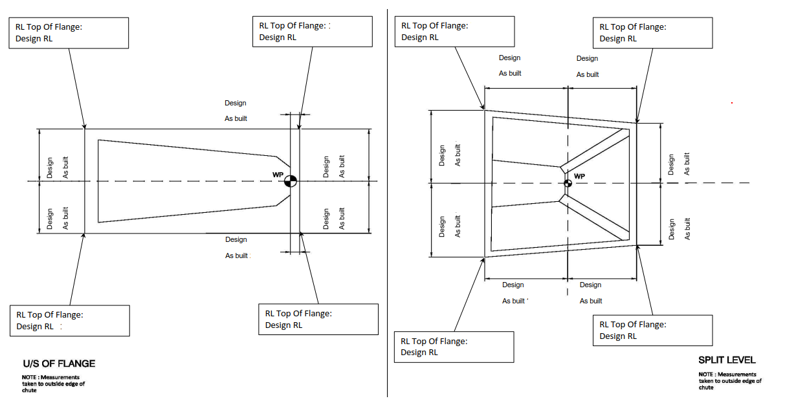
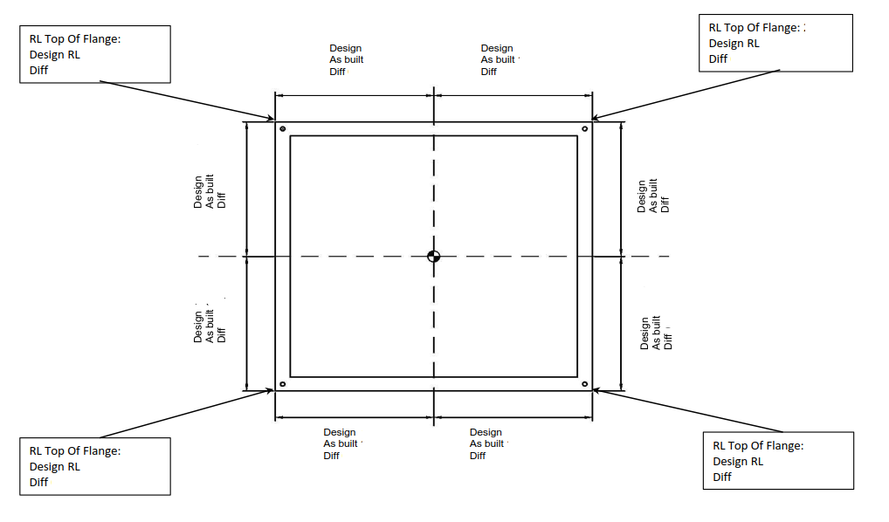

COMMENTS, OBSERVATIONS & ATTACHMENTS
(Complete a Punchlist Form and attach if any of the checks above marked as “Punch”)
COMPLETED
I hereby confirm the work has been completed in accordance with Contract specified drawings, specifications & standards.
PERFORMED BY CONTRACTOR: |  | REVIEW BY SUPERVISOR/LEAD ENGINEER: |  | EPCM ACCEPTED BY:
Signature: |  | Signature: |  | Signature:
Name: |  | Name: |  | Name:
Title: |  | Title: |  | Title:
Date: |  | Date: |  | Date:

