60113 Course Reference Material
Oracle PL/SQL: Basics

National Education Training Group, Inc.



Copyright © 1998 National Education Training Group, Inc.
All rights reserved. No part of the material protected by this copyright may be reproduced or utilized in any form or by any means, electronic or mechanical, including photocopying, recording, broadcasting, or by any information storage and retrieval system, without permission in writing from National Education Training Group, Inc.
Skill Builder is a registered trademark of National Education Training Group, Inc. All other trademarks referenced are the trademark, service mark, or registered trademark of their respective holders. National Education Training Group, Inc. is not affiliated with any company or any other product or vendor mentioned in this course and its accompanying materials.
The software and technology used in the CD-ROM portion of this course contain trade secrets that NETG considers to be confidential and proprietary information, and your right to use this material is subject to the restrictions in the license agreement under which you obtained it.
Contents
Objectives
PL/SQL: An Introduction
PL/SQL: An Introduction
PL/SQL Program Constructs
Developing a Simple PL/SQL Block
PL/SQL Datatypes
PL/SQL Composite Datatypes
Declaring PL/SQL Tables
Handling PL/SQL Variables and Datatypes
PL/SQL Programming Conventions
Procedure Builder: An Overview
Accessing the Database Using PL/SQL
Retrieving Data
Manipulating Data
SQL Cursors
Managing Transactions
Controlling Flow in PL/SQL Blocks
Conditional Control
Looping Constructs: Iterative Control
Explicit Cursors
Cursors: An Introduction
Explicit Cursors: Application
Explicit Cursor: Attributes
Explicit Cursor Applications: Advanced
Completion Time Estimate
Tips
PL/SQL: An Introduction
Developing a Simple PL/SQL Block
Command Reference
IF
SELECT
LOOP
FOR
Declaring PL/SQL Variables
Declare a PL/SQL TABLE Type
Declare a PL/SQL Table
Declare a PL/SQL RECORD Type
Declare a PL/SQL Record
Table Structures
Summit Sports Goods
s_customer
s_dept
s_emp
s_image
s_item
s_ord
s_product
s_region
s_warehouse
Glossary

Objectives

PL/SQL: An Introduction

PL/SQL: An Introduction
PL/SQL: Features
Identify the features of PL/SQL.
PL/SQL: Benefits
Identify the advantages of using PL/SQL.
PL/SQL Engine Functionality
Identify the methods by which a PL/SQL block of code is processed by the different PL/SQL engines in a client-server environment.

PL/SQL Program Constructs
PL/SQL Blocks: An Introduction
Identify the features of the sections of a basic PL/SQL blocks.
PL/SQL Program Constructs: Features
Match the PL/SQL program constructs with their features.
PL/SQL Blocks: Syntax Rules
Identify the syntax rules applied while creating a PL/SQL block.

Developing a Simple PL/SQL Block

PL/SQL Datatypes
Declaring Variables: Guidelines
Identify the guidelines for declaring PL/SQL variables.
PL/SQL Datatypes: Introduction
Identify the features of PL/SQL datatypes.
Scalar Datatypes: Classification
Match the scalar datatypes with their descriptions.
Declaring Scalar Variables
Declare a variable to store a specific value.
Declaring Scalar Variables With %Type
Declare a scalar variable by using the %TYPE attribute.

PL/SQL Composite Datatypes

Declaring PL/SQL Tables
Declaring PL/SQL Tables
Declare a PL/SQL TABLE type that contains the elements of a specific datatype.
Declaring PL/SQL Records
Declare a PL/SQL RECORD type to store a row from a table.
Declaring PL/SQL Records With %ROWTYPE
Declare a PL/SQL record by using the %ROWTYPE attribute.

Handling PL/SQL Variables and Datatypes
Assigning Values to Variables
Assign values to a variable.
Manipulating Values Using Operators
Compare the values of two variables by using a relational operator.
Manipulating Values Using SQL Functions
Manipulate the value of a variable by using an SQL function.
Converting Datatypes
Convert the datatype of a variable by using the data conversion function.
Variable Scope in Nested Blocks
Identify the scope of a variable in the nested PL/SQL blocks.

PL/SQL Programming Conventions
Code: Writing Conventions
Identify the object categories according to their standard case convention.
Identifiers: Naming Conventions
Match the identifiers with their naming conventions.

Procedure Builder: An Overview
Procedure Builder: Components
Match the Procedure Builder components with their descriptions.
Program Unit Editor: Components
Match the components of the Program Unit Editor with the tasks for which they are used.
PL/SQL Interpreter: Components
Match the components of PL/SQL Interpreter with the tasks for which they are used.

Accessing the Database Using PL/SQL

Retrieving Data
Retrieving Data With SELECT..INTO Clause
Retrieve data from a table into user-defined variables by using SELECT..INTO clause.
SELECT..INTO Statements: Exceptions
Identify the conditions when various SELECT exceptions are raised

Manipulating Data
Inserting Data
Insert new rows into a table by using the DML INSERT command.
Updating Data
Update data in a table by using the DML UPDATE command.
Deleting Data
Delete data in a table by using the DML DELETE command.

SQL Cursors
SQL Cursors: Features
Identify the features of a SQL cursor.
SQL Cursors Attributes
Match the SQL cursor attributes with their descriptions
Committing Current Transactions
Confirm the current transaction by using the COMMIT command.

Managing Transactions
Discarding Current Pending Changes
Discard current pending changes by using the ROLLBACK command.
Controlling Intermediate Transaction Points
Control a transaction at an intermediate transaction point by using the SAVEPOINT command.

Controlling Flow in PL/SQL Blocks

Conditional Control
Performing Actions Selectively
Write the IF statement for performing actions selectively in a PL/SQL block.
Boolean Conditions: Evaluations
Match the Boolean conditions with their results, given the values of the variables in the Boolean conditions.

Looping Constructs: Iterative Control
Repeating Statements Using Basic Loop
Write a basic loop to insert new lines for specific fields in a PL/SQL table.
Repeating Statements Using FOR Loop
Write a FOR loop to count the number of times a loop is executed and the last value for an index based on the specified lower and upper bounds.
Repeating Statements Using WHILE Loop
Write a WHILE loop to insert the first new line items into the fields of a PL/SQL table.
Nested Loops
Identify the features of labels in a nested loop in PL/SQL.

Explicit Cursors

Cursors: An Introduction
Cursor Type
Identify the declaration methods of the types of cursors.
Explicit Cursors: Features
Identify the features of an explicit cursor.
Controlling Explicit Cursors
Sequence the steps for controlling explicit cursors.

Explicit Cursors: Application
Declaring Explicit Cursors
Declare an explicit cursor to store the values retrieved from specified fields of a database table.
Opening Explicit Cursors
Open an explicit cursor.
Retrieving Data From Explicit cursors
Retrieve data from an explicit cursor by using the FETCH statement.
Closing Explicit Cursors
Close an explicit cursor by using the CLOSE statement.

Explicit Cursor: Attributes
Checking Status Using %ISOPEN Attribute
Write the code to check the status of a cursor by using the %ISOPEN attribute.
Checking Status Using %FOUND Attribute
Write the condition to check the status of a cursor by using the %FOUND attribute in a WHILE LOOP.
Exiting a Loop Using %NOTFOUND Attribute
Write the condition to exit a loop when no row is found by using the %NOTFOUND attribute.
Counting Rows Returned Using %ROWCOUNT
Write the code to retrieve a specified number of rows by using the %ROWCOUNT attribute.

Explicit Cursor Applications: Advanced
Declaring Explicit Cursors With Parameters
Declare an explicit cursor with parameters.
Retrieving Rows Using an Explicit Cursor
Write the code to retrieve rows in an explicit cursor by using the cursor FOR loop.
Updating Latest Fetched Row
Update a table for the latest fetched row using the WHERE CURRENT OF clause.

Completion Time Estimate

Unit Title | Total Hours
PL/SQL: An Overview | 1 hour 15 minutes
Developing a Simple PL/SQL Block | 2 hour
Accessing the Database Using PL/SQL | 1 hour 30 minutes
Controlling Flow in PL/SQL Blocks | 1 hour
Explicit Cursors | 1 hour 45 minutes
Total Length of the Course | 7 - 8 hours

Tips

PL/SQL: An Introduction
- You can store SQL-intensive code on the server to reduce the number of individual SQL statements sent over the network..
- To make a PL/SQL block of code easy to read, start each statement on a new line and indent each level of the block..
- An example of an anonymous block is a block in the Developer 2000 components.
- A function is similar to a procedure, except that a function must return a value.

Developing a Simple PL/SQL Block
- PL/SQL version 2.3 and higher enables the creation of PL/SQL tables of records.
- A PL/SQL record can also take its structure from other objects such as a cursor definition.
- An exception section can contain nested blocks.

Command Reference

IF
Syntax
IF condition THEN
statements;
[ELSIF condition THEN
statements;]
[ELSE statements;]
END IF;
Purpose
The IF statement is used to execute statements selectively based on a condition being fulfilled.

SELECT
Syntax
SELECT <columns name, group_function>
FROM <table_name>
[WHERE condition]
[GROUP BY group-by-expression]
[HAVING group condition]
[ORDER BY column_name];
Purpose
The SELECT command is used from the SQL prompt to fetch rows and columns from one or more tables.

LOOP
Syntax
LOOP
statement1;
statement2;
END LOOP;
Purpose
The LOOP statement is the simplest form of iterative control statements which is used to execute a set of statements multiple times.

FOR
Syntax
FOR counter IN lower bound .. upper bound LOOP
statements
END LOOP;
Purpose
The FOR loop is used to execute a set of statements within a loop a specific number of times.

Declaring PL/SQL Variables
Syntax
identifier [CONSTANT] datatype [NOT NULL] [:= | DEFAULT expr];
Purpose
This syntax is used to declare PL/SQL variables.

Declare a PL/SQL TABLE Type
Syntax
TYPE type_name IS TABLE OF scalar_datatype [NOT NULL]
INDEX BY BINARY_INTEGER;
Purpose
A TABLE type is a user-defined composite datatype. It used to declare a PL/SQL tables to store bulk data.

Declare a PL/SQL Table
Syntax
identifier type_name;
Purpose
A PL/SQL table is used to declare a PL/SQL tables for storing bulk data.

Declare a PL/SQL RECORD Type
Syntax
TYPE type_name IS RECORD
(field_name1 field_type
[NOT NULL {:= | DEFAULT} expr],
(field_name2 field_type
[NOT NULL {:= | DEFAULT} expr], ...);
Purpose
A PL/SQL RECORD type is used to declare a PL/SQL records for storing bulk data.

Declare a PL/SQL Record
Syntax
identifier type_name;
Purpose
A PL/SQL record is used for storing bulk data.

Table Structures

Summit Sports Goods

s_customer
COLUMN NAME NULL? TYPE
--------------------------------------------------------------------------
ID NOT NULL NUMBER(7)
NAME NOT NULL VARCHAR2(50)
PHONE VARCHAR2(50)
ADDRESS VARCHAR2(400)
CITY VARCHAR2(30)
STATE VARCHAR2(20)
COUNTRY VARCHAR2(30)
ZIP_CODE VARCHAR2(75)
CREDIT_RATING VARCHAR2(09)
SALES_REP_ID NUMBER(7)
REGION_ID NUMBER(7)
COMMENTS VARCHAR2(255)

s_dept
COLUMN NAME NULL? TYPE
--------------------------------------------------------------------------
ID NOT NULL NUMBER(7)
NAME NOT NULL VARCHAR2(25)
REGION_ID NUMBER(7)

s_emp
COLUMN NAME NULL? TYPE
--------------------------------------------------------------------------
ID NOT NULL NUMBER(7)
LAST_NAME NOT NULL VARCHAR2(25)
FIRST_NAME VARCHAR2(25)
USERID NOT NULL VARCHAR2(8)
START_DATE DATE
COMMENTS VARCHAR2(255)
MANAGER_ID NUMBER(7)
TITLE VARCHAR2(25)
DEPT_ID NUMBER(7)
SALARY NUMBER(11, 2)
COMMISSION_PCT NUMBER(4, 2)

s_image
COLUMN NAME NULL? TYPE
--------------------------------------------------------------------------
ID NOT NULL NUMBER(7)
FORMAT VARCHAR2(25)
USE_FILENAME VARCHAR2(25)
FILENAME VARCHAR2(25)
IMAGE LONG RAW

s_item
COLUMN NAME NULL? TYPE
--------------------------------------------------------------------------
ORD_ID NOT NULL NUMBER(7)
ITEM_ID NOT NULL NUMBER(7)
PRODUCT_ID NOT NULL NUMBER(7)
PRICE NUMBER(11, 2)
QUANTITY NUMBER(9)
QUANTITY_SHIPPED NUMBER(7)

s_ord
COLUMN NAME NULL? TYPE
--------------------------------------------------------------------------
ID NOT NULL NUMBER(7)
CUSTOMER_ID NOT NULL NUMBER(7)
DATE_ORDERED DATE
DATE_SHIPPED DATE
SALES_REP_ID NUMBER(7)
TOTAL NUMBER(11,2)
PAYMENT_TYPE VARCHAR2(6)
ORDER_FILTERED VARCHAR2(1)

s_product
COLUMN NAME NULL? TYPE
--------------------------------------------------------------------------
ID NOT NULL NUMBER(7)
NAME NOT NULL VARCHAR2(50)
SHORT_DESC VARCHAR2(255)
LONGTEXT_ID NUMBER(7)
IMAGE_ID NUMBER(7)
SUGGESTED_WHLSL_PRICE NUMBER(11, 2)
WHLSL_UNITS VARCHAR2(25)

s_region
COLUMN NAME NULL? TYPE
--------------------------------------------------------------------------
ID NOT NULL NUMBER(7)
NAME NOT NULL VARCHAR2(50)

s_warehouse
COLUMN NAME NULL? TYPE
--------------------------------------------------------------------------
ID NOT NULL NUMBER(7)
REGION_ID NOT NULL NUMBER(7)
ADDRESS LONG
CITY VARCHAR2(30)
STATE VARCHAR2(20)
COUNTRY VARCHAR2(30)
ZIP_CODE VARCHAR2(75)
PHONE VARCHAR2(50)
MANAGER_ID NUMBER(7)

Glossary

aim
Aim is a statement of business intent that can be measured subjectively; for example, to improve quality or to develop a sustainable level of growth.

alias
An alias is a secondary name used in a SQL statement to reference a column or a table.

application
An application is one or more program modules used to achieve a specific result. Applications can be nested within other applications. For example, an application to control a company's inventory could consist of various screen applications for input of data, and other report and chart applications to display the data visually.

Application Function Hierarchy
The application function hierarchy presents a vertical view of the business functionality. The purpose of the application function hierarchy is to provide another means for you to analyze the functional requirements of the business and to allow you to determine the application to be automated.

arc
An arc is a feature used to identify two or more mutually exclusive relationships or foreign keys. An arc appears as a curved line drawn across two or more connector ends to show that they are mutually exclusive.
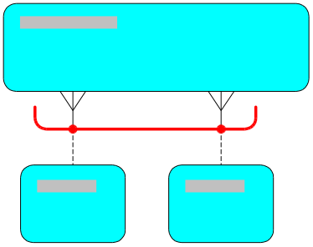

arc mapping
Arc mapping is a style used during entity to table transformation in the design stage, to map two or more subtype entities to separate tables that are to be included in an arc. In this approach, each instance of the subtype is made mutually exclusive by a foreign key arc generated on the table that implements the supertype entity.
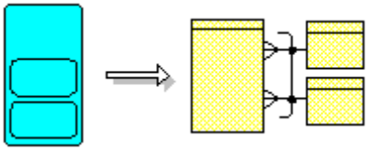

arced-subtype
An arced-subtype is an entity subtype that has an arc mapping

atomic function
Atomic function is a business function that cannot be broken down into component functions.

atomic process
A process that cannot be broken down into component processes is called atomic process.

attribute
An attribute is a detail that further defines an entity. For example, the entity Employee may have the following attributes: Employee Number, Position, Last Name, First Name and Other Initials. Attributes are mapped to columns during the first-cut design process.

base process
Base process is a business process in a process hierarchyfrom which a process model is created. A base process can have a parent processand/or child processes.

business
A business is an enterprise (in either the private or the public sector) that is concerned with providing products and/or services to satisfy customer requirements; for example, a car manufacturer or a health care organization.

business aim
A business aim is a statement of business intent that can be measured subjectively; for example, to improve quality or to develop a sustainable level of growth.

business constraint
A business constraint is any external, management or other factor that restricts the development of a business or of a system in terms of resource availability, dependencies and timescales.

business direction model
A business direction model is a model that documents the overall direction, structure and objectives of a business. Components include business aims and objectives critical success factors and key performance indicators as well as an organization structure.

business function
What a business does or needs to do, irrespective of how it does it.

business function hierarchy
A business function hierarchy is an arrangement of business functions that results from the process of function decomposition.

business model
A business model is a collection of models that represents a definition of a business. Components include models of business objectives, business function and information.

business objective
A business objective is a statement of business intent that can be measured quantitatively. Business aims and objectives are similar in concept, but the achievement of an objective is measurable in some specific manner; for example, to increase profit by 10% during the next financial year.

business process
Business process is an activity or collection of activities that adds some kind of value for the customers of a business. A business process has well-defined start and end points, both of which are associated with a customer. A business process has measurable performance standards, such as times and costs, and can be illustrated graphically in a process diagram.

business process re-engineering
Business process re-engineering is a method of business improvement that involves the fundamental rethinking and radical redesign of business processes to achieve dramatic improvements in key measures of performance.

business terminology
Definitions of the business terminology used in an application system. A comprehensive system glossary can be produced containing these commonly used terms.

business unit
Within a parent organization, a business unit is a part that, for any purpose, is treated as a separate unit; for example, a department.

cardinality
Cardinality the definition of the number of iterations that a relationship represents; that is, many or one. Also called 'degree'.

cascade delete
Cascade delete is a process whereby, when an object is deleted, all its subordinate objects (and their subordinates) and so on are also deleted.

cascade update
Cascade update is a process whereby, when the value of a primary key or of a unique identifier of an object is changed, the values of all those related objects that explicitly quote the original value are changed to reflect this new value.

change event
A change event is an event that occurs when the status of something changes is called a change event. Typically, a change event is a trigger to another event.

CHAR(n)
CHAR(n) is a datatype that stores character type of data. It has a fixed length character data of length n.

check constraint
A check constraint is a set of validation rules specified for a column that requires a given condition to evaluate to true or to be unknown for each row in the table. If the condition evaluates to false then the statement is rolled back. Check constraints can be used to validate columns whose values must fall within a specified range, or to validate mutually exclusive columns that are defined in an arc.

child function
A child function is a business functionthat is a component subfunction of another function, which is at the level above in the hierarchy and is called its parent function.

child process
A child process is a process step that has a parent process. A child process can itself have one or more child processes.

cluster
Cluster is a means of storing data from multiple tables together, when the tables contain common information that is likely to be accessed concurrently.

collapsed function
In a function hierarchy,a business functionwhose child functions have been collapsed or hidden from view is called a collapsed function.

column
Column is the means of implementing an item of data within a table. It can be in character, date, number or other format, and can be optional or mandatory.

column alias
Column alias is an alternative name for a column expression that is used as the column heading when the results of a query are returned. A column alias can be used to return a more meaningful column heading for column expressions that includes calculations. For example, a column alias ANNSAL might be used as a substitute for the expression SAL*12.

column mapping
Column mapping is a mapping that indicates the column that is to be used to store instance values for a given attribute.

combination unique identifier
A combination unique identifier is an identifier that is composed of one or more attributes and one or more relationships.

common function
A common function is a business functionthat appears in more than one place in the same hierarchy. It is either a master function or a copy (slave function). Only the master function can have the full detailed definition recorded against it, including function decomposition.

concatenation operator
The concatenation operator links columns to other columns, arithmetic expressions or constant values to create a character expression.

conceptual modeling
Conceptual modeling is concerned with modeling the business, and should ignore physical constraints and issues. Data models, application function hierarchiess, and process models are all part of the conceptual model, and are the result of the analysis phase.

conditional flow
Decision steps allow the specification of conditional process flows, flows that are followed only if certain conditions are true.

connector
A connector is a graphical representation of relationships in entity relationship.
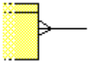

copy function
In a function hierarchy diagram, a common function that is an exact copy of a master function, is called a copy function. Common functions are used when the same business function appears in more than one place in the same hierarchy. Only the master function can have the full detailed definition recorded against it, including function decomposition. Also called 'slave function'.

critical path
A critical path is the series of elements in which a change to the total time of a single element results in a corresponding change to the duration of the entire business process.

critical success factor
Any business event, dependency, deliverable or other factor whose non-attainment would seriously impair the likelihood of achieving a business objective is called a critical success factor.

cross referencing
Cross referencing is a technique to validate the quality, completeness, and consistency of the process model and data model.

data dictionary
Data dictionary is a set of definitions of the tables, columns, views and other items that constitute a database.

data entry
Data entry is a type of process step. It specifically represents a data entry operation, such as entering data into a computer system.
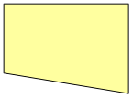

data flow
Data flow is a type of flow in a process diagram. It specifically represents the flow of data between process steps or between a process step and a store.
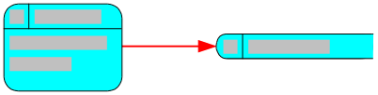

data item
Data item is an item of data, on a dataflow diagram or in a data store, that is not an attribute of a known entity. This is converted to an attribute when the analysis is more complete.
In some other methodologies, something whose definition is the equivalent of an attribute at the business level.
With other database management systems, a means of implementing an item of data within a file.
Sometimes, equivalent to a column.

data model
A data model is a set of database design objects, comprising of tables and their columns and foreign key. Data model is a synonym for entity model in some methodologies.

data store
In a process diagram, a type of store. It specifically represents a store of data, such as a database, rather than a store of materials, such as a warehouse.


database
Database is an arbitrary collection of tables or files under the control of a database management system (DBMS).

database design
A database design is a set of relations, referential integrity constraints and other database objects.

database link
A database link is a named object that describes a 'path' from one database to another.

database object
A database object is a logical structure that refers directly to the data within a database. Database objects include structures such as tables, views, sequences, stored procedures, synonyms, indexes, clusters and database links.

database procedure
A database procedure is a set of SQL and PL/SQL statements that are grouped together to be run as a unit to perform a very specific task. Procedures and functions are nearly identical; the difference is that functions always return a single value to the caller, whereas procedures do not return a value to the caller.

dataflow diagram
A dataflow diagram shows the sources and recipients of data. Use it to draw all of the functions in a system and show the flow of data between them. You can illustrate data using data stores. You can also use dataflow diagrams to show that all functions use and change data.

datatype
A datatype is a standard form of data.
When database tables are created, their columns are defined as containing data of a certain datatype. The Oracle datatypes used in column definitions are CHAR, VARCHAR2, VARCHAR, NUMBER, DATE, LONG, RAW, LONG RAW, ROWID and MLSLABEL.

DATE
DATE is a datatype that stores point-in-time values in a table. The default format of this datatype is DD-MON-YY.

Database Management System (DBMS)
DBMS is a system that encompasses computerized management facilities for structuring and manipulating data, and for ensuring privacy, recovery and integrity in a multi-user environment.

Data Definition Language (DDL)
DDL is a subset of SQL that is used to create, alter, drop and otherwise change definitions of tables, views and other database objects.

decision points
In a process model, a type of process step. It specifically indicates a place in the flow where there is a choice of possible paths. The result of the decision determines which path the flow follows.


degree
Degree is the definition of the number of iterations that a relationship represents; that is, many or one. Also called cardinality.

denormalization
Denormalization is a design process whereby information is replicated in a controlled manner, and derived columns and, in rare cases, repeating data are introduced to enable the system to meet some performance goal.

derived attribute
Derived attribute is a value derived by an algorithm from the values of other attributes and automatically updated in the database whenever the value of any of its source attributes is changed. For example, profit is derived as the difference between income and costs. The value of a derived attribute should not be separately updated.

derived column
A value derived by an algorithm from the values of other columns and automatically updated in the database whenever the value of any of its source columns is changed. The value of a derived column should not be separately updated.

Developer/2000
Developer/2000 is a set of application development tools that allow developers to create screen-based applications for users, reporting features and graphical displays of charts, images and drawings.

diagram
A diagram is a pictorial representation of the information to be modeled, designed, or coded.

distributed database
A database that is physically located on more than one computer processor, connected via some form of communication network is called distributed database. An essential feature of a true distributed database is that the users/programs work as if they had access to the whole database locally. All processing to give this impression is carried out by the database management system.

distributed processing
The ability to have several computers working together in a distributed network, where each processor can be used to run different activities for a user, as required.

dog-leg
On a diagram, an angled joint in a relationship, dataflow or foreign key connector. Dog-legs are used to improve the readability of large diagrams where it is necessary to bend connectors around other objects.
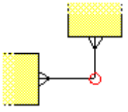

domain
A domain is a set of business validation rules, format constraints and other properties that apply to a group of attributes. For example, a list of values, a range, a qualified list or range, or any combination of these. Attributes and columns in the same domain are subject to a common set of validation checks.

elementary business function(EBF)
A business function that, if started, must either be completed successfully or be backed out so that any changes it made up to the point of failure are undone, as though they had never happened. There is no intermediate stage for an elementary business function (EBF).

elementary business process(EBP)
The smallest unit of activity of meaning to the user, which when complete leaves the information in a consistent state.

elementary process
Elementary process is a process that, if started, must either be completed successfully or be backed out so that any changes it made up to the point of failure are undone, as though they had never happened.

entity
An entity is a thing of significance, whether real or conceptual, about which the business or system being modeled needs to hold information. For example, if the business needs to process sales orders, an entity to represent sales orders would be recorded.
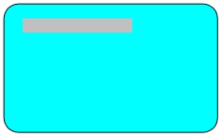

entity instance
An entity instance is a specific occurrence of an entity.

entity model
An entity model is a model of the information requirements of a business. The entity model consists of entities and their attributes and relationships.

entity modeling
Entity modeling is the process of creating an entity model.

entity relationship diagram
Entity relationship diagram is a diagram used for modeling the information requirements of a business. The diagram is used to represent entities, the relationship between them, and the attributes used to describe them.

entity subtype
Entity subtype is one of two or more subdivisions of an entity. Each subtype has common attributes and/or relationships defined explicitly, once only, at the higher level. A subtype can have attributes, relationships and/or subtypes of its own.
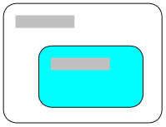

entity supertype
Entity supertype is an entity that has subtypes.


event
An event is a happening, the arrival of a significant point in time, a change in status of something, or the occurrence of something external that causes the business to react. The four types of event (change event), external event, realtime event and system event can all act as triggers to one or more business functions.

event analysis
Event analysis is a technique for identifying and defining the events that cause work to execute or are the result of work having been performed. Event analysis is used in conjunction with process modeling.

external
A person, business unit, application or entity that might provide or receive information from a business function. An external acts as a source or recipient of data flows into or out of the application.

external business function
A business function that is outside the scope of the application and that can act as a source or recipient of data flows into or out of the application.

external event
An external event is something that happens outside the control of the business, but which is significant to the business in some way.

field
A field is the intersection of a row and a column.

file
A collection of data, treated as the basic unit of information maintained by an operating system.
A method of implementing part or all of a database.

flow
In a process model, a flow shows the movement of data or materials between process steps, or between a process step and a store. Types of flow are data flow, material flow and temporal flow.

focus function
On a diagram, a business function displayed at the top of a hierarchy. The focus function need not be a root function.

foreign key
In a table, one or more columns whose values must match the values in the primary key of the referenced table. The columns in the foreign key typically reference the primary key of another table but may reference the same table. This mechanism allows two tables to be joined together.
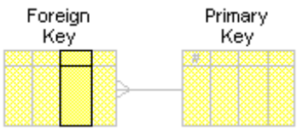

foreign key mapping
When transforming an entity model into a first-cut data design, a mapping that indicates which entity relationship a given foreign key is to implement.

frame function
In a dataflow diagram, the main business function that is displayed on the diagram. Functions that are inside the frame function are called local functions; functions that are outside the frame function are called global functions.
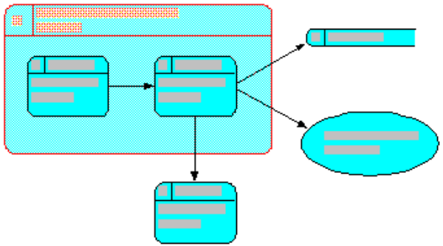

function
A PL/SQL subprogram that performs an operation and returns a value on completion of the operation. A function is a value construct that requires a name and the full PL/SQL syntax, including declarations and the BEGIN and END keywords.

function decomposition
Function decomposition is the breakdown of a business function into smaller units that are themselves business functions. This gives rise to an arrangement of functions in groups or hierarchies that is known as a business function hierarchy.

function dependency
The condition whereby a business function cannot start until either another function has completed, or until a specific event has taken place.

function hierarchy
A function hierarchy is a simple grouping to represent all the business functions in an area of a business in a strict hierarchy. This forms part of the business model that is produced in the analysis stage.

function label
A function label is a unique reference for a business function.

function logic
A function label is the detailed definition of precisely what a function does, including the way it manipulates information, business policies and algorithms (for example, an algorithm to work out staged payments for a building contract).

functions
Functions are a feature of SQL and are used to perform calculations on data and modify individual data items. Functions can also be used to manipulate output for groups of rows and to alter date formats for display.

global flow
In a dataflow diagram, a data flow between a global function and a local function on a diagram.
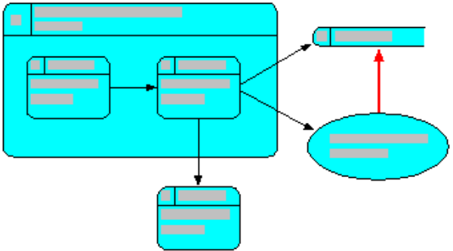

global function
In a dataflow diagram, a business function that resides outside the frame function on a diagram.
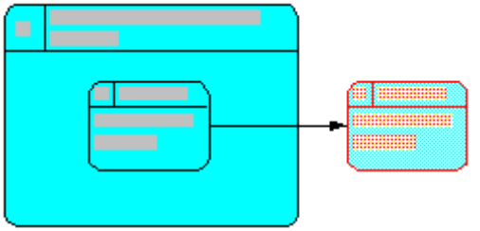

global process step
In a process model, a copy of a process step that is used when the same process step appears in more than one place in the process hierarchy. Only the original process step can have a detailed definition recorded for it. Any changes to the original are automatically reflected in all copies; copies cannot themselves be changed.

hidden arc
An arc that has only one of its relationship or foreign key ends displayed on the diagram.
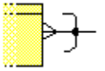

hierarchy
Hierarchy is a tree-like structure used to represent levels of elements and the associated inheritance of properties that is entailed.

icon
A graphical representation of, typically, an object, attribute, program, window or tool.

image
An illustrative picture or other graphic.

index
Index is a means of accessing one or more rows with particular performance characteristics in a table. An index can quote one or more columns and can be a means of enforcing uniqueness on their values.

inherited unique identifier
An subtype entity inherits a unique identifier from its supertype.

internal entity
Internal entity is a thing of significance within the scope of the application.

intersect entity
An entity that resolves a many to many relationship.
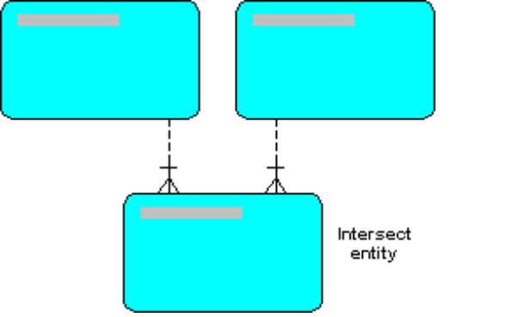

intersection table
A table that often has foreign keys to two or (rarely) more tables. Typically used to implement a many-to-many relationship between two entities, it is normally used when it is important to record that there is some relationship between one thing and another without further qualification; for example, a distribution list.


join
A combining of data from two (or more) tables in a single SELECT statement.

journal
A table that contains a record of any insert, update or delete operation performed on the records in the base table that it accompanies.

key
Any set of columns that is frequently used for the retrieval of rows from a table.

key performance indicator
A significant measure that is used, on its own or in combination with other key performance indicators, to monitor how well a business is achieving its quantifiable business objectives.

key result
The outcome that a business is trying to achieve on receipt of an event.

leaf function
A business function at the lowest level of a function hierarchy; that is, a function that has not (yet) been decomposed (for example, because definition is incomplete).

leaf process
A leaf process is at the lowest level of a process hierarchy, that is, a process that has not (yet) been decomposed (for example, because analysis is incomplete).

local function
In a dataflow diagram, a business function that resides inside the frame function on a diagram.
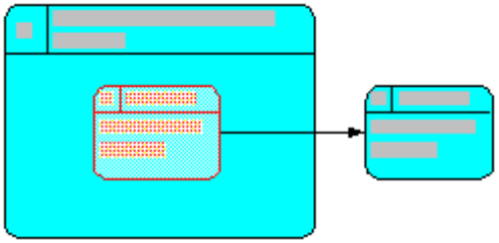

location
A location is a uniquely identifiable geographic location, from which one or more business units can be wholly or partly operating.

logical modeling
Logical modeling is concerned with representing the business in database terms, and is the result of the design phase. Data schema diagrams and module data diagrams are part of the logical model. Very often, the logical model will have been transformed from the conceptual model.

logical system design
Logical system design is the task of designing a system to support business needs without making final decisions about the physical implementation. The same logical design should be appropriate for many physical implementations that use, for example, different versions of a database management system.

many to many
A relationship between two entities where instances of each entity may be associated with many instances of the other.
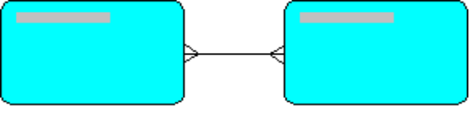

master function
A master function is a common function that has one or more copy (or slave functions) elsewhere in the same function hierarchy. Only the master function can have the full detailed definition recorded against it, including further function decomposition.

master table
A master table is a table of which one or more read-only snapshots are held on one or more remote nodes.

master/detail structure
A master detail structure describes a 1:m relationship between two elements (entities, tables, or table usages).
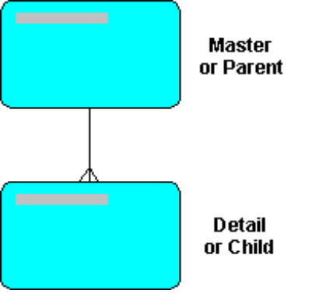

material flow
In a process model, a type of flow. It specifically represents the flow of materials between process steps or between a process step and a store.

material store
In a process model, a type of store. It specifically represents a store of materials, such as a warehouse, rather than a store of data, such as a database.


matrix diagram
Matrix diagram is a diagram in the form of a two-dimensional grid that allows you to plot the associations between two elements. For example, use a matrix diagram to examine the way business functions use entities.

maximum cardinality
Maximum cardinality defines the maximum number of entities possible at the other end of the relationship for each entity at this end. A maximum cardinality of null indicates that there is no maximum number.
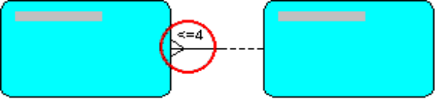

mechanism
A mechanism describes how an activity is executed. Mechanisms refer to people or their jobs, techniques, paper or screen forms, organization structures, and machines of any kind, including computers.

meta-model
A meta-model is a model of one of the models at either business or implementation level. Such a meta-model might be of an entity relationship diagram.

method
Method is a systematic manner in which a task is performed. The method provides a set of rules to developing the system.

minimum cardinality
Minimum cardinality is the minimum number of entities possible at the other end of the relationship for each entity at this end. This tells you both the degree at that end of the relationship and the optionality at this end. A minimum cardinality of zero indicates that the relationship is optional.

multimedia
The use of sound, graphics, animation and photographic and video images in presenting information.

network
An interconnected network of computers, as referred to in distributed processing.

node
On a diagram, a node is an object that represents an instance of a thing. For example, an entity, a business function or a data item.

non-transferable relationship/foreign key
A relationship or foreign key whose value must always be connected to a particular instance of the unique identifier or primary key with which it is associated. Items based on non-transferable foreign keys are made non-updatable in generated applications.
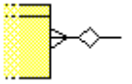

normalization
Normalization is a step-by-step process whose outcome is that information is recorded only once and is cross-related to all related data.

NULL
NULL is a value that is unavailable, unassigned, unknown and inapplicable. It is not the same as zero or space.

null
In some implementations of database management systems, a value for a column, or data item that means 'there is no current value'.

nullify
A usage for an attribute that indicates whether the values of this attribute are set to null by the function.

NUMBER
NUMBER is a datatype that stores fixed and floating point numbers.

objective
Objective is a statement of business intent that can be measured quantitatively. Business aims and objectives are similar in concept, but the achievement of an objective is measurable in some specific manner; for example, to increase profit by 10% during the next financial year.

occupant entity
Occupant entity is an entity, an instance of which is stored (in the implemented database) as a row in a table.

one to many
A relationship between two entities where instances of the first entity may be associated with many instances of the second, but instances of the second entity may only be associated with one instance of the first.
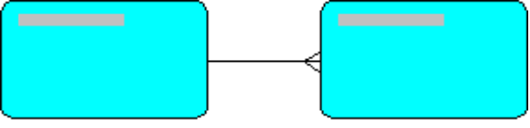

one to one
A relationship between two entities where instances of each entity may be associated with one and only one instance of the other.
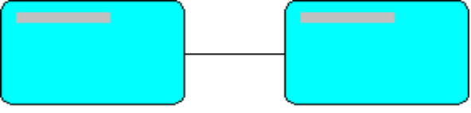

optionality
Optionality is the state of a relationship or foreign key end: either mandatory or optional.

Oracle
Oracle is a database company that offers a comprehensive set of application building and end-user products and services for information technology needs.

Oracle7 Server
Oracle7 Server is a flexible RDBMS provided by Oracle. Its features allow you to store and manage information with all the advantages of a relational structure and PL/SQL.

organization unit
In a process model, an organization unit represents part of the structure of your business, or of the organizations with which you do business. An organization unit can represent the entire business, a group or department within the business, a person within a group or department, or a role. Each organization unit has a corresponding swimlane, to help identify who is responsible for each stage of a business process.

outcome
In a process model, a type of event that occurs after completion of the business process illustrated on the diagram. A diagram can include more than one outcome, to cover all the possible consequences of a process.


outcome event
Outcome events are used in the process model to document the possible reactions a process has to the triggering event. There are three types: internal, external, and temporal.

parent function
A business function that has component subfunctions, which are displayed at the level below in the hierarchy and are called its child functions.

parent process
In a process model, a business process that is subdivided into one or more process steps in a process hierarchy. Each of these process steps can be further subdivided.

parent/child structure
A parent structure describes a 1:m relationship between two elements (entities, tables, or table usages).

performance indicator
A measure that is used, on its own or in combination with other performance indicators, to monitor how well a business is achieving its quantifiable business objectives.

phase
Phase is a part of the business that is being taken through the stages of analysis to production.

pig's ear
A graphical representation of a recursive relationship.
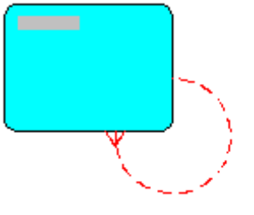

PL/SQL
A procedural extension of SQL that provides programming constructs such as blocks, conditionals, and procedures.

primary entity
The primary entity is the entity that is mapped to a particular table and is the entity supertype of all the other entities that are mapped to that table.

primary index
Primary index is an index used to improve performance on the combination of columns that is most frequently used to access rows in a table.

primary key
Primary key is the set of mandatory columns used to enforce uniqueness of rows, within a table. This is normally the most frequent means by which rows are accessed.
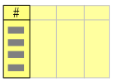

primary unique identifier (primary UID)
The primary unique identifier of an entity is that which has been chosen to be the candidate primary key after the entity has been transformed into a table.

process
Process is a definition of how one or more business functions are to be carried out by a system. A business function is what a business needs to do; a process is what a system needs to do; a mechanism is how the system does it.

process decomposition
Process decomposition is the breakdown of a process into smaller units that are themselves processes. This gives rise to an arrangement of processes in groups/hierarchies known as a process hierarchy.

process dependency
The condition whereby all or part of a process cannot start or continue until either all or part of another process has completed, or a specific event has taken place.

process diagram
Process diagram is a diagram illustrating a particular business process.

process flow
A process flow represents the sequential order of the process steps. It shows the order in which the process steps are performed, but also illustrates the dependencies that processes have on one another.

process hierarchy
Process hierarchy is a simple grouping to represent all the processes in an area of a business in a strict hierarchy. This forms part of the business model that is produced in the analysis stage.

process label
A process label is a unique reference for a process.

process logic
Process logic is the detailed definition of precisely what a process does, including the way it manipulates information, business policies and algorithms (for example, an algorithm to work out staged payments for a building contract).

process model
A process model shows the events that trigger a process, the flow of data to and from the sub-processes, and the outcome of the process. Each process is drawn in the swimlane of the business unit that performs it. You can also record information about times and unit costs.

process name
Process name is a short, succinct sentence that starts with a verb and describes what a business does or needs to do.

process step
A process step represents a task, activity or function that forms part of a business process, in a process model. Subtypes of process step are data entry, decision point and report.


prototyping
Prototyping is a technique for demonstrating a concept rapidly, to gain acceptance and check feasibility. A prototype should be constructed during analysis; to check requirements (discarding the prototype afterward), design; to check the feasibility of alternative options and to agree style (optionally discarding the prototype afterward) and build; to construct incrementally those programs that need close user involvement

Relational Database Management System (RDBMS)
RDBMS is a computer program designed to store and retrieve shared data that is held in tables consisting of one or more rows, each row containing the same set of columns.

realtime event
Any point in the life of an enterprise when, under specified conditions, real time reaches a predetermined date and time.

realtime system
A system in which events control the mechanisms. These are often used to control machinery (for example, a control system for an aircraft) and are often time and/or safety critical.

record
In a relational database management system, record is an alternative word for row.
In a non-relational database system, an entry, in a file, that consists of individual elements of information that together provide full details about an aspect of the information needed by the system. The individual elements are held in fields, and all records are held in files. An example of a record might be an employee, whose details (for example, date of birth, department code, full name) are found in the individual fields that make up the record.

record type
A record type is a predetermined set of fields within a row or (in non-relational database systems) within a file.

recursive relationship/foreign key
Recursive relationship/foreign key is a relationship representing a link between an entity and itself, in an entity relationship diagram.
In a table, this is a foreign key column whose value must match the value in the primary key of the same table.

referential integrity constraints
Referential integrity constraints is a set of validation rules applied to an entity table, such as uniqueness constraints, domain validation of columns, or correspondence of foreign keys to the primary key of their related table.

relation
Relation is a term that collectively refers to tables, views and snapshots.

relationship
Relationship is any significant way in which two things of the same or of different types can be associated. Note that it is important to name relationships.

resolved flow
In a dataflow diagram, a data flow representing the relationship between two branches of a hierarchy at a level lower than the one displayed on the diagram.


reverse engineering
Reverse engineering is an automatic and/or manual procedure that takes a component of an existing system and transforms it into a logical definition in a Repository. Such a Repository definition derived in this way will often be refined, integrated with some new top-down definition of requirements, and forward-engineered or generated to some replacement technology.

role
In a process model, a role is a particular function in a business process. A role can be performed by a person or by a piece of equipment with which a person interacts.
A role is a named group of related privileges granted to one or more database users. Thus several privileges can be granted at once by assigning a particular role to a user.

root function
In a hierarchy, a business function that has no parent function in the application. Sometimes called 'semantic root'.

root process
A business process, in a process hierarchy, that has no parent process in the application.

row
In a table, a row is an entry that typically corresponds to an instance of some real thing, and that consists of a set of values for all mandatory columns and relevant optional columns. A row is often an implementation of an instance of an entity. Sometimes used synonymously with 'tuple'.

schema
Schema is a logical collection of database objects belonging to a particular user. By default, each database user creates and has access to all objects in their corresponding schema.

secondary index
Secondary index is an optimization technique, for use on a set of optional or mandatory columns, to improve the performance of access to rows.

secondary unique identifier (secondary UID)
A secondary unique identifier of an entity are those that have been chosen to be the candidate unique keys after the entity has been transformed into a table.

SELECT
A SELECT statement retrieves information from the database, implementing all algebraic operators.

separate table mapping
Separate table mapping is a style of mapping that you can choose to map an entity subtype to a different table from its supertype. Details about the subtype and those inherited from its supertype are stored in the table that implements the subtype. Thus, each instance of the subtype is stored in the subtype table only.
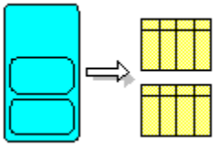

sequence
Sequence is a database object created like a table and used to generate unique keys (sequence numbers). Sequence information is stored in the data dictionary.

single table mapping
A style of mapping in which an entity supertype and its subtypes are mapped to the same table. By default, subtypes are mapped to the same table as the supertype.
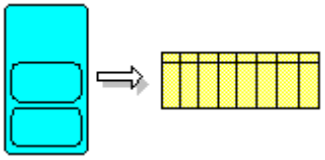

Single-row function
A single-row function operate on only a single row and returns one result per row.

slave function
In a function hierarchy diagram, a common function that is an exact copy of a master function. Common functions are used when the same business function appears in more than one place in the same hierarchy. Only the master function can have the full detailed definition recorded against it, including function decomposition. Also called 'copy function'.

snapshot
On a remote node, a read-only copy of a master table held on a database server. A snapshot, which is periodically refreshed to reflect changes made to the master table, can be queried but cannot be updated; only the master table can be updated.
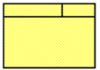

snapshot log
A table that is associated with the master table for a snapshot. The server uses the snapshot log to track rows that have been updated in the master table.

source entity
Source entity is an entity that is implemented by a table. The table contains columns to implement attributes and relationships on that entity, or inherits these from its supertype.

Structured Query Language (SQL)
SQL is an internationally accepted standard language for relational systems, covering not only query but also data definition, manipulation, security and some aspects of referential integrity.

SQL*Plus
An interactive SQL-based language for data manipulation, data definition and the definition of access permissions for a database.

state
A recognizable or definable condition that a system or an object can be in at some point in its life-cycle.

state transition diagram
A visual means of modeling an object, the states through which it might go during its life-cycle, the events that affect it, and its interrelationships to other objects and states. Such diagrams can be used to model objects such as an entity, a system, a program, a process or a business function, and are particularly useful to model realtime situations.

store
In a process model, a store represents a collection of information or materials. Subtypes of store are data store and material store.

structure chart
A structure chart is a diagram that represents how a process or program can be designed in terms of actions and their sequence, choice and iteration.

structures
Structures consist of a collection of objects or relations that store data.

subfunction
A subfunction is a business function that has a parent function.

sub-process
A sub-process is a system process that has a parent process.

subtype table
A table to which an entity subtype is mapped is called subtype table.
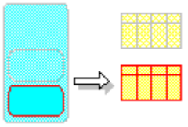

subtype-specific details
The attributes and relationships that are recorded against an entity subtype, not those inherited from its supertype.

supertype table
The table to which an entity supertype is mapped is a supertype table.
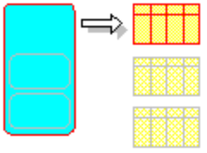

supertype-specific details
Supertype-specific details are the attributes and relationships that are recorded against an entity supertype, not those recorded against its subtypes.

surrogate key
A primary key created in the absence of any suitable unique key that can act as the primary key of the table.

swimlane
Swimlane is a horizontal division on a diagram, similar in appearance to a lane in a swimming pool in a process model. Each swimlane corresponds to an organization unit, the name of which appears at the side of the diagram. An element is placed in a swimlane to identify the organization unit that is responsible for it.

synonym
Synonym an alias for a database object. A synonym is not itself an object; it is a direct reference to its base object. Synonyms are used to mask the real name and owner of an object, to provide public access to an object, and to provide location transparency for tables, views or program units of a remote database.

system
System is a named, defined and interacting collection of real-world facts, procedures and processes, along with the organized deployment of people, machines, various mechanisms and other resources that carry out those procedures and processes.

system event
System event is something significant that occurs within the control of the business, such as the completion of a particular business function, and that can act as a trigger to initiate further functions.

table
A table is a basic storage structure of an RDBMS, consisting of one or more columns and zero or more rows.

table
Table is a logical data structure for holding data in relational database management system. Data is stored in columns and rows. The table definition defines what type of data the table can store and specifies referential integrity constraints used to restrict inserts, updates and deletions to the table’s data. A table is often an implementation of part or all of an entity.
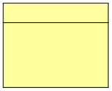

table link
A table link represents a foreign key constraint that exists between two tables.

table mapping
A style of mapping that indicates the table that is to be used to store instances of a given entity.

tablespace
A table space is a logical portion of a database, used in allocating storage for table data and table indexes.

temporal flow
In a process mode, a type of flow. It specifically represents a time-based dependency, indicating that the process step at the destination of the flow cannot begin until a process step at the source of the flow has been completed. An example of a temporal flow, on a diagram that represents the delivery of goods from a warehouse, is the original delivery to the warehouse.

time unit
In a process model, a time unit is the unit of measurement used for time durations on a diagram. Time units can be seconds, minutes, hours, half-days, days, weeks, months, quarters, half-years or years.

transferable relationship/foreign key
A relationship or foreign key between an object of type A and another object of type B whereby an instance of A can be disconnected from one instance of B and connected to another instance of B. Typically, relationships and foreign keys will be transferable.

transition
A transition is a valid change of a system or object from one state to another, modeled on a state transition diagram.

treewalk link
A table link that is used to create a recursive relationship for a table usage.
This relationship is used by Report Generator and the Graphics Generator to search either up or down a table from a specified point.

trigger
An event that causes one or more business functions or processes to be performed. This can be an implied event (for example, the completion of another function) or of all or part of another process.
In a process model, a type of event that occurs before the start of the flow that the diagram illustrates. A diagram can include more than one trigger, to cover all the possible origins of a process.

triggering event
Triggering events cause processes to execute. There are three types: internal, external, and temporal.

TRUNC
A TRUNC is a function that truncates the column or value to n decimal places.

tuple
Tuple is a set of values for an attribute. Sometimes used synonymously with row.
Sometimes, a distinction is made between tuples and rows: rows do not have to be unique within a table, whereas a tuple must be unique within a relation.

type and instance
A class of things and an individual item of that class. For example, each element is an instance of an element type.

unique identifier (UID)
Unique identifier is a combination of attributes and/or relationships that serves to identify uniquely an occurrence of an entity.

unique key
In a table, one or more columns that serve to identify uniquely an occurrence of a row is called a unique key. Primary keys and unique indexes are alternative ways of implementing unique identifiers.

unspecified organization unit
Unspecified organization unit is a artificial organization unit that does not represent any organization unit within the business area or outside the business area. It is used for many purposes such as modeling external interfaces with only one or two flows to a process step and modeling processes for which the responsible organization unit is unknown.

usage
Usage represents the manner in which elements interact. Function to entity usages are create, retrieve, update, delete, and archive (CRUDA). Function to attribute usages are insert, retrieve, update, nullify, and archive (IRUNA).

value chain
Value chain is the path of increase in the value added by each successive stage of a process.

VARCHAR2(n)
VARCHAR2(n) is a datatype that is similar to CHAR datatype, but it can also store a variable number of characters.

view
A view is a means of accessing a subset of the database as if it were a table. It can be restricted to named columns and/or specific rows; it can change column names or derive new columns; and it can be used to access a combination of related tables and/or views.
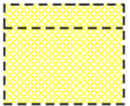

WHERE clause
The WHERE clause is used along with the SELECT statement to specify the condition based on which rows will be extracted from a table.

working style requirements
Working style requirements defines the manner of working that can apply to different user roles in the performance of business functions. For example, the use of a few simple buttons for shop-floor working, or the use of sophisticated workstations for designers.

