

Skill Builder®
^{With Classic Interface}

National Education Training Group, Inc.

January 1998

Copyright Notice
Copyright © 1998 National Education Training Group, Inc. All rights reserved.
No part of the material protected by this copyright may be reproduced or used in any form or by any means, electronic or mechanical, including photocopying, recording, broadcasting, or by any information storage and retrieval system, without permission in writing from National Education Training Group, Inc.
Learning Object™, Precision Learning™, Skill Builder®, and SkillVantage® Manager are trademarks of National Education Training Group, Inc. All other trademarks referenced are the trademark, service mark, or registered trademark of their respective holders. National Education Training Group, Inc. is not associated with any product or vendor.
The software and technology used to implement this product contains trade secrets that National Education Training Group, Inc. considers to be confidential and proprietary information, and your right to use this material is subject to the restrictions in the license agreement under which you obtained it.

Table of Contents
Overview
Using the Keyboard
Using the Mouse
Skill Builder Components
Control Panel
Course Map
Buttons and Indicators
Viewing Options
Precision Learning Track
Quick Quiz
Tips
Score Tracking
Using Skill Builder
Getting the Most from Skill Builder Courses
Moving Around in Skill Builder Courses
Printing Your Assessment Results
Post-assessments and Preassessments
Assessment Overview
Preassessments Overview
Assessment Window Features and Functions
Scores
Feedback Levels
Results Window
Review Window
Customizing Skill Builder
Setting Preferences
Creating a Logo
Index

Overview
Welcome to National Education Training Group's interactive training environment for Skill Builder. We're glad you chose one of the most popular multimedia training courses available. This PC-based user training system can help you learn many popular desktop, client/server and programming applications because the courses are designed to simulate actual software.

Using the Keyboard
The only keyboard function associated with Skill Builder navigation is the optional use of the Enter key to move forward one page at a time. Any other use results from instructional requirements and will usually be limited to text entry or the use of the keyboard instead of the mouse. In general, follow the directions in the course regarding the use of the keyboard.

Using the Mouse
The following standardized terminology and techniques are used to describe mouse actions:
Term | Definition
Click | Place the mouse pointer on the desired area and quickly press and release the left mouse button.
Double-click | Place the mouse pointer on the desired area and quickly press and release the left mouse button twice.
Drag | Place the mouse pointer on the desired area, then hold down the left mouse button while you move the mouse pointer to the new location.
Point | Move the mouse pointer to the desired location or icon.

Skill Builder Components

Control Panel
The Control Panel contains buttons and displays that help you to move through the course and set up the Skill Builder environment to suit your preferences. You will always find it in the lower portion of various Skill Builder windows.
While you are viewing the instructional portion of the course, the Control Panel displays a row of the course movement buttons: Rewind, Replay Audio, Pause/Resume, Page Forward, Fast Forward, and Notepad. When you click on the Course Map button (the globe), this row changes to display the Course Map function buttons: Go To, Cancel and Other Views.

Course Map
The Course Map is a special display of the course contents in an index format. You can view it by clicking on the Course Map button on the Control Panel. It displays the course information in a variety of ways.
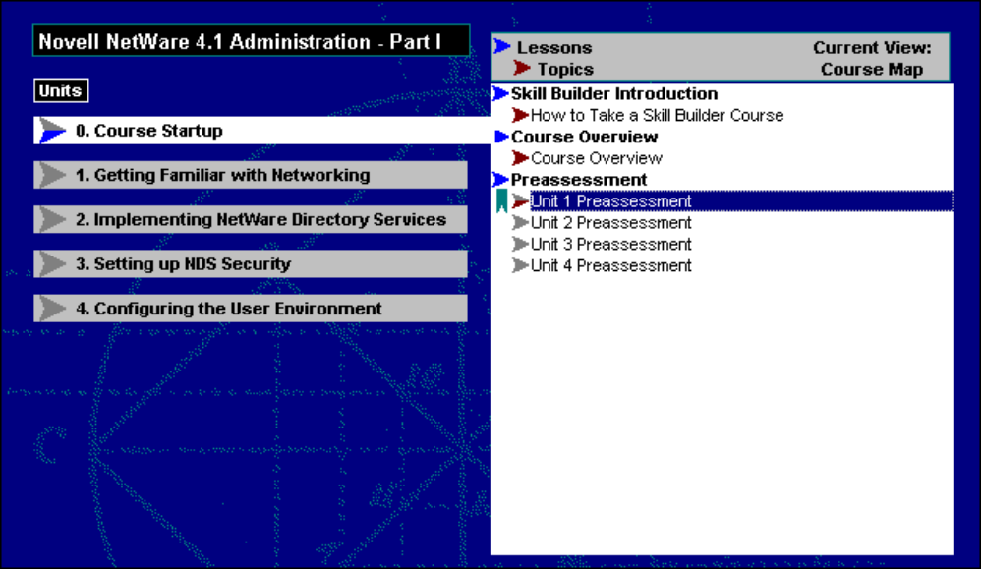
Course Map
The upper left block of the Course Map displays the course and unit titles. The unit that is currently selected has a white background and corresponds to the list, or index, of the current unit's lessons and topics in the right block of the Course Map. The format and content of this listing can be changed by clicking on the Other Views button. For more information on the Other Views button, see Course Map Function Buttons.
When you click on the Course Map button, the window changes from course instruction to the Course Map and three new buttons appear. They replace the course movement, or navigation, buttons displayed when you are moving through the normal course instruction.

Buttons and Indicators

Course Map Button

The Course Map button, which pictures a globe, changes the window to display an index of the course contents. This information helps you move around in the course and determine your progress. For more detailed information, see the Course Map section of this Help file.

Reference Button

The Reference button, which shows an open book, opens a submenu of the following options and features:
Options and Features | Definition
Course Reference Materials | The Course Reference Materials option provides access to supplemental information about the course content, including the Procedures and the Course Objectives.
Where Am I? | This option displays a dialog box noting your current location in the course. If you have a problem with the course or if you have questions about the content, you will want to note the unit/lesson/topic and page numbers for future reference.
Preferences | The Preferences button lets you customize the Skill Builder environment to fit your personal preferences. You can change the Emphasis Pointer Type, toggle the ToolTips option and Automatic Page Forward off or on, and select various audio and text settings. For more information, see Setting Preferences.
About | The About option tells you the Skill Builder version of the course, the course title and the names of the people who developed the course.

Notepad Button

The Notepad button, which pictures a pad and pencil, opens the Windows Notepad utility that lets you take notes on the instruction. You can save and print notes you typed in the Notepad for future reference. Subsequent accesses to Notepad automatically open your saved file. This allows you to easily access the Notepad file created for the course.
If you have questions about using the Windows Notepad, look in Notepad's own Help file. From the menu bar in Notepad, just click on Help.

Help Button

The Help button, or question mark, initiates the Help feature you are using right now. This online Help file provides information on how to use Skill Builder course features.

Exit Button

The Exit button, which pictures a door, lets you leave the course whenever and wherever you want. When you click on it, a message box appears and asks if you really want to exit the course. Click on Yes to leave; click on No if you decide to stay in the course. Depending on where you select to exit the course, additional messages may appear.

Rewind Button

The Rewind button is for moving backwards through the course. It moves you backward through the topic to defined page breaks, and only as far back as the beginning of the current topic. You cannot go back one page at a time.

Replay Audio Button

The Replay Audio button shows audio waves while the audio segment of the currently displayed page is playing. When the audio is paused or complete, the waves are lowlighted. If the audio segment is complete, clicking on this button replays the audio. If the button is clicked during audio playback, the audio segment restarts at its beginning. If a page does not have an audio segment, the button is inactive.
The Replay Audio button works only with computers that have sound capability, and the button is available only when course audio files are provided.

Pause/Resume Button

The Pause/Resume button works only with computers that have sound capability, and the button is available only when audio is available. If you click on the Pause button, the audio will stop immediately. When you click on the button again, the audio will begin where it left off. If you select the Page Forward button after clicking the Pause button, you will be taken to the next page in the course.

Page Forward Button

The Page Forward button moves you forward through the course, a Preassessment or a Post-assessment one page at a time. You may also move forward through the course one page at a time by using the Enter key. However, you cannot use the Enter key when you are instructed to perform an interaction (such as typing in text or clicking with the mouse), when you are viewing the Course Map, or when you are at the last page of the course.

Fast Forward Button

The Fast Forward button moves you ahead to the next segment of information. Unlike the Page Forward button, which moves you ahead one page at a time, the Fast Forward button moves you ahead several pages at a time. You can fast forward from topic to topic, but you will find it much faster to use the Course Map.

Progress Indicator
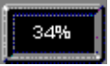
The Progress indicator shows the percentage of the unit completed thus far. It reflects your progress according to the method by which you are taking the course. It also indicates your progress through a Post-assessment or a Preassessment.

Unit, Lesson, Topic Indicator
The Unit, Lesson, Topic indicator displays the current course location by unit, lesson and topic numbers. The displayed title is the title of the current topic.
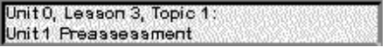

Completion Indicators
The Completion indicators are displayed in all views. These arrowhead-shaped markers located next to the unit, lesson, and topic headings, reflect completion status according to the method by which you are taking the course, either by normal course progression, by Preassessment competency, or by access to the topics tagged for review by the Post-assessments. The key to the completion indicators is displayed in the lower left block of the Course Map, as shown below:
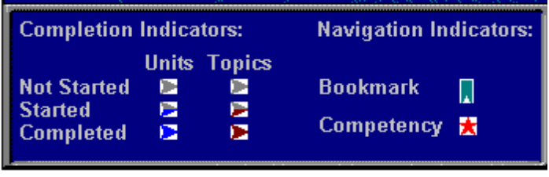
Completion and Navigation Indicator Panel

Completed topic  Completed unit  Topic not started | Unit not started  Topic started  Unit started

Navigation Indicators
The following table contains the navigation indicators in Skill Builder:
Navigation Indicator | Definition
Bookmark indicator | The green Bookmark indicator marks your current location in the course and repeats the Unit, Lesson and Topic information in the Control Panel at the bottom of the window. If Learner Management was chosen/enabled during the installation, the bookmark will mark your place in the course should you exit before completing the course. This makes it easy to start up exactly where you stopped when returning to the course.
Competency indicator | The Competency indicator marks the topics in which you have demonstrated competency while using the Post-assessment or Preassessment options. A red star appears on the Course Map to the left of the topics where competency has been achieved.

Course Map Function Buttons
The following table contains the Course Map function buttons and definitions:
Button | Definition
 | This button moves you to the start of the Topic or Lesson selected (highlighted) in the Topic Listing in the Course Map.
 | This button exits the Course Map and returns you to the location in the course where you chose the Course Map option.
 | This button brings up a submenu of five options: New Features, Topic Index, Precision Learning Track, Post-assessment Results, and Course Map.

Viewing Options

New Features
The New Features view changes the contents of the list box to include any topics in the course that cover the new features of the most recently released version of the software application you are learning. All the New Features for the entire course are displayed in the list box.

Topic Index
The Topic Index view displays an alphabetized list of all the topics in the course, including Post-assessments, Overview and Objectives, Summaries and Preassessments.

Post-assessment Results
The Post-assessment Results view presents the same Post-assessment score matrix provided at the end of each Post-assessment.

Precision Learning Track
After completing a Preassessment for a unit, Skill Builder creates Precision Learning Track; that is, a list of topics that you need to review based upon your performance in the Preassessment. After reviewing these topics and completing the Post-assessment, Skill Builder updates the previous Precision Learning Track and creates a new, usually smaller, list of topics for you to review.
The Precision Learning Track opens the current unit and gives you a list of topics for review. Simply double-click on the topic needing review to access that portion of the course. If there are no topics to review in the current unit, the next unit in the course with available review topics will be opened. All units that do not require review will be unavailable.
If you try to access the Precision Learning Track before completing a Preassessment or a Post-assessment, or if you have correctly answered all of the questions in the Preassessment, a message box displays stating, Currently there are no items to review. When accessing a review topic from the Precision Learning Track window, simply click on the Course Map button and you will be returned to the Precision Learning Track panel of the Course Map.
Your Precision Learning Track review list will normally exist for one session only. To preserve it across sessions, either use Skill Builder's Learner Management option or request that NETg's SkillVantage Manager be installed in your environment.

Quick Quiz

Quick Quiz items are either true or false, or multiple choice. They are intended to serve as knowledge checks rather than Post-assessment items. The Quick Quiz focuses primarily on concepts and information about the course. There is no scoring or retention of performance on the Quick Quiz. All Quick Quiz items are seen on the first pass through the course. However, once the topic is completed, the appearance of Quick Quiz items is determined on a random basis.

Tips

Tips are presented in a standardized dialog box and provide useful suggestions or information about the subject you are learning. When you have finished reading the tip, click on OK to return to the course.
All tips are seen on the first pass through the course. But once a topic has been completed, the tips associated with that topic will display only on a random basis.

Score Tracking
SkillVantage Manager, Skill Builder's Learner Management option, or any commercially available learner management system will work in conjunction with Skill Builder courses. However, you must have SkillVantage Manager to allow the Network version of the Skill Builder course to use the bookmarking feature and track the scores.
If Skill Builder Learner Management is activated during course installation, your scores will be written at the conclusion of the Post-assessment to a file on the hard drive (SCORES.TXT) in the directory specified during installation. SCORES.TXT is created when the first user completes a Post-assessment. A new record is added to the file after each attempt.
The record layout for SCORES.TXT is n,ccccc,a,ss,pp%,ult,t where:
Variable | Definition
n | User index
ccccc | Course number
a | Number of attempts
ss | Number of points received
pp | Percent of correct responses
ult | Post-assessment unit-lesson-topic number
t | Title of the Post-assessment

Note: A Post-assessment unit-lesson-topic of 0000000 represents your overall score for the course.
A user's index is unique for each course taken by that user. You can cross reference a user's index to a given user and course by looking in NEADMN.TXT. NEADMN.TXT will be created in the same directory as SCORES.TXT.
Here's what your file will look like if you want to cross-reference the User Login IDs with the contents of SCORES.TXT.
The record layout for NEADMN.TXT is n,u,lccccc where:
Variable | Definition
n | User index
u | User login ID
l | Language identifier (a=English)
ccccc | Course number

Using Skill Builder

Getting the Most from Skill Builder Courses
To get the most from the materials while taking a course, be sure to:
- Take notes.
- Use the Preassessment capabilities.
- Use the Course Reference Materials.
- Review and repeat instruction as necessary.
- Review instruction in response to feedback from the Post-assessments.
- Take the course over several sessions rather than all at once.
- Practice or apply your new skills as soon as possible.
Skill Builder's overall design and features, such as the Notepad, Course Reference Materials, Precision Learning Track, Post-assessments with feedback and a Course Map with multiple viewing options make it easy to learn. The practice is up to you.

Moving Around in Skill Builder Courses
Skill Builder courses are designed to meet the different needs and learning styles of adult learners. A variety of ways for you to control your learning environment are provided. For example, you may prefer a step-by-step sequential approach through the units, lessons and topics in a course. Or, you may decide to evaluate your present knowledge of the subject matter by taking a Preassessment for each unit. The Preassessments are found in the Course Startup unit. After you complete the Preassessment for each unit, Skill Builder automatically creates a unique Precision Learning Track. The learning track eliminates the topics in which you are already proficient and allows you to target specific topics for review or focused learning. Skill Builder supports all these approaches and makes it easy to switch from one to the other.
The Course Map is the key to moving around in Skill Builder courses. It provides access to a variety of content listings and makes it easy to move from one content area to another with a click of the mouse. The Course Map also includes the Control Panel, with various navigational buttons.
If you accidentally move to a section of the course that you do not want to view, a single click on the Course Map button on the Skill Builder Control Panel is all it takes to return to the Course Map. Courses are designed to present content in a logical sequence, but they also allow you to access lessons or topics randomly.
It is also easy to access the Course Reference Materials, the Notepad, and the Help feature without disrupting the flow of instruction. If the course refers to supplemental information stored in the Course Reference Materials, stopping to take a look at that information will not lose your place in the instruction. The same is true for the Notepad and Help functions. As soon as you Exit the windows for these functions, Skill Builder returns you to your previous location in the course. Some learners find it helpful to keep Notepad open and toggle back and forth between the course and Notepad.

Printing Your Assessment Results
Use the following steps to print your individual Results window:
1. From the Results window, press the Alt + Print Scrn keys at the same time.
2. Open Paint or Paintbrush.
3. From the Edit menu, click on Paste. (The Results window should appear in the drawing area).
4. From the File menu, click on one of the following:
- Print to print the results.
- Save to save the image to a file.
Note: You may also save the graphic image of the Results window by pasting the image into a Word document.

Post-assessments and Preassessments

Assessment Overview
The assessments are designed to assess your proficiency of the skills taught in each unit as described in the objectives. The various types of questions are multiple choice, matching, simulation, sequencing and labeling. Skill Builder randomly selects Post-assessment questions from a pool of items for each objective, then randomizes the order of their presentation and the order of their choices.
The assessments require you to accomplish a number of tasks. You could perform many of these tasks in several different ways. However, your performance will be scored as correct only if you complete the task as taught by the course and as specified in the question.
Skill Builder randomly selects Preassessment questions from a pool of items for each course objective, then randomizes the order of their presentation. The order of the choices is also randomized for each question, which means that the Preassessments are different for each learner.

Preassessments Overview
The Preassessment function uses performance-based assessment techniques to evaluate your skills and knowledge. A Preassessment is available for each unit of the course from the Course Startup option on the Course Map. By choosing to examine your knowledge before you take the course, you can focus your training on areas in which you need further instruction. Preassessments can be taken only once, either before accessing the course or at any time during the course.
Before you start each Preassessment, a window displays the general instructions. You can only move forward through the Preassessments, so the Fast Forward and Rewind buttons are disabled. Therefore, if you skip a question, you will not have an opportunity to return and answer it later, and the score for that item will be incorrect. You have one attempt per page to select the appropriate response for each Preassessment component or simulation.
At the end of each Preassessment, the results are calculated. All items are scored. Your score will be displayed on the Results window at the end of each unit. The Results window displays the number of correct answers per unit, and the percentage of correct answers per unit. The last line in the box calculates the total correct responses per course.
After viewing the Preassessment Results window, you can proceed by clicking on the Page Forward button. An Exit dialog box appears allowing you to:
- Select the Preassessment for the next available unit.
- Start your Precision Learning Track for the current unit.
- Go to the Course Map to select another topic.

Assessment Window Features and Functions

Assessment Title Bar
Title Bar Example
The Assessment title bar provides important information. The left side of the title bar shows the unit number, and your location within the Preassessment or Post-assessment. The question type, noted at the center of the bar, changes to reflect the question type for each item as you progress through the Post-assessment or Preassessment. The right side of the title bar shows the number of the current assessment item and the total number of assessment items in this module. After you answer the parts of each question, the information in the center of the bar changes to yellow, and indicates whether the simulation items were correct or incorrect.

Assessment Text Area
The text area at the top of the window has the question or statement to which you must respond. Follow the directions in this box for the number of answer choices available for multiple choice items. Remember, never select all of the options in a multiple choice question. Skill Builder regards the selection of all choices as incorrect and gives a score of 0 for the entire item.
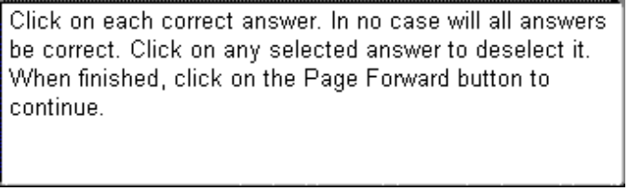
Text Box Example
The text area in the lower left portion of the window provides navigational information and specific instructions for the current item or question. The information supplied here is of particular importance in the simulation items because it provides specific instructions for the simulation steps.

Labels
Labels are used several ways in the Post-assessment or Preassessment. In the multiple choice questions, you click on the correct choice or choices to highlight them. In matching, you click on the label and drag it to the appropriate match item. In sequencing, you click on the label and drag it to the correct position in a list.
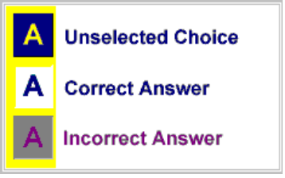
After each multiple choice, matching or sequencing item, Skill Builder provides feedback to you according to the specified feedback level. The feedback window repeats the item as it appears initially, but changes the color of the labels to reflect the correct response. No feedback appears if feedback has been turned off under User Preferences. Each unselected choice remains the same, each correct answer changes to a yellow background with black letters, and each incorrect answer changes to a light yellow background with red letters.
The simulation summary window, which is viewed at the end of each simulation group, uses an X or a check mark symbol. A check appears to the left of the correct steps and a X appears to the left of the incorrect steps.

Scores
Each objective has an assigned perfect score based on the question type, which is used in the calculation of the Preassessment and Post-assessment results. Skill Builder uses four basic types of questions to assess learner competence. The following table describes how Skill Builder determines scores according to the type of question:
Question Type | Scores
Sequencing | 1 point for each correctly sequenced step
Matching | 1 point for each correctly matched item
Multiple Choice or  True/False | 1 point for the correct answer
Multiple-Multiple Choice  (a multiple choice question with 2 or more answers) | 1 point for each correct answer
Simulation | 1 point for each step within a sequence which is completed correctly
Labelling | 1 point for each correctly labeled area

Feedback Levels
The level or type of feedback that you receive during the Preassessments and the Post-assessments is specified during installation. The installation settings may also allow the feedback level to be changed at any time during the course.

Full Feedback, Level 2
The default setting is Level 2, or Full Feedback. Full feedback offers several advantages. At this setting Skill Builder displays the original assessment items, but with the correct response or responses marked. The title bar carries the feedback of correct or incorrect, depending on your answer. This type of feedback is given for every matching, multiple choice and sequencing item.
Simulations: For incorrect answers, immediate feedback is given in a message box, which appears over the current window at the completion of each step within a simulation. You can move the message box off the window in order to recheck the original assessment item. When you are finished reading the response, clicking on the OK button moves the module forward to the next step in the simulation. A correct response moves you immediately to the next step.
The Full Feedback level provides you with a summary screen at the completion of all the steps in a simulation. The Simulation Summary screen shows the correct response for each step of the simulation. A symbol appears to the left of each step indicating whether you answered that particular step correctly. The title bar displays incorrect if one or more steps of the simulation were answered incorrectly. The title bar displays correct only if all the steps in a simulation were answered correctly. The Simulation Summary screen will not appear after a simulation where you used the Page Forward button to progress through the entire simulation without answering any of the questions.

Partial Feedback, Level 1
The second choice is Level 1, or Partial Feedback, which only indicates whether the response is correct or incorrect for matching, multiple choice or sequencing. This response is positioned in the center of the title bar.
Simulations: For incorrect simulation items, immediate feedback is given via a message box, which appears over the current window at the completion of each step in a simulation. You can move the message box off the window if you want to recheck the original assessment item. When you are finished reading the response, clicking on the OK button will move the module forward to the next step in the simulation.
The Partial Feedback level provides you with a summary screen at the completion of all the steps in a simulation. A symbol appears to the left of each step, indicating whether you answered that particular step correctly. Level 1 feedback will not display the assessment answers as it did in Level 2. You will only see the prompt message that was in the text box for that step. The title bar will display incorrect if one or more steps of the simulation were answered incorrectly. If all of the steps in a simulation were answered correctly, feedback of correct is shown in the title bar. The Simulation Summary screen will not appear after a simulation where you used the Page Forward button to progress through the entire simulation without answering any of the questions.

No Feedback, Level 0
The third choice is Level 0, or No Feedback. When the Feedback level is set to Level 0, you receive no feedback during the entire Post-assessment or Preassessment.
The difference between the feedback in the Preassessment and Post-assessment is significant only at the completion of the assessments. The Preassessment will not allow you to access the Review Window to begin the review process. It does set up the Precision Learning Track and the objectives needing review can be accessed from the Precision Learning Track view.

Results Window
Your assessment scores are tracked and reported via the Results window at the end of each Post-assessment or Preassessment. This window displays the number of attempts to take the Post-assessment, the scores for the Preassessment and Post-assessment, and Scores expressed as percentages in the Preassessment and Post-assessment.
Post-assessment
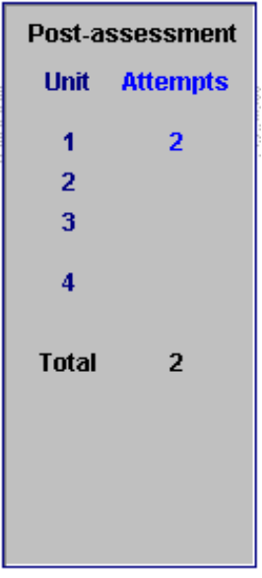 | Post-assessment Attempts: SkillVantage Manager, Skill Builder Learner Management or any commercially available learner management system will work in conjunction with Skill Builder courses to track and retain the number of times a Post-assessment is accessed.  If any of these learner management systems have been activated by your Learning Resource Center manager, you will be asked to provide a unique ID and password before entering the course. If the ID and password window does not appear and you go directly into a course, this feature is not available and the Post-assessment attempts and totals will be calculated only for the current session. The number of attempts will not be retained across future sessions of the course. If learner management is activated, the attempts and totals will be calculated and retained across all future sessions of the course.
Scores
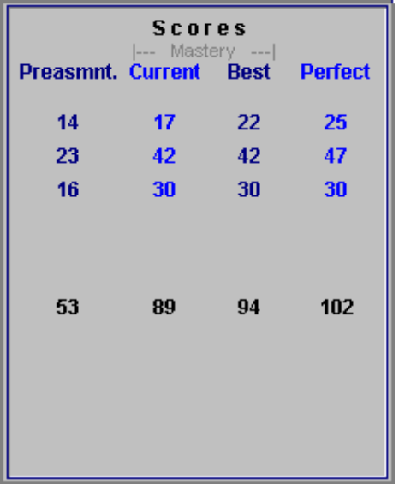 | Scores: The Scores section tracks the Preassessment scores, the current Post-assessment scores, your Best Post-assessment scores and the Perfect Post-assessment score for each unit in the course. If learner management is activated, the scores will be calculated and retained across all future sessions of the course.

Percentages
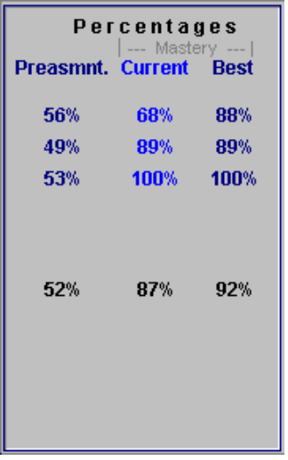 | Percentages: The Percentages section gives feedback in the form of percentages for the Preassessment and Post-assessment scores. It provides the Preassessment score, the most current Post-assessment percentages and your Best Post-assessment percentages. If learner management is activated, the percentages will be calculated and retained across all future sessions of the course.

Review Window
The Review window at the end of the Post-assessment displays the Lessons that you need to review. When you click on the lesson title in the Review Lessons box, the objectives for that lesson appear in the text box on the right. To review the lesson objectives, click on a lesson title. The text of the selected lesson title changes to a blue color.
Next, click on the lesson objective. The text will change to a dark red color. This action starts your review and you are automatically taken to that specific portion of the course. When you take a Post-assessment multiple times during one training session, only the most recent list of review titles is available. The Review window is refreshed after each review session.

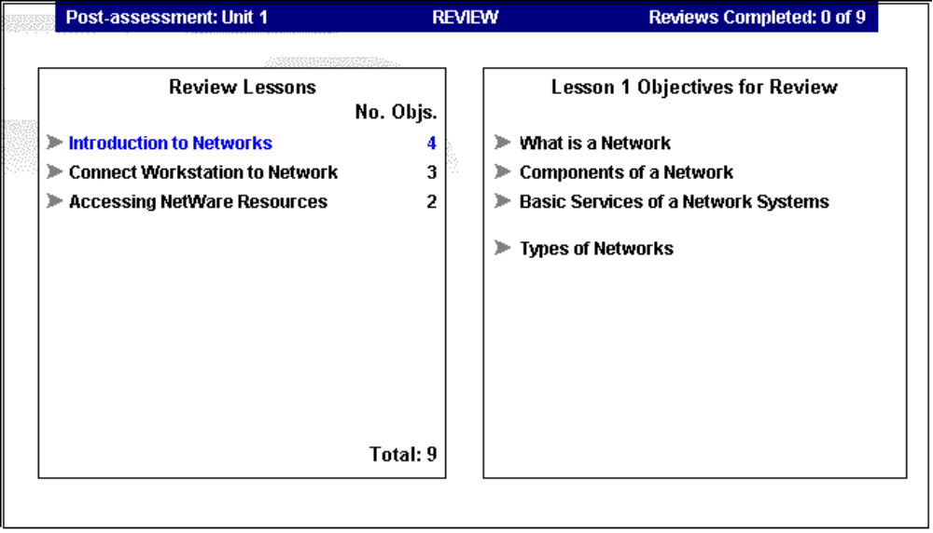
Review Window

Customizing Skill Builder

Setting Preferences
The User Preferences option lets you customize some of Skill Builder's features to fit your personal preferences. When you select User Preferences, a dialog box appears that allows you to select settings for audio playback, emphasis pointers, ToolTips and Automatic Page Forward. Any of these settings can be changed as often as you like while in the course. Some settings may be unavailable if course audio is not provided, or if other restrictions have been preset.
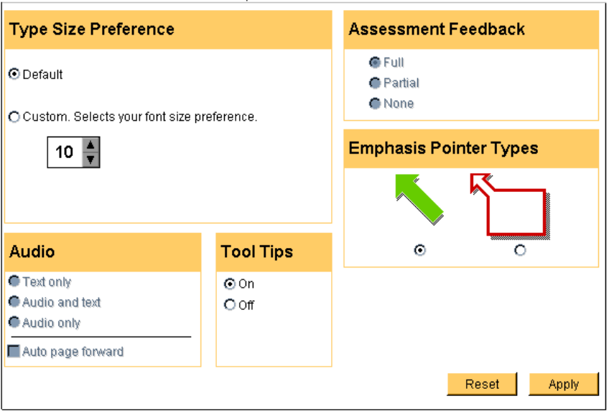
After you have chosen your options, click on Apply to implement the changes and then return to the course. The Reset button returns all controls to their previous settings.

Understanding Preferences
For versions of the course with audio, you may select the combination of text and audio that suits your learning style or preference. The Audio setting may also affect the way Skill Builder advances from one page to another. The Automatic Page Forward feature does not work when you are asked to use the mouse or type in text on the page. The following table contains a list of related settings:
Setting | Definition
Assessment Feedback Full | When Full is selected, Assessment Feedback provides the correct answer and a correct or incorrect indication.
Assessment Feedback Partial | When Partial is selected, Assessment Feedback provides only the correct or incorrect indication.
Assessment Feedback None | When None is selected, no feedback is provided during assessments.
Audio Only | If Audio Only is selected, all instruction is delivered by audio narration, meaning that narrative text does not appear on the window. If Automatic Page Forward has been enabled, the course automatically advances to the next page as soon as the audio ends for the current page.
Text Only | When Text Only is selected, all instruction is delivered in text format in the lower left portion of the window. To move forward in the course, you click on the Forward button on the Control Center or press the Enter key on the keyboard. Automatic Page Forward is not available when the Text Only option is selected
Audio and Text | When Audio and Text is selected, audio is played at the same time the text is displayed. If Auto Page Forward is selected, this setting automatically advances you to the next page as soon as the audio ends for the current page.
Automatic Page Forward | The Auto Page Forward feature is off by default. If this feature is enabled, the course will automatically advance to the next page when the audio is finished for the current page. If the Auto Page Forward is disabled, you would use the Page Forward button on the Control Panel, or the Enter key, to move forward in the course.
Emphasis Pointer Type | You can choose between two emphasis pointers: a green arrow or a moving text box. When you start a Skill Builder course, the green arrow is set as the default pointer. If you want to change the pointer, click on the radio button next to your selection. The text box pointer is not available when audio is set to Audio Only, which indicates that text will not be seen on the window.
ToolTips | When the mouse pointer remains over an object for a short time, the ToolTips feature displays the purpose of the object. ToolTips can be turned on or off as many times as desired throughout the course.
Type Size | Type size defaults to 10 point or 12 point depending on the screen resolution. If the screen resolution is less than or equal to 800 x 600, then 10 point type is displayed. If the screen resolution is greater than 800 x 600, then 12 point is displayed. You can change the type size to a custom setting between 8 point and 24 point size.
Creating a Logo

You have the option of inserting your own company logo into the Skill Builder opening sequence only in the Network version of Skill Builder courses. Follow these steps:
1. Create your graphic logo as a bitmap (.bmp). The image size must be 640 x 480 with 16 colors.
2. Save this bitmap as LOGO.BMP.
3. Place LOGO.BMP in the subdirectory containing SKILLB.EXE. For example, if you installed the Skill Builder player to C:\SKILLB, you would put LOGO.BMP in the C:\SKILLB directory. The new logo will now appear in the opening graphic sequence portion of the Skill Builder course.

Index
A
Assessessment overview 12
Assessment Feedback Full 19
Assessment Feedback None 20
Assessment Feedback Partial 19
Assessment window features and functions 13, 14
Audio Off (Text Only) 20
Audio On 20
audio settings 19
Automatic Page Forward 19, 20
B
Both Audio and Text 20
C
Cancel button 7
completion indicators 6
control panel 2
Course Map 2
Course Map button 2, 3
Course Map function buttons 7
creating a logo 21
E
Exit button 4
F
Fast Forward button 2, 5
feedback levels 15, 16
Full Feedback
Level 2 15
function buttons
Course Map 7
G
getting the most from Skill Builder courses 10
Go To button 7
green arrow 20
H
Help button 4
I
indicator
progress 5
indicators
completion 6
navigation 6
K
keyboard usage 1
L
labels 13, 14
Learning Track
Precision 7
levels
feedback 15, 16
logo creation 21
M
mouse usage 1
moving around in Skill Builder courses 10
N
navigation indicators 6
New Features view 7
No Feedback
Level 0 16
Notepad button 4
O
option
Preferences 19
Other Views button 7
overview
Assessment 12
Preassessments 12
P
Page Forward button 2, 5
panel
control 2
Partial Feedback
Level 1 15
Pause/Resume button 2, 5
Post-assessment Results view 7
Post-assessments 12
Preassessments overview 12
Precision Learning Track 7, 8
preferences 19
Preferences option 19
printing your assessment results 11
Progress Indicator 5
Q
Quick Quiz 8
R
read me first 10
Reference button 3
Replay Audio button 2, 4
Results window 16
Review window 18
Rewind button 2, 4
S
scores 14
tracking 8
setting preferences 19
settings
audio 19
T
test results
printing 11
text boxes 13
Text Only (Audio Off) 19
tips 8
title bar 13
Tooltips 20
Topic Index view 7
tracking scores 8
Type Size 20
U
understanding preferences 19
Unit
Lesson
Topic Indicator 5
using the keyboard 1
using the mouse 1
V
view
New Features 7
Post-assessment Results 7
Topic Index 7
W
window
Results 16
Review 18

