BUSINESS BLUEPRINT

Project Name | Issue and Defect Tracking System in SAP
Module | IDTS SAP01
Created by | DonHV / IDTS SAP01 Team
Version | v0.3
Date | 2026-07-23

Change history
Changed date | Items changed | Changed content / reason | Updated by | Type (A/C/D) | Version
2026-07-23 | IDTS content baseline | Consolidated IDTS business content and evidence boundary | DonHV | C | v0.2
2026-07-23 | Official-template remediation | Filled from the untouched SAP490 template; preserved sections, headers/footers, styles, numbering and tables | DonHV | C | v0.3
A – Create C – Change D – Delete

Advisor Signature
 | Full name & Role | Signature | Date | Note
Created by | DonHV / Project Leader |  | 2026-07-23 | Prepared
Reviewed by | Mentor / Supervisor |  |  | Pending review
Approved by | Mentor / Supervisor |  |  | Pending approval

FU Signature
 | Full name & Role | Signature | Date | Note
Reviewed by | Mentor / Supervisor |  |  | Pending review
Approved by | Mentor / Supervisor |  |  | Pending approval

Table of Contents
OVERVIEW
• Glossary
• IDTS Solution Context and Scope
ORGANIZATIONAL STRUCTURE
BUSINESS PROCESS
• IDTS-BP-01 Issue and Defect Management
• Process Flow
• Process Description
REPORTS

OVERVIEW

Glossary
Term | Definition | Note
Assignee | Developer who owns technical handling of the bug
nextProcessor | Current person or role/queue expected to take the next action; not a second assignee
Component Category | Valid Application Component and Defect Category pair used for assignment
Developer Responsibility | Mapping of Developer capability to Component Category and optional SAP Module
NotificationDeliveries | Separate asynchronous email-delivery outbox and attempt record
AiSuggestions | Normalized, safe, human-review audit record for optional advisory AI output
AuthSessions | Server-managed authenticated session records | No raw password storage

IDTS Solution Context and Scope
IDTS is an internal SAP-oriented issue and defect tracking system for software testing. It provides a controlled process to record, classify, assign, review, follow up, retest, close, audit, and monitor defects without becoming a source-code or full ALM platform.
Business objectives:
• Reduce duplicate or incomplete defect reports through structured capture and similar-bug support.
• Assign defects using Application Component, Defect Category, Component Category, and Developer Responsibility.
• Keep assignee and current action owner clear throughout rejection and information-request follow-up.
• Preserve comments, history, notifications, and reviewable evidence for mentor and QA review.
• Give PM users workload, overdue, queue, status, and nextProcessor visibility.
In scope:
• Structured defect creation, duplicate support, SAP-context classification, assignment and reassignment.
• Pending Assignment, Developer review, request more information, reject with reason and clear follow-up ownership.
• Status processing through Resolved, Retest Required, Closed, and Reopened.
• Comments, attachments, history events/logs, in-app notifications, email outbox, and PM monitoring.
• Optional review-only AI suggestions for similar bugs, classification, summaries, and Smart Assign rationale.
Out of scope:
• Direct source-code fixing, source control, code review, CI/CD, transport, or release management.
• A full Jira, SAP Cloud ALM, SAP Solution Manager, ServiceNow, or enterprise incident-management replacement.
• Autonomous AI assignment, classification, duplicate confirmation, lifecycle transitions, or mandatory root-cause analysis.
• Hardcoded credentials, private endpoints, organization-wide integrations, or a final production topology decision.
Current solution baseline:
Application — SAP CAP Node.js, OData V4, SAP Fiori Elements/SAPUI5
Authentication — AuthService login with server-managed AuthSessions; backend role checks remain authoritative
Data profiles — SQLite for local development; Render-hosted shared QA uses PostgreSQL through the integration profile
Attachments — @cap-js/attachments with local DB fallback and externally bound S3 object storage for shared QA
Notifications — In-app Notifications plus asynchronous NotificationDeliveries email outbox; provider failure does not roll back workflow
Advisory AI — Optional suggestions stored as normalized AiSuggestions audit rows; human review is mandatory and normal CAP actions remain authoritative
Functional capabilities:
BP-01 — Bug reporting — Create structured defects with human-readable bug number and evidence context. — Must
BP-02 — Duplicate support — Search and optionally review similar-bug suggestions; confirmed relationships remain a human decision. — Must
BP-03 — Classification — Maintain optional SAP Module and required Application Component/Defect Category with valid Component Category. — Must
BP-04 — Assignment — Filter by Developer Responsibility; validate selected Developer; support Pending Assignment and reassignment. — Must
BP-05 — Lifecycle — Enforce role/status transitions, required reasons, nextProcessor, retest, close, and reopen. — Must
BP-06 — Collaboration — Comments and attachments support clarification and QA evidence without directly changing status. — Must
BP-07 — Audit and notification — Persist grouped history, field-level logs, in-app notifications, and separate email-delivery attempts. — Must
BP-08 — PM monitoring — Expose workload, overdue, pending, rejected, retest, and current-action-owner views. — Must
BP-09 — Advisory AI — Provide optional review-only suggestions with safe audit data and failure isolation. — Optional
Information objects and integrations:
Bugs — Defect record, classification, status, ownership, dates, reproduction, expected/actual result
Users / Developers / AuthSessions — Internal profile, business role, Developer view, and server-managed authentication session
SAPModules / ApplicationComponents / DefectCategories / ComponentCategories — Classification master data and valid assignment key
DeveloperResponsibilities — Developer capability mapping by Component Category and optional SAP Module
Comments / Attachments — Discussion and evidence; attachment content follows configured storage profile
HistoryEvents / HistoryLogs — Readable grouped history and append-only field-level audit
Notifications / NotificationDeliveries — In-app event and separate asynchronous email-delivery outbox
DuplicateLinks / AiSuggestions — Confirmed human-reviewed relationships and normalized advisory-AI audit rows
Local — SQLite and local attachment DB fallback — Developer verification only; not production acceptance
Shared QA — Render CAP runtime, PostgreSQL integration profile, externally bound S3 object storage — Binding and persistence evidence required
Email — Database outbox processed asynchronously through private SMTP configuration — No live-provider success claim without approved evidence
AI — Disabled-by-default mock or optional server-side provider — Failure-safe; no secrets, attachments, raw response, or autonomous decision
Data ownership and retention:
Bugs and classification — Tester creates; PM governs correction — Application business data — Retain for project audit; changes are history-backed
Developer responsibility — PM / authorized maintainer — Assignment master data — Review when team capability changes
Comments and attachments — Author supplies; project controls access — Collaboration and evidence — Attachment bytes follow configured DB/S3 profile
HistoryEvents / HistoryLogs — System — Append-only audit evidence — Do not overwrite to hide prior values
Notifications / deliveries — System — Operational communication record — Keep safe status/attempt data; never provider secrets
AuthSessions — System — Security session data — Token hash only; expire/revoke according to policy
AiSuggestions — System plus human reviewer — Advisory audit record — Normalized output only; no raw prompt/response
Interfaces and control boundaries:
Fiori Elements / SAPUI5 — Human UI — OData V4 metadata, list/object pages, role-aware actions — UI visibility is not authorization
CAP BugService — Business API — Entities, bound actions, validations and transactions — Backend is authoritative
AuthService / AuthSessions — Authentication — Login/logout, bearer session resolution — Hash/token/no-secret controls
SQLite — Local persistence — Developer and programmatic verification — Not shared-QA or production acceptance
Render / PostgreSQL — Shared QA persistence — CAP integration profile — Availability and continuity evidence remain environment-dependent
S3-compatible storage — Attachment bytes — Externally bound object store — Compatibility/binding and persistence evidence required
NotificationDeliveries — Email boundary — Database outbox to private provider — At-least-once; failure isolated; local disabled is SKIPPED
AI provider — Advisory boundary — Minimum allowlisted request and validated response — Disabled by default; human review mandatory
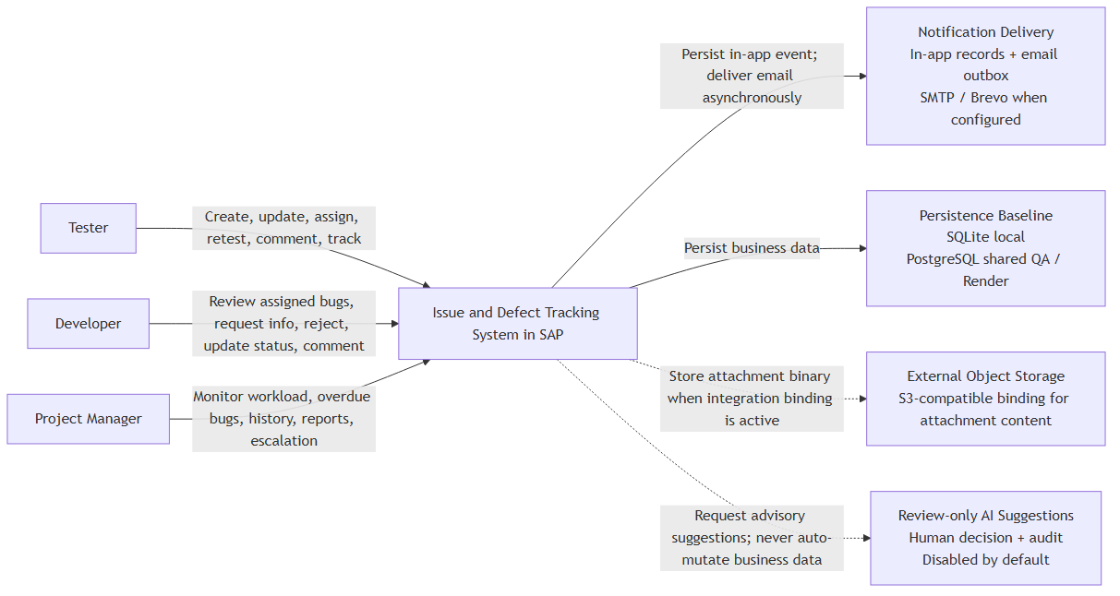
Figure 1 — IDTS system context and external boundaries

ORGANIZATIONAL STRUCTURE
IDTS uses a small cross-functional operating model. Testers own defect quality and verification; Developers own authorized technical handling; PM owns queue health, escalation, and oversight; the System enforces permissions, state changes, audit, and delivery instructions. DonHV consolidates BA/PM and SAP490 evidence, while mentor review remains an external review activity rather than an approval already obtained.
Roles and responsibilities:
Tester — Create and classify bugs; select assignee when appropriate; provide requested information; retest; close or reopen; comment and attach evidence.
Developer — Review assigned/authorized bugs; comment; request information; reject unsuitable assignment/classification with reason; progress and resolve.
PM — Monitor all defects, workload, overdue items, pending/rejected/retest queues, nextProcessor, history, reports, and escalation notifications.
System — Validate authorization and business rules; maintain status and nextProcessor; persist audit, notification, delivery, attachment, and AI-review records.
RACI:
Create and classify defect | R/A | C | C | I
Select or change assignee | R | C | A | I
Review, request information, reject, resolve | C | R/A | I | I
Resubmit requested information | R | C | A | I
Retest, close, or reopen | R | C | A | I
Maintain history and notifications | I | I | C | R/A
Monitor workload, overdue, and queues | C | I | R/A | I
Review AI suggestions and decide whether to continue with a normal authorized action | R | R | A | I

BUSINESS PROCESS

IDTS-BP-01 Issue and Defect Management

Process Flow
The normal create flow persists Assigned when an authorized user explicitly selects a valid Developer, or Pending Assignment when no suitable Developer is selected. New remains legacy/import compatibility only.
Lifecycle and ownership rules:
New | Legacy/import compatibility only | Not persisted by the normal create flow
Pending Assignment | Tester/PM or unassigned queue | No suitable Developer explicitly selected
Assigned / In Review / In Progress | Assigned Developer | Technical handling states
Need More Information | Tester/PM follow-up | Developer reason and nextProcessor required
Rejected | Tester/PM follow-up | Reason and correction/reassignment path required; not terminal
Resolved / Retest Required | Tester/PM verification | Retest before final acceptance when required
Closed / Reopened | Tester/PM | Close accepted work; reopen when the issue persists
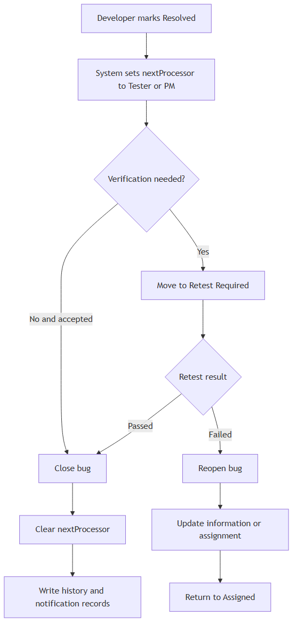
Figure 2 — Resolve, retest, close and reopen flow
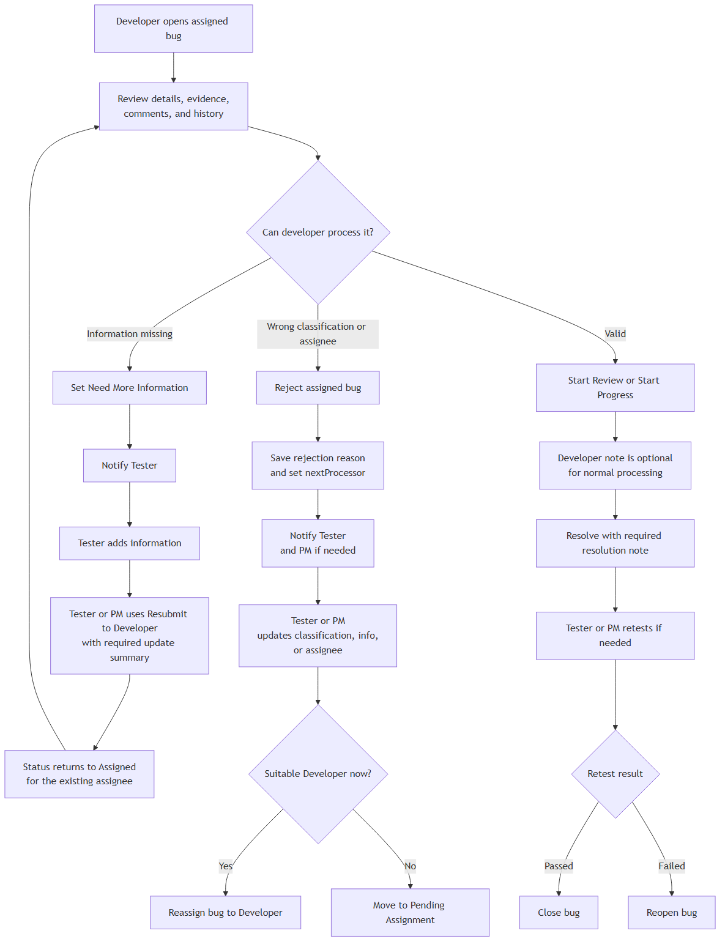
Figure 3 — Developer review and controlled follow-up

Process Description
Step # | Step Name | Detailed Description | Role
BP‑01 | Authentication and access | Purpose: Establish an authenticated IDTS identity and backend role boundary.  Input/output: Active user email and password supplied to AuthService. → Bearer token backed by a server-side AuthSessions row.  Control: Password hash verification, active-user check, session expiry/revocation, backend role mapping.  State/next owner: No defect status change. | Authenticated user or rejected login response.  Audit/notification: Authentication/session audit data only; never raw passwords or tokens. | No defect notification. | User; System
BP‑02 | Defect creation | Purpose: Create a complete, uniquely identifiable defect without inventing an assignee.  Input/output: Title, description, reproduction, actual/expected result, priority, severity, environment, classification and optional evidence. → Persisted Bugs row with bugNumber, ownership, child evidence metadata, history and notification instructions.  Control: Required fields, valid catalog codes, authorized creator, system-managed fields overwritten, selected assignee validated.  State/next owner: Assigned when a valid Developer is explicitly selected; otherwise Pending Assignment. New is not the normal persisted start. | Assigned Developer or Tester/PM queue.  Audit/notification: Create event plus field-level audit for authoritative values. | In-app assignment/queue notification; email outbox instruction when eligible. | Tester; PM may coordinate
BP‑03 | Duplicate and similar support | Purpose: Help a human avoid duplicate work without autonomous linking.  Input/output: Draft or persisted defect text and safe classification fields. → Ranked candidates and optional suggested relation label.  Control: Exclude source bug, bounded result count, deterministic fallback, sanitized AI/provider boundary.  State/next owner: No automatic status change and no automatic DuplicateLinks write. | Human reviews, ignores, or confirms a relationship separately.  Audit/notification: Safe AiSuggestions audit row only for a persisted source check. | None unless a later confirmed business action requires it. | Tester or authorized reviewer
BP‑04 | SAP-context classification | Purpose: Capture the business context used for reporting and responsibility matching.  Input/output: Optional SAP Module, Application Component, Defect Category. → Validated Component Category and consistent classification references.  Control: Application Component and Defect Category compatibility; SAP Module remains optional for pure IDTS defects.  State/next owner: No status change by classification alone; may enable assignment/reassignment. | Assignment decision owner.  Audit/notification: Old/new classification values and correction reason when material. | Relevant assignee/follow-up notification after an actual assignment change. | Tester; PM correction support
BP‑05 | Assignment and Pending Assignment | Purpose: Route work to an eligible Developer or an explicit follow-up queue.  Input/output: Validated classification, Developer Responsibilities, availability/workload context, optional selected Developer. → Assignee and nextProcessor, or a clear unassigned queue.  Control: No automatic Developer selection during create; selected Developer must match active responsibility rules.  State/next owner: Assigned when selected; Pending Assignment when no suitable Developer is selected; reassignment is an action, not a status. | Assigned Developer or Tester/PM queue.  Audit/notification: Assignment/reassignment event with previous and new owner. | Notify new assignee; PM/Tester visibility for pending queue. | Tester/PM
BP‑06 | Developer review and processing | Purpose: Allow the assigned Developer to assess and process authorized work.  Input/output: Assigned bug, evidence, comments, history and current capabilities. → In Review/In Progress progression, request, rejection, or resolution decision.  Control: Assigned-developer rule and transition allow-list; normal review notes optional, decision reasons required where specified.  State/next owner: Assigned → In Review/In Progress; In Review may progress or resolve according to runtime. | Assigned Developer until a follow-up decision changes owner.  Audit/notification: Status event and meaningful notes/reasons. | Notify stakeholders when the action changes ownership or requires follow-up. | Assigned Developer
BP‑07 | Request More Information and resubmit | Purpose: Obtain missing evidence, then return the same assigned work to Developer review.  Input/output: Developer reason; Tester/PM information update and required resubmit summary. → Updated defect/comments/attachments and a restored Assigned state.  Control: Request action only from Assigned/In Review/In Progress by assigned Developer; resubmit requires existing assignee and update summary.  State/next owner: Need More Information → Assigned on Resubmit to Developer. It is not a post-retest transition. | Tester/PM while waiting; existing assigned Developer after resubmit.  Audit/notification: Request and resubmit events, reason, summary and changed fields. | Notify Tester/PM on request and Developer on resubmit. | Developer requests; Tester/PM responds
BP‑08 | Rejection, correction and reassignment | Purpose: Return unsuitable classification or assignment for controlled correction rather than terminate the defect.  Input/output: Developer rejection reason and current assignment/classification. → Rejected follow-up record, corrected data, reassignment or Pending Assignment.  Control: Reason mandatory; nextProcessor mandatory; Rejected cannot silently end and does not route through Need More Information in MVP.  State/next owner: Assigned/In Review/In Progress → Rejected → Assigned or Pending Assignment. | Tester/PM after rejection; new Developer or queue after correction.  Audit/notification: Immutable rejection reason plus correction/reassignment history. | Notify Tester/PM, then the new assignee when work is reassigned. | Developer rejects; Tester/PM corrects
BP‑09 | Resolve, retest, close and reopen | Purpose: Separate Developer resolution from Tester/PM acceptance.  Input/output: Resolution note, current state, retest outcome or reopen reason. → Resolved, Retest Required, Closed, or Reopened state with ownership.  Control: Resolution and reopen reasons required where configured; transitions must match the runtime state machine.  State/next owner: Resolved → Retest Required/Closed/Reopened; Retest Required → Closed/Reopened. No Request More Information branch exists here. | Tester/PM during verification; Developer after authorized reopen assignment flow.  Audit/notification: Resolution, retest, close or reopen event with actor and reason. | Notify verification owner and assigned Developer when reopened. | Developer resolves; Tester/PM verifies
BP‑10 | Comments and attachments | Purpose: Preserve collaboration and evidence without bypassing lifecycle controls.  Input/output: Authorized comment text or attachment metadata/content through the configured storage profile. → Comment or attachment linked to the defect and available to authorized readers.  Control: Comment role, file constraints, safe metadata, storage binding, and no-secret rule.  State/next owner: No direct status change. | Current lifecycle owner remains unchanged.  Audit/notification: Append collaboration/evidence history where applicable. | Notify interested users only according to configured event rules. | Tester, Developer, PM according to permission
BP‑11 | Notifications and email outbox | Purpose: Record in-app events and attempt email delivery without coupling provider failure to workflow success.  Input/output: Committed business event and eligible active recipient. → Notifications row plus NotificationDeliveries status/attempt data.  Control: Recipient eligibility, private provider configuration, bounded retry, sanitized failure details.  State/next owner: No independent status change; delivery failure never rolls back the business transaction. | Recipient or operational retry owner.  Audit/notification: Delivery status, attempts, timing and safe error classification. | In-app is persisted; email may be SENT, FAILED or SKIPPED. Local disabled provider remains SKIPPED. | System
BP‑12 | PM monitoring and escalation | Purpose: Give PM an operational view of workload, queues, overdue items and current action ownership.  Input/output: Defect states, assignee, nextProcessor, due dates, workload and history. → Role-aware workload, overdue, pending, rejected and retest views.  Control: Backend-filtered data and consistent current-action-owner calculation.  State/next owner: Monitoring alone does not change status; authorized coordination actions use normal transitions. | PM decides follow-up or escalation without becoming a second assignee.  Audit/notification: Any subsequent assignment/status action is audited normally. | Escalation or queue notifications only when configured. | PM
BP‑13 | AI suggestions for human consideration | Purpose: Offer bounded assistance while keeping every business decision human and CAP-authoritative.  Input/output: Minimum allowlisted defect fields; no credentials, private email, attachments or storage references. → Sanitized suggestion and confidence/explanation; a persisted audit row starts in PENDING.  Control: AI disabled by default, timeout/failure isolation, output validation, no raw prompt/response persistence.  State/next owner: No autonomous assignment, classification, duplicate confirmation or lifecycle change. | The user reviews the displayed suggestion and may separately perform a normal authorized business action. The current service exposes no suggestion-state update action.  Audit/notification: AiSuggestions records the normalized request/result audit in PENDING; current actions do not persist ACCEPTED, REJECTED or IGNORED reviewer outcomes. | No notification is created by the suggestion itself. | Authorized user

REPORTS
The following IDTS views support operational monitoring and mentor review.
No. | Description | Audience
1 | Operational defect list — Status, priority, severity, classification, assignee, nextProcessor, due/overdue | Tester / Developer / PM according to role
2 | PM workload and queue view — Workload, Pending Assignment, Rejected follow-up, Retest Required, overdue | PM
3 | Audit evidence — History events/logs, comments, attachments, notification and delivery status | Authorized users / mentor evidence
4 | Test and defect evidence — Test Scenario, Unit Test, Functional Test, Test Report, Test and Fix Bug | QA / mentor review; evidence status must remain truthful
Security, quality and controls:
Authorization — Backend resolves bearer sessions and enforces Tester, Developer, and PM permissions; UI visibility is not the security boundary.
Data integrity — Required classification, valid responsibility, required reasons, lifecycle transitions, and nextProcessor rules are server-validated.
Auditability — Important changes retain actor, role, timestamp, action, old/new value, and reason where applicable.
Failure isolation — Email or AI provider failure cannot roll back or block the normal authorized bug workflow.
No-secret handling — Passwords, bearer tokens, SMTP credentials, object-storage secrets, private endpoints, and AI credentials remain outside source and review artifacts.
Usability — Fiori List Report/Object Page, value helps, messages, semantic status, and role-aware actions support beginner and enterprise review.
Traceability and evidence:
Business requirements — docs/ba/brd/brd.en.md — BRD v1.5
Software requirements — docs/ba/srs/srs.en.md — SRS v1.4
Functional behavior — docs/ba/frs/frs.en.md — FRS v1.5
Business rules and scope — IDTS-Business-Rule.md; IDTS-PROJECT-SCOPE-SAP01.md — Canonical
Architecture and process — docs/diagrams and rendered Diagram Pack — Source-controlled Mermaid/PlantUML plus rendered assets
QA evidence — Current mentor Test Scenario, Unit Test, Functional Test, Test Report, Test and Fix Bug — Only executed evidence may be reported as PASS
Current verification status:
BP-01 — Executed PASS
BP-02–BP-09 — Partly executed; three suites Pending
BP-10 — Pending in current Test Report
BP-11 — Executed PASS; provider disabled/SKIPPED
BP-12 — Executed PASS
BP-13 — Pending in current Test Report
Acceptance — Not complete; UAT Prepared only
Known limitations and pending acceptance:
• Mentor review and approval remain Pending; this Draft is not a signed acceptance artifact.
• UAT is Prepared but not signed. The Final Project Report remains a template/pending deliverable and is not claimed complete.
• Live SMTP/provider success is not claimed without approved private configuration and captured evidence.
• Final shared-QA attachment acceptance depends on active PostgreSQL/S3 bindings and persistence/download evidence.
• Optional AI is disabled by default; live-provider capability is not a prerequisite for the normal workflow and is not claimed without evidence.
• The current educational/shared-QA baseline is not a final enterprise production topology, availability commitment, or performance certification.

