BUSINESS BLUEPRINT

Project Name | Issue and Defect Tracking System in SAP
Module | IDTS SAP01
Created by | DonHV / IDTS SAP01 Team
Version | v0.4
Date | 2026-07-23

Change history
Changed date | Items changed | Changed content / reason | Updated by | Type (A/C/D) | Version
2026-07-23 | Official-template baseline | Consolidated IDTS content in the official SAP490 template | DonHV | C | v0.3
2026-07-23 | Table-layout remediation | Converted ten approved content sections to true Word tables; business meaning unchanged | DonHV | C | v0.4
A – Create C – Change D – Delete

Advisor Signature
 | Full name & Role | Signature | Date | Note
Created by | DonHV / Project Leader |  | 2026-07-23 | Prepared
Reviewed by | Mentor / Supervisor |  |  | Pending review
Approved by | Mentor / Supervisor |  |  | Pending approval

FU Signature
 | Full name & Role | Signature | Date | Note
Reviewed by | Mentor / Supervisor |  |  | Pending review
Approved by | Mentor / Supervisor |  |  | Pending approval

Table of Contents
OVERVIEW
• Glossary
• IDTS Solution Context and Scope
ORGANIZATIONAL STRUCTURE
BUSINESS PROCESS
• IDTS-BP-01 Issue and Defect Management
• Process Flow
• Process Description
REPORTS

OVERVIEW

Glossary
Term | Definition | Note
Assignee | Developer who owns technical handling of the bug
nextProcessor | Current person or role/queue expected to take the next action; not a second assignee
Component Category | Valid Application Component and Defect Category pair used for assignment
Developer Responsibility | Mapping of Developer capability to Component Category and optional SAP Module
NotificationDeliveries | Separate asynchronous email-delivery outbox and attempt record
AiSuggestions | Normalized, safe, human-review audit record for optional advisory AI output
AuthSessions | Server-managed authenticated session records | No raw password storage

IDTS Solution Context and Scope
IDTS is an internal SAP-oriented issue and defect tracking system for software testing. It provides a controlled process to record, classify, assign, review, follow up, retest, close, audit, and monitor defects without becoming a source-code or full ALM platform.
Business objectives:
• Reduce duplicate or incomplete defect reports through structured capture and similar-bug support.
• Assign defects using Application Component, Defect Category, Component Category, and Developer Responsibility.
• Keep assignee and current action owner clear throughout rejection and information-request follow-up.
• Preserve comments, history, notifications, and reviewable evidence for mentor and QA review.
• Give PM users workload, overdue, queue, status, and nextProcessor visibility.
In scope:
• Structured defect creation, duplicate support, SAP-context classification, assignment and reassignment.
• Pending Assignment, Developer review, request more information, reject with reason and clear follow-up ownership.
• Status processing through Resolved, Retest Required, Closed, and Reopened.
• Comments, attachments, history events/logs, in-app notifications, email outbox, and PM monitoring.
• Optional review-only AI suggestions for similar bugs, classification, summaries, and Smart Assign rationale.
Out of scope:
• Direct source-code fixing, source control, code review, CI/CD, transport, or release management.
• A full Jira, SAP Cloud ALM, SAP Solution Manager, ServiceNow, or enterprise incident-management replacement.
• Autonomous AI assignment, classification, duplicate confirmation, lifecycle transitions, or mandatory root-cause analysis.
• Hardcoded credentials, private endpoints, organization-wide integrations, or a final production topology decision.

Current solution baseline
Layer | Current implementation | Purpose | Current limitation
Application | SAP CAP Node.js, OData V4, SAP Fiori Elements/​SAPUI5 | CAP/​Fiori application and OData service | Educational/​shared-QA baseline; no production certification
Authentication | AuthService login with server-managed Auth​Sessions; backend role checks remain authoritative | Authenticated identity and backend role boundary | Custom bearer sessions; not enterprise SSO
Data profiles | SQLite for local development; Render-hosted shared QA uses PostgreSQL through the integration profile | Local development and shared-QA persistence | Continuity remains environment-dependent
Attachments | @cap-js/​attachments with local DB fallback and externally bound S3 object storage for shared QA | Store and retrieve defect evidence | Shared-QA acceptance needs active S3 evidence
Notifications | In-app Notifications plus asynchronous Notification​Deliveries email outbox; provider failure does not roll back workflow | In-app events and asynchronous email attempts | Live-provider success is not claimed
Advisory AI | Optional suggestions stored as normalized Ai​Suggestions audit rows; human review is mandatory and normal CAP actions remain authoritative | Optional review-only assistance | Disabled by default; review state remains PENDING

Functional capabilities
Capability ID | Capability | Primary role | Main result | Related process
BP-01 | Bug reporting (Must) | Tester | Create structured defects with human-readable bug number and evidence context. | BP-02
BP-02 | Duplicate support (Must) | Tester / reviewer | Search and optionally review similar-bug suggestions; confirmed relationships remain a human decision. | BP-03
BP-03 | Classification (Must) | Tester / PM | Maintain optional SAP Module and required Application Component/​Defect Category with valid Component Category. | BP-04
BP-04 | Assignment (Must) | Tester / PM | Filter by Developer Responsibility; validate selected Developer; support Pending Assignment and reassignment. | BP-05
BP-05 | Lifecycle (Must) | All business roles | Enforce role/​status transitions, required reasons, next​Processor, retest, close, and reopen. | BP-06–BP-09
BP-06 | Collaboration (Must) | All business roles | Comments and attachments support clarification and QA evidence without directly changing status. | BP-10
BP-07 | Audit and notification (Must) | System | Persist grouped history, field-level logs, in-app notifications, and separate email-delivery attempts. | BP-11
BP-08 | PM monitoring (Must) | PM | Expose workload, overdue, pending, rejected, retest, and current-action-owner views. | BP-12
BP-09 | Advisory AI (Optional) | Authorized user | Provide optional review-only suggestions with safe audit data and failure isolation. | BP-13

Information objects and integrations
Object / System | Stored information | Source / Owner | Used by | Integration method
Bugs | Defect record, classification, status, ownership, dates, reproduction, expected/​actual result | Tester / PM | All business roles | CAP entity / OData V4
Users / Developers / Auth​Sessions | Internal profile, business role, Developer view, and server-managed authentication session | System / PM | Authentication and authorization | AuthService and bearer session
SAPModules / Application​Components / Defect​Categories / Component​Categories | Classification master data and valid assignment key | PM / reference data | Classification and assignment | Associations and value help
Developer​Responsibilities | Developer capability mapping by Component Category and optional SAP Module | PM | Assignment | CAP responsibility lookup
Comments / Attachments | Discussion and evidence; attachment content follows configured storage profile | Authorized users | Collaboration and QA | Composition; DB/​S3 attachments
History​Events / HistoryLogs | Readable grouped history and append-only field-level audit | System | Audit | Append-only compositions
Notifications / Notification​Deliveries | In-app event and separate asynchronous email-delivery outbox | System | Recipients and operations | Database outbox / worker
Duplicate​Links / Ai​Suggestions | Confirmed human-reviewed relationships and normalized advisory-AI audit rows | Human decision / System | Duplicate/​AI review | Confirmed link / read-only audit
Local | SQLite and local attachment DB fallback; Developer verification only; not production acceptance | Developer environment | Local verification | CAP SQLite adapter
Shared QA | Render CAP runtime, PostgreSQL integration profile, externally bound S3 object storage; Binding and persistence evidence required | Platform configuration | Shared QA | HTTPS/​OData V4; PostgreSQL/​S3 bindings
Email | Database outbox processed asynchronously through private SMTP configuration; No live-provider success claim without approved evidence | System / operations | Notification recipients | Notification​Deliveries worker / SMTP
AI | Disabled-by-default mock or optional server-side provider; Failure-safe; no secrets, attachments, raw response, or autonomous decision | System / authorized user | Advisory actions | Server-side allowlisted provider request

Data ownership and retention
Data object | Business owner | Technical storage | Retention / current handling | Security note
Bugs and classification | Tester creates; PM governs correction | PostgreSQL / SQLite | Retain for project audit; changes are history-backed | Role-filtered access
Developer responsibility | PM / authorized maintainer | Relational master data | Review when team capability changes | PM-maintained
Comments and attachments | Author supplies; project controls access | Database and configured S3 | Attachment bytes follow configured DB/​S3 profile | Authorized readers only
History​Events / HistoryLogs | System | Relational append-only records | Do not overwrite to hide prior values | Do not overwrite prior evidence
Notifications / deliveries | System | Database outbox | Keep safe status/​attempt data; never provider secrets | No provider secrets
Auth​Sessions | System | Database token hashes | Token hash only; expire/​revoke according to policy | No raw password or token
Ai​Suggestions | System plus human reviewer | Database normalized audit | Normalized output only; no raw prompt/​response | No raw prompt/​response; PENDING only

Interfaces and control boundaries
Boundary | Caller | Receiver | Protocol / Interface | Validation / Control
Fiori Elements / SAPUI5 | Browser user | CAP BugService | OData V4 metadata, list/​object pages, role-aware actions | UI visibility is not authorization
CAP BugService | Fiori/​Auth clients | CAP services | Entities, bound actions, validations and transactions | Backend is authoritative
AuthService / Auth​Sessions | Browser login | AuthService / Auth​Sessions | Login/​logout, bearer session resolution | Hash/​token/​no-secret controls
SQLite | CAP runtime | SQLite | Developer and programmatic verification | Not shared-QA or production acceptance
Render / PostgreSQL | CAP runtime | PostgreSQL | CAP integration profile | Availability and continuity evidence remain environment-dependent
S3-compatible storage | Attachment service | S3 object store | Externally bound object store | Compatibility/​binding and persistence evidence required
Notification​Deliveries | CAP event / worker | Email provider | Database outbox to private provider | At-least-once; failure isolated; local disabled is SKIPPED
AI provider | CAP AI action | AI provider | Minimum allowlisted request and validated response | Disabled by default; human review mandatory
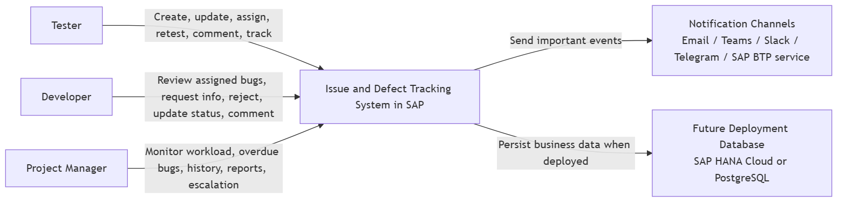
Figure 1 — IDTS system context and external boundaries

ORGANIZATIONAL STRUCTURE

Roles and responsibilities
Role | Main responsibilities | Allowed actions | Restricted actions
Tester | Create and classify bugs; select assignee when appropriate; provide requested information; retest; close or reopen; comment and attach evidence. | Create/​classify; supply information; retest; close/​reopen | Cannot bypass validation or act as an unassigned Developer
Developer | Review assigned/​authorized bugs; comment; request information; reject unsuitable assignment/​classification with reason; progress and resolve. | Review assigned work; request information; reject; resolve | Cannot process unassigned work or bypass transition rules
PM | Monitor all defects, workload, overdue items, pending/​rejected/​retest queues, next​Processor, history, reports, and escalation notifications. | Monitor and coordinate queues, assignment and escalation | Cannot become a second assignee or bypass backend controls
System | Validate authorization and business rules; maintain status and next​Processor; persist audit, notification, delivery, attachment, and AI-review records. | Validate, persist, audit and deliver configured events | No autonomous business or AI decision

RACI responsibility matrix
Activity | Tester | Developer | PM | System
Create and classify defect | R/​A | C | C | I
Select or change assignee | R | C | A | I
Review, request information, reject, resolve | C | R/​A | I | I
Resubmit requested information | R | C | A | I
Retest, close, or reopen | R | C | A | I
Maintain history and notifications | I | I | C | R/​A
Monitor workload, overdue, and queues | C | I | R/​A | I
Review AI suggestions and decide whether to continue with a normal authorized action | R | R | A | I

BUSINESS PROCESS

IDTS-BP-01 Issue and Defect Management

Process Flow

Bug lifecycle, status transition and next processor
Current status | User action | Allowed role | Next status | Assignee effect | Next processor
Create | Submit valid defect | Tester / PM | Assigned or Pending Assignment | Set valid Developer or remain empty | Developer or Tester/​PM queue
New | Legacy/​import handling only | System | No normal-flow claim | Preserve imported value | As imported
Pending Assignment | Assign valid Developer | Tester / PM | Assigned | Set Developer | Developer
Assigned | Start technical review | Assigned Developer | In Review / In Progress | Unchanged | Developer
Assigned / In Review / In Progress | Request more information | Assigned Developer | Need More Information | Unchanged | Tester / PM
Need More Information | Resubmit information | Tester / PM | Assigned | Keep existing Developer | Developer
Assigned / In Review / In Progress | Reject with reason | Assigned Developer | Rejected | Preserve until correction | Tester / PM
Rejected | Correct and assign/​reassign | Tester / PM | Assigned or Pending Assignment | Set valid Developer or clear | Developer or Tester/​PM queue
In Review / In Progress | Resolve with required context | Assigned Developer | Resolved | Unchanged | Tester / PM
Resolved | Retest / accept / reopen | Tester / PM | Retest Required / Closed / Reopened | Follow authorized flow | Tester / PM or Developer
Retest Required | Record pass or failure | Tester / PM | Closed or Reopened | Follow authorized flow | Tester / PM or Developer
Closed | Reopen with reason | Tester / PM | Reopened | Follow authorized assignment flow | Tester / PM or Developer
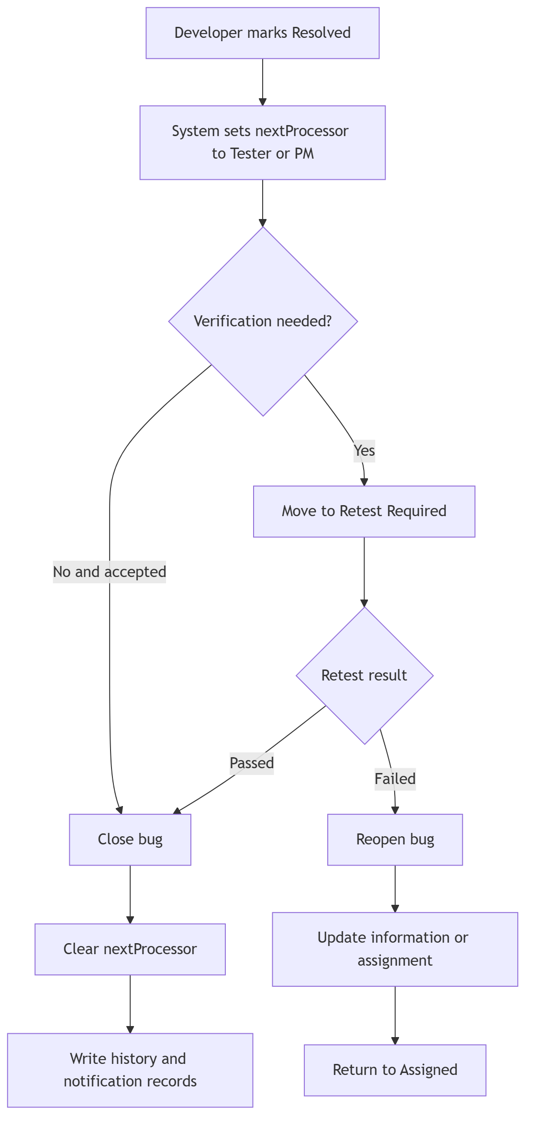
Figure 2 — Resolve, retest, close and reopen flow
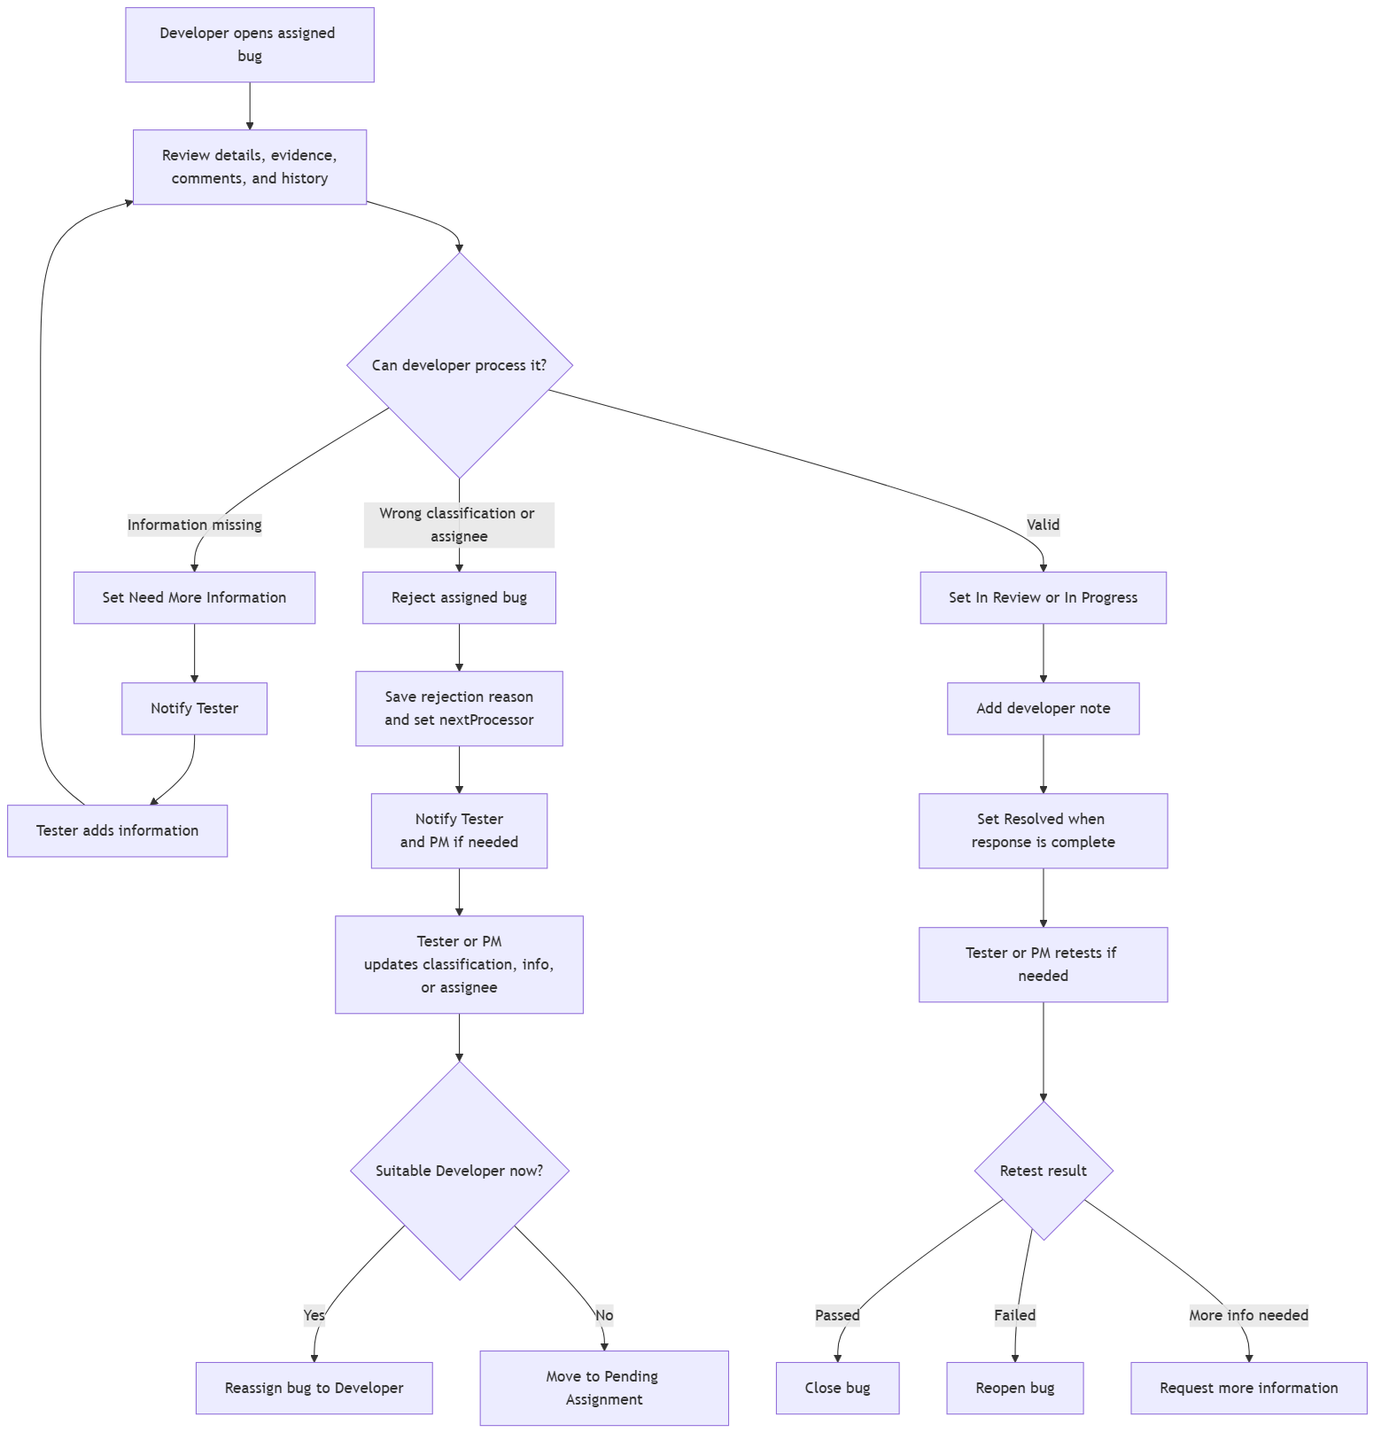
Figure 3 — Developer review and controlled follow-up

Process Description
Step # | Step Name | Detailed Description | Role
BP‑01 | Authentication and access | Purpose: Establish an authenticated IDTS identity and backend role boundary.  Input/output: Active user email and password supplied to AuthService. → Bearer token backed by a server-side AuthSessions row.  Control: Password hash verification, active-user check, session expiry/revocation, backend role mapping.  State/next owner: No defect status change. | Authenticated user or rejected login response.  Audit/notification: Authentication/session audit data only; never raw passwords or tokens. | No defect notification. | User; System
BP‑02 | Defect creation | Purpose: Create a complete, uniquely identifiable defect without inventing an assignee.  Input/output: Title, description, reproduction, actual/expected result, priority, severity, environment, classification and optional evidence. → Persisted Bugs row with bugNumber, ownership, child evidence metadata, history and notification instructions.  Control: Required fields, valid catalog codes, authorized creator, system-managed fields overwritten, selected assignee validated.  State/next owner: Assigned when a valid Developer is explicitly selected; otherwise Pending Assignment. New is not the normal persisted start. | Assigned Developer or Tester/PM queue.  Audit/notification: Create event plus field-level audit for authoritative values. | In-app assignment/queue notification; email outbox instruction when eligible. | Tester; PM may coordinate
BP‑03 | Duplicate and similar support | Purpose: Help a human avoid duplicate work without autonomous linking.  Input/output: Draft or persisted defect text and safe classification fields. → Ranked candidates and optional suggested relation label.  Control: Exclude source bug, bounded result count, deterministic fallback, sanitized AI/provider boundary.  State/next owner: No automatic status change and no automatic DuplicateLinks write. | Human reviews, ignores, or confirms a relationship separately.  Audit/notification: Safe AiSuggestions audit row only for a persisted source check. | None unless a later confirmed business action requires it. | Tester or authorized reviewer
BP‑04 | SAP-context classification | Purpose: Capture the business context used for reporting and responsibility matching.  Input/output: Optional SAP Module, Application Component, Defect Category. → Validated Component Category and consistent classification references.  Control: Application Component and Defect Category compatibility; SAP Module remains optional for pure IDTS defects.  State/next owner: No status change by classification alone; may enable assignment/reassignment. | Assignment decision owner.  Audit/notification: Old/new classification values and correction reason when material. | Relevant assignee/follow-up notification after an actual assignment change. | Tester; PM correction support
BP‑05 | Assignment and Pending Assignment | Purpose: Route work to an eligible Developer or an explicit follow-up queue.  Input/output: Validated classification, Developer Responsibilities, availability/workload context, optional selected Developer. → Assignee and nextProcessor, or a clear unassigned queue.  Control: No automatic Developer selection during create; selected Developer must match active responsibility rules.  State/next owner: Assigned when selected; Pending Assignment when no suitable Developer is selected; reassignment is an action, not a status. | Assigned Developer or Tester/PM queue.  Audit/notification: Assignment/reassignment event with previous and new owner. | Notify new assignee; PM/Tester visibility for pending queue. | Tester/PM
BP‑06 | Developer review and processing | Purpose: Allow the assigned Developer to assess and process authorized work.  Input/output: Assigned bug, evidence, comments, history and current capabilities. → In Review/In Progress progression, request, rejection, or resolution decision.  Control: Assigned-developer rule and transition allow-list; normal review notes optional, decision reasons required where specified.  State/next owner: Assigned → In Review/In Progress; In Review may progress or resolve according to runtime. | Assigned Developer until a follow-up decision changes owner.  Audit/notification: Status event and meaningful notes/reasons. | Notify stakeholders when the action changes ownership or requires follow-up. | Assigned Developer
BP‑07 | Request More Information and resubmit | Purpose: Obtain missing evidence, then return the same assigned work to Developer review.  Input/output: Developer reason; Tester/PM information update and required resubmit summary. → Updated defect/comments/attachments and a restored Assigned state.  Control: Request action only from Assigned/In Review/In Progress by assigned Developer; resubmit requires existing assignee and update summary.  State/next owner: Need More Information → Assigned on Resubmit to Developer. It is not a post-retest transition. | Tester/PM while waiting; existing assigned Developer after resubmit.  Audit/notification: Request and resubmit events, reason, summary and changed fields. | Notify Tester/PM on request and Developer on resubmit. | Developer requests; Tester/PM responds
BP‑08 | Rejection, correction and reassignment | Purpose: Return unsuitable classification or assignment for controlled correction rather than terminate the defect.  Input/output: Developer rejection reason and current assignment/classification. → Rejected follow-up record, corrected data, reassignment or Pending Assignment.  Control: Reason mandatory; nextProcessor mandatory; Rejected cannot silently end and does not route through Need More Information in MVP.  State/next owner: Assigned/In Review/In Progress → Rejected → Assigned or Pending Assignment. | Tester/PM after rejection; new Developer or queue after correction.  Audit/notification: Immutable rejection reason plus correction/reassignment history. | Notify Tester/PM, then the new assignee when work is reassigned. | Developer rejects; Tester/PM corrects
BP‑09 | Resolve, retest, close and reopen | Purpose: Separate Developer resolution from Tester/PM acceptance.  Input/output: Resolution note, current state, retest outcome or reopen reason. → Resolved, Retest Required, Closed, or Reopened state with ownership.  Control: Resolution and reopen reasons required where configured; transitions must match the runtime state machine.  State/next owner: Resolved → Retest Required/Closed/Reopened; Retest Required → Closed/Reopened. No Request More Information branch exists here. | Tester/PM during verification; Developer after authorized reopen assignment flow.  Audit/notification: Resolution, retest, close or reopen event with actor and reason. | Notify verification owner and assigned Developer when reopened. | Developer resolves; Tester/PM verifies
BP‑10 | Comments and attachments | Purpose: Preserve collaboration and evidence without bypassing lifecycle controls.  Input/output: Authorized comment text or attachment metadata/content through the configured storage profile. → Comment or attachment linked to the defect and available to authorized readers.  Control: Comment role, file constraints, safe metadata, storage binding, and no-secret rule.  State/next owner: No direct status change. | Current lifecycle owner remains unchanged.  Audit/notification: Append collaboration/evidence history where applicable. | Notify interested users only according to configured event rules. | Tester, Developer, PM according to permission
BP‑11 | Notifications and email outbox | Purpose: Record in-app events and attempt email delivery without coupling provider failure to workflow success.  Input/output: Committed business event and eligible active recipient. → Notifications row plus NotificationDeliveries status/attempt data.  Control: Recipient eligibility, private provider configuration, bounded retry, sanitized failure details.  State/next owner: No independent status change; delivery failure never rolls back the business transaction. | Recipient or operational retry owner.  Audit/notification: Delivery status, attempts, timing and safe error classification. | In-app is persisted; email may be SENT, FAILED or SKIPPED. Local disabled provider remains SKIPPED. | System
BP‑12 | PM monitoring and escalation | Purpose: Give PM an operational view of workload, queues, overdue items and current action ownership.  Input/output: Defect states, assignee, nextProcessor, due dates, workload and history. → Role-aware workload, overdue, pending, rejected and retest views.  Control: Backend-filtered data and consistent current-action-owner calculation.  State/next owner: Monitoring alone does not change status; authorized coordination actions use normal transitions. | PM decides follow-up or escalation without becoming a second assignee.  Audit/notification: Any subsequent assignment/status action is audited normally. | Escalation or queue notifications only when configured. | PM
BP‑13 | AI suggestions for human consideration | Purpose: Offer bounded assistance while keeping every business decision human and CAP-authoritative.  Input/output: Minimum allowlisted defect fields; no credentials, private email, attachments or storage references. → Sanitized suggestion and confidence/explanation; a persisted audit row starts in PENDING.  Control: AI disabled by default, timeout/failure isolation, output validation, no raw prompt/response persistence.  State/next owner: No autonomous assignment, classification, duplicate confirmation or lifecycle change. | The user reviews the displayed suggestion and may separately perform a normal authorized business action. The current service exposes no suggestion-state update action.  Audit/notification: AiSuggestions records the normalized request/result audit in PENDING; current actions do not persist ACCEPTED, REJECTED or IGNORED reviewer outcomes. | No notification is created by the suggestion itself. | Authorized user

REPORTS
The following IDTS views support operational monitoring and mentor review.
No. | Description | Audience
1 | Operational defect list — Status, priority, severity, classification, assignee, nextProcessor, due/overdue | Tester / Developer / PM according to role
2 | PM workload and queue view — Workload, Pending Assignment, Rejected follow-up, Retest Required, overdue | PM
3 | Audit evidence — History events/logs, comments, attachments, notification and delivery status | Authorized users / mentor evidence
4 | Test and defect evidence — Test Scenario, Unit Test, Functional Test, Test Report, Test and Fix Bug | QA / mentor review; evidence status must remain truthful

Verification and acceptance status
Area | Verification method | Current evidence | Status | Remaining gap
Auth and role boundary | qa:auth:programmatic | BRD/​SRS auth requirements; AuthService | Executed PASS | None in current local run
Core defect lifecycle | Current test scenarios plus three broader suites | Business rules BR-01–BR-46; FRS workflows | Partly executed; three suites Pending | Three broader suites remain Pending
Comments and attachments | Comments/​attachments regression | SRS/​FRS collaboration and storage rules | Pending in current Test Report | Current report still Pending
Notification outbox | qa:email-outbox:programmatic | Notification​Deliveries rules | Executed PASS; provider disabled/​SKIPPED | Live provider disabled / SKIPPED
PM monitoring | qa:pm-monitoring:programmatic | PM reporting requirements | Executed PASS | None in current local run
AI human-review boundary | AI provider/​human-review regression | AI canonical rules and Ai​Suggestions | Pending in current Test Report | Provider/​human-review test Pending
Mentor/​UAT/​sign-off | Mentor/​user execution | UAT and final-report artifacts | Not complete; UAT Prepared only | UAT execution and sign-off Pending

Known limitations
ID | Limitation | Impact | Current mitigation | Follow-up / Owner
LIM-01 | Mentor review and approval remain Pending; this Draft is not a signed acceptance artifact. | No formal acceptance | Keep Draft/​Pending labels | Mentor / DonHV
LIM-02 | UAT is Prepared but not signed. The Final Project Report remains a template/​pending deliverable and is not claimed complete. | No user acceptance result | Keep UAT Prepared | Mentor / users
LIM-03 | Live SMTP/​provider success is not claimed without approved private configuration and captured evidence. | Email acceptance incomplete | Use in-app/​outbox evidence only | Operations / DonHV
LIM-04 | Final shared-QA attachment acceptance depends on active PostgreSQL/​S3 bindings and persistence/​download evidence. | Attachment acceptance incomplete | Require binding and persistence proof | Operations / QA
LIM-05 | Optional AI is disabled by default; live-provider capability is not a prerequisite for the normal workflow and is not claimed without evidence. | AI acceptance incomplete | Keep disabled; disclose PENDING-only audit | DonHV / QA
LIM-06 | The current educational/​shared-QA baseline is not a final enterprise production topology, availability commitment, or performance certification. | No production-readiness claim | Limit claims to educational/​shared QA | PM / architecture

