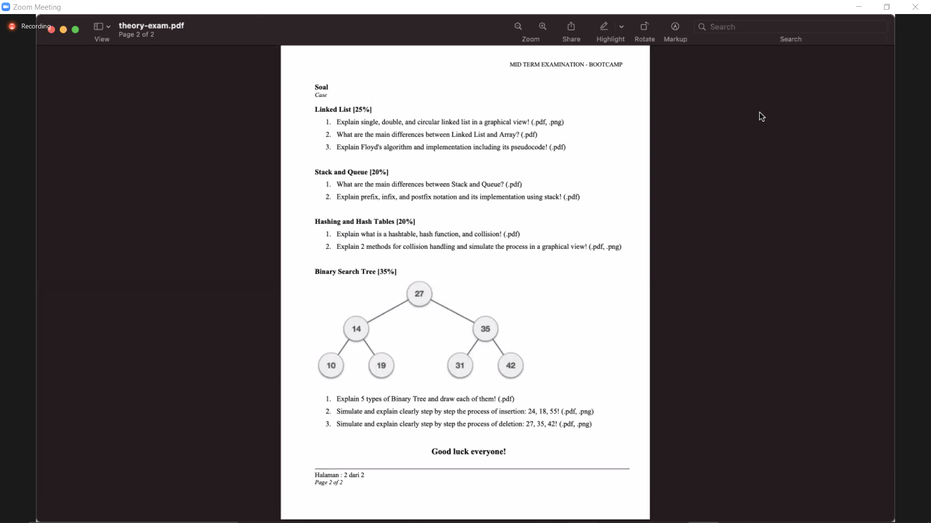

Linked-list

1. Single = most common and each node has data and a pointer to the next node

Double = adding another pointer to the single linked list

Circular = is a variation of a linked list and the last element of this linked-list is linked to the first element forming a circular loop

1. Array = collection of element of a similar data type

Linked-list = an ordered collection of element of the same type in which each element is connected to the next using pointers

1. Floyd-Warshall Algorithm is an algorithm for locating the shortest path between all the pairs of vertices in a weighted graph. This algorithm works for both the directed and undirected weighted graphs. But, it does not work for the graphs with negative cycles

Stack and queue

1. A stack is an ordered list of element where the insertion and deletion part are made the same end, but a queue is the opposite of stack which are open at both end.
2. Prefix = form with binary operators before operand = \*12, +(\*12)3 = +\*123

Postfix = form with binary operator after operands = 12\*, (12\*)3+ = 12\*3+

Infix = form with binary operators in between operands = 1\*2, (1\*2)+3 = 1\*2+3

Hasing and hash tables

1. Hashtables = Tables which can be searched for an item in a certain time using a hash fuction to form an address from the key

Hash function = Function which, when applied to the key, produces a integer which can be used as an address in a hash table

Collision = When a hash function maps two different keys to the same table address, a collision is said to occur

1. Collision handling :

Separate chain = Hangs an additional data structure off of the buckets

Open Addressing = Looking for availability in the next spot generated by an algorithm.

Binary search tree

1. Type :

* Full binary tree = Has no zero children or two children
* Complete binary tree = All the tree levels are filled entirely with node, except the lowest level
* Perfect binary tree = All the internal nodes have strictly two children and every external or leaf node is at the same level within the tree
* Balanced binary tree = the tree height is O(logN) where N is the number of nodes
* Degenerate binary tree = If every internal node has only a sigle child

1. 24 = 27->14-> 19->24

18 = 27->14->19->18

55 = 27->35->42->55

1. 27 = 24nya ke atas menggantikan 27

35 =35 langsung dihapus dari treenya

42 = 42 langsung dihapus dari treenya