Final Exam

Post

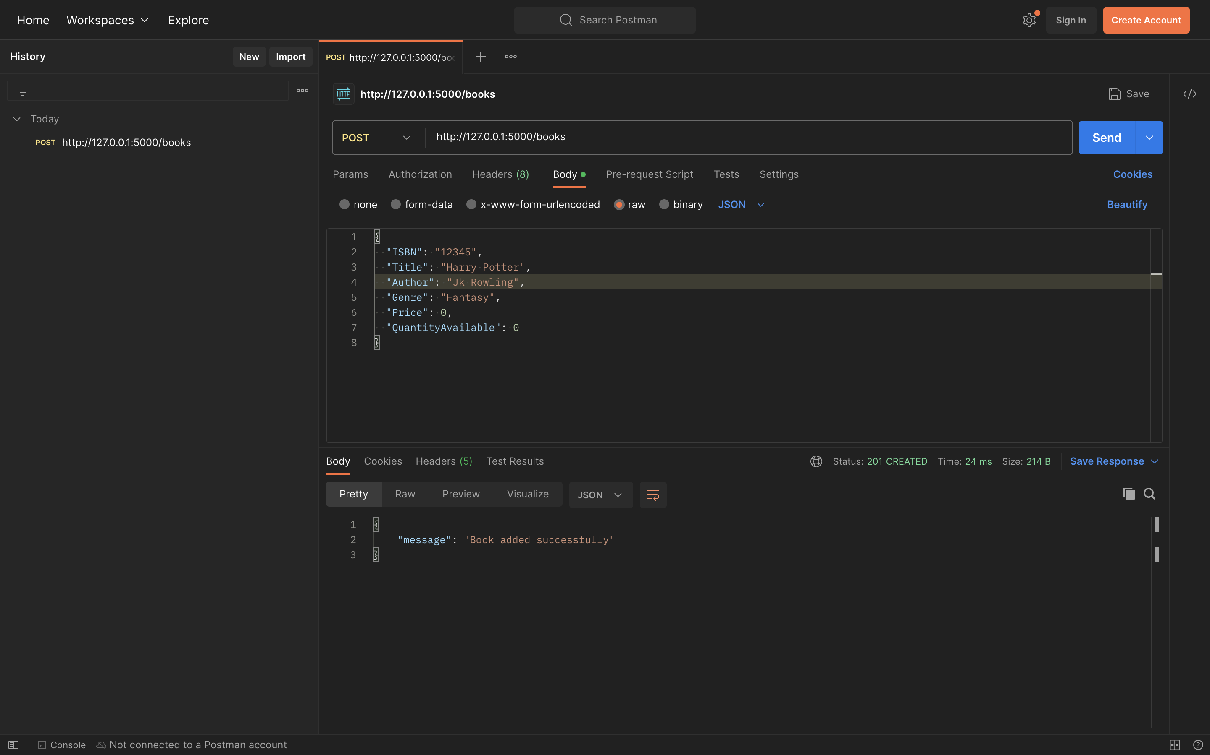

Get

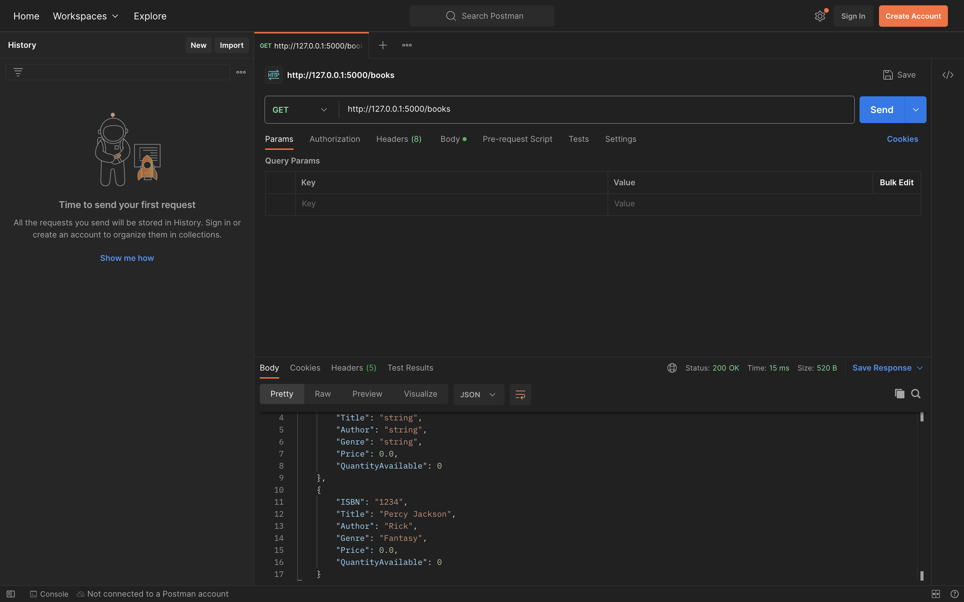

Put

Delete

