Project report

Line-following Ackerman car based in PID-controller

Table of contents

Objective 2

Introduction 3

Geometry of Ackerman car 4

Implementation 5

References 6

# Objective

Create a scene in V-REP simulator with Ackermann car model. Then make the car follow the line. Stabilize its movement using PID controller. Choose optimal speed and coefficients corresponding coefficients PID coefficients.

# Introduction

## Ackermann steering

Ackermann steering geometry is a geometric arrangement of linkages in the steering of a car or other vehicle designed to solve the problem of wheels on the inside and outside of a turn needing to trace out circles of different radii.

It allows preventing situation in which left and right wheels of a car move different trajectories (as on the picture below).

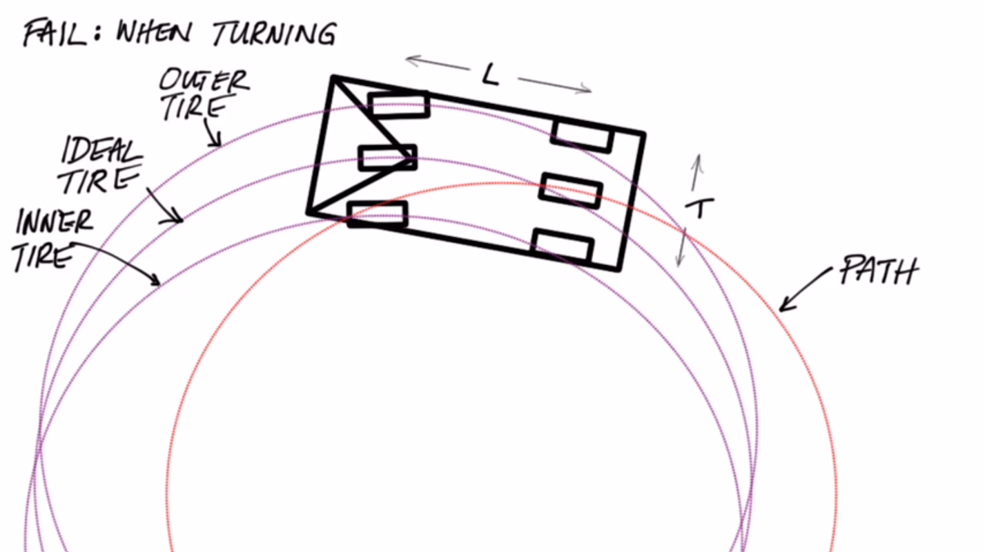

Ackerman steering was invented for solving this problem.

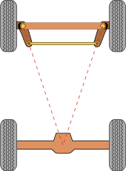 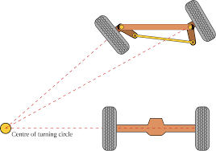

## PID-controller

PID-controller is a simple kind of controllers, which is widely used in stabilization of different closed-loop systems. IN continuously calculate the error value and automatically applies correction by combining 3 parts:

* Proportional (P): current error value
* Integral (I): previous errors
* Derivative (D): estimation of future errors by its current rate of change

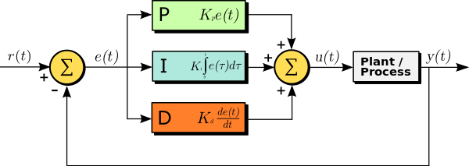

The overall control function in continuous time domain can be expressed as:

In discrete time domain it has the following form:

So, in this work the formulae of PID-controller in discrete time domain is used.

# Description of the system

## Construction of the Ackermann car

In simulations, the Ackerman car with following parameters was used:

* L = 0.1289 – distance between front and back axis;
* T = 0.0755 - distance between front left and back wheels.

Also it has 3 vision sensors on the front bumper.

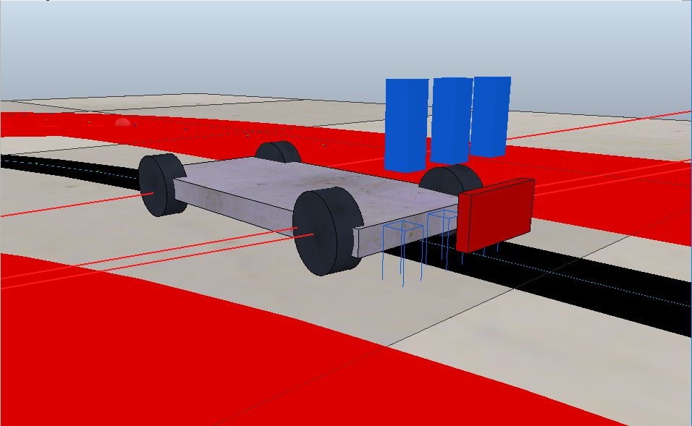

## Geometry of Ackermann car

On the picture below, you can find description of the car’s maneuvers.

For r – desired trajectory radius, desired rotation angle δ can be found as

With ri = r - T/2 = L * tan δ - T/2, ro = r + T/2 = L * tan δ + T/2:

These equations will be used later.

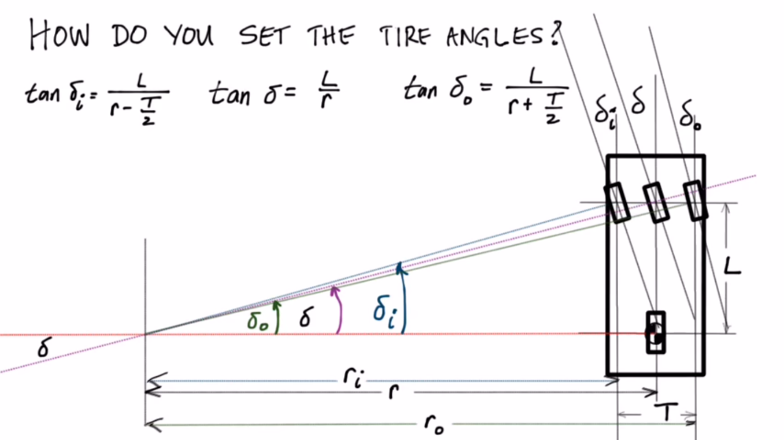

## Environment

In the simulation, the following trajectory was used (black line between red areas).

Red areas don’t have influence on car’s motion but they are used for detection of its position: if the car is on these areas, then it has left its stability threshold and is not on the line anymore.

## 

## Vision Sensors

The Ackermann car model has 3 vision sensors of orthographic projection-type.

Left and right vision sensors are used for detection relative position of the car to the black line and calculating the error. For this case, we take the difference between their average of intensity values. These values vary in [0, 1] (0 for black and 1 for white colour). In a position, when the path lies exactly in the middle of 2 sensors, the tracked values from both sensors would be the same (so, difference is zero, there is no need in correction). The value of difference vary in [-1, 1], so the correction angle would depend on this value.

The third (middle) sensor is used for detecting lap of the car with red area (that means it doesn’t following line anymore). For this case the average of red value from the sensor is used. This value is also vary in [0, 1]. The simulation stops when it becomes more than 0.9.

# Choice of algorithms and technologies

## Choosing environment

At the first part of the project, when the task was small and the whole algorithm fitted in 50 lines of code, it was easier to maintain it in default V-REP’ Lua scripts. At that time there was a single scene file containing model and code in it.

Then the tasks became more complex, so that it was more rational to move it to a separate project on Python and control simulation through V-REP remote API. So, now there is a separate file with a model and a separate project with code.

## Choosing optimal parameters

At the first stage, choosing the values of speed and PID coefficients was performed heuristically. However, since it is not very efficient way then it was decided to create an automatic test engine.

The first test engine performed test runs of simulation with different combination of parameters from predefined ranges. (The source code for this generator is in file “TestDataGenerator.py”).

But it still wasn’t so efficient and it was decided to perform the selection of parameters using genetic algorithms. (The source code of the algorithm in file “NEAT_Tester.py”).

## Checking end of simulation

When the selection of appropriate parameters performed manually, there was no need for automatic detecting the fact of leaving the stable state by the car and moving out of the path.

After creating an automatic test engine there was a need for detecting such situations, stopping simulation and logging its duration. The first idea was to check relative location of the car to the floor, so that if the car ran out of the floor and “flew in space” then the simulation terminated.

However, there were cases when the car ran out of the path, but haven’t fell down but hovered on a border of the floor. For this case was decided to check relative location to the floor not of a whole car but only of front wheels, so than whenever their position is lower than position of the floor, then the simulation was stopped.

But then a new problem appeared. In some cases the car after getting off the track could run around for a long time, so that it gave wrong results. The solution for this problem was chosen to additional border lines: when the car crosses them, then simulation terminates. These lines are painted red and detected by middle vision sensor.

# Program description

## Files overview

The program consists of several files:

* “ackerman_car.ttt” (V-REP scene file)
* Python project for simulation control:
  + “vrep.py”, “vrepConst.py”, “remoteApi.dll” (V-REP Remote API library files)
  + “main.py” (program starting script)
  + “simulation.py” (contains functions for opening/closing connection to V-REP, run simulation)
  + “LineFollower.py” (Contains algorithm of car’s movement, handling objects’ states)
  + “TestDataGenerator.py” (creates test cases by generating combinations of different parameters (i.e., speed, Kp, Ki, Kd coefficients) from a given range)
  + “NEAT_Tester.py” (contains algorithm for performing automatic selection of coefficients using genetic algorithms)

Also it contains data gathered by running different test engines (i.e., TestDataGenerator and NEAT_Tester)

# Implementation

For scanning state of the system I use 2 vision sensors. Their output value varies in [0, 1] (0 for black and 1 for white colour). The difference of value taken from these sensors (value in [-1, 1]) helps to determine size and direction of error (car’s deviation from the centre of path line).

The algorithm uses principle of discrete PID controller, so, as a value of integral is computed as a sum of all errors, derivative as a difference of current and previous errors.

The car in the system moves with constant angular velocity of all wheels, and we control its position by changing front steering (desired) angle (δ). The value of this angle depends on components of PID controller. Values of angles on each of front wheels are computed by formulas revealed in one of previous parts of report.

# Final version software

All resources (code and model) are available here:

<https://github.com/DaryaLari/ControlTheoryProject>

# References

<https://en.wikipedia.org/wiki/Ackermann_steering_geometry>

<https://www.youtube.com/watch?v=i6uBwudwA5o>

<https://en.wikipedia.org/wiki/PID_controller>