1. Expand the POST Pet Add a new pet to the store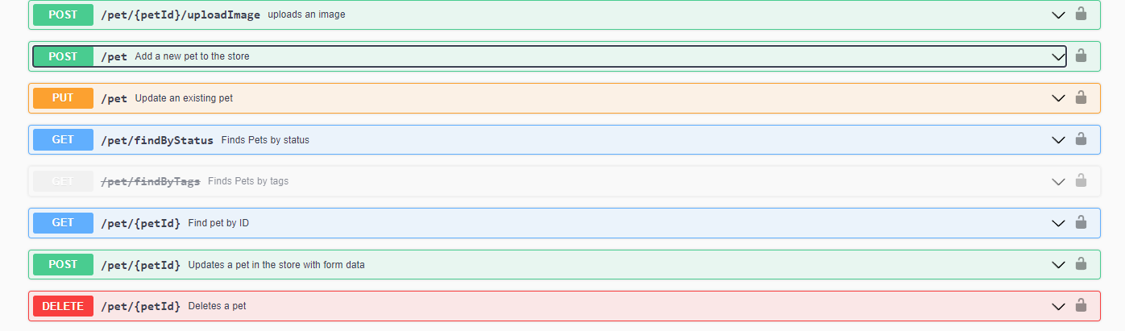
2. 2. Click on the bottom Try it out.

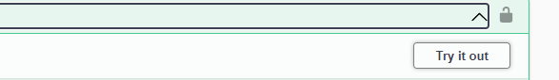

After the example value in the Request Body field becomes editable.

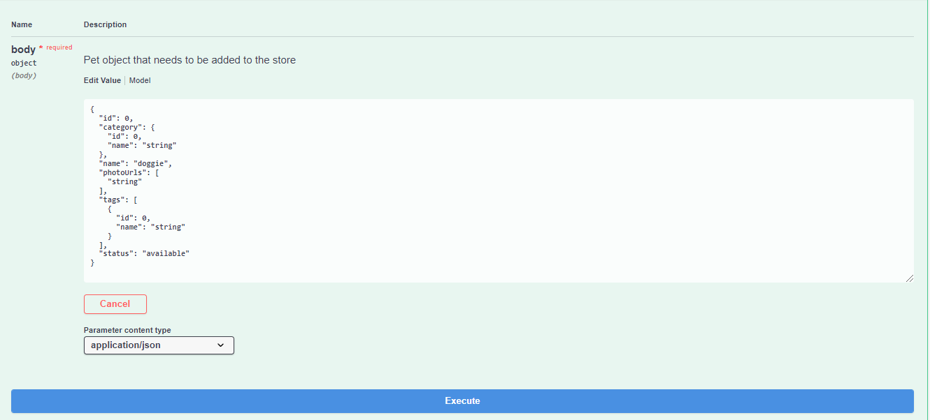

1. In the Example Value field, change the first id value and the second name value to something you’d recognize and click "Execute".
2. 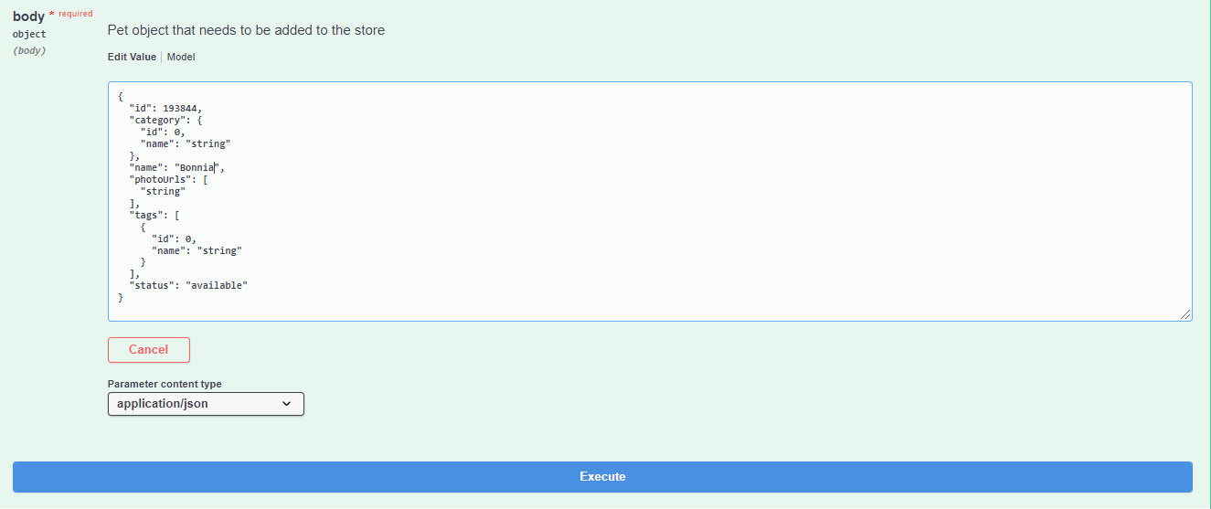

       Swagger submits the request and shows the curl that was submitted. The Responses section shows the response.   The data fields open:

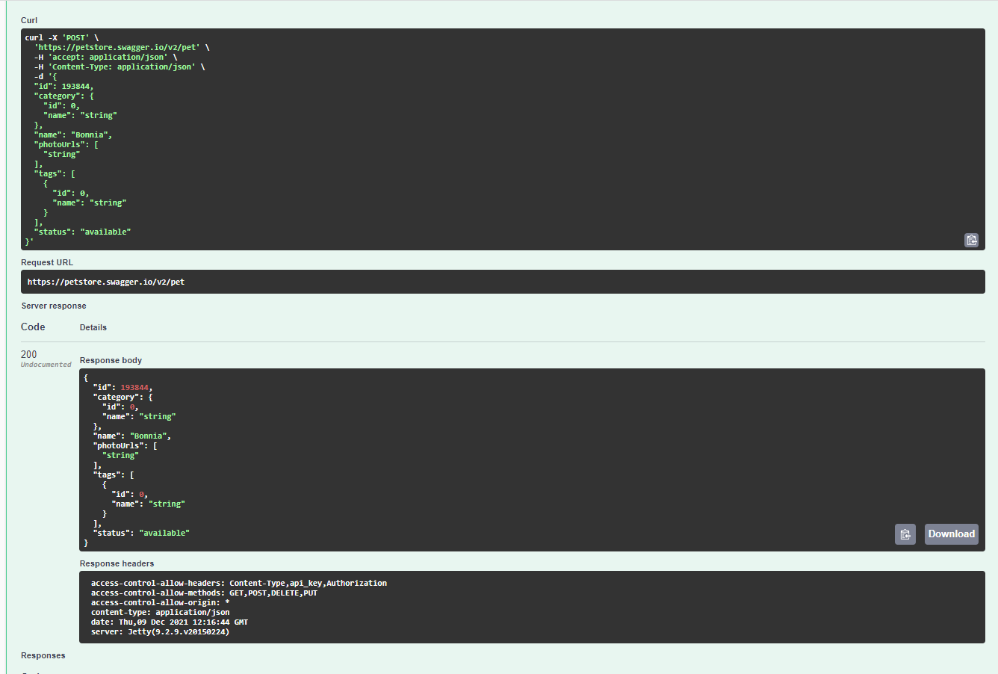

2nd Testcase

Expand the Get Pet Finds pet by status buttom. The data fields open:

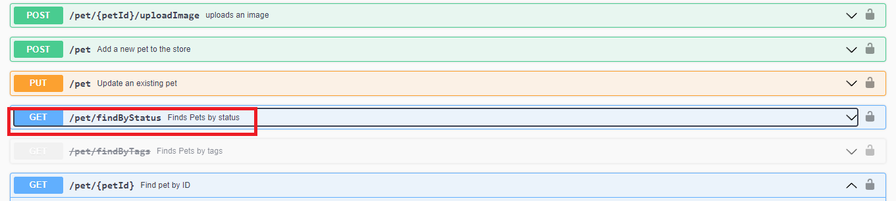

2 Click on the bottom Try it out.

C:\Users\Lenovo\DashaQA\test case\petstore\try it out .png

After the value field becomes editable.

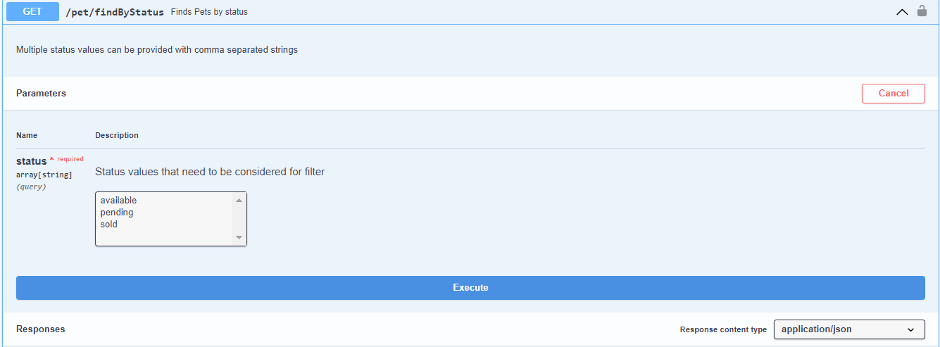

3 In the Value field, select Status values that need to be considered for filter and click Execute.

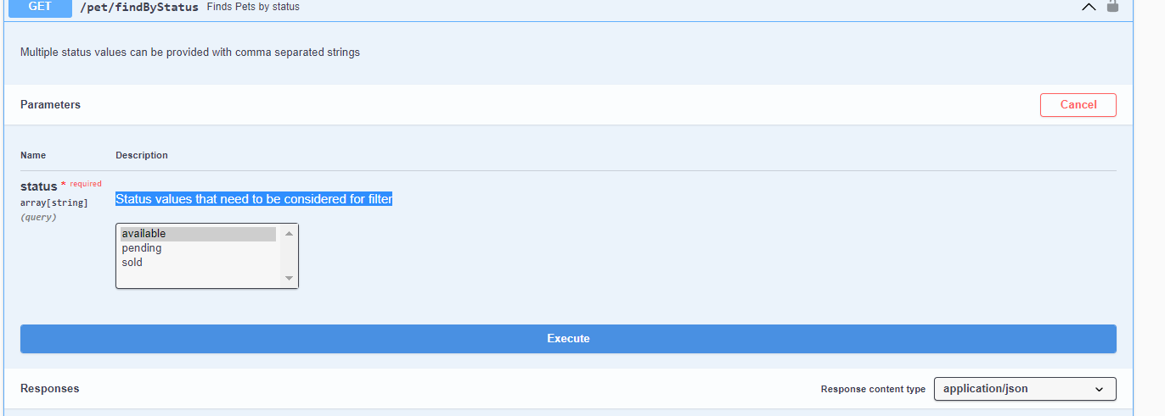

Swagger submits the request and shows the curl that was submitted. The Responses section shows the response with out parametres that we were selected. 