**MODEL 1 ARCHITECTURE HATEBERT:**

**WITH SM**

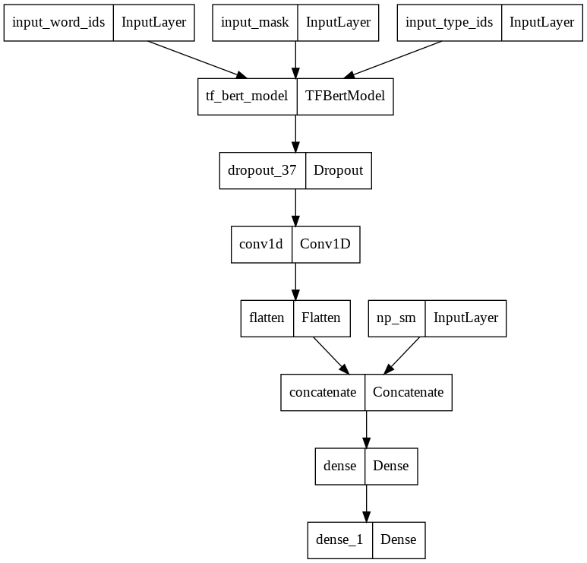

Accuracy curve   
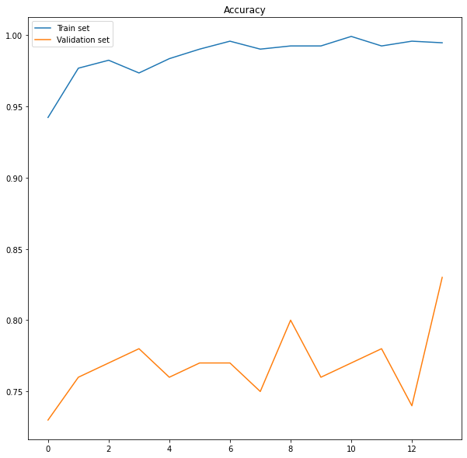

Accuracy: 83.00%

Confusion Matrix

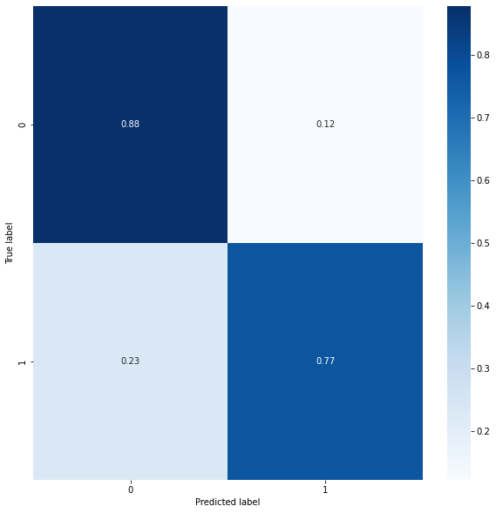

**Compared to HateBert without SM**

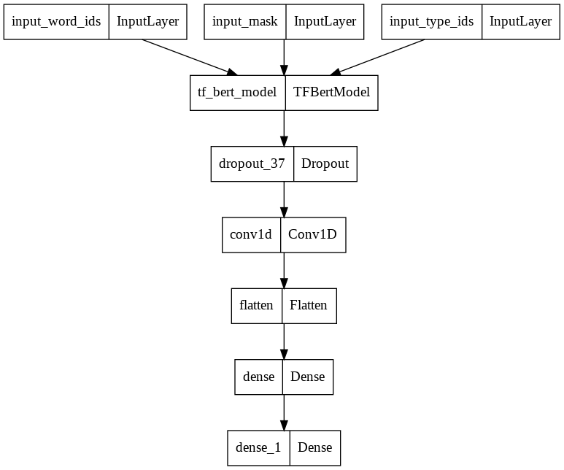

Accuracy curve

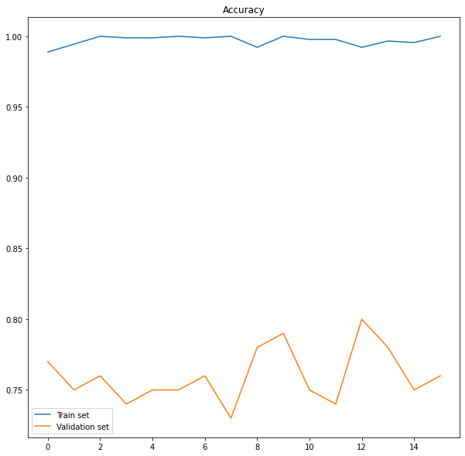

Accuracy: 76.00%

Confusion Matrix

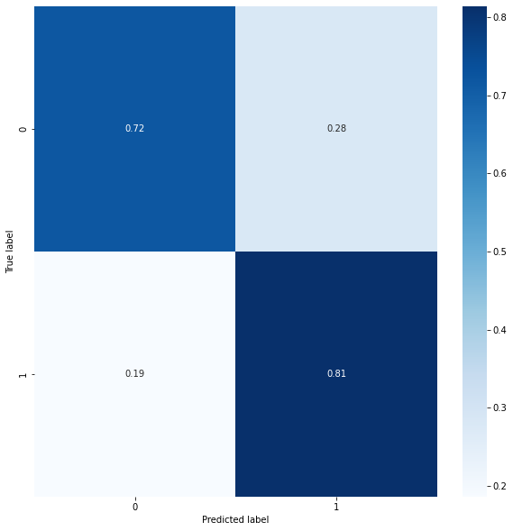

**MODEL 2 ARCHITECTURE ROBERTA:**

**WITH SM**

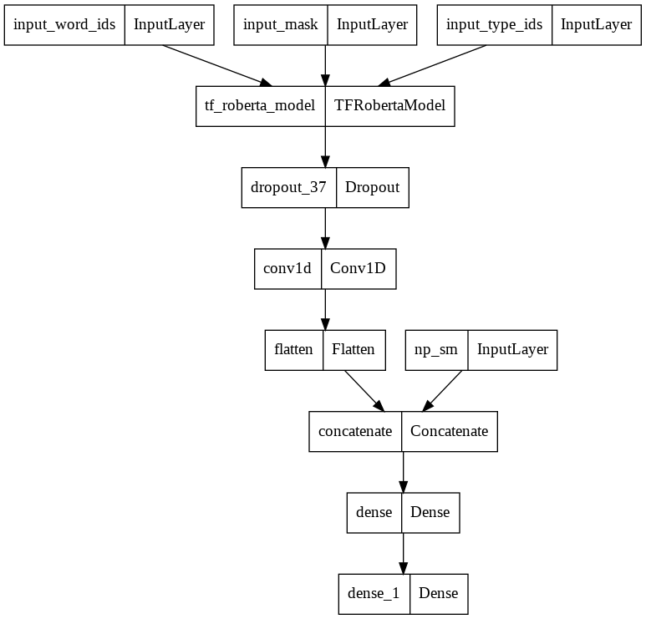

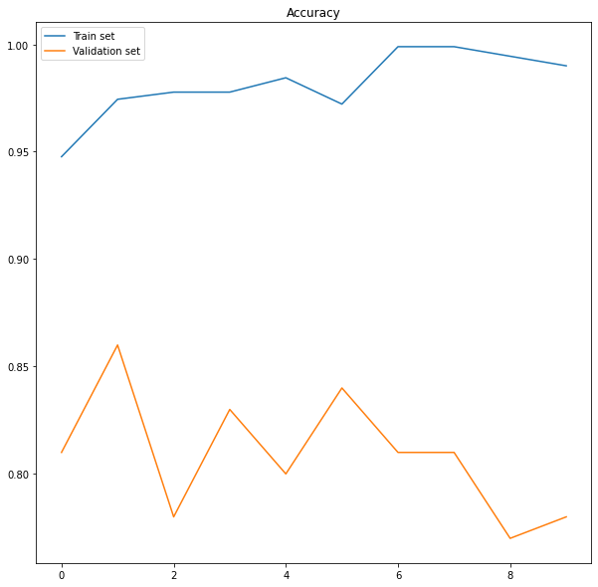

Accuracy: 78.00%

Confusion matrix:

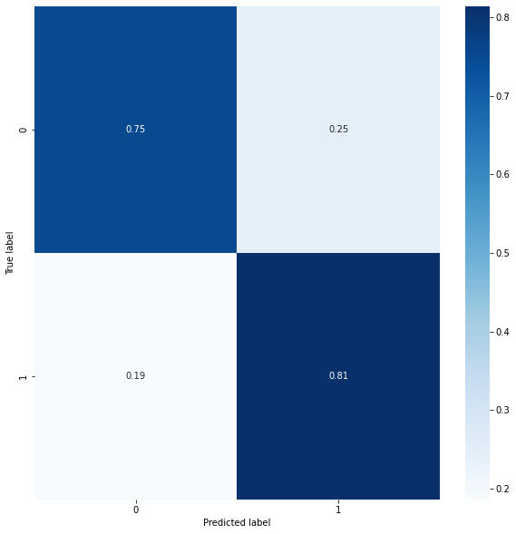

**Compare to Roberta without SM**

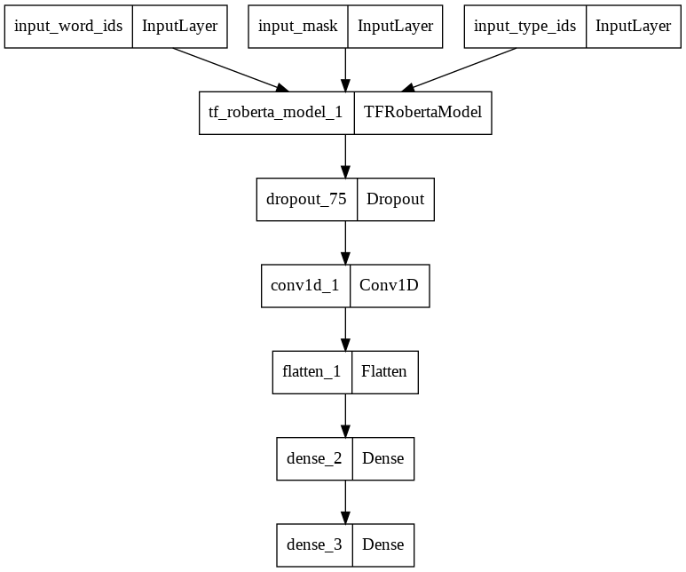

Accuracy curve

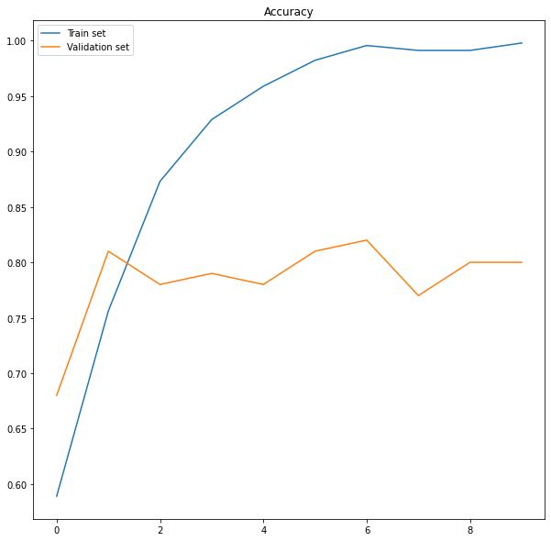

Accuracy: 80.00%

Confusion Matrix

