**№1**

Software environment:

**Platform:** Google Chrome 88.0.4324.150

**OS:** Windows 8.1 x64

**Summary:** The “Name” field is allowed to be filled in with numbers and special characters without an error message on the “Employees” form.

**Description:** The “Name” field is allowed to be filled in with numbers and special characters without an error message on the “Employees” form.

**Steps to reproduce:**

1. Go to the https://qatest-25939.firebaseapp.com/

2. Fill in the “Name” field only with numbers and special characters.

3. Pay attention to the “Name” field

**Actual result:** The “Name” field is filled in with numbers and special characters on the “Employees” form.

**Expected result:** The error message is displayed on the “Name” field after filling in only with numbers and special characters.

**Additional info:**

The bug is repeated on such platforms:

Opera 73.0.3856.329

Firefox Browser 84.0.2

**Attached Files:**

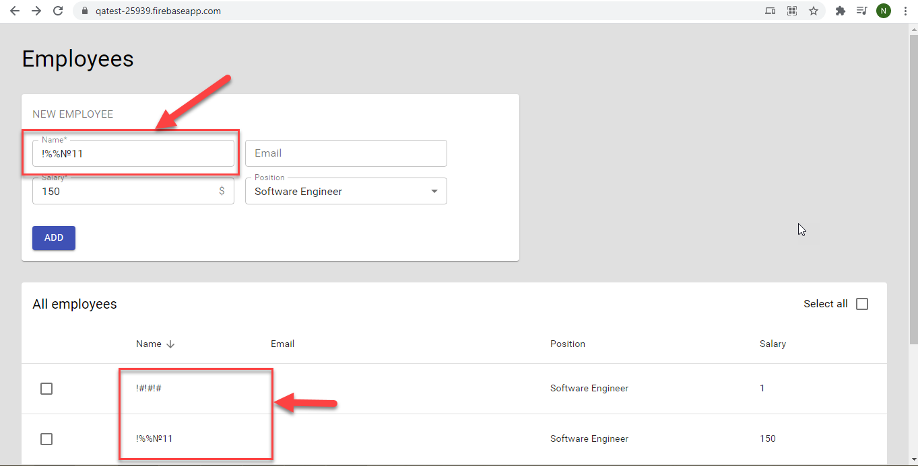

**№2**

Software environment:

**Platform:** Google Chrome 88.0.4324.150

**OS:** Windows 8.1 x64

**Summary:** The entered position is not saved on the “Employees” form after selecting the “Other” option.

**Description:** The entered position is not saved on the “Employees” form after selecting the “Other” option in the “Position” pop-up list and filling in the “Position” field with valid data.

**Steps to reproduce:**

1. Go to the https://qatest-25939.firebaseapp.com/

2. Fill up all required fields.

3. Select the “Other” option in the “Position” pop-up list.

4. Enter the title of position in the “Position” field.

5. Click on the “Add” button.

6. Click on the newly added item to edit.

7. Pay attention to the empty field in the “Position” field.

**Actual result:** The entered position is not saved and displayed on the “All employees” list and on the “Edit employee” page after selecting the “Other” option in the “Position” pop-up list and filling in the “Position” field with valid data.

**Expected result:** The entered position is displayed on the “All employees” list and on the “Edit employee” page after selecting the “Other” option in the “Position” pop-up list and filling in the “Position” field with valid data.

**Additional info:**

The bug is repeated on such platforms:

Opera 73.0.3856.329

Firefox Browser 84.0.2

**Attached Files:**

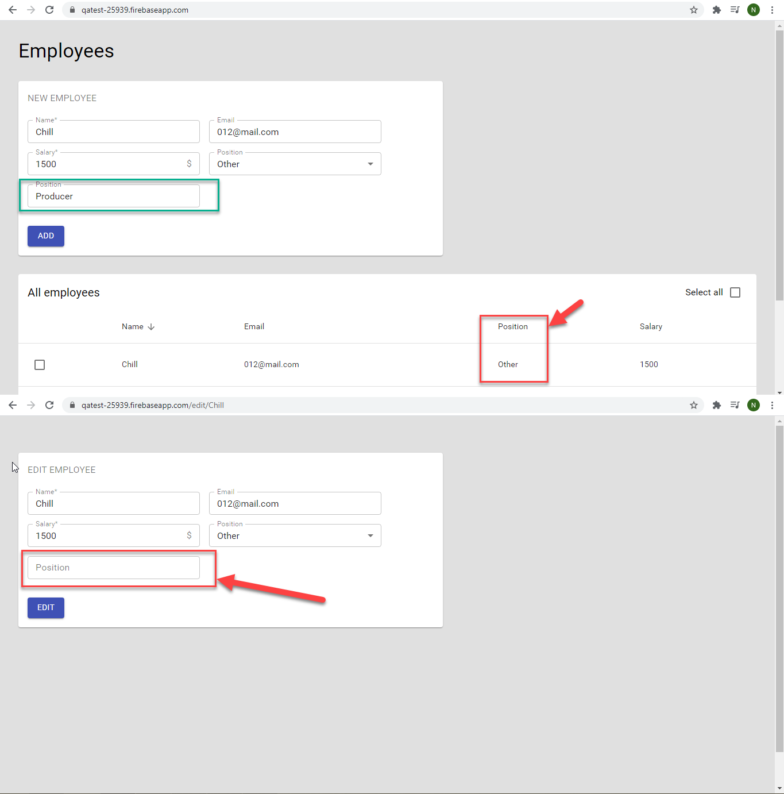

**№3**

Software environment:

**Platform:** Google Chrome 88.0.4324.150

**OS:** Windows 8.1 x64

**Summary:** The same email address can be added multiple times with different names and positions on the “New employee” form.

**Description:** The same email address can be added multiple times with different names and positions on the “New employee” form.

**Steps to reproduce:**

1. Go to the https://qatest-25939.firebaseapp.com/

2. Fill up the “Name” field with “Name1” name and the “Position” field with “Hardware engineer”.

3. Enter the “012@mail.com“in the email field.

4. Click on the “Add” button.

5. Fill up the “Name” field with “Name2” name and the “Position” field with “QA engineer”.

6. Enter the “012@mail.com“in the email field.

7. Click on the “Add” button.

8. Pay attention to the same email address on the different employee's line.

**Actual result:** The same email address added twice with different names and positions on the “New employee” form.

**Expected result:** The error message is displayed on the “Email” field on the “New employee” form after entering the already added email address.

**Additional info:**

The bug is repeated on such platforms:

Opera 73.0.3856.329

Firefox Browser 84.0.2

**Attached Files:**

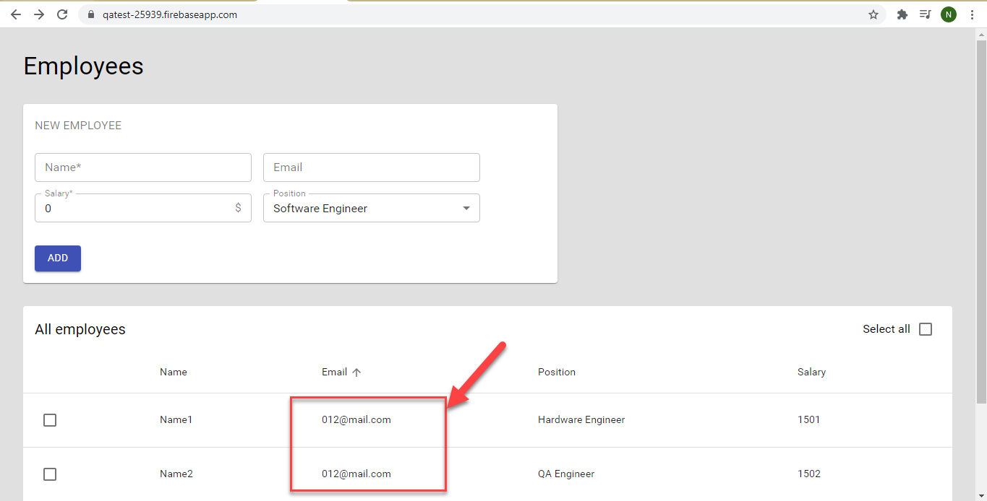

**№4**

Software environment:

**Platform:** Google Chrome 88.0.4324.150

**OS:** Windows 8.1 x64

**Summary:** The employee’s name is not saved and updated on the "All employees" list after editing “Name” of employee on the "Edit employee" page.

**Description:** The employee’s name is not saved and updated on the "All employees" list after editing “Name” of employee on the "Edit employee" page.

**Steps to reproduce:**

1. Go to the https://qatest-25939.firebaseapp.com/

2. Fill up the all required fields.

3. Click on the “Add” button.

4. Click on the newly added item to edit.

5. Enter the new “Name” on the “Edit employee” form.

6. Click on the “Edit” button.

7. Pay attention to the “Name” on the “All employees” list.

**Actual result:** The employee’s “Name” is remained the same on the "All employees" list after editing “Name” of employee on the "Edit employee" page.

**Expected result:** The employee’s “Name” is saved and updated on the "All employees" list after editing “Name” of employee on the "Edit employee" page.

**Additional info:**

The bug is repeated on such platforms:

Opera 73.0.3856.329

Firefox Browser 84.0.2

**Attached Files:**

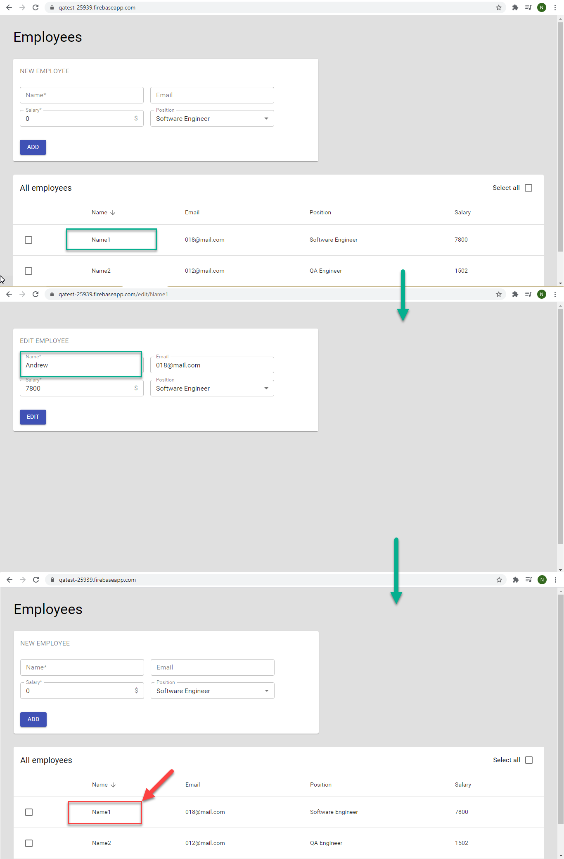

**№5**

Software environment:

**Platform:** Google Chrome 88.0.4324.150

**OS:** Windows 8.1 x64

**Summary:** The invalid email address can be entered in the “Email” field after filling up the “Email” field with special characters.

**Description:** The invalid email address can be entered in the “Email” field after filling up the “Email” field with special characters.

**Steps to reproduce:**

1. Go to the https://qatest-25939.firebaseapp.com/

2. Fill in the “Email” field using special characters, but symbol before “@” must be number or latin letter.

3. Click on the “Add” button.

4. Pay attention to the invalid email in the “Email” field on the “All employees” list.

**Actual result:** The email is assigned on the “Email” field after filling the “Email” field with special characters on the “New employee” form.

**Expected result:** The error message is not displayed on the “Email” field after filling up the “Email” field with special characters.

**Additional info:**

The bug is repeated on such platforms:

Opera 73.0.3856.329

Firefox Browser 84.0.2

**Attached Files:**

