SCAIMS / APGORRS User Manual
Step-by-step guide for farmers and agriculture office staff
Updated: July 1, 2026

This manual is written for non-technical users. Some screens show the APGORRS name; those screens are part of the same SCAIMS agriculture system.

How to Use This Manual
Follow the steps in order. Compare your screen with the screenshot under each step. If the screen looks different, check that you opened the correct menu item before continuing.

Before You Start
- Use a phone, tablet, laptop, or desktop with internet access.
- Prepare your username and password if you already have an account.
- Prepare your RSBSA Number if you are registering as a farmer.
- Prepare a clear profile image for account creation.
- Ask the agriculture office for help if you are unsure about RSBSA, parcel size, crop details, or report details.
Important: Keep your username and password private. Do not share your account with another person.

Part 1. Farmer Guide
Use this section to register, log in, add farm parcels, read updates, and submit crop reports.

Step 1. Open the SCAIMS home page
- Use this page as the starting point of the system.
- Choose Register Your Farm if you are a new farmer and still need an account.
- Choose Login if you already have an account.
- Choose View Crop Map only when you want to look at the crop map.
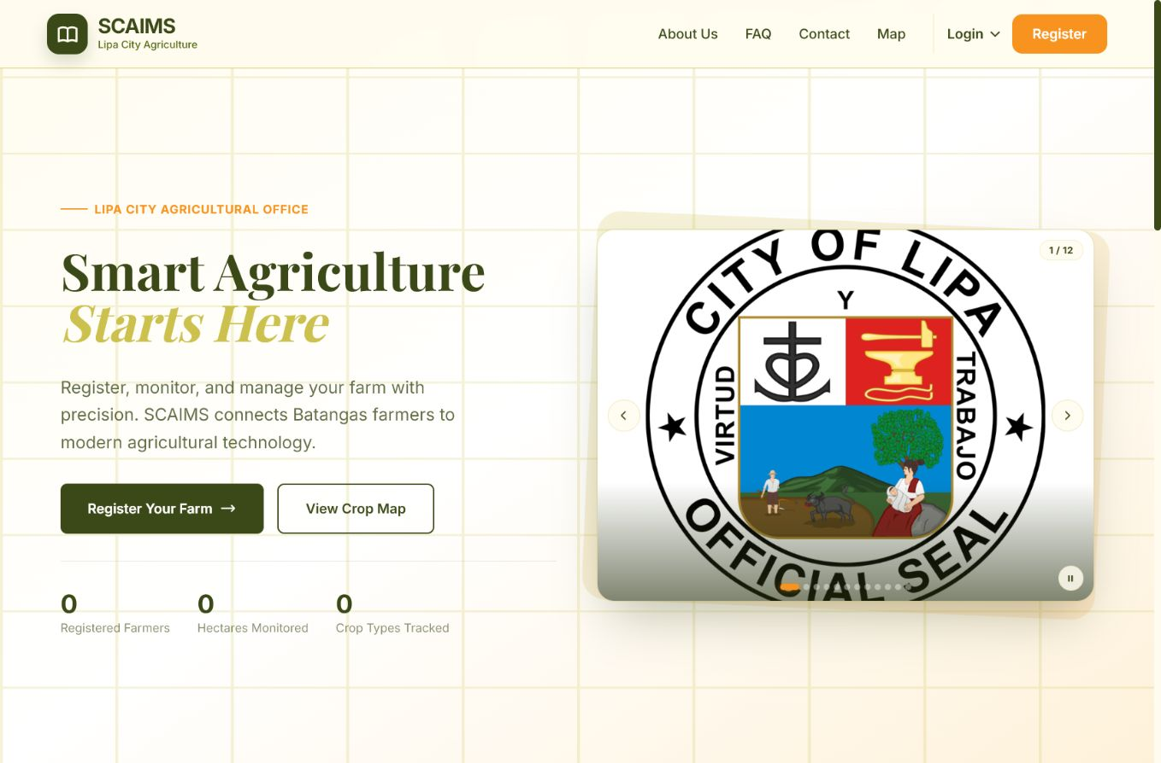
SCAIMS home page.

Step 2. Log in as a farmer
- Enter your Username and Password.
- Complete the reCAPTCHA check if it appears.
- Click Sign In as Farmer.
- If you do not have an account yet, click Create a Farmer Account.
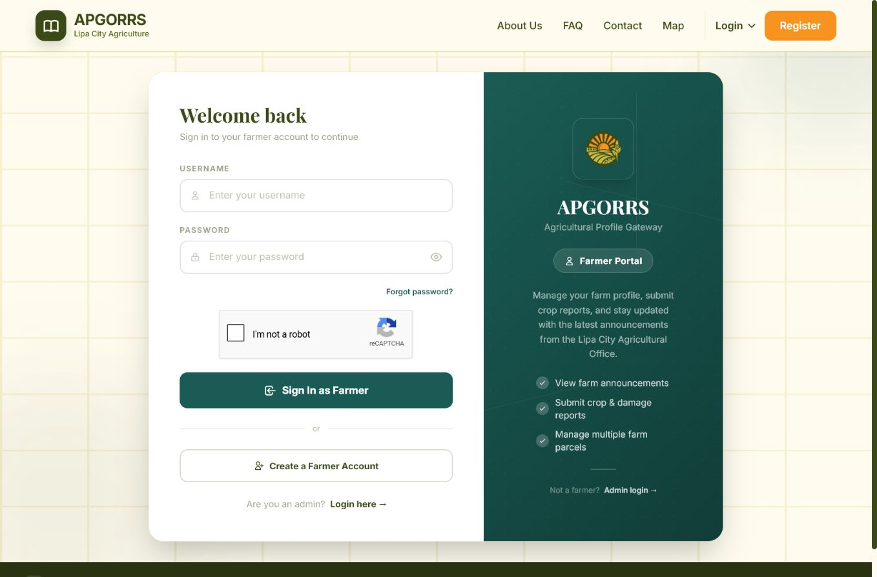
Farmer login page.

Step 3. Answer the RSBSA question
- Read the question asking if you are already registered in RSBSA.
- If you are already registered, click Oo, ako ay nakarehistro.
- If you are not yet registered, click Hindi, kailangan ko pang magparehistro and follow the RSBSA instructions first.
- Return to this registration page after your RSBSA registration is approved.
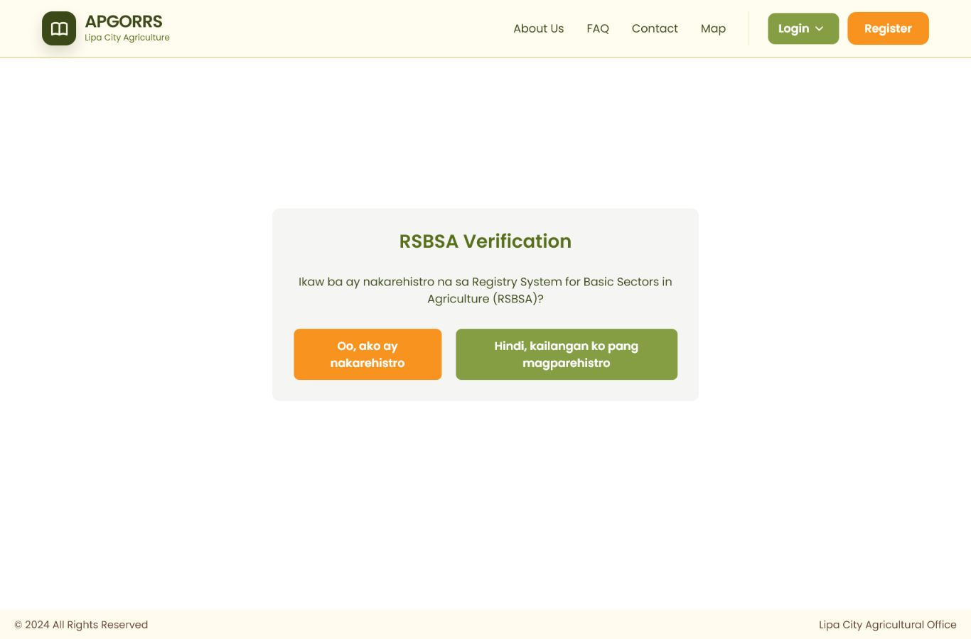
RSBSA verification page.

Step 4. Fill out the farmer registration form
- Enter your name, birthdate, sex, contact number, address, barangay, and RSBSA Number.
- Use this RSBSA Number format: XX-XX-XX-XXX-XXXXXX.
- Use an 11-digit Philippine mobile number that starts with 09.
- Read the terms and privacy notice, check the box if you agree, then click Submit.
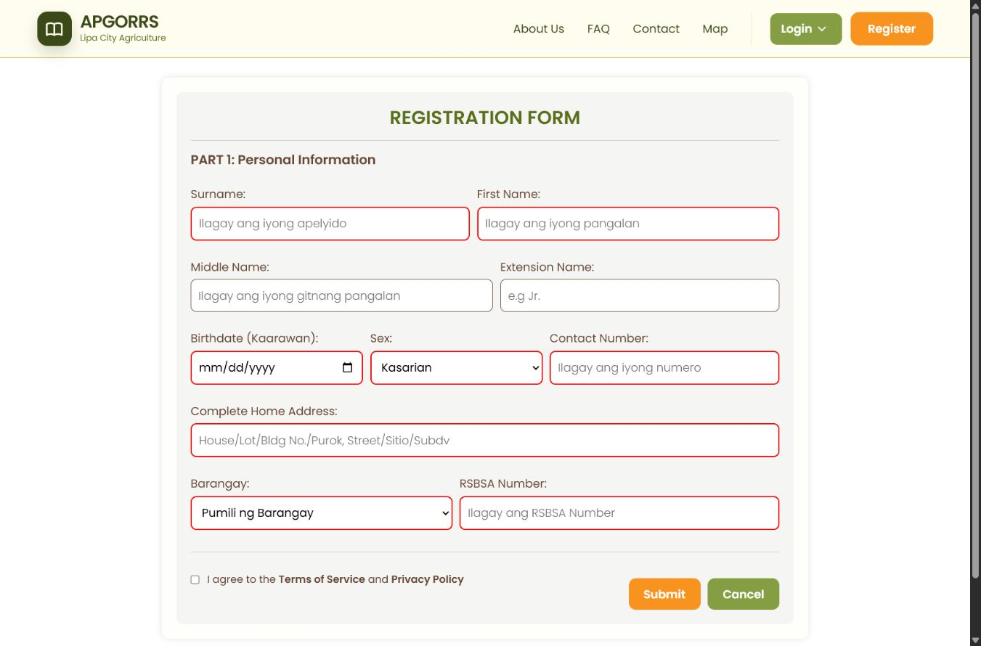
Farmer registration form.

Step 5. Create your farmer account
- Choose a username that you can remember.
- Create a strong password with at least 8 characters, including uppercase, lowercase, number, and special character.
- Type the same password again in Confirm Password.
- Upload a clear profile image, then click Create Account.
- Write down your username and password in a safe place.
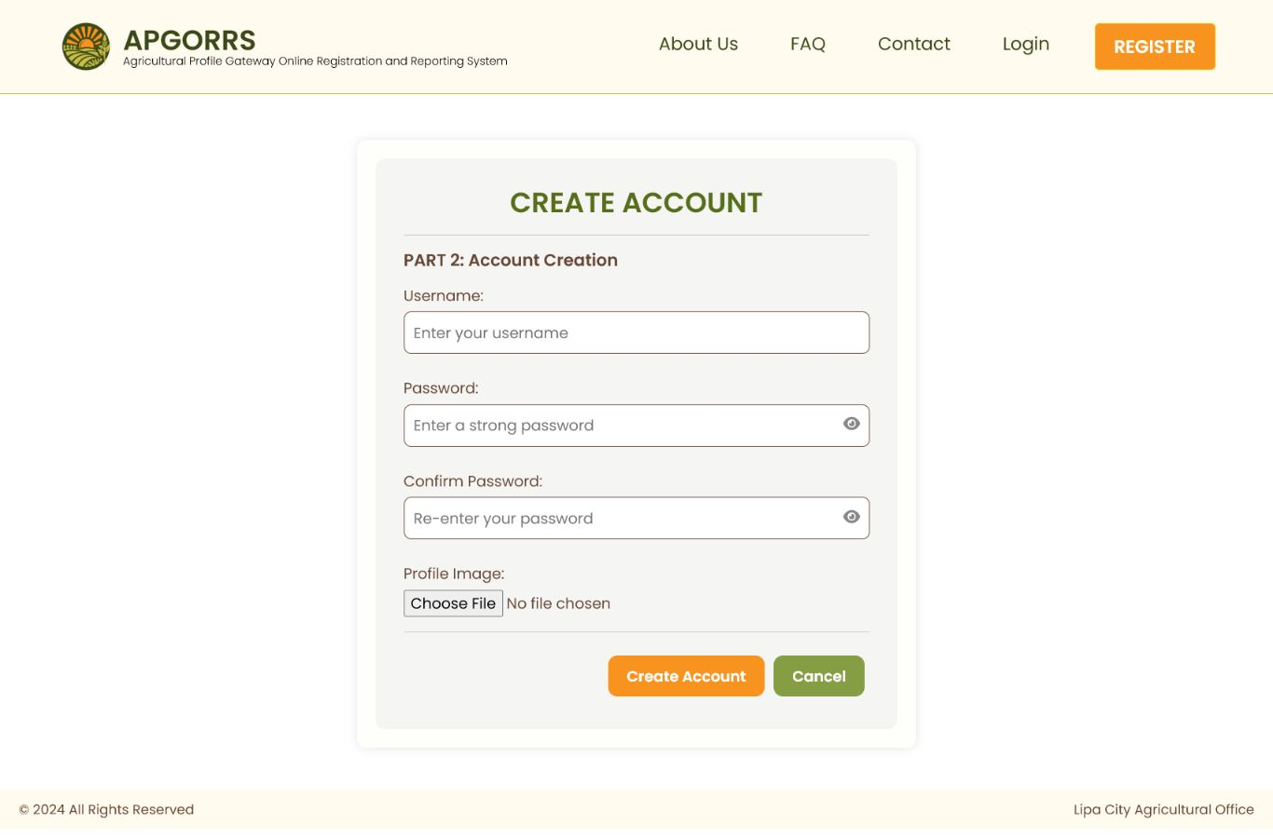
Create account page.

Step 6. Read the latest updates
- After logging in, open Home from the left menu.
- Read the latest announcements from the agriculture office.
- Check this page before submitting reports so you do not miss important reminders.
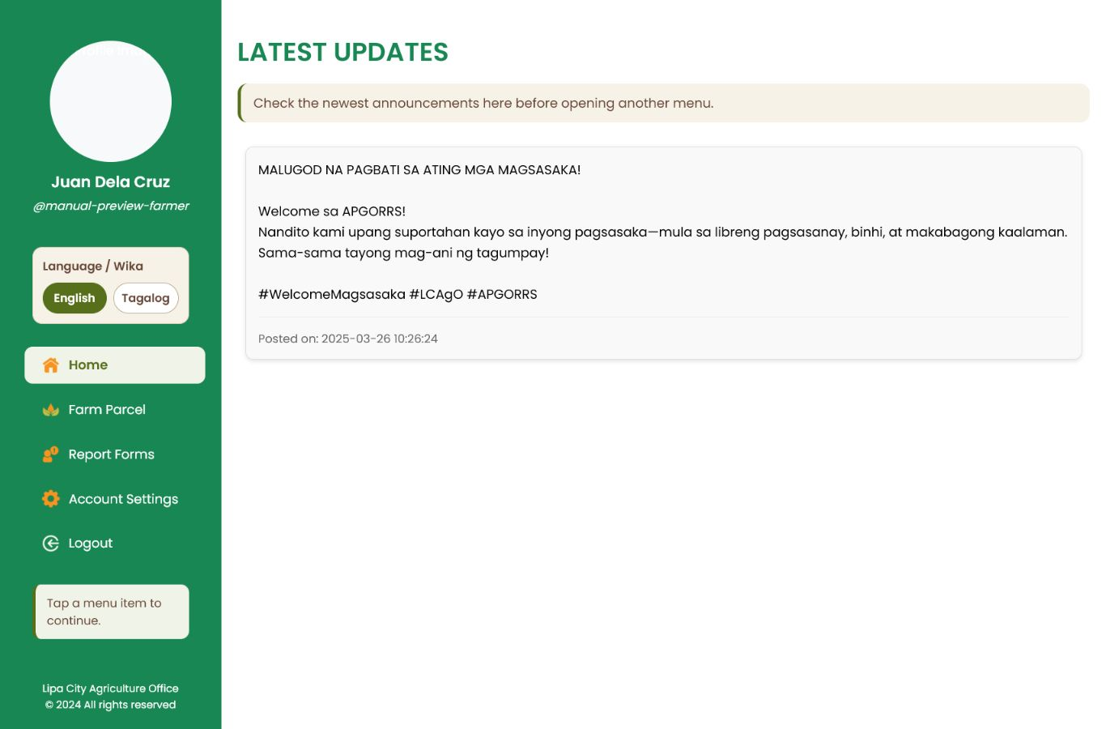
Farmer home page with latest updates.

Step 7. Open the report form
- Click Report Forms from the left menu.
- Under Choose Type of Report, select Crop Harvest Report for harvest information.
- Select Crop Damage Report if crops were damaged by pest, disease, weather, or another cause.
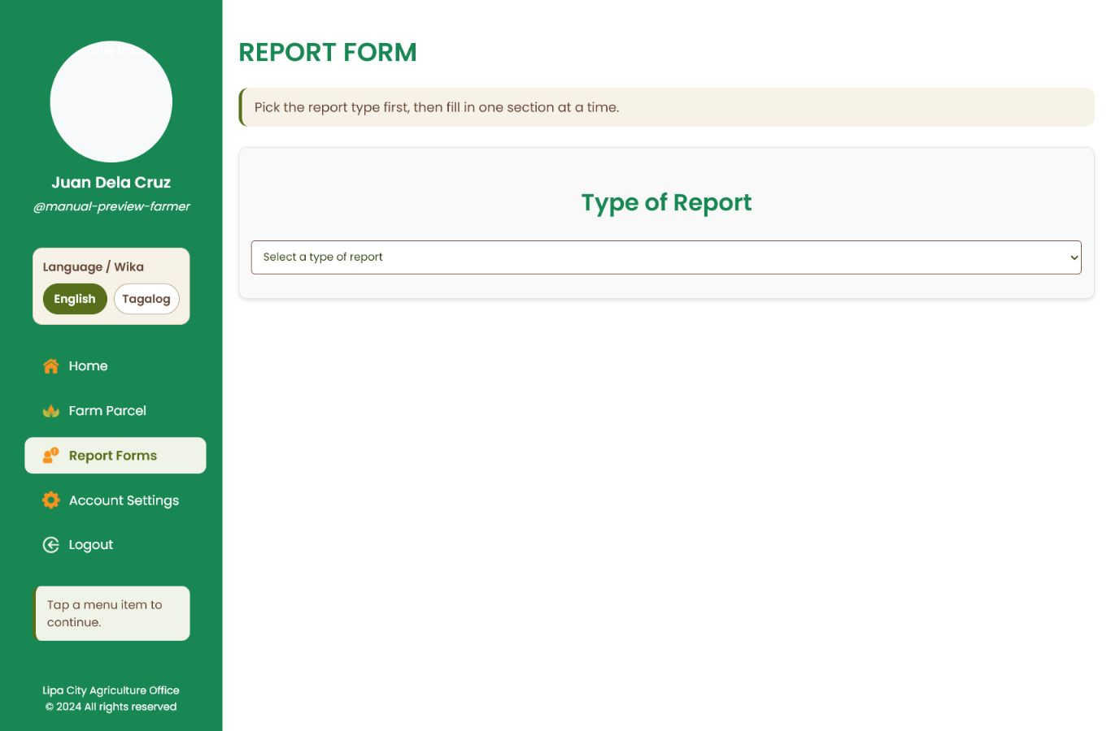
Report form page before choosing a report type.

Step 8. Submit a crop harvest report
- Choose the parcel location and crop details.
- Enter the planting date, harvest date, estimated harvest in kilograms, crop status, number of trees if applicable, and farm gate price.
- For Number of Trees, type N/A if the crop does not use tree count.
- Coordinates are optional. If you are not sure, choose Do not include coordinates or leave them blank.
- Review the details, then click Submit Report.
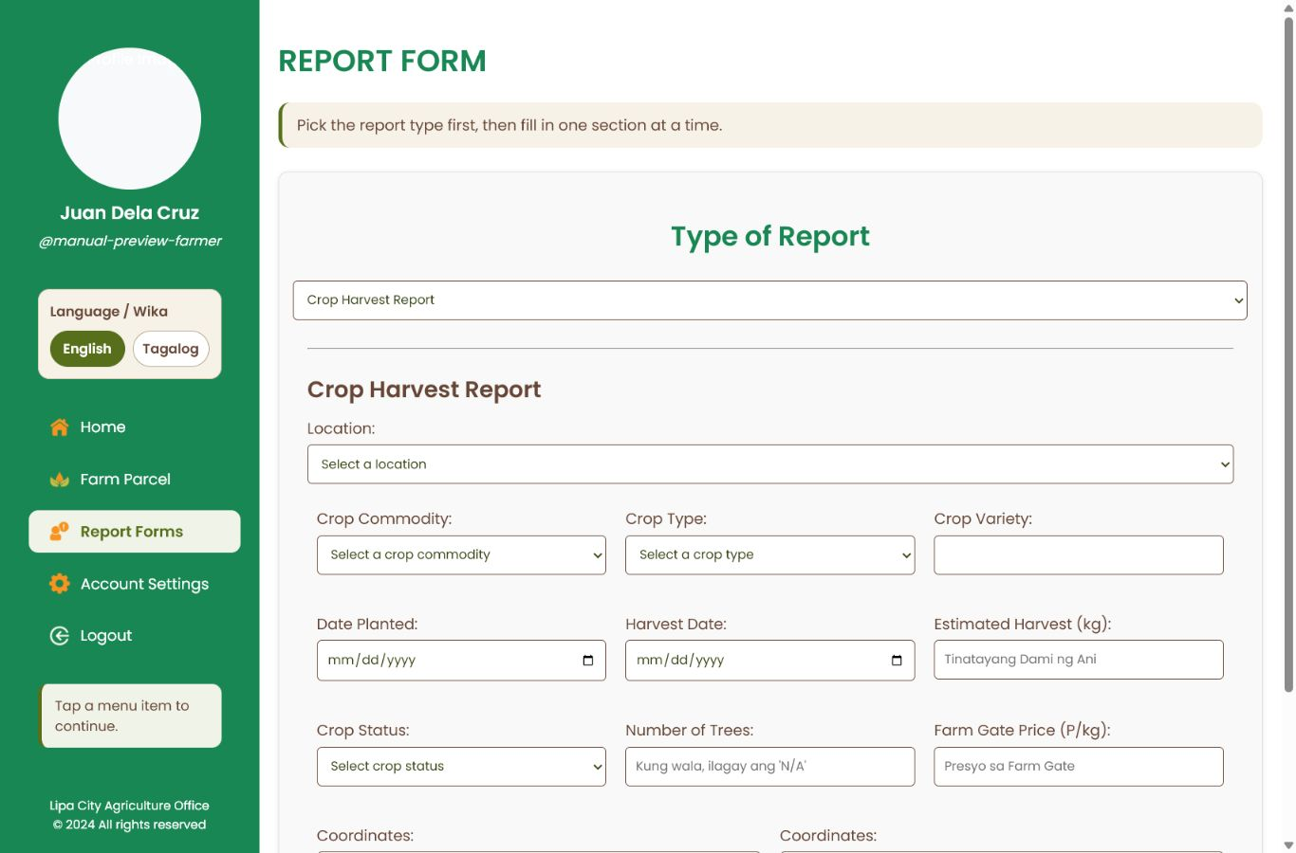
Crop harvest report fields.

Step 9. Submit a crop damage report
- Choose the parcel location and crop details.
- Enter the date of occurrence, cause of damage, percentage of damage, estimated loss in kilograms, number of trees if applicable, and farm gate price.
- For Number of Trees, type N/A if the crop does not use tree count.
- Coordinates are optional. If you are not sure, choose Do not include coordinates or leave them blank.
- Review the details, then click Submit Report.
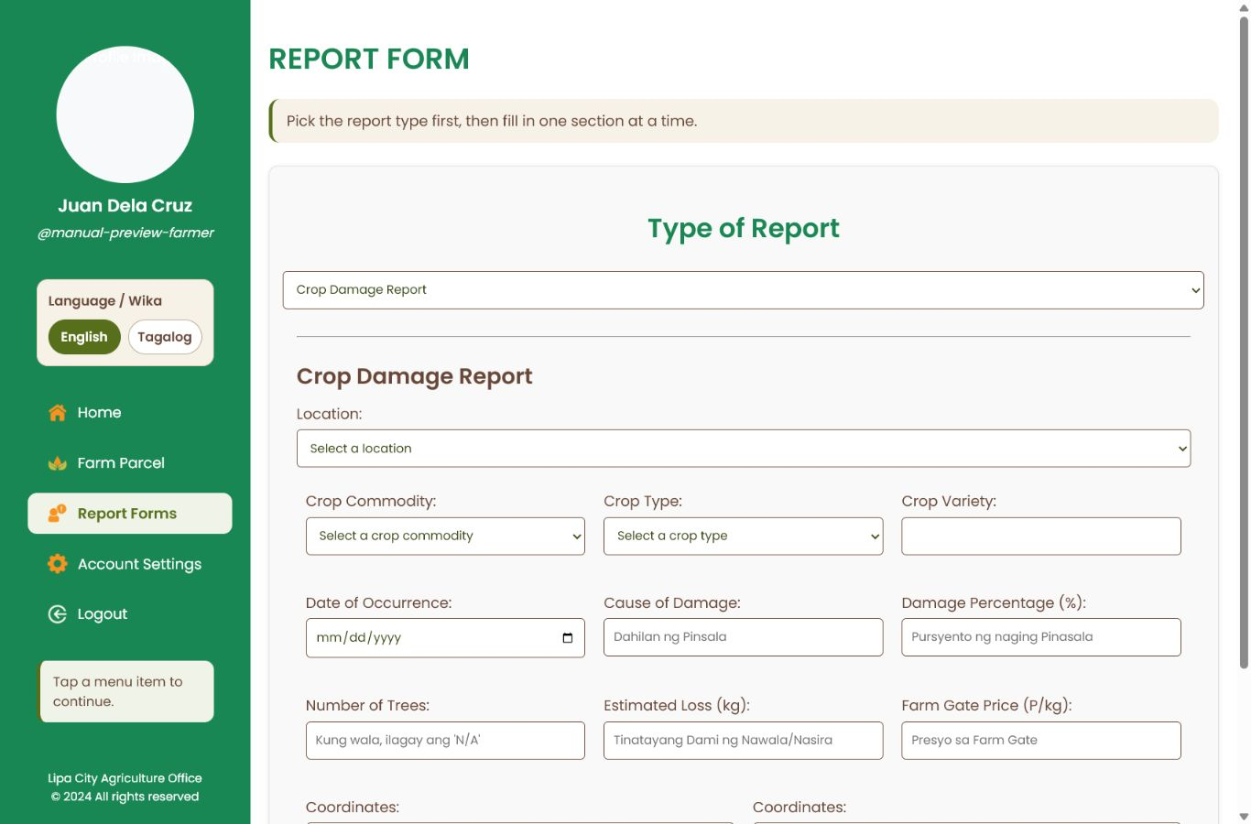
Crop damage report fields.

Step 10. Add a farm parcel
- Click Farm Parcel from the left menu.
- Enter the parcel location, parcel size in hectares, ownership type, number of crops, farm type, and whether you are an organic practitioner.
- If more crop fields appear after entering the number of crops, fill them out before saving.
- Click Add Parcel when the information is complete.
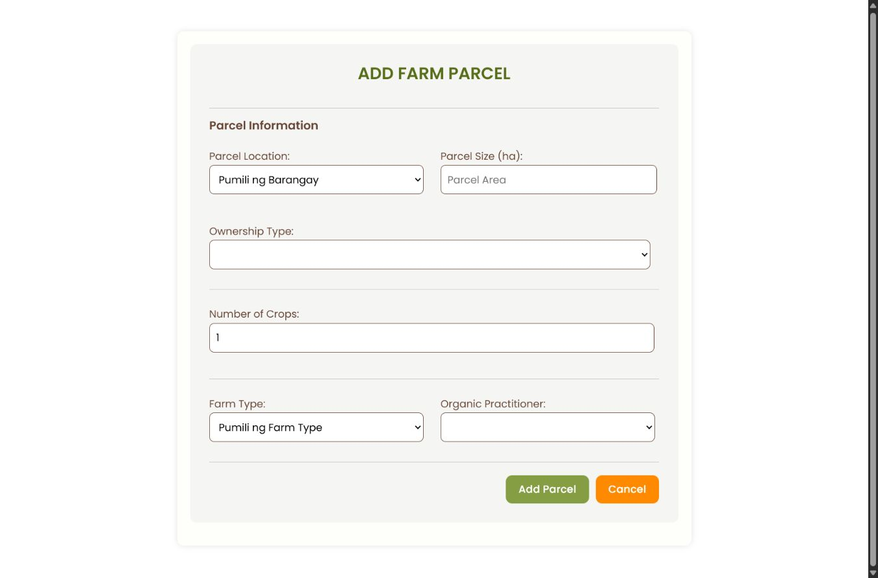
Add farm parcel form.

Step 11. Log out of the farmer account
- When you are finished, click Logout from the left menu.
- Logging out helps protect your account, especially when using a shared computer or phone.
Farmer menu with Logout option.

Part 2. Admin and Office Staff Guide
Use this section to manage users, farm parcels, updates, suggestions, and submitted reports.

Step 12. Log in as an admin
- Enter the Admin Username and Password provided by the office.
- Complete the reCAPTCHA check if it appears.
- Click Sign in as Admin.
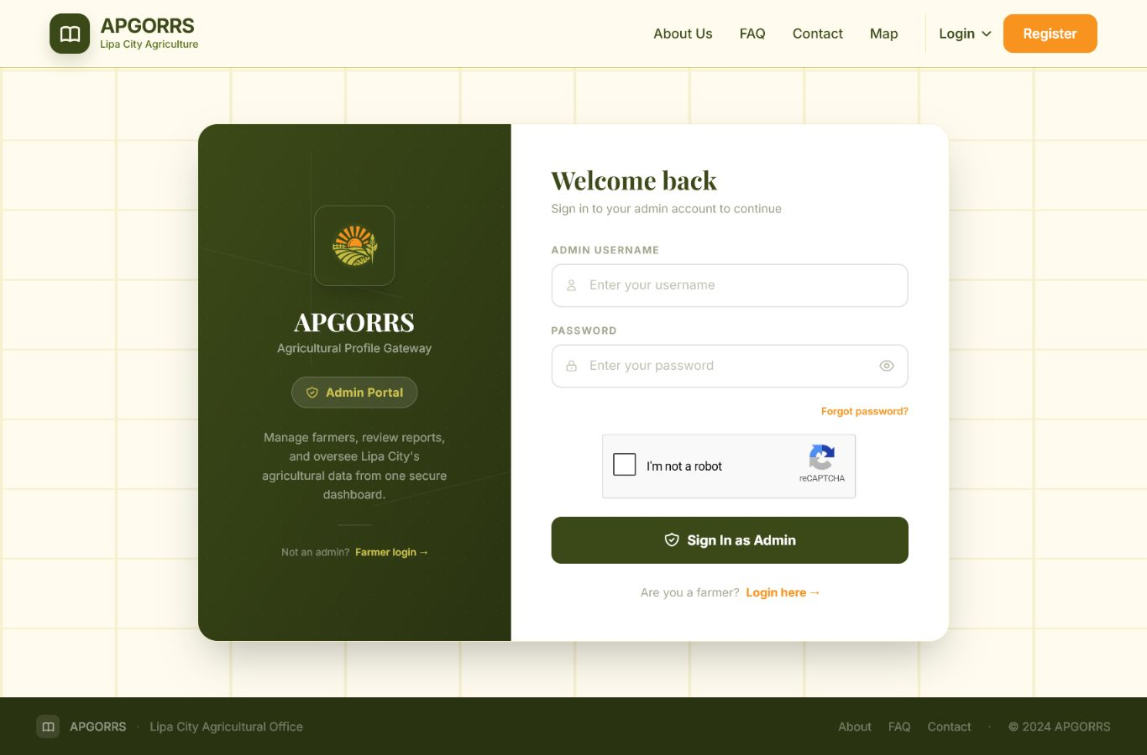
Admin login page.

Step 13. Check the admin dashboard
- Use the dashboard to see totals for registrations, farm parcels, and submitted reports.
- Click a card arrow or use the left menu to open the related section.
- Review this page first to get a quick summary of system activity.
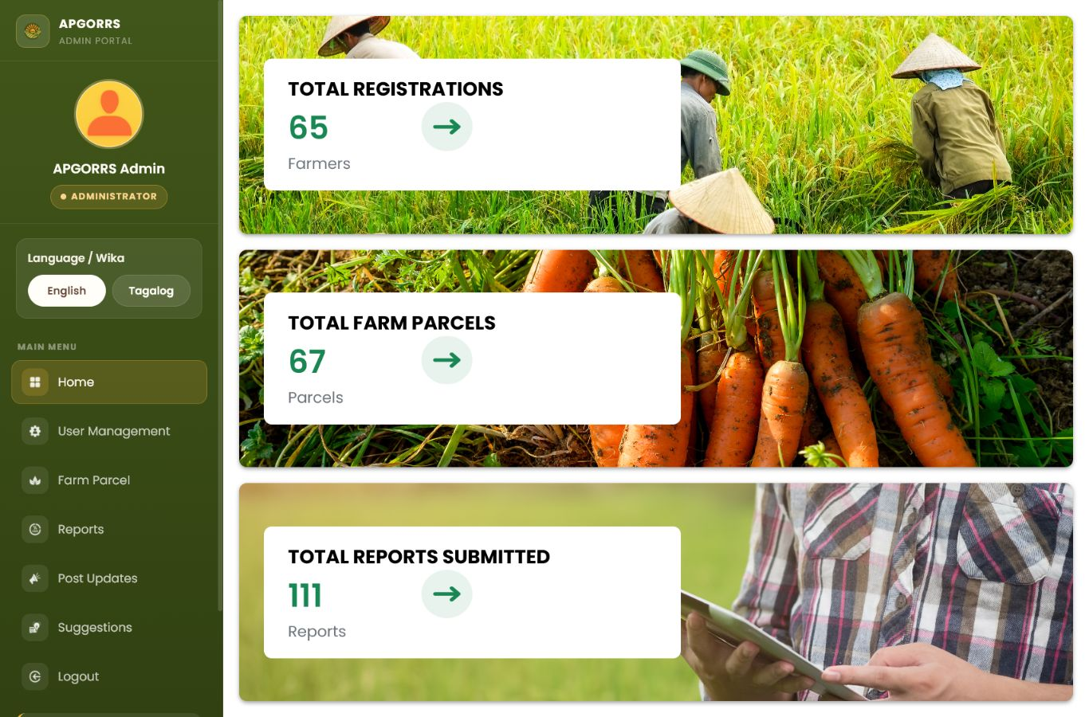
Admin dashboard summary.

Step 14. Manage user records
- Open User Management from the left menu.
- Use the search box or filters to find a farmer or admin record.
- Use Edit when information must be corrected. The system may ask for the admin PIN before saving changes.
- Use Deactivate or Activate when an account status needs to be changed.
- Use Export if the office needs a copy of the list.
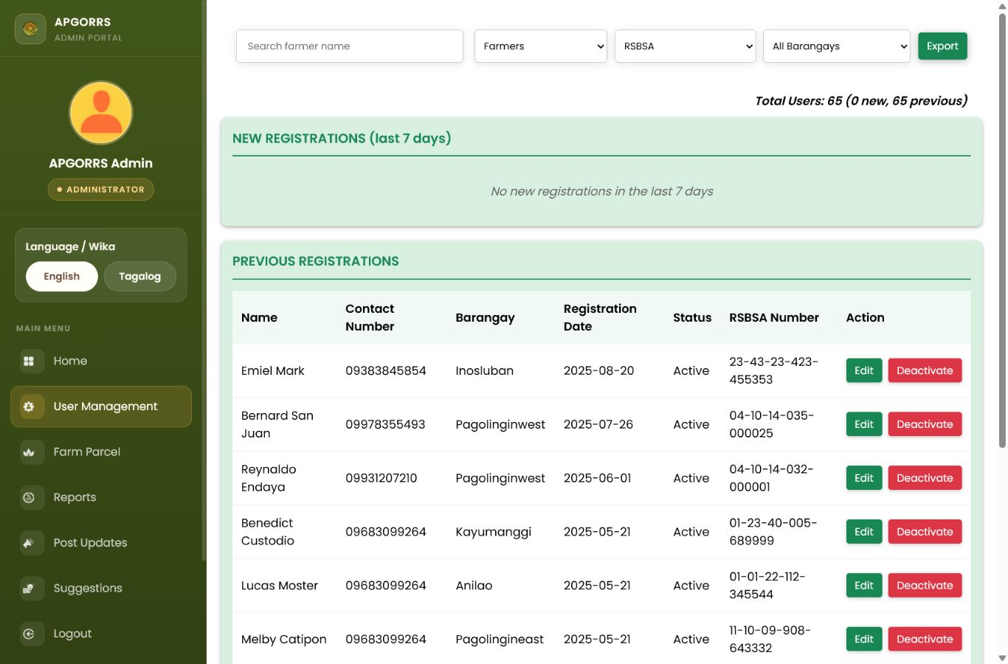
Admin user management page.

Step 15. Review farm parcels
- Open Farm Parcel from the left menu.
- Search by farmer name or use the filters for location, crop commodity, or crop type.
- Click View Parcel Details to check the parcels registered under a farmer.
- Use Export if the office needs a copy of the records.
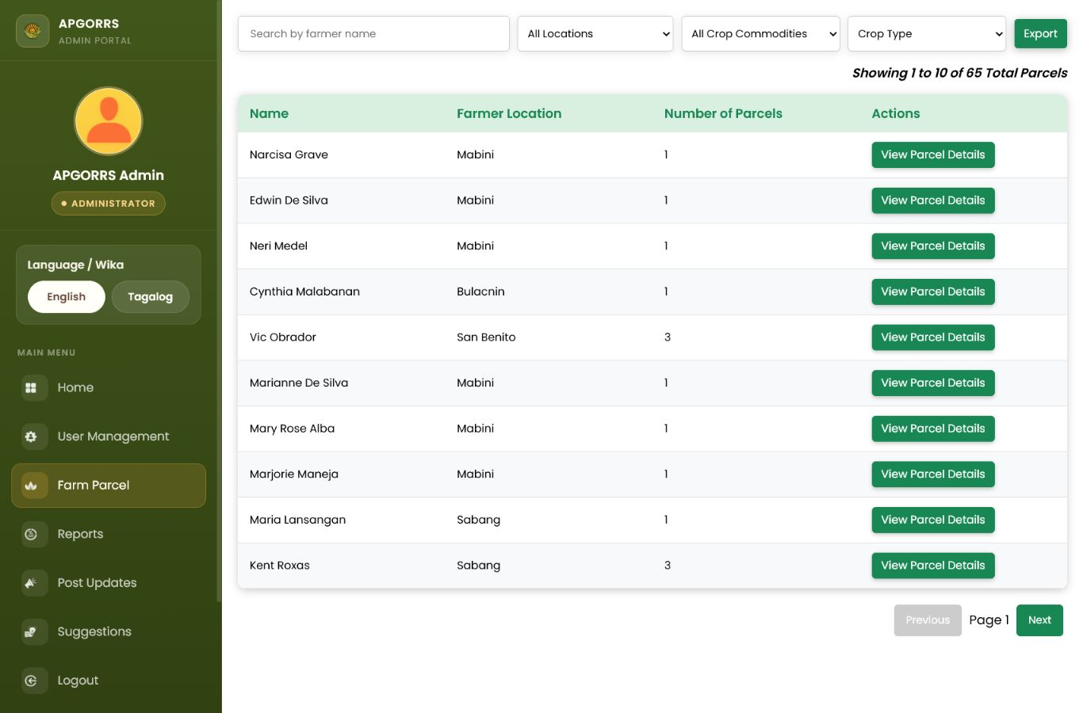
Admin farm parcel records.

Step 16. Post updates for farmers
- Open Post Updates from the left menu.
- Type the announcement or reminder in the text box.
- Click Add Images if a picture should be included.
- Click Post Update. The post will appear in the farmers' Latest Updates page.
- Delete only posts that are outdated or incorrect.
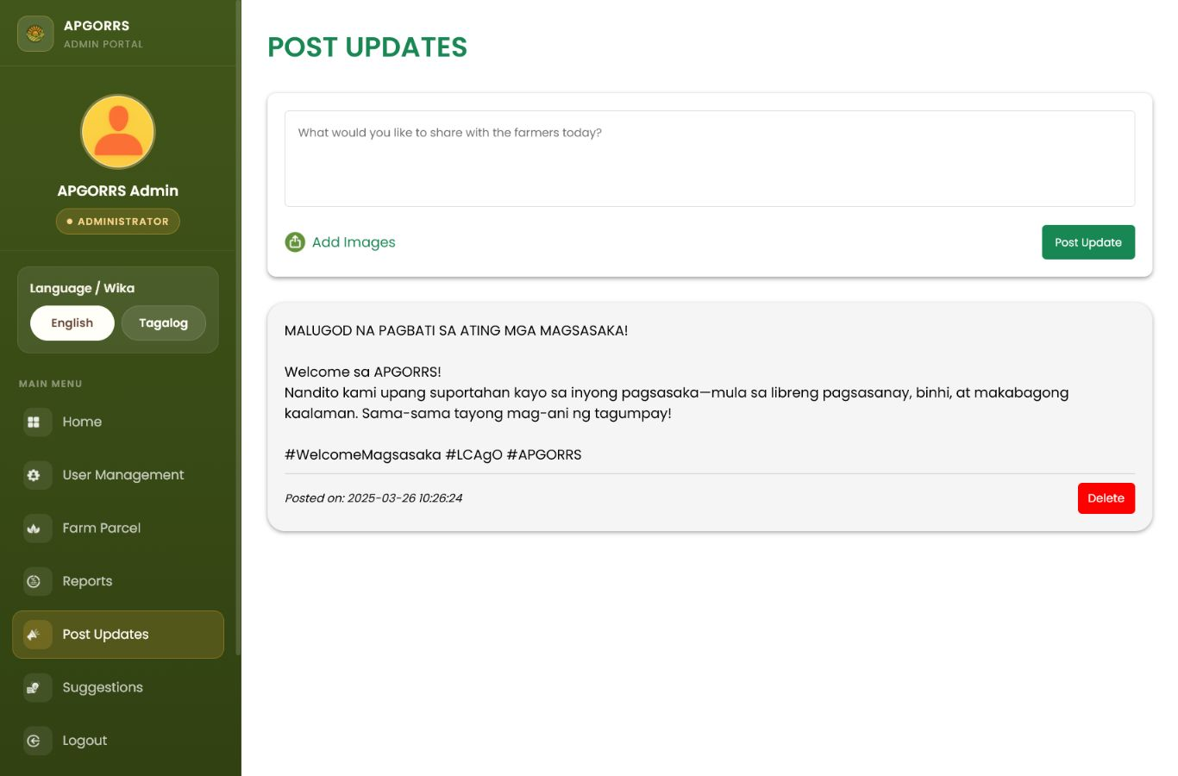
Admin post updates page.

Step 17. Review farmer suggestions
- Open Suggestions from the left menu.
- Check New Suggestions first, then review Previous Suggestions if needed.
- Use the month filter to narrow the list.
- Mark suggestions as read after review, and delete only when the office no longer needs the record.
- Use Export Suggestions if a copy is needed.
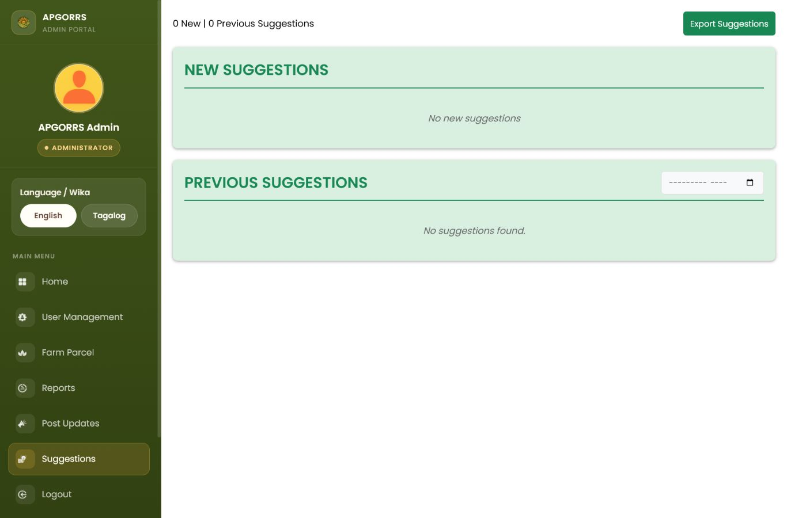
Admin suggestions page.

Step 18. Open reports overview or submit for a farmer
- Open Reports from the left menu.
- Use the Crop Reports card for harvest reports and the Damage Reports card for damage reports.
- If a farmer needs help, use Submit Report For A Farmer, search for the farmer, choose the report type, and complete the form on their behalf.
- Review charts to see barangays or crops that need attention.
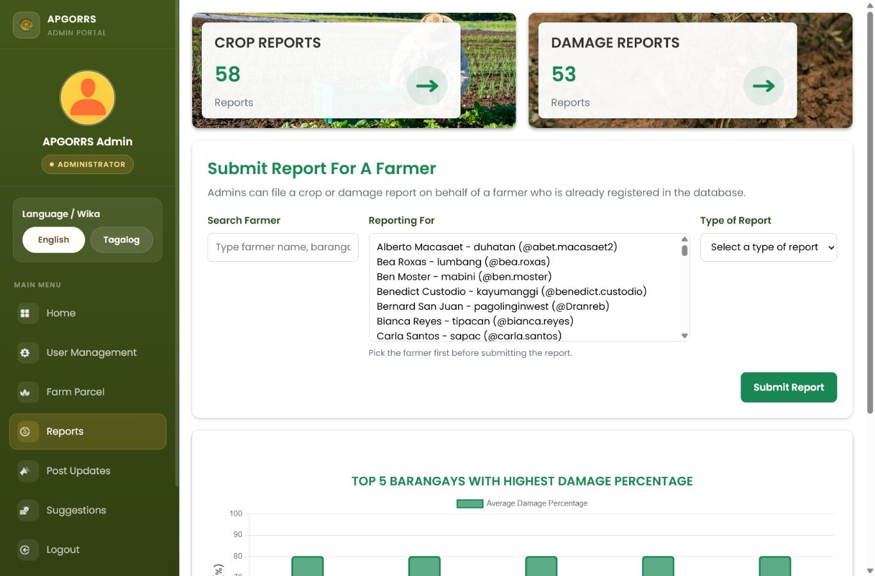
Admin reports overview page.

Step 19. Review crop harvest reports
- Open Crop Reports from the reports section.
- Use search and filters for farmer, reporter, month, crop, or barangay.
- Click View to open the report details.
- If coordinates are included, use the GIS map options to view the location or directions.
- Use Export or View Graph when the office needs a report summary.
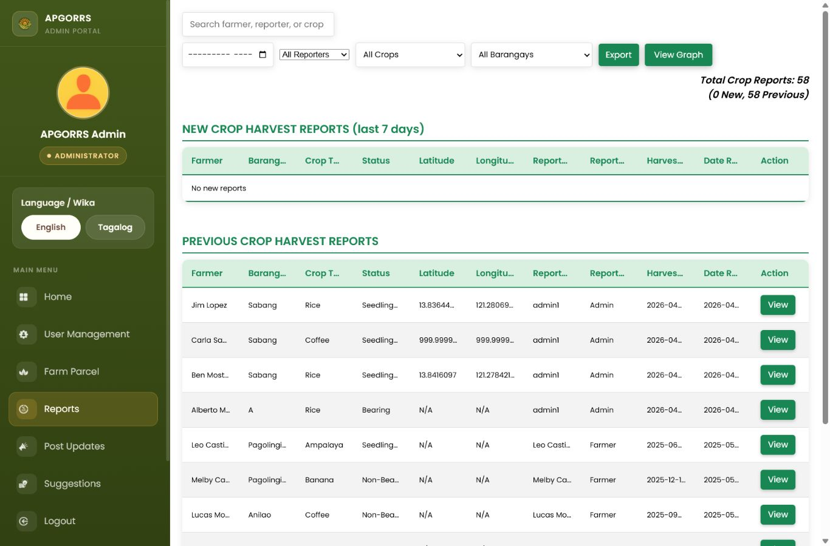
Admin crop harvest reports page.

Step 20. Review crop damage reports
- Open Damage Reports from the reports section.
- Use search and filters for farmer, reporter, date, crop, or barangay.
- Click View to open the report details.
- If coordinates are included, use the GIS map options to view the location or directions.
- Use Export or View Graph when the office needs a report summary.
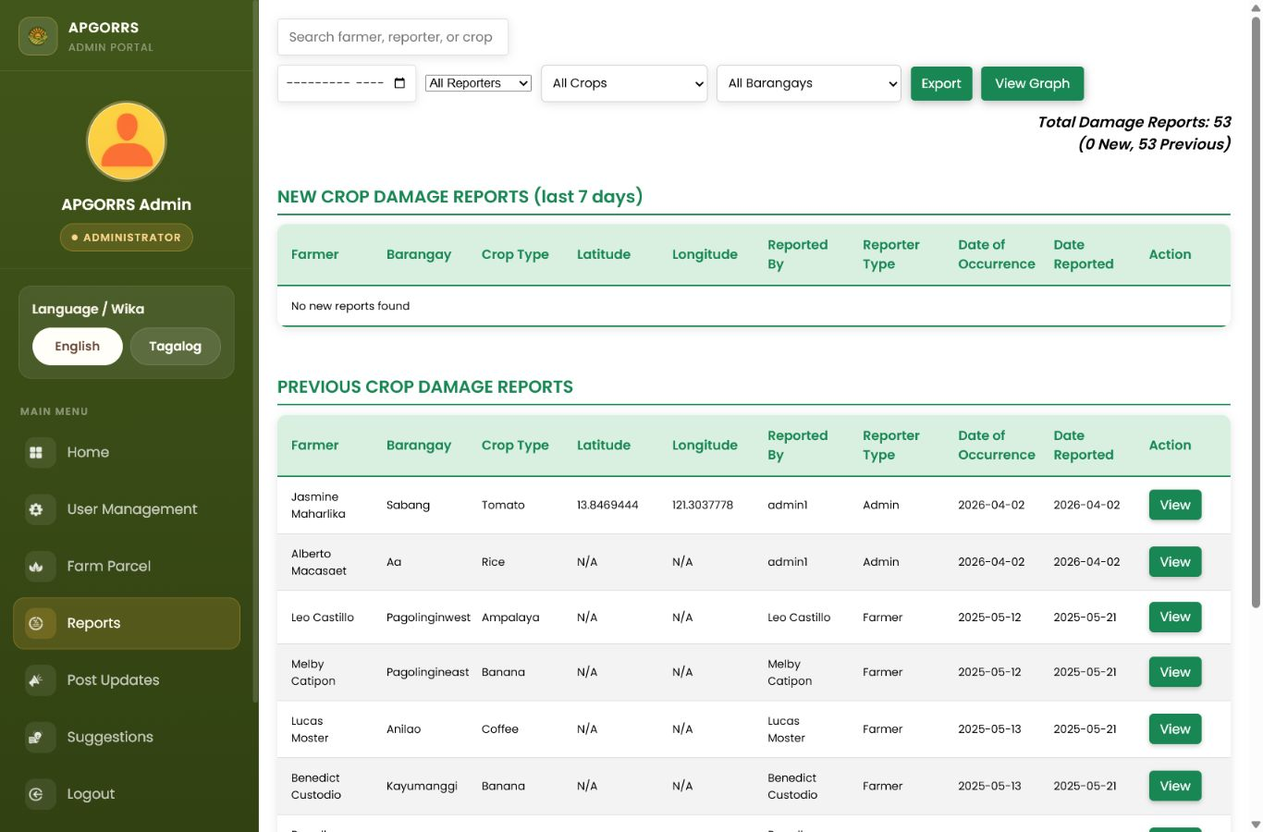
Admin crop damage reports page.

Step 21. Log out of the admin account
- When office work is finished, click Logout from the left menu.
- Logging out protects farmer records and office data, especially on shared computers.
Admin menu with Logout option.

