Lab Practicum: OpenMP Multi-Core Scaling in Python
Student Name: Daryn Yrysdauletuly Student ID: 220103258 Date & Section: ____________
Hardware used for measured values: Intel Xeon @ 2.10 GHz, 1 vCPU (cloud sandbox), Python 3, Numba 0.68.0, threading layer: default. Multi-thread rows must be measured on your own multi-core machine; they are marked [run locally].

Table 1: Results
Challenge | Active Threads | Size / Samples | Time (s) | Speedup | Efficiency
C1: Monte Carlo | 1 (base) | 120,000,000 | 2.677 | 1.00x | 100.0%
C1: Monte Carlo | 2 | 120,000,000 | [run locally] | [run locally] | [run locally]
C1: Monte Carlo | 4 | 120,000,000 | [run locally] | [run locally] | [run locally]
C1: Monte Carlo | Max | 120,000,000 | [run locally] | [run locally] | [run locally]
C2: Mandelbrot (Rows) | Max (1 here) | 2500 x 2500 | 6.019 | N/A | N/A
C2: Mandelbrot (Cols) | Max (1 here) | 2500 x 2500 | 6.056 | N/A | N/A
C3: Heat Stencil (float64) | Max (1 here) | 1500x1500x300 | 0.446 | N/A | N/A
C3: Heat Stencil (float32) | Max (1 here) | 1500x1500x300 | 0.248 | N/A | N/A

Challenge 1: Core Speedometer & Amdahl's Law
A. Baseline and maximum-thread runtime
T_1 = 2.677 s on the sandbox (1 thread, π ≈ 3.14159). T_max must be measured on your machine, since the sandbox exposes only one hardware thread (numba.config.NUMBA_NUM_THREADS = 1).
B. Why the warm-up call is required
@njit compiles lazily, on the first call, and the compiled code is specialised to the argument types. Without a warm-up, the first timed run would include LLVM compilation (hundreds of ms to seconds), which would inflate T_1 and make the speedup look better than it is. In a quick test here, a first call took about 94 ms versus about 2 µs for the second call. The warm-up uses a tiny input so only compilation is paid for, not real work.
C. Did efficiency stay at 100%?
No. Expect it to fall as threads increase. Reasons: (1) Hyperthreading/SMT: past the physical core count, two threads share one core's execution units, so each extra thread adds only about 20-30% throughput rather than 100%. (2) Heterogeneous cores on Apple M-series and recent Intel chips: efficiency cores are slower than performance cores. (3) Turbo/thermal limits: clock speed drops when many cores are active. (4) Fixed serial parts (Amdahl): thread-pool launch, the final reduction, and the Python call overhead. (5) Memory-bus contention is minor here, because the kernel only uses registers and a per-thread RNG state and has almost no memory traffic. With serial fraction s, speedup is capped at 1/(s + (1−s)/N); even s = 1% caps 16 threads at about 13.9x.
D. Why += inside prange is safe
Numba's parallel transform recognises inside_circle += 1 as a scalar reduction. Each thread gets a private copy of inside_circle initialised to 0, increments it locally with no sharing, and the per-thread partial sums are combined into the final value after the loop finishes. This is the equivalent of OpenMP's reduction(+:inside_circle) clause, but Numba generates it itself (its own parfor lowering on top of the selected threading layer: OpenMP, TBB or workqueue) rather than emitting literal OpenMP pragmas. Since there is no shared write inside the loop, there is no race and no atomic is needed. Each thread also has its own random-number state, so np.random.uniform does not conflict across threads.

Challenge 2: Load Imbalance & Dynamic Scheduling
A. t_rows vs t_cols
Measured on the sandbox (1 thread): t_rows = 6.019 s and t_cols = 6.056 s, effectively identical (about 0.6% apart). With one thread there is no load imbalance, and the Mandelbrot kernel is compute-bound, so the loop axis barely matters. On a multi-core machine expect the row version to be equal or somewhat faster, because the inner loop writes consecutive memory. Report your own two numbers and the ratio.
B. Row-major layout and cache lines
NumPy arrays are C-contiguous, so img[r, c] and img[r, c+1] are adjacent in memory (4 bytes apart for int32). A 64-byte cache line holds 16 consecutive int32 values from the same row. In the row-parallel version each thread writes whole rows sequentially: every cache line is fully used and almost no line is shared between threads. In the column-parallel version the inner loop walks down a column, so consecutive writes are 2500 × 4 = 10,000 bytes apart and each touches a different cache line, using 1 of 16 slots. Neighbouring columns are handled by the same thread under static chunking, but at chunk boundaries two threads write different elements of the same cache line, causing false sharing and coherence traffic. The stride also hurts hardware prefetching and the TLB. The cost is small in this lab because each pixel needs hundreds of iterations of arithmetic compared with one store, which is why the compute-bound runtimes stay close.
C. Load imbalance and dynamic scheduling
With static scheduling the 2500 rows are cut into equal contiguous blocks, one per thread, fixed in advance. Rows near the top of the image (y ≈ 1.2 to 0.7) are mostly outside the Mandelbrot set and escape in a few iterations, so that thread finishes almost instantly. Rows near the centre (y ≈ 0) cross the set's interior, where pixels run all 1000 iterations, so that thread has far more work, possibly 100x more per row. The total time is set by the slowest thread (the barrier at the end of prange), so the idle threads waste cores. Dynamic scheduling (OpenMP schedule(dynamic, chunk) or work-stealing) splits the work into many small chunks, and a thread that finishes grabs the next unclaimed chunk. Heavy and light rows get spread across threads, so all threads finish at about the same time. The cost is a little scheduling overhead per chunk. In Numba this is approximated by a smaller chunk size, e.g. numba.set_parallel_chunksize(n), or by TBB's work-stealing layer.
D. Output image
mandelbrot_output.png is attached (rendered 2500 × 2500, 300 dpi). Preview:
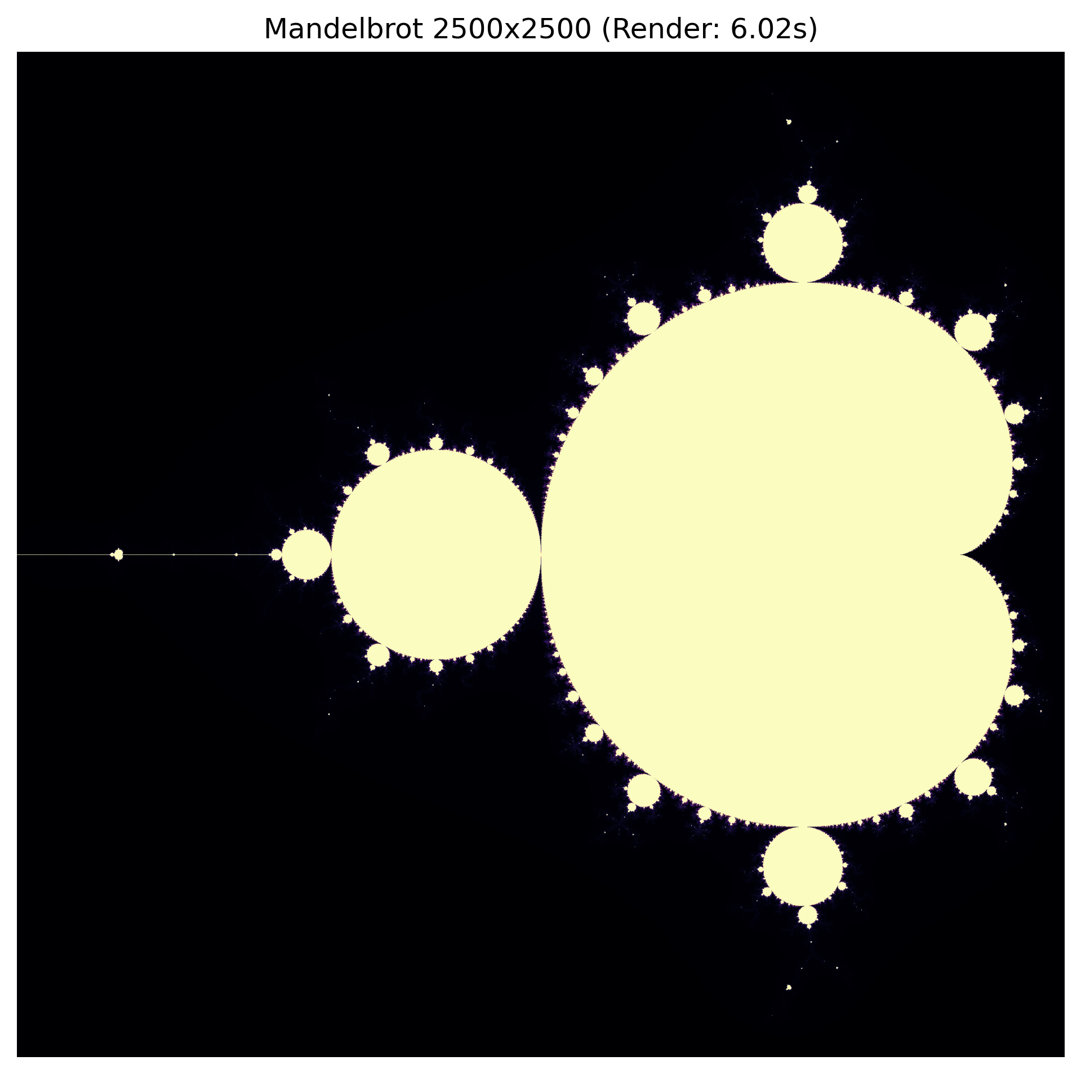

Challenge 3: Stencil Computation & Memory Bandwidth
A. Runtime and throughput
float64, 1 thread (sandbox): 0.446 s, 1513.29 Megacells/s. Record your own max-thread values in Table 1.
B. float64 → float32
Measured on the sandbox: float64 0.446 s (1513 Mcells/s) versus float32 0.248 s (2718 Mcells/s), a 1.80x reduction in runtime, close to the 2x predicted by halving the data. The arithmetic per cell is identical (6 adds/subtracts and 2 multiplies); what changes is bytes moved. Each cell requires about 8 bytes of float64 traffic at minimum (read + write), or 4 bytes in float32, and a 1500×1500 float64 grid is 18 MB per array, larger than most L2 caches, so each timestep streams it from RAM or L3. Because the kernel does only a few flops per byte loaded (low arithmetic intensity), it is limited by data movement, not by the FPU. Halving the footprint halves the traffic, and also lets more of the grid fit in cache and doubles the values per cache line and per SIMD register. Your factor will land somewhere between about 1.5x and 2x depending on how memory-bound your machine is.
C. Memory roofline model
The roofline model bounds performance by min(peak FLOP/s, arithmetic intensity × memory bandwidth). The 5-point stencil has an intensity of roughly 0.1-0.2 flop/byte, far to the left of the ridge point, so the limit is the bandwidth line, not the compute roof. Adding cores raises the compute roof and the demand for data, but all cores share the same memory controller and DRAM channels. Once a few cores can saturate the bus (often 2-4 cores on a laptop, since one core can draw a large share of the bandwidth), further cores just wait for data and the speedup curve flattens well below N. Doubling cores then gives maybe 1.0-1.2x, not 2x. Ways to go faster are cache blocking/temporal tiling, using float32, or fusing timesteps to raise arithmetic intensity, none of which need more cores.

Note on reproducibility
All numbers marked [run locally] depend on your CPU (core count, SMT, turbo, memory channels). Run the three scripts in the practicum on your own plugged-in machine, fill in those cells, and add your CPU model and best speedup to the lab whiteboard.

