Use Cases and Logical Architecture

- XID: x00204831@mytudublin.ie
- Name: Daryna Tertychna
- Project Title: Crime Visualisation Map

Section 1: For Each Use Case:

Use Case 1: User Regis
Title (goal) | Create account, sign in/out
Primary Actor | Registered user/ Visitor
Story | A visitor opens the app, picks sign up, enters email & password (and optional name). The input is validated by the system, a hashed password is saved, and the profile is created. The user logs In, receives a session/JWT token, and has access to personalised features (saved locations, alerts). Logout throws away the token.

Use Case 2: View Interactive Risk Map with filters
Title (goal) | Explore crime risk on the map
Primary Actor | Registered User (Visitor just view)
Story | On login, the user lands on a map with colour-coded regions (e.g., red = higher risk, green = lower). The user opens the filters panel and selects crime type (theft, fraud, assault), time period (last quarter, last 12 months), and region. Frontend sends request to the API for data; the map responds, updating colours and legend.

Use Case 3:
Title (goal) | Search by Address / Eircode / Current Location
Primary Actor | Registered User / Visitor
Story | The users type an address/eircode and they can also tap use my location key. The system validates the input, recentre the map, loads the local risk summary, and shows a small report near the filter button.

Use Case 4: Save Home/Work for quick access
Title (goal) | What is the name of this function?
Primary Actor | Registered User
Story | The user clicks save location, assigns it a name (home or work) and an area. The system stores the region key in the profile. On the Profile > Favourites page, a user can rename or remove favourites.

Use Case 5: Ask the AI Chatbot
Title (goal) | Natural-language help
Primary Actor | Registered User / Visitor
Story | The user opens the chatbot and asks: "What are the safest areas near Dublin 8?" The chatbot understands the question, applies the current filters, gets predictions and provides a plain language answer. For transparency, it could specifies the data source and time frame.

Use Case 6: Admin – Data Management
Title (goal) | Maintain dataset and predictions
Primary Actor | Admin
Story | Admin logs in to the admin management field, imports a new CSV if needed, runs ETL and starts model retraining. The console shows validation results, model metrics, and deploy status. Admin can roll back to last model if case of a failure.

Section 2: Logical Architecture

In this section use www.draw.io to show how your architecture is distributed. Your architecture should to show:

Frontend - React, MapboxGL, (Chart.js)
Backend - Python, FastAPI
Database -- PostgreSQL
AI/ML - XGBoost, spaCy or HuggingFace Transformers (existing model)
Cloud, deployment - AWS
Devops - docker, GitHub Actions or Jenkins
Visualization - Plotly, (Mapbox), RESTful APIs

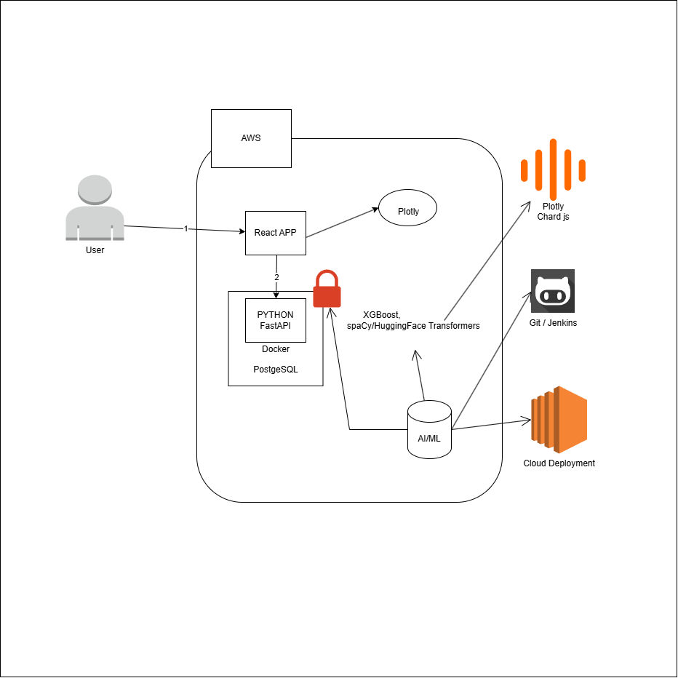

Logical Architecture Discussion
- Discuss each component of your architecture
Frontend – React. Fast, big ecosystem, easy state management.
MapboxGL - Provides basemap tiles and enables us to draw choropleth layers, markers, and popups. Executed totally in the browser with a public token.
Chart.js - Draws trend lines, category breakdowns, and model confidence charts.

Backend – Python, FastAPI - Very fast, excellent typing, auto-docs (OpenAPI/Swagger), straightforward async support.

Database – PostgreSQL - strong, SQL, excellent JSON support, PostGIS adds spatial types.

AI/ML – XGBoost - predicts risk by region from features like history counts, seasonality, and offence mix., spaCy - tag news text (e.g., "fraud", "burglary") and extract places/dates. or HuggingFace Transformers (existing, pre-trained model)

Cloud, deployment – AWS - S3 + CloudFront host the React frontend, SNS/SES send notifications and alerts.

Devops - docker, GitHub Actions or Jenkins - Docker makes the app portable and reliable. CloudWatch monitors logs and performance.

Visualization - Plotly, Mapbox, RESTful APIs - FastAPI returns JSON data. React utilizes Plotly/Chart.js for charts and Mapbox for map views.

