Setup

At the start of the game, shuffle the deck and deal each player 6 cards. Choose the proper divider for the amount of players. Place the divider on top of the spinner, and the deck in the center of the spinner.

Each player gets their own zone of the spinner.

Turns

At the start of your turn, draw a card. You can play one card on any space in your zone. Cards can only be played on top of blank spaces or on top of cards with a lower cost than the card being played. Rotate the amount of clicks in the direction specified, then follow any instructions on the. The next player clockwise then starts their turn.

Lockdowns

If a player is unable to play a card, or the final lockdown has been played, the board is locked down. Every player except for the one that caused the game to end gets one more turn, where the board cannot be spun. The player with the most total victory points in their zone at the end of the game wins.
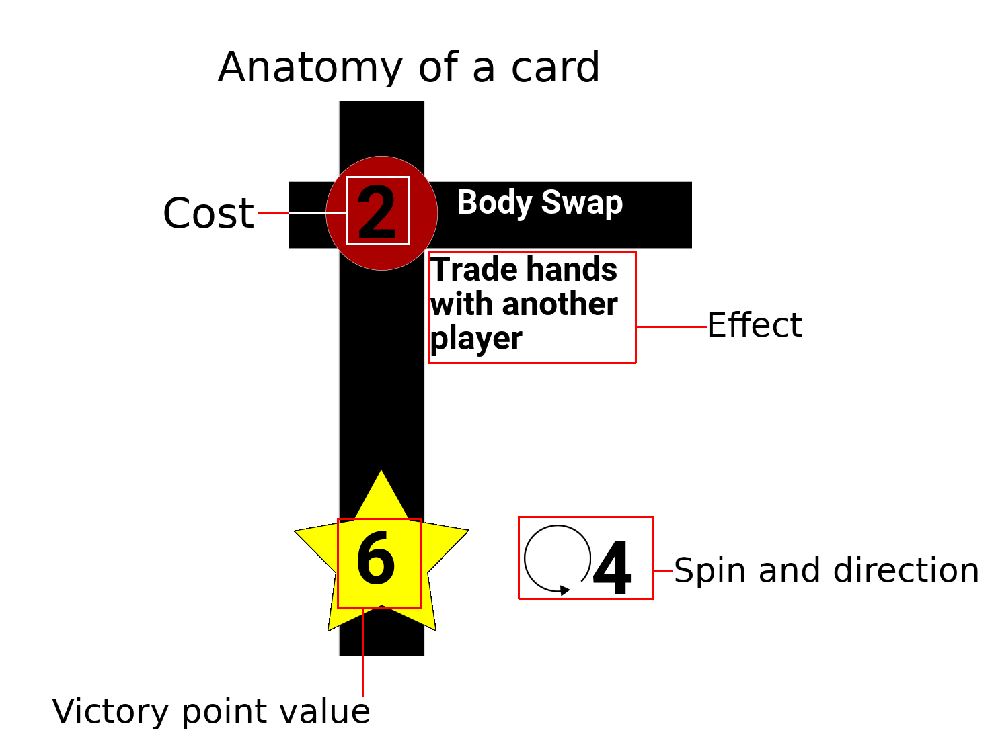

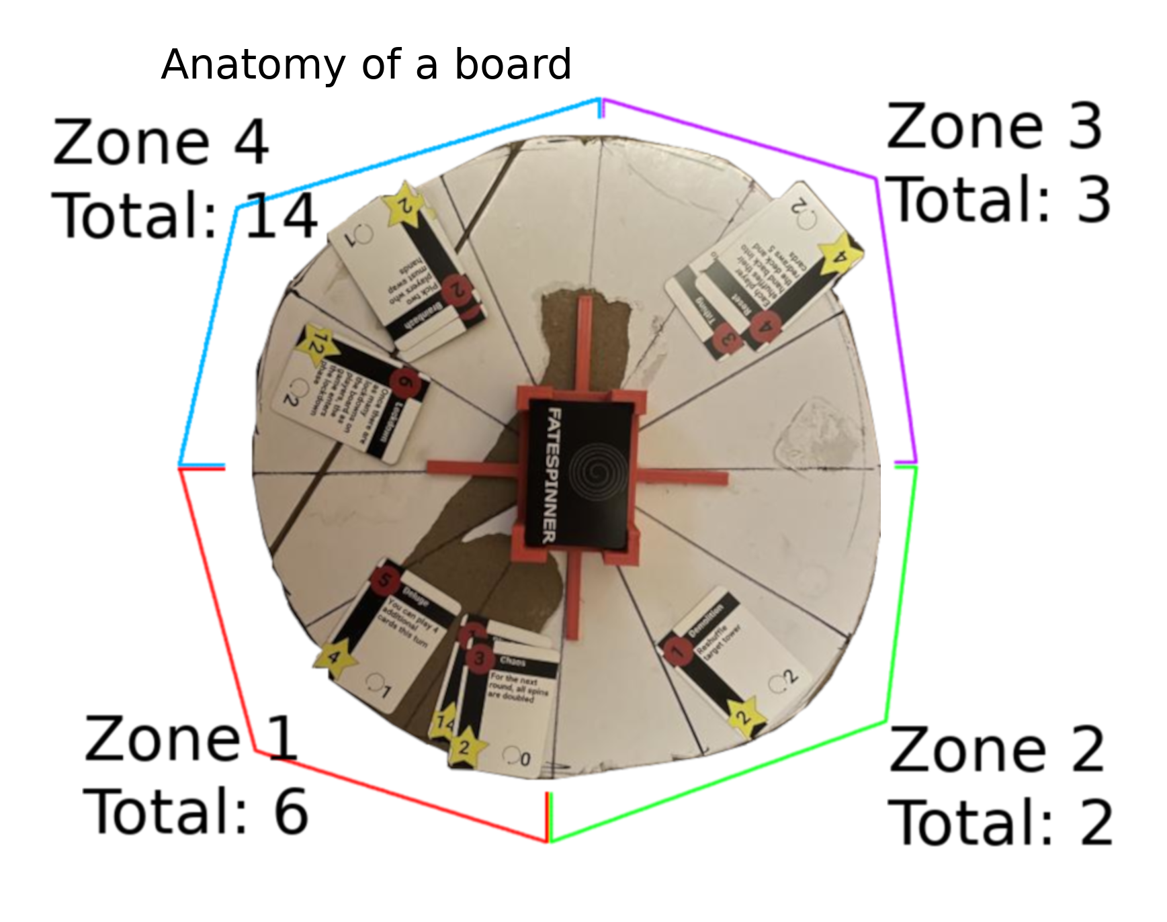


FATESPINNER

by Alvaro Gudiswitz and Daniel Jackson
rulebook v1.1

