Aditya Dasani (NUID- 001560067)

**Program Structures & Algorithms**

**Spring 2021**

**Assignment No. 3**

* **Task**

Implement height-weighted Quick Union with Path Compression. For this, you will flesh out the class UF_HWQUPC. All you have to do is to fill in the sections marked with // TO BE IMPLEMENTED ... // ...END IMPLEMENTATION.

* **Output**

All my unit test cases are passing. I am running the code for 13 different values of n and getting the number of pairs and number of trees(components).

One loop is for finding the number of pairs that are to be connected till we reach 1 tree(component).

Another loop is for finding the number components that will be formed till we run the loop till n-1 count and will create multiple trees at the end. We find the relation between number of objects, number of trees and number of pairs.

* **Relationship Conclusion:**

The relationship between number of objects and number of pairs is, for reaching 1 component it takes n - 1 pairs.

When the loop is till (n - 1), the number of trees is equal to the number of objects - number of pairs. (trees= n - m).

**The third loop is for finding the relation between number of objects and number of pairs over log of objects which gives the relationship is linear. m=n*log(n) where m is number of pairs and n is number of objects.**

* **Evidence to support the conclusion**

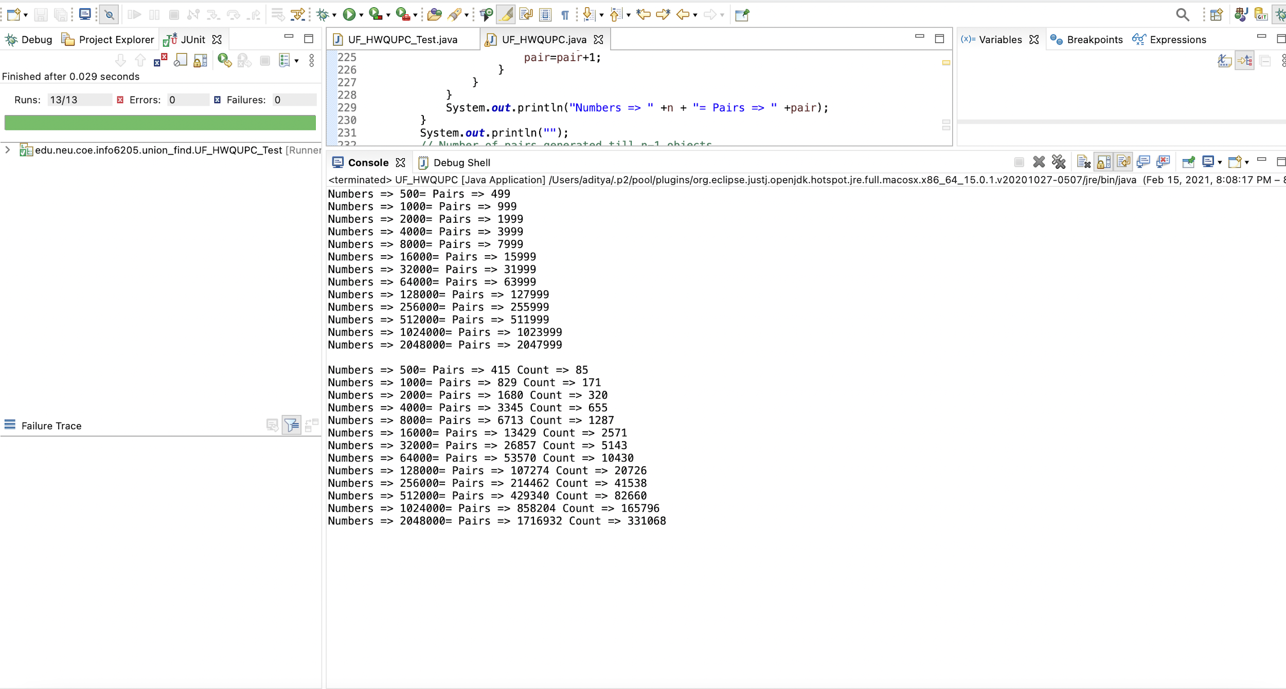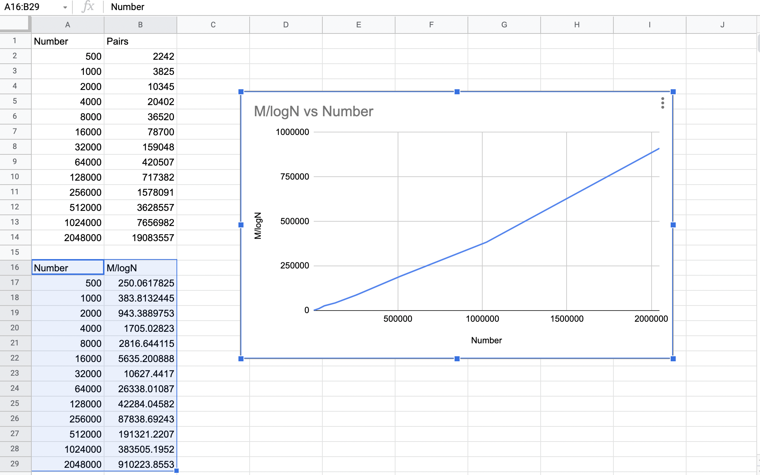

* **Unit Test Result**

