Aditya Dasani (NUID- 001560067)

**Program Structures & Algorithms**

**Spring 2021**

**Assignment No. 2**

* **Task**

Run Benchmark test, timer and Insertion sort and note timer for Insertion sort using benchmark class methods for different number of elements in an array. Derive the relationship between them.

* **Output**

All my unit test cases are passing. I am running the code for 7 different values of elements in an array for random array, ordered array, reverse array and partially ordered array. Also my program is running for 3 times for each number of elements and giving the value of time taken to sort the elements in array using Insertion Sort.

* **Relationship Conclusion:**

1. For Reversed Array it takes the highest time to sort and if we plot the log v/s log graph of the number of elements v/s time taken for the reversed array to sort we get a slope of 2.

2. Which means time taken by reverse array to sort is proportional to square of n.

* **Evidence to support the conclusion**

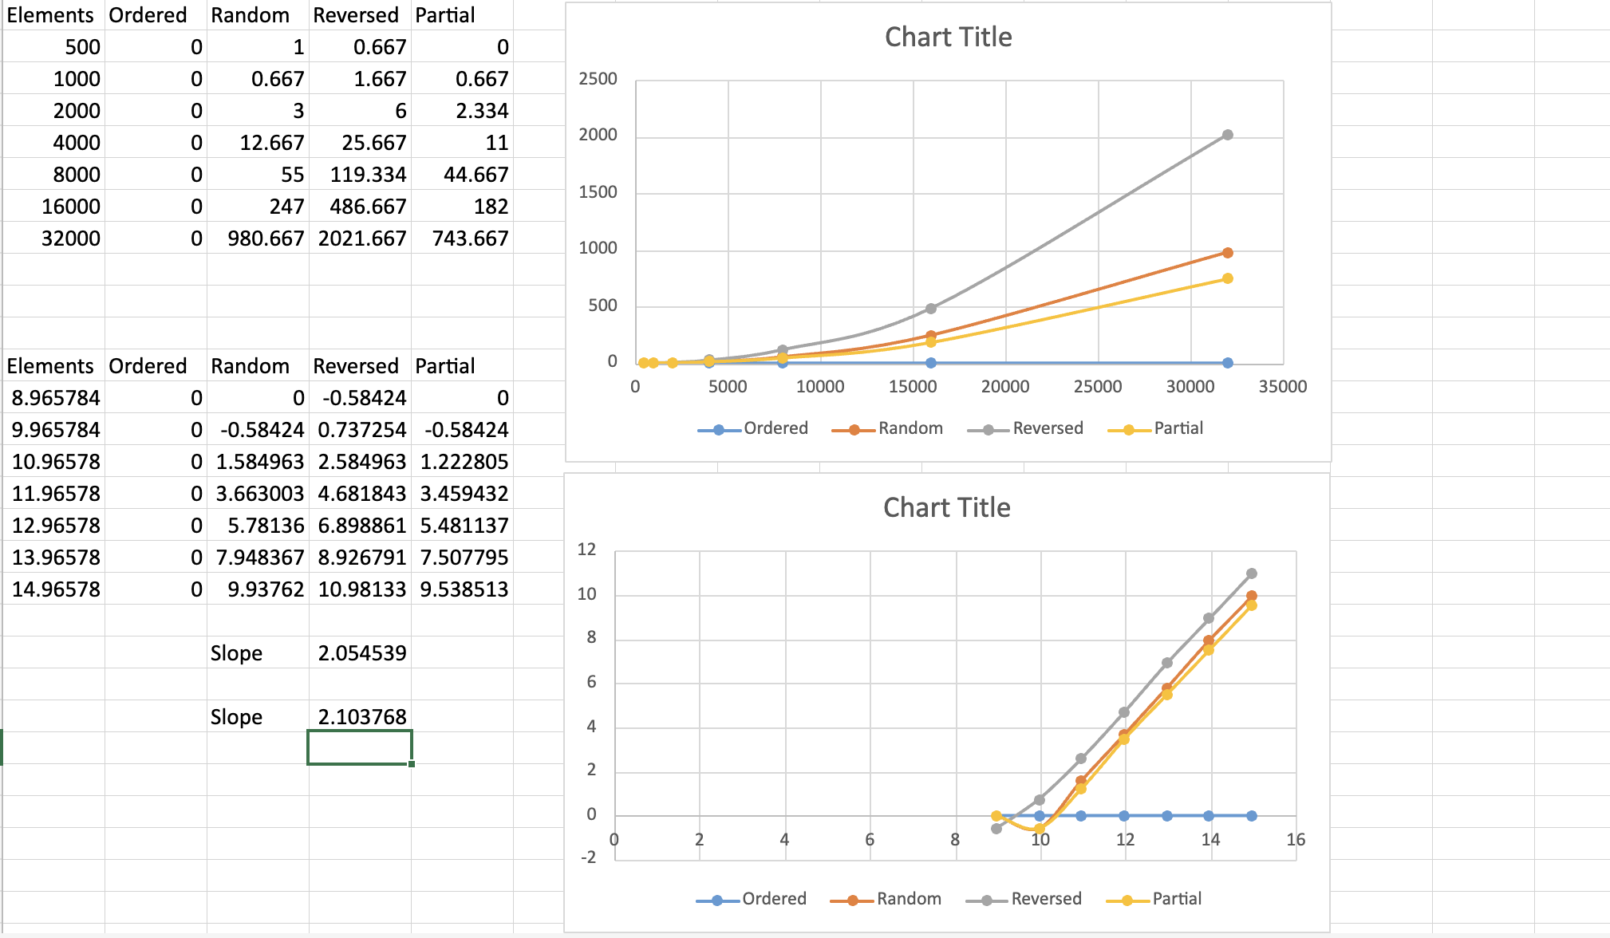

* **Unit Test Result**

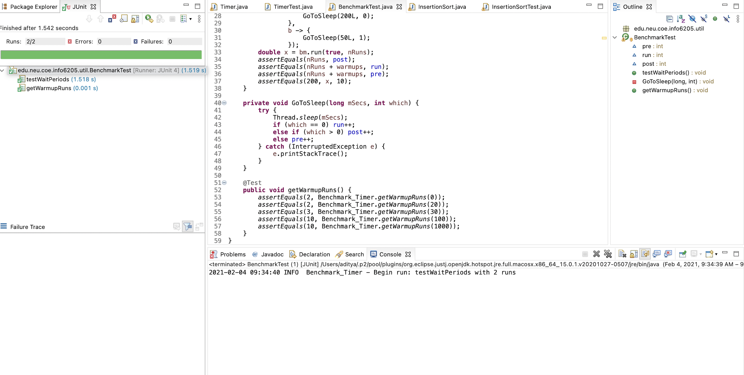

BenchmarkTimer tests passing.

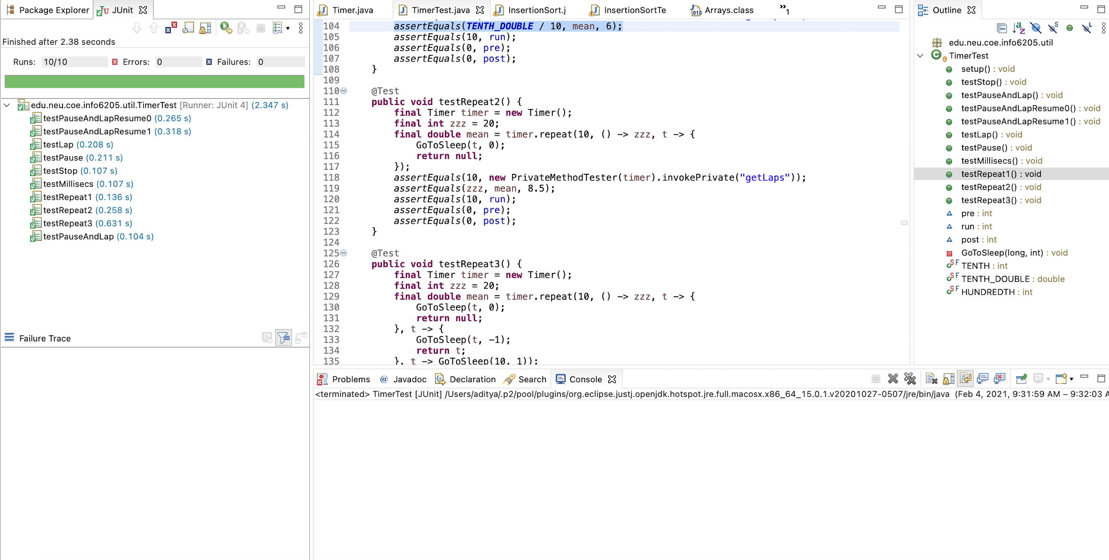

Timer tests passing.

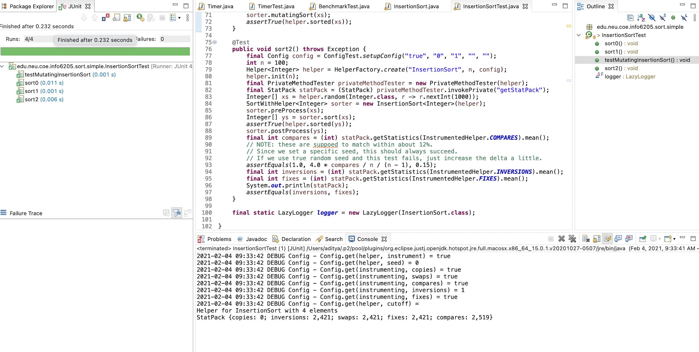

Insertion Sort tests passing.