**ASSIGNMENT 1**

**FUNDAMENTALS OF LINUX COMMANDS**

1. **Which command is used to know the current working directory?**

When you type ‘pwd’ in the terminal and hit enter, it outputs the full path of the current directory you are in. This is useful for understanding your location within the filesystem.

Example: $ pwd



1. **How would you find out its contents?**

To find out the contents of a directory in linux, we use the ‘ls’ command. This command lists all the files and subdirectories within the current directory or a specified directory.

Example: $ ls



1. **Identify the commands with inputs to do the following**
2. **create a directory d1**

To create a directory, we use the ‘mkdir’ command followed by the desired directory name.

Example: $ mkdir directory_name

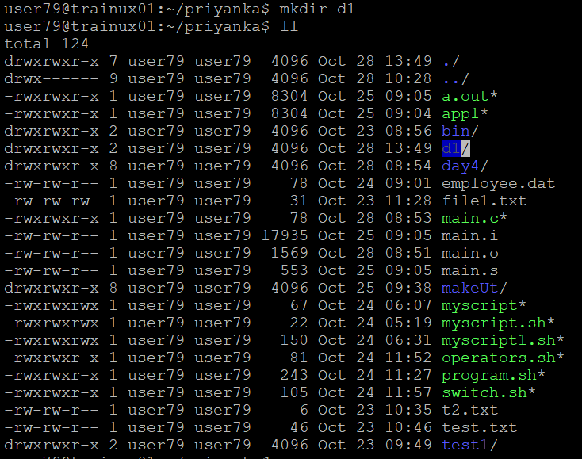

1. **create a subdirectory d2 in d1**

To create a subdirectory in directory, we have to open the directory which we want to create a subdirectory in that directory by using command ‘cd’. Then by using ‘mkdir’ command we create a subdirectory in specified directory.

Example:

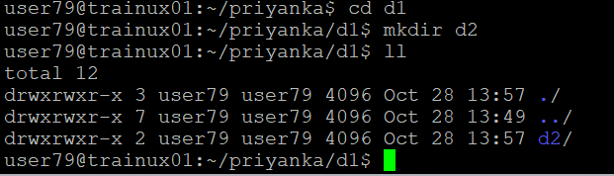

1. **change to directory d2**

To change one directory to other directory, we use ‘cd’ command. It is used to navigate between directories in a file system.

Example: $ cd directory_name

1. **create an empty file “f1.txt”**

To create a empty file in a linux, we have to use the ‘touch’ command.

Example: touch file_name



1. **display the contents of “f1.txt”**

To display the content of a particular text file, we use ‘cat’ command. It shows all contents in that text file.

Example: $ cat file_name

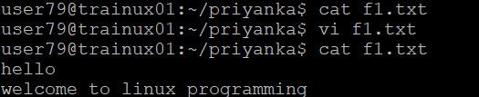

1. **view the contents of d1 from current directory d2**

To view the contents of one directory from current directory, we use ‘ll ../’ command. Here ‘../’ represents the parent directory.

Example: $ ll ../

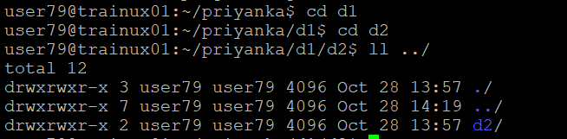

1. **Use the ls command with its options. How will you identify directories from the listing?**

* -a, --all = do not ignore entries starting with .
* -A, --almost-all = do not list implied . and ..
* -B, --ignore-backups = do not list implied entries ending with ~
* -d, --directory = list directories themselves, not their contents
* -l = use a long listing format
* -R, --recursive = list subdirectories recursively
* -t = sort by modification time, newest first
* -h, --human-readable = with -l and/or -s, print human readable sizes (e.g., 1K 234M 2G)

We identify directories from listing by using ‘ls -d */’ command.



1. **Use ls to do the following**
2. **List files with single character names.**

To list files with single character name in a directory, we can use the ‘ls’ command combined with a wildcard pattern.



1. **List hidden files also. [ Note: Hidden files are files having name started with a “.”]**

By using ‘ls -la’ command we can find the hidden files. Here hidden files are started with a ‘.’.



1. **Suppose there are files tb1.1, tb2.1, tb3.1, ….tb10.1. Write command to list all the files [Hint: use wild card characters]**

First we have to create files tb1.1,tb2.1,….tb10.1 by using ‘touch’ command it create empty file. Here we use ‘{}’ because the files we create is in sequence so by using flower braces it create at a time all files.



After creating the files then to list all the files we use ‘ls’ command with ‘*’ after the file name because it gives all the file names start with ‘tb’.

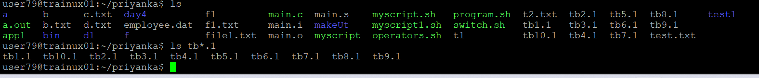

1. **Write the command to list all files in descending order of their size.**

To list all the files in descending order of their size we use the ‘ll -S’ command.

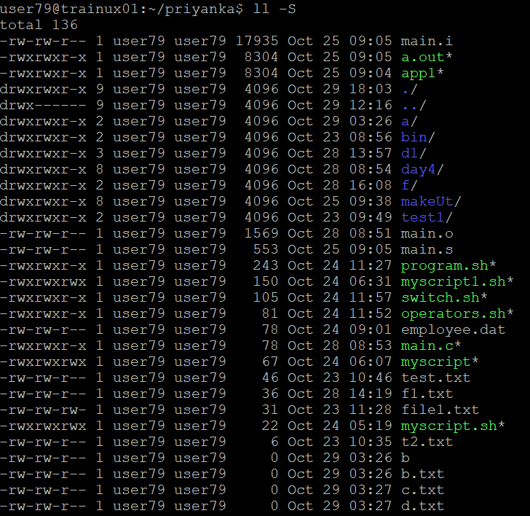

1. **Suppose there are files temp1, temp2, temp3. Write command to remove the files without listing them explicitly**

First we have to create the files by using touch command. Then to remove the files without listing them explicitly we use ‘rm -rf filename*’.

Here rm is used to remove the file and -rf is using for forcefully recursively to remove the file.

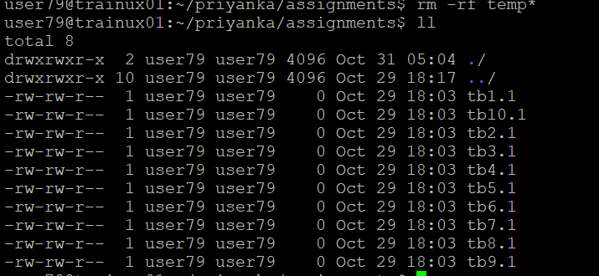

1. **Which command is used to list top few lines in the file?**

To list top few lines in the file we use ‘head’ command. Here we want to print only top 3 lines then we have to use head -n 3 filename.txt.

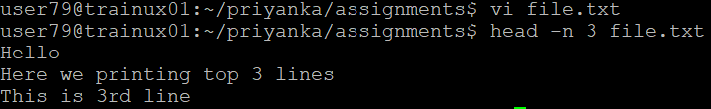

1. **Create a directory “testdir”**

To create a directory we have to use ‘mkdir’ command.

Example: mkdir filename

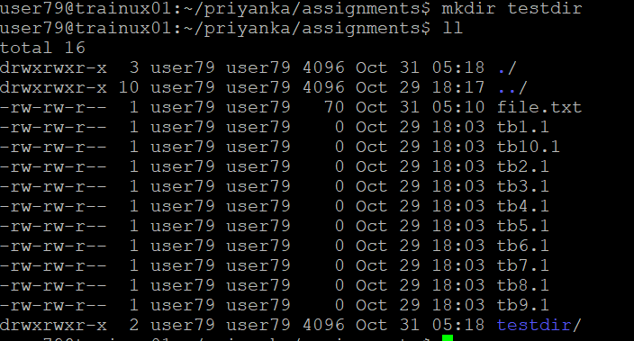

1. **Use cp command to do the following** 
   1. **Copy the file tb1.1 (created above) in the same directory.**

By using ‘cd’ command we have to the copy the files. In command after cp we have to write which file we have to copy an then ‘./’ is used to go to the path then we have to write which directory we have to copy that file.

Example: cp filename ./directory name

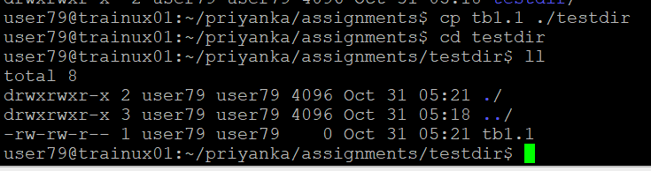

* 1. **Write a command to copy all the files i.e tb1.1,tb2.1,tb3.1,…..tb10.1 in a new directory –“new”**

First create a directory of name new by using ‘mkdir’. Then we have to use ‘cp’ command for to copy all the file.

Example: cp tb {1..10}.1 ./new

‘{}’ is used to get the similar patterns

‘./’ is used for go to the path

* 1. **Create a subdirectory in new in named “new1”.**

We have to use ‘mkdir’ command to create the directory. In this we have to create sub directory so, first go to where we have to create the subdirectory by using ‘cd’ command. Then create the directory in that directory shown in below.

Example:

$ cd new

$ mkdir new1

* 1. **Write a command to copy selectively only tb2.1, tb6.1, tb7.1 and tb10.1 in the directory new1.**

We know that, to copy the file we have to use ‘cp’ command. After cp command write the files which we have to copy into the directory new1.

* 1. **Write a command to copy the entire directory “new” to a directory “newprogs”. [Note: use the –R option of “cp” command]**

To copy the entire directory ‘new’ to a directory ‘newprogs’ we have to use cp command with -R option.

Then the entire directory that is sub directories and the files contain in it. These all copy into the ‘newprogrs’ directory.

1. **Find out the difference between** 
   1. **“mv” & “cp”**

The ‘mv’ and ‘cp’ commands in Linux are both used for handling files and directories.

|  |  |
| --- | --- |
| mv command | cp command |
| The ‘mv’ command is used to move files or directories from one location to another or to rename them. | The ‘cp’ command is used to copy files or directories from one location to another. |
| When we use ‘mv’, the original file is removed from its original location and placed in the new location. | When we use ‘cp’, the original file remains in its original location, and a duplicate is created at the specified destination. |
| Syntax:  mv filename ./ destination | Syntax:  cp filename ./destination |

* 1. **“rm”, “rmdir”**

The ‘rm’ and ‘rmdir’ commands in Linux are both used for deleting files and directories.

|  |  |
| --- | --- |
| rm command | rmdir command |
| The ‘rm’ command is used to remove files and directories. | The ‘rmdir’ command is specifically used to remove empty directories. |
| It can delete both files and directories with the appropriate flags. | It can only delete directories that are completely empty. |
| -r: Recursively removes directories and their content.  -f: Forces the removal without prompting for confirmation. | Syntax:  rmdir directory name |
| Syntax:  rm filename  rm -r filename |  |

* 1. **“mkdir” and “mkdir -p”**
* The ‘mkdir’ command in Linux is used to crate directories, and the ‘-p’ option modifies its behavior.
* The ‘mkdir’ can only create a single directory at a time, while ‘mkdir -p’ can create multiple levels of directories in one command
* ‘mkdir’ will error out if the directory already exists, whereas ‘mkdir -p’ will simply skip creating it if it already exists.

1. **Use a single command rmdir once to remove “testdir” and all its sub directories and files created above.**

* By using ‘rmdir' command we cannot remove the directories which contains files and subdirectories.
* It can only remove while the directory is empty.

1. **Which command is used to get the manual information of a command?**

The ‘man’ command is used to get the manual information of a command. It provides detailed documentation about the command, including its options, usage, and examples.

Syntax:

$ man [command name]



1. **If you are not able to change to a directory what could be the likely cause?**

* The specified directory may not exist. Double -check the spelling and path you are trying to access.
* Check the permission using ‘ls -l’ and ensure you have read and execute permissions for that directory.
* If you are using a relative path, make sure you are in the correct current directory.
* There could be a typo in the ‘cd’ command itself. Ensure that you are typing the command correctly.

1. **Explain the differences among the following commands:**
2. **cd /**

This command takes you to the root directory of the filesystem. The root directory is the top-level directory from which all other directories branch out.

1. **cd ..**

This command moves you up one level in the directory hierarchy. For instance, if you are currently in ‘/home/user/Priyanka/new’ and you run ‘cd ..’, you will take to ‘/home/user/priyanka’.

1. **cd**

This command moves you to home directory. For example, if you are currently in ‘/home/user/priysnka/new’ and you run ‘cd’, you will taken to ‘/home’.

1. **cd ../..**

This command moves you up two levels in the directory hierarchy. For example, if you are in ‘/home/user/Priyanka/new’, running ‘cd ../..’ will take you to ‘/home/user’.