**ASSIGNMENT -4**

**Shell Script Assignment**

1. **Create a script named “myscript” in current directory to do the following.**
2. **display “hello user”**

* To display the content in script we have to use ‘echo’ command.

1. **list files in current directory**

* To list the files in current directory we have to use ‘ls’ command.

1. **name of logged in user**

* To know whom logged there is a command i.e ‘whoami’.

1. **Date**

* To know the date simple we have to write ‘date’ it gives the date.
* First create a ‘myscript’ by using vi editor or touch command by adding ‘.sh’ extension.
* Then write the commands for above questions as shown in the figure.

* Then run the ‘myscript.sh’ by using the command “sh myscript.sh”.
* It displays the output according to your commands.

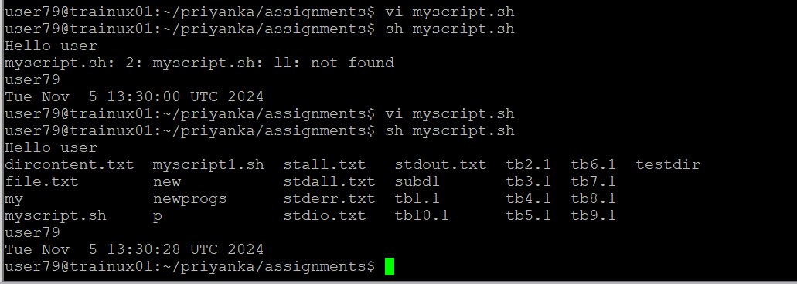

1. **Add execute permission and Run the script from**
2. **current directory**

* To run the script from current direct we have to change the permission by using “chmod” command.

Eg: chmod o-r filename

g-group u- user a- all o - others

w- write x- execute r - read

"-" - take away permission

"+"- give permission

* After changing the permissions, we have to run the script by using ‘./script_name.sh’ command.

1. **Create a subdirectory named “test”**

* To create a directory, we use “mkdir” command.

Ex: mkdir directory_name

1. **Change to “test” directory. Run the script “myscript” [Hint: You will have to update PATH to include the directory containg script to run script from any location].**

* To run the script from the subdirectory, we use “../” before the filename.

