# Printf Scanf Assignment

**Mandatory:**

Q1. WAP with

1a. function readdisplay() to read the following data types only one at a time at run time and to display.

1. char type
2. integer type
3. char array of maximum 80 characters
4. short type
5. float type

TestData:

‘c’, 8978, “hello”, 8, 45.678

‘H’, 254, “hello Hi How”, 256, 145.2678

1b. Create a copy of readdisplay() as function readdisplay2() with changes below

* Instead of reading 1 data at a time, read all inputs using a single scanf().

Test readdisplay2() by changing the read order. Do you observe any issue?

1c. display the char array content in upper case

1d. Add code to display the size of each data type mentioned in Q1a and sizeof the variables of each datatype (You may refer sample code in data_type_size.c )

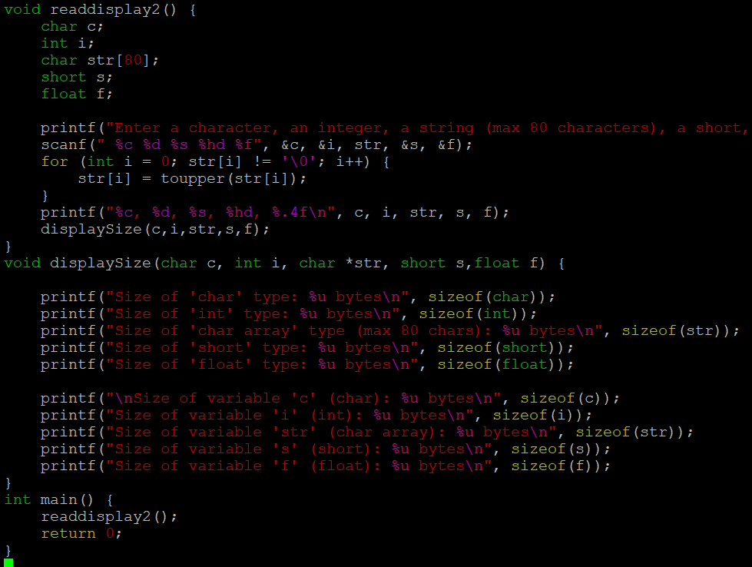

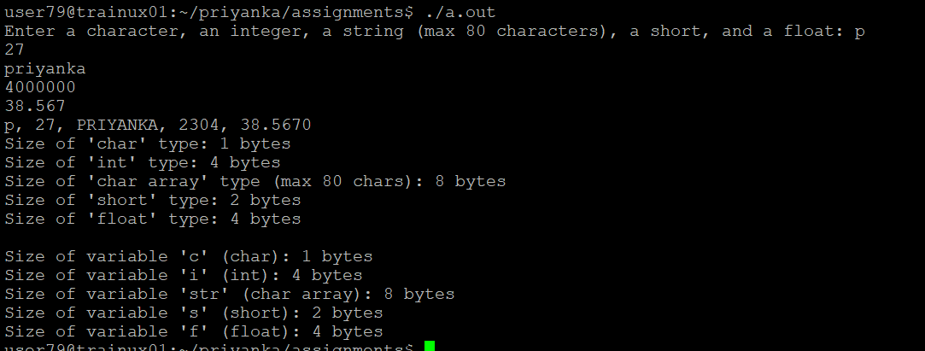

Q2. Try to run the program with code snippet below. Check the output and analyse. Fix it to get correct result.

#include<stdio.h>

int main()

{

unsigned long int ul = 200333333334340;

printf("value is:%d\n", ul);

return 0;

}

