**DAY -4:**

**Tools:**

1. **GCC:**

* - g = debugging

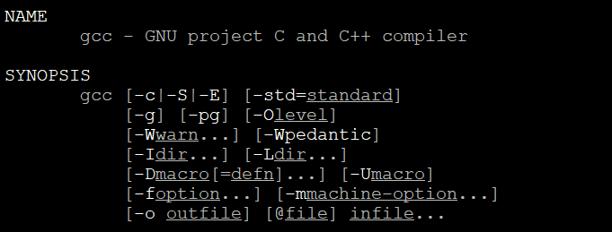

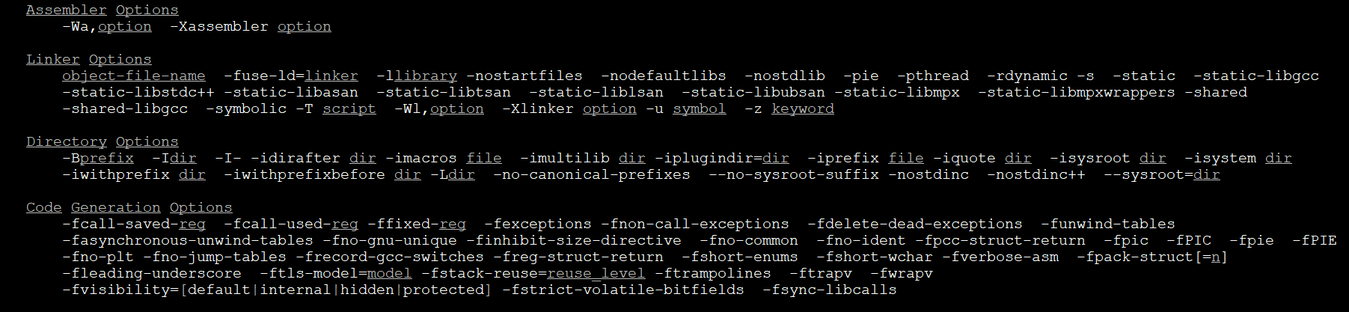

* - Dumpspecs, --save-temps ==developer options

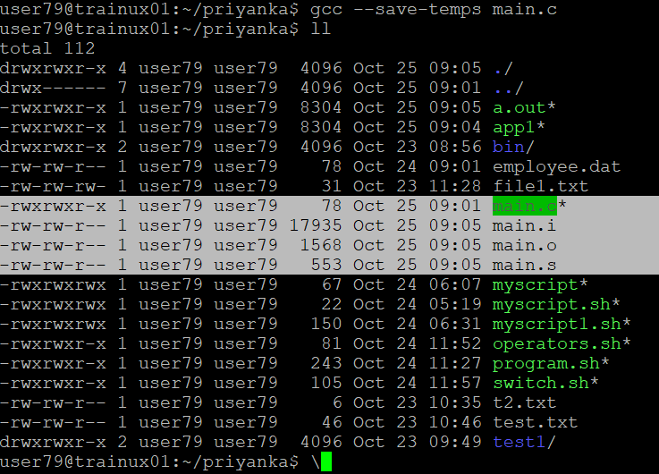

1. **Make:**

mkdir mainprj

cd mainprj

mainprj>mkdir inc obj scripts lib src bin

Created header file in inc

cd inc

mainprj/inc>vi calc.h

cd ../

cd src:cd inc

mainprj/src/>vi calc.c

mainprj/src>vi main.c

cd ../

mainprj/>gcc -c ./src/calc.c -I./inc -o .obj/calc.o

mainprj/>gcc -c./src/main.c -I/inc/ -o .obj/main.o

src$ gcc -c -I../inc/ ../src/calc.c -o ../obj/calci.o