**DAY 5:**

./bin/app – for execution

Implicit declaration error – you have used the interface name but you have not declare the interface name

**To copy one repository to another:**

* Open our repocitory then create mkdir bhimafldr

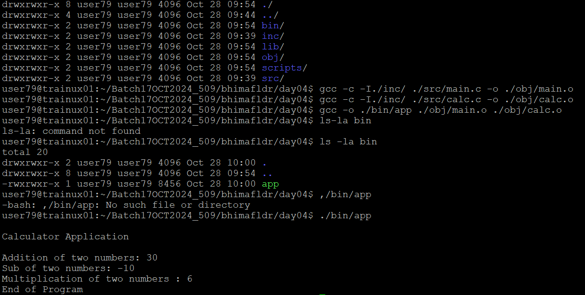

* Cd bhimafldr
* Pwd
* Copy the path
* Come back to home by cd
* Open CGBatch
* Pull the content
* Cp file name/ copy the path
* Then go to our repository open the fldr then ll we see the content

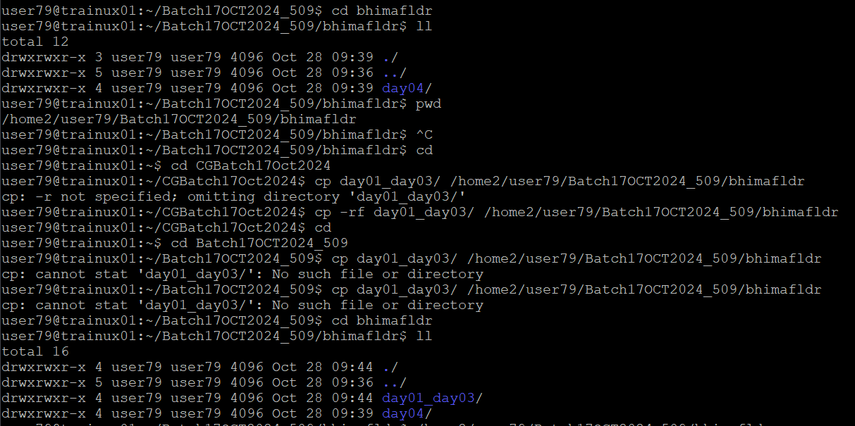

**Creating variables for folders:**

Ex: OBJ = ./obj

SRC =./src

cp -rf ~/CGBatch17Oct2024/day04/

**Makefile:**

**To build the application by using make utility**

Targetapp: target1 target2

Gcc -o ./bin/target target1 target2

Target1: dependencies1

Gcc -c sourcecodes

Target2: dependencies2

Gcc -c sourcecodes

**Gcov:**

**Error in splint:**

**Segmentation fault(core dump) – exceeds the memory allocation**

Splint is used for static allocation – at source level it debugg

Valgrid is used for dynamic allocation