Vi Editor – Assignments

- Invoke the vi editor with a filename (which is to be created)
- Type a few lines(at least 10) in the editor. Let one or more lines contain the words given below.
Delhi mumbai Chennai Mumbai
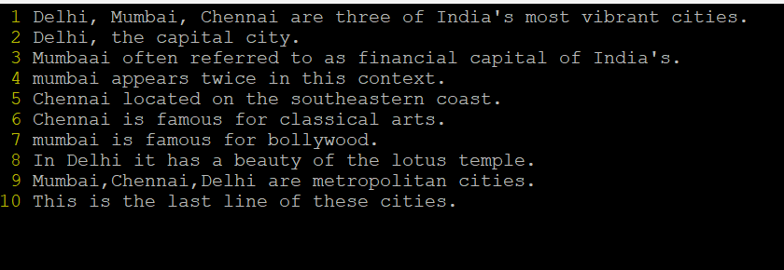
- Save the file without exiting the editor
- Press ‘Esc’ to make sure you are in command mode.
- Type ‘:w’ and hit ‘Enter’.
- Navigate quickly to the beginning & end of the file
- To go to the beginning of the file: Press ‘gg’.
- To go to the end of the file: Press ‘G’.
- Delete first two lines & copy it after the last line.
- To delete first two lines: go to first and then press ‘d2+down arrow’.
- To copy it after the last line: First copy by pressing ‘y+2’, go to last line by ‘G’ then, press ‘p’.
- Now Copy the last two lines & paste them before the first line.
- To copy the last 2 line: Press ‘y+2’, go to first line by ‘gg’ then, press ‘O’ it creates a new line above the line. Then, press ‘p’.
- Combine last two lines of the file in a single line.
- To combine last two lines of the file- in a single line : Press ‘J’ to combine the cursor in the last 2nd line.
- How will you insert a line before the first line? (Hint : Find such an option in the tutorial document)
- To insert a line before the first line: Press ‘O’
- How will you paste a yanked buffer before the current line?
- First copy the yanked buffer by ‘y’ in normal mode.
- To paste before current line press ‘P’ in Esc mode.
- Search the document for a string “delhi”
- Type ‘/Delhi’ and then press ‘Enter’. This will start search for the string.
- The cursor will move to the first occurrence. You can press ‘n’ to go next occurrence or ‘N’ to go back to the previous occurrence.
- Replace a single occurrence of “delhi” with “Mumbai”
- Place the cursor at the beginning of the word.
- Press ‘cw’ it will delete the word and then type the word.
- Replace all occurrences of “delhi” on a particular line with “Mumbai” using one command
- Navigate to the line where you want to make replacement.
- Type ‘:s/Delhi/Mumvai/g’ then press ‘Enter’
- Replace “delhi” with “mumbai” for the entire document using one command.
- Type ‘%s/Delhi/Mumbai/g’
- Replace all occurrences of “delhi” with “mumbai” for part of a document (e.g. line number 13 to 37).
- Type ‘3,7s/Delhi/Mumbai/g
- Undo the above command
- Press ‘u’ to undo command
- Replace only the first occurrence of “delhi” with “mumbai” in each line, for part of a document (e.g. line number 13 to 37).
- Type ‘3,7s/Delhi/Mumbai/
- Undo the above comment. Redo it. Undo it again.
- To undo press ‘u’
- To redo it press ‘ctrl+r’
- Again, you want undo press ‘u’
- Replace all occurrences of “delhi” with “mumbai” for complete file interactively.
- Type ‘%s/Delhi/Mumbai/gc’
- ‘c’ at the end of the command stands for “confirm”
- ‘y’ to replace the occurrence
- ‘n’ to skip it
- ‘a’ to replace all remaining occurrence without asking
- ‘q’ quit the replacement process
- ‘l’ to replace the current occurrence and then quit
- Search for a word backwards. Loop through all matches.
- Press ‘?’ to start backward search
- Search for a word forwards. Loop through all matches
- Press ‘?’ to start forward search
- Join two lines together.
- Press ‘J’ to join the two lines.
- Enable line numbering and then disable it
- Enter ‘set number’
- To diable it enter set nonumber’
- Make the search case insensitive
- Type ‘set ignorecase’
- Delete 4 lines (and then paste them somewhere else)
- To delete press ‘d4+uparrow or downarrow’
- To paste ‘p’
- What is the command to delete part of the line starting from the current cursor position?
- Make sure your in normal mode.
- Type ‘d’ followed by’$’ and press ‘Enter’
- It delete everything from the cursor position to line line.
- What is the command to delete the current word?
- To delete current word press ‘dw’

