Aspiring for a challenging job at a reputable firm that will allow me to grasp the field of overall quality management of projects while also contributing to the organization’s growth and development.



**ACADEMIC QUALIFICATIONS**

|  |  |  |  |
| --- | --- | --- | --- |
| **Academic**  **Qualification** | **University/Board** | **Year** | **Percentage /CGPA** |
| B.Tech. (IT) | JNTUGV | 2025 | 8.2CGPA |
| INTER | BOARD OF INTERMEDIATE EDUCATION AP | 2021 | 89.6% |
| SSC | Board of Secondary Education, AP | 2019 | 9.7 CGPA |

# TECHNICAL SKILLS



**Programming :** Python, Java, C,C++

**Development :** HTML, CSS, JS

**Database :** MySQL

**Operating Systems :** Windows



**PROJECT**

**EXPERIENCE**

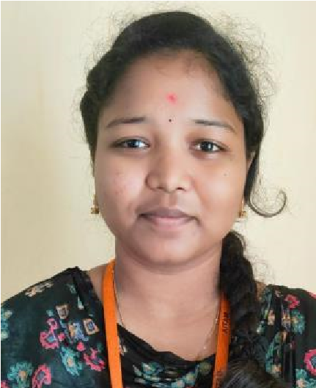

**DASARI**

**BHAVANA**

**Email**

**:**

**bhavanadasari18**

**@gmail.com**

**Contact**

: +91

-

7989588330

**LinkedIn**

:

[https://www.linkedin.com/in/dasar](https://www.linkedin.com/in/dasari-bhavana-68b03b282)

[i](https://www.linkedin.com/in/dasari-bhavana-68b03b282)

[-](https://www.linkedin.com/in/dasari-bhavana-68b03b282)

[bhavan](https://www.linkedin.com/in/dasari-bhavana-68b03b282)

[a](https://www.linkedin.com/in/dasari-bhavana-68b03b282)

[-](https://www.linkedin.com/in/dasari-bhavana-68b03b282)

[68](https://www.linkedin.com/in/dasari-bhavana-68b03b282)

[b03b](https://www.linkedin.com/in/dasari-bhavana-68b03b282)

[28](https://www.linkedin.com/in/dasari-bhavana-68b03b282)

[2](https://www.linkedin.com/in/dasari-bhavana-68b03b282)



**OBJECTIVE**

**Data analysis using python: |** Feb 2023 – Mar 2023

In this project, I successfully completed Data analysis Using python as part of My Skill oriented courses at Aditya Institute of Technology Management.



**INTERNSHIP EXPERIENCE**

**Community Internship:**

This is mainly to find and resolve proablems in rural areas. There we find some technological issues and we resolve those by using our limited resources .



**CERTIFICATIONS**

* **Basics of python** issued by Infosys spring board.



**CO CURRICULAR ACTIVITIES**

* Completed a Course on Python Fundamentals provided by Infosys.
* Participated in a webinar on career guidance program for engineering graduates conducted by Eazy BTech
* Participated in State Level Technical Quiz Championship

Aditya Institute of Technology and Management, Tekkali 2021-2025

* Participated in School Level Quiz Competition

# EXTRA CURRICULAR ACTIVITIES



* Performed stage acting in Youth festivals.
* Volunteered for a workshop conducted on industrial training on Android.
* An active member of Developers Club.
* Participated in Various Sports Meets held at Mandal level.
* An active member of NSS.



**PERSONAL DETAILS**

**Father Name :** D.Radha krishna.(Late) **Date of Birth :** 26-2-2003.

**Languages Known :** English, Telugu,Hindi.

**Hobbies/Interests :** Playing games

**Address :** 8-24 pilla street mettavalasa,bobbilli

**Date:** 04/07/2023. D.BHAVANA

**Place:** Tekkali. Signature

Aditya Institute of Technology and Management, Tekkali 2021-2025