Name : Dasari Jayanth

Roll No : 2019BCS-016

Course : Compiler Design

Course Code: BCCS 3106 - 2021

# **Assignment Number - 1a**

Date Of Submission: **08-09-2021**

Aim:

To Write a program for lex/flex scanner generator to identify valid identifiers.

Procedure:

Input strings will be compared using Regex.

The taken string is checked to find if it starts with an alphabet(either capital or small) or an underscore and whether all letters are alphanumerics. If it satisfies above it prints valid else invalid.

Code:

%{

#include <stdio.h>

%}

%%

[a-z A-Z _]([a-z A-Z 0-9 _])* {printf("Valid");}

.* {printf("invalid");}

%%

int yywrap()

{

}

int main()

{

yylex();

return 0;

}

Input/Output -1a: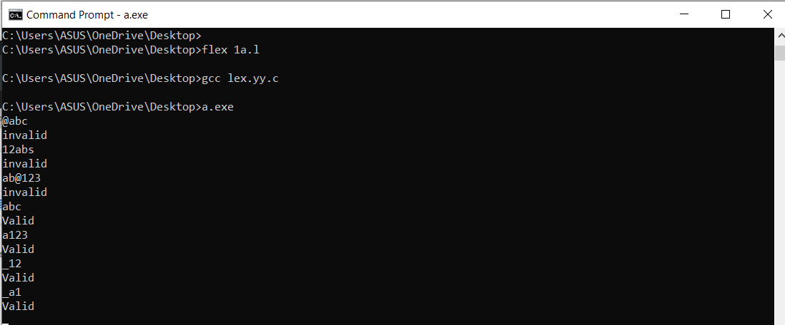

Inference:

The above code successfully identifies a string as valid identifier or not.

For a string to be an identifier, it should follow the rules below.

It should start with either an underscore(‘_’) or alphabets[A-Z or a-z]. Identifiers should only contain alphanumeric characters including underscore.

1st input : @abc output: invalid

Explanation: An identifier shouldn’t start with ‘@’.It shouldn’t even contain special characters.

2nd input : 12abs output: invalid

Explanation: Identifiers should not start with numbers.

4th input : abc output: valid

Explanation: It satisfies all rules of identifier and contains only alpha numericals.

# 

# **Assignment Number - 1b**

Date Of Submission: **08-09-2021**

Aim:

To Write a program for lex/flex scanner generator to count the number of vowels or consonants.

Procedure:

Initially two variables are declared to store the count of vowels and consonant alphabets in the string.

The entered string will be matched with the vowels(a,e,i,o,u,A,E,I,O,U). Wherever the elements are vowels in the string, the vowel count will be increased. And for the remaining elements of the string that matches with the alphabets, the consonants count is incremented.

Finally, it prints the count of vowels and consonants in the given string.

Code:

%{

#include<stdio.h>

int v=0;

int c=0;

%}

%%

"a"|"e"|"i"|"o"|"u"|"A"|"E"|"I"|"O"|"U" {v++;}

[a-zA-z] {c++;}

%%

int yywrap()

{

}

int main()

{

printf("Enter the String: ");

yylex();

printf("No. of vowels= %d and No. of Consonants= %d",v,c);

return 0;

}

Input/Output -1b:

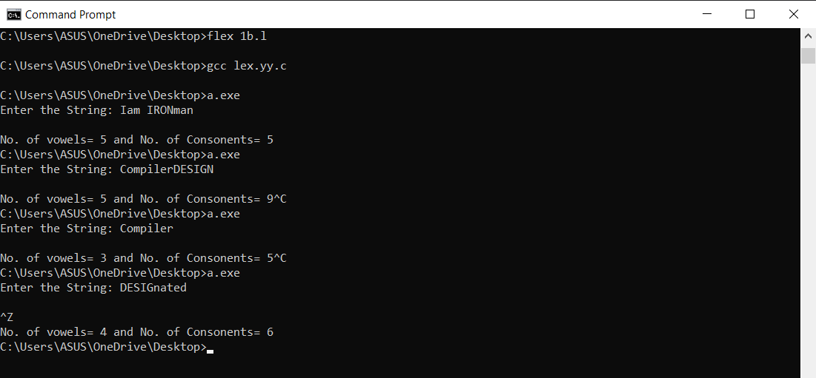

Inference:

The above code is successful in counting the no. of vowels and consonants in the given string.

If an ele of a string is a vowel, then the count of vowels is incremented by 1 then it checks other elements for the same (if it is a vowel). Similar way for consonants.

Input2: CompilerDESIGN Output: No. of vowels : 5 (o,i,e,e,i)

No. of consonants : 9 (C,m,p,l,r,D,S,G,N)