Name : Dasari Jayanth

Roll No : 2019BCS-016

Course :System Software Lab

Course Code : BCCS 3106 - 2021

# **Assignment Number - 2a**

Date Of Submission: **14-09-2021**

**Aim:**

To write a program for lex/flex scanner generator to determine the length of the longest word in the given string.

**Procedure:**

First we initialize a variable ‘length’ and give it the value ‘0’. Now, we use **yyleng**, a built-in variable to store the length of the words pointed to by **yytext**(here pointing to the words of the string). We compare the yyleng value(length of the word yytext currently pointing at) with the previously stored ‘length’ variable and store the largest value in the variable ‘length’. After reading the whole string, we print the value of the length variable.

**Code:**

%{

int length = 0;

%}

%%

[a-zA-Z]+ {

if (yyleng > length) {

length = yyleng;

}}

%%

int yywrap()

{

}

int main() {

yylex();

printf("Length of largest word is: %d", length);

printf("\n");

return 0;}

**Input/Output -2a:**

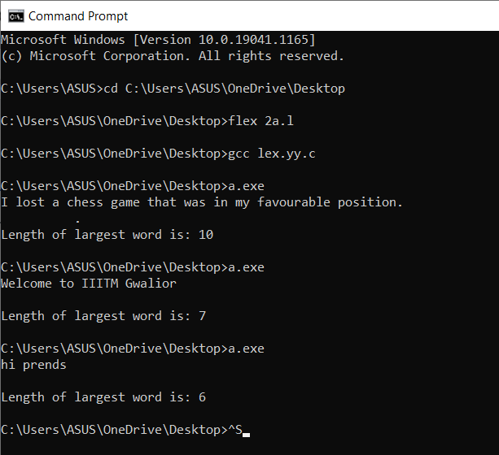

**Inference:**

Input String: ‘Welcome to IIITM Gwalior’.

Output: 7

Reasoning: Here, there are two largest words in the given string: ‘Welcome’ and ‘Gwalior’ which

are of length ‘7’. So, the length of the largest word is 7.

Input String: ‘hi prends’.

Output: 6

Reasoning: Largest word in a given string is ‘prends’ which contains 6 letters(‘p’,’r’,’e’,’n’,’d’,’s’).

So, The length of the largest word is 6.

**Hence**, we can conclude that the code written above returns the length of the largest word in the given string.(by user).

# 

# **Assignment Number - 2b**

Date Of Submission: **14-09-2021**

**Aim:**

To Write a program for the lex/flex scanner generator to do Decimal to Binary Conversion.

**Procedure:**

**yytext** is the pointer that points at the string or char or word we entered and **atoi()** is the predefined function that returns the integer equivalent of the argument we pass.

First, Initialize the variables ‘num’, ‘r’, a=1,b=0.

We pass the user input in atoi() and store the integer value in num. While num>0 we divide the ‘num’ by 2 and store the remainder in ‘r’, multiply the remainder by ’a’ in which we store the decimal place (like for one’s place a=1, for ten’s place a=a*10 =>a=10 and soon at each loop until the num>0). We store the value of b+(r*a) in b (since r*a contains the value at the particular decimal place* that decimal’s value like one’s*1, (value at ten’s place)*10,..). When num<=0, we exit the loop and print the result(stored in ‘b’) we got.

**Code:**

%{

#include<stdio.h>

int num, r, a=1, b=0;

%}

DIGIT [0-9]

%%

{DIGIT}+ { num=atoi(yytext);

while (num > 0)

{

r= num % 2;

b+= r*a;

a*= 10;

num/= 2;

}

printf("%d", b);

b=0;

a=1; }

%%

int yywrap()

{

}

int main()

{

yylex();

return 0;

}

**Input/Output -2b:**

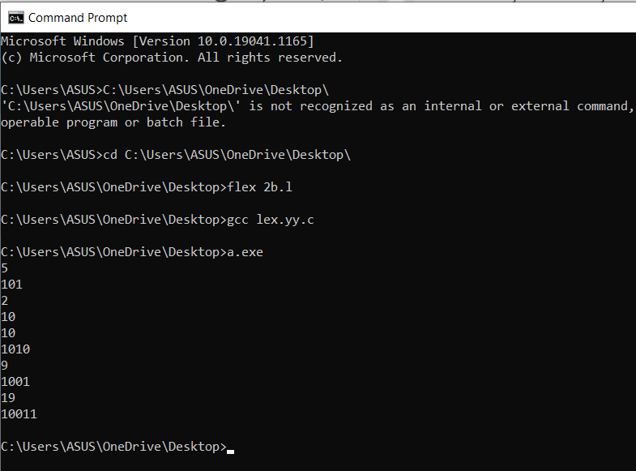

**Inference:**

Input : 5

Output : 101

Reasoning: The binary form of the decimal number ‘5’ is 101.

((2^2)*1 + (2^1)*0 + (2^0*)1 = 4+0+1 = 5).

Input : 10

Output: 1010

Reasoning: The binary form of the decimal number ‘10’ is 1010.

((2^3)*1 + (2^2)*0 + (2^1)*1 + (2^0)*0 = 8+0+2+0 = 10).

**Hence**, we can say that the above written code gives the binary form of the entered decimal number by the user as the result.