Name : Dasari Jayanth

Roll No : 2019BCS-016

Course :System Software Lab

Course Code : BCCS 3106 - 2021

# **Assignment Number - 5**

Date Of Submission: **10-10-2021**

**Aim:**

To write a program for the lex/flex scanner generator to input a series of numbers and output the count of Positive numbers, Negative numbers, and Fractions.

**Procedure:**

First initialize variables pn, nn, f, to store the count of positive integers, negative integers and fractions respectively.

We take user input series.

First Regex expression is to measure positive integers.(included ‘0’)

Second regex expression is to measure negative integers.

At last the regex exp is for fractions, we added ‘?’ before ‘-’ because by adding so it considers all the values that start with 0 or more no. of the previous expression (in this case ‘-’) so if fraction is positive no. of ‘-’ is 0 and if -ve no. of ‘-’ is >1. So, both negative and positive fractions are included and every time we come across a fraction we increment the var ‘f’ to store the count. Similarly done to above two variables ‘pn’ and ‘nn’. And adding ‘0’ in pn is also a similar concept(‘?’ Concept in regex). Finally we print each count separately.

**Code:**

%{

int pn=0;

int nn=0;

int f=0;

%}

%option noyywrap

DIGIT [0-9]

%%

\+?{DIGIT}+ pn++;

-{DIGIT}+ nn++;

\-?{DIGIT}*\.{DIGIT}+ f++;

. ;

%%

int main()

{

yylex();

printf("\nNo. of positive numbers: %d", pn);

printf("\nNo. of Negative numbers: %d", nn);

printf("\nNo. of Fractions: %d", f);

return 0;

}

**Input/Output -5:**

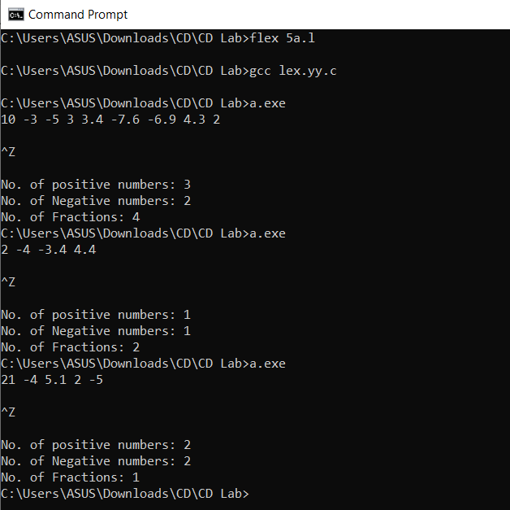

**Inference:**

Input : 10 -3 -5 3 3.4 -7.6 -6.9 4.3 2

Output: Positive No. : 3; Negative No. : 2; Fractions: 4

Reasoning: Positive integers(10, 3, 2), Negative integers(-3, -5), fractions(-7.6, -6.9, 3.4, 4.3).

Input : 2 -4 -3.4 4.4

Output: Positive No. : 1; Negative No. : 1; Fractions: 2

Reasoning: Positive integers(10, 3, 2), Negative integers(-3, -5), fractions(-7.6, -6.9, 3.4, 4.3)

**Hence**, we can conclude that the code written above returns the count of positive integers, negative integers and fractions present in the given input series.