Name : Dasari Jayanth

Roll No : 2019BCS-016

Course :System Software Lab

Course Code : BCCS 3106 - 2021

# **Assignment Number - 6**

Date Of Submission: **29-10-2021**

**Aim:**

To write a program for the lex/flex scanner generator to print the total characters and white spaces.

**Procedure:**

At first we initialize two variables s_c and ch_c to ‘0’(zero) to store the count of spaces and characters respectively.

First we take the user input string.

We count the spaces present in the string using a regex equation & store it in s_c.

We count the no. of characters present in the string using the regex equation & store it in ch_c.

Finally we print the count of spaces and characters of the user input string. **Code:**

%{

#include<stdio.h>

int s_c=0, ch_c=0;

%}

%%

([ ])+ s_c++; //space counter

. ch_c++; //characters counter

%%

int yywrap(){}

int main()

{

yylex();

printf("\nNo. of spaces=%d", s_c);

printf("\nNo. of characters=%d", ch_c); }

**Input/Output -6:  
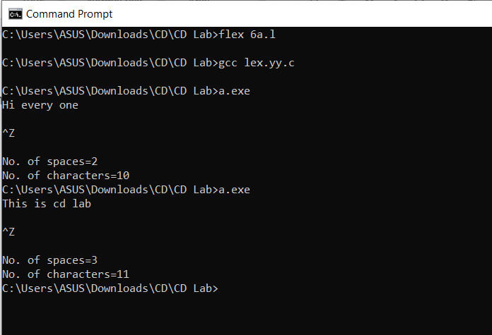  
  
Inference:**

Input : Hi every one

Output: No. of spaces: 2; No. of characters : 10

Reasoning: characters: {‘h’, ‘i’, ‘e’, ‘v’, ‘e’, ‘r’, ‘y’, ‘o’, ‘n’, ‘e’} and spaces:{ after ‘hi’ and ‘every’}

Input : This is cd lab

Output: No. of spaces: 3; No. of characters : 11

Reasoning: characters: {‘T’, ‘h’, ‘i’, ‘s’, ‘i’, ‘s’, ‘c’, ‘d’, ‘l’, ‘a’, ‘b’} and spaces: {after ‘This’, ‘is’ & ‘cd’}

**Hence**, we can conclude that the code written above returns the count of no. of characters, and the White spaces present in the given input string.