ASSIGNMENT-1
1. TO CREATE 3 INSTANCES
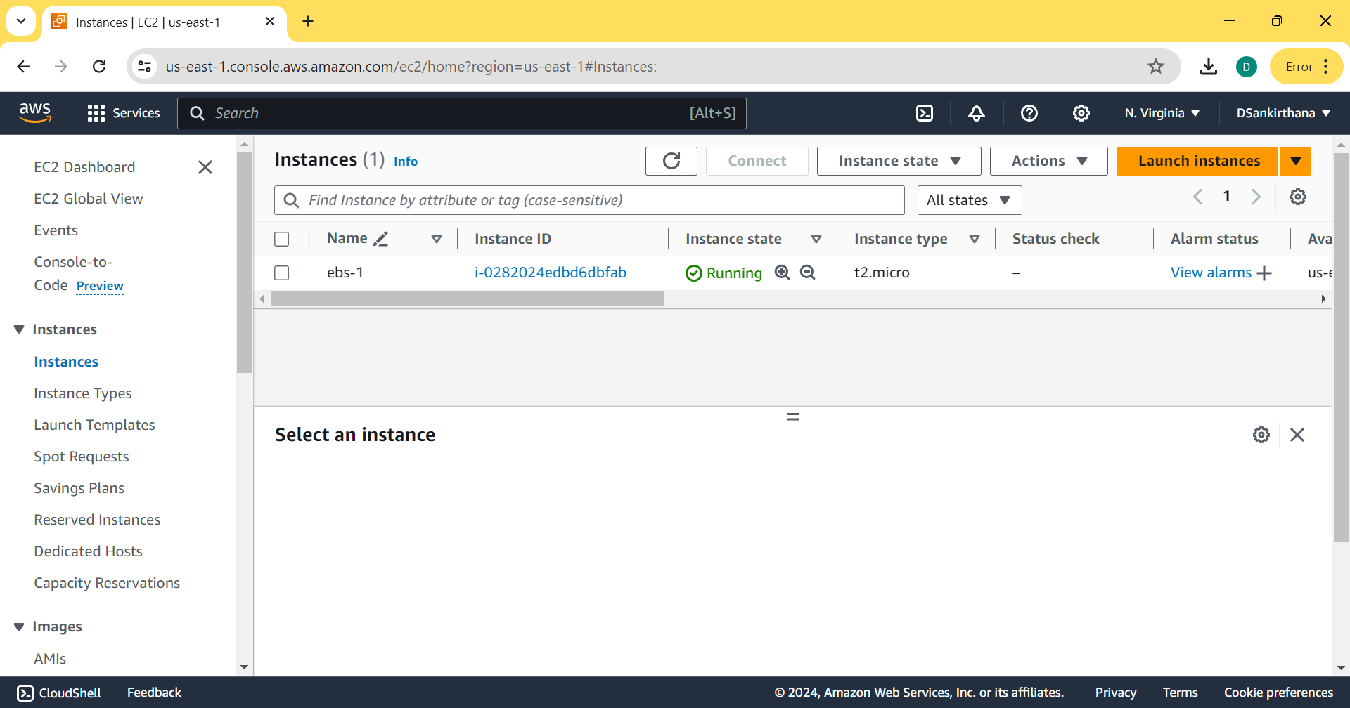
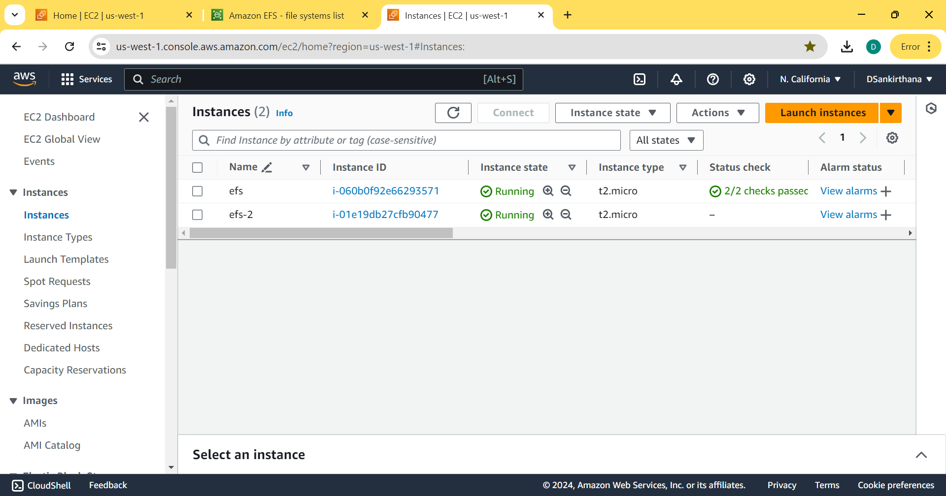
2. TO ATTACH EBS TO ONE VOLUME
1. CREATE INSTANCE
2. CREATE VOLUME
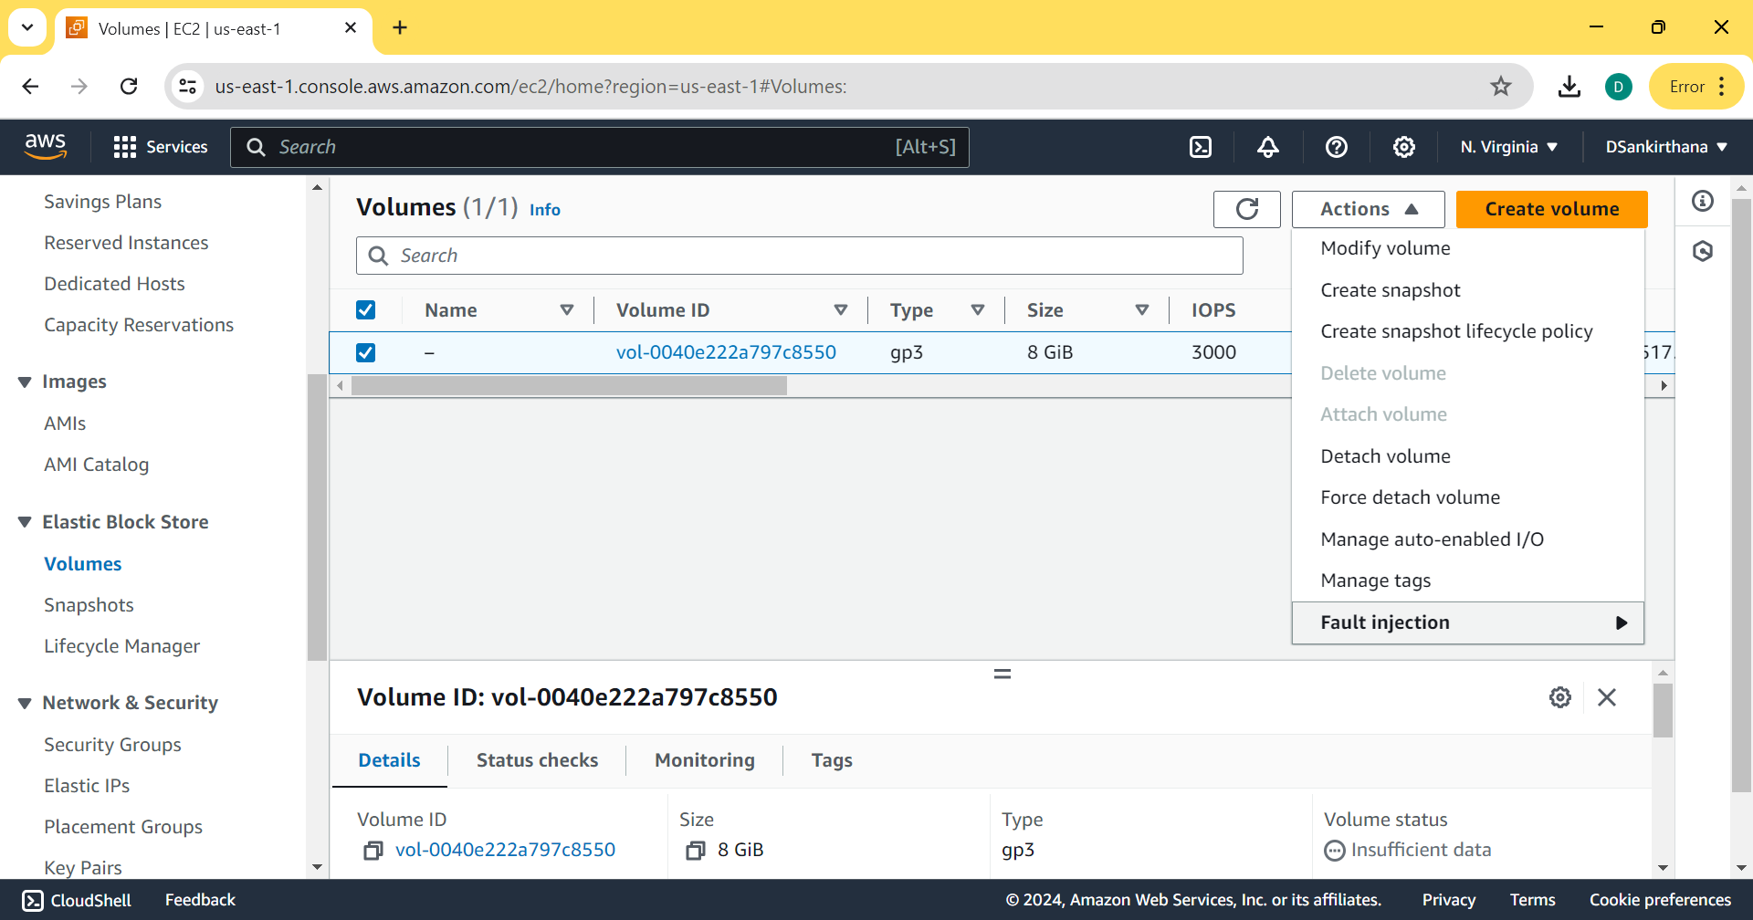

3. CONNECT INSTANCE
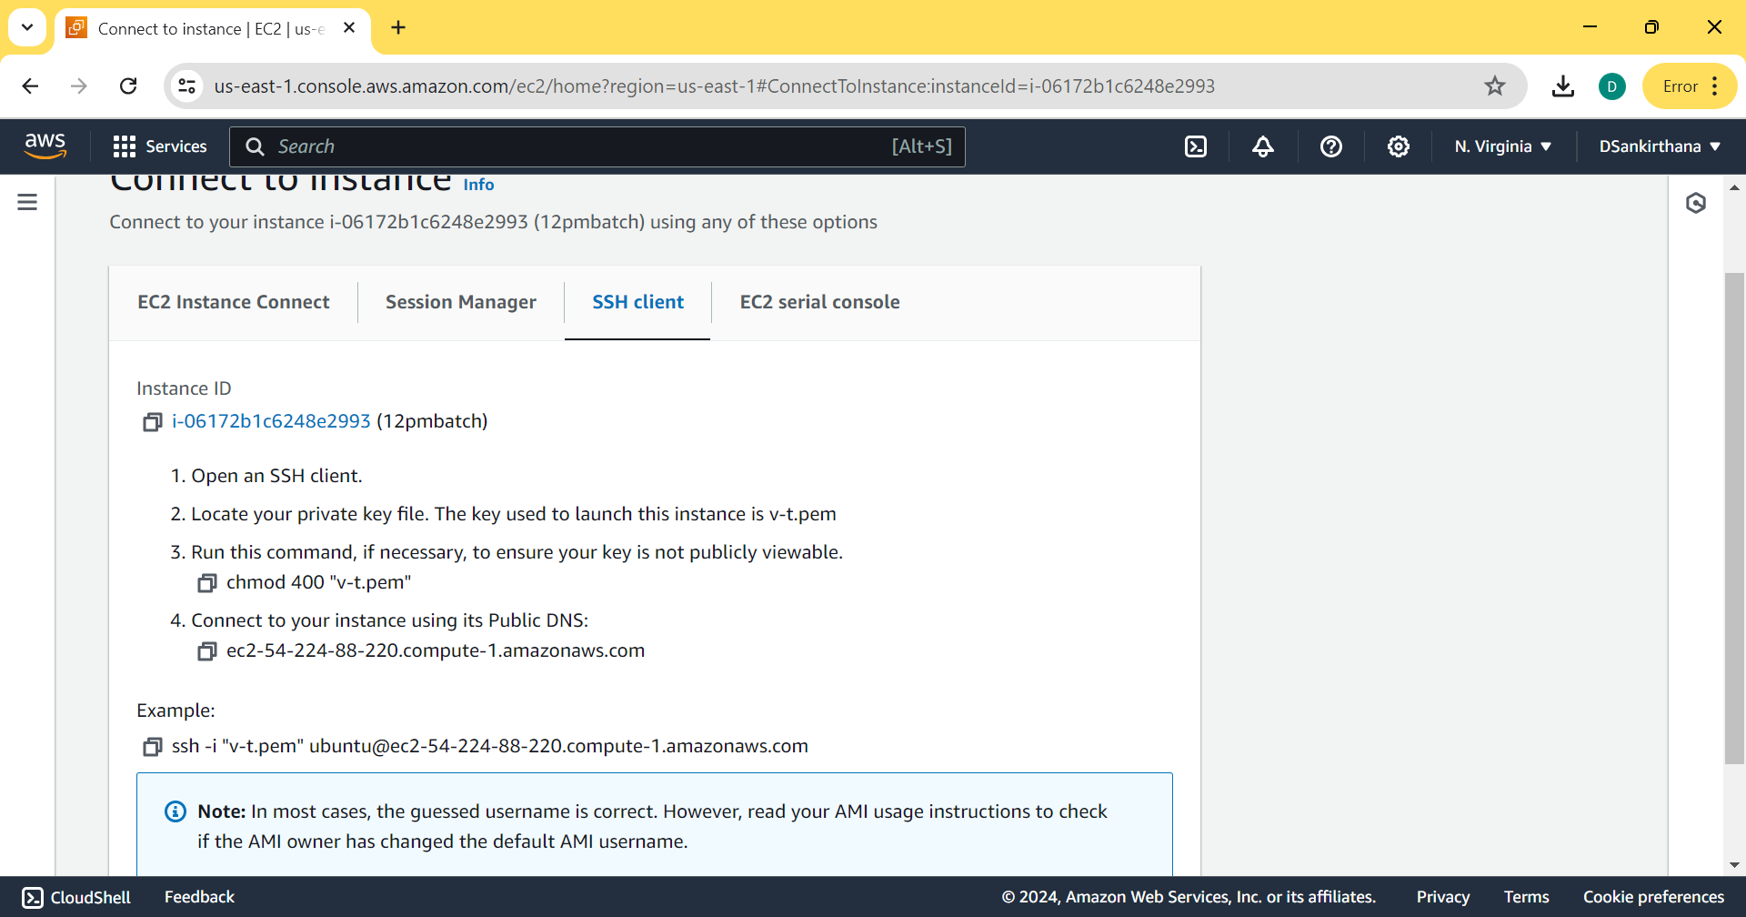
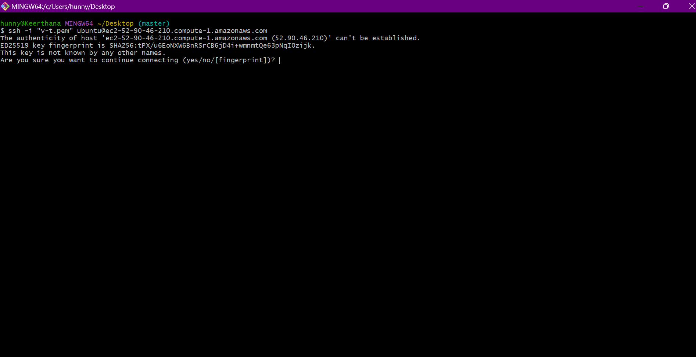
4. CHECK STORAGE
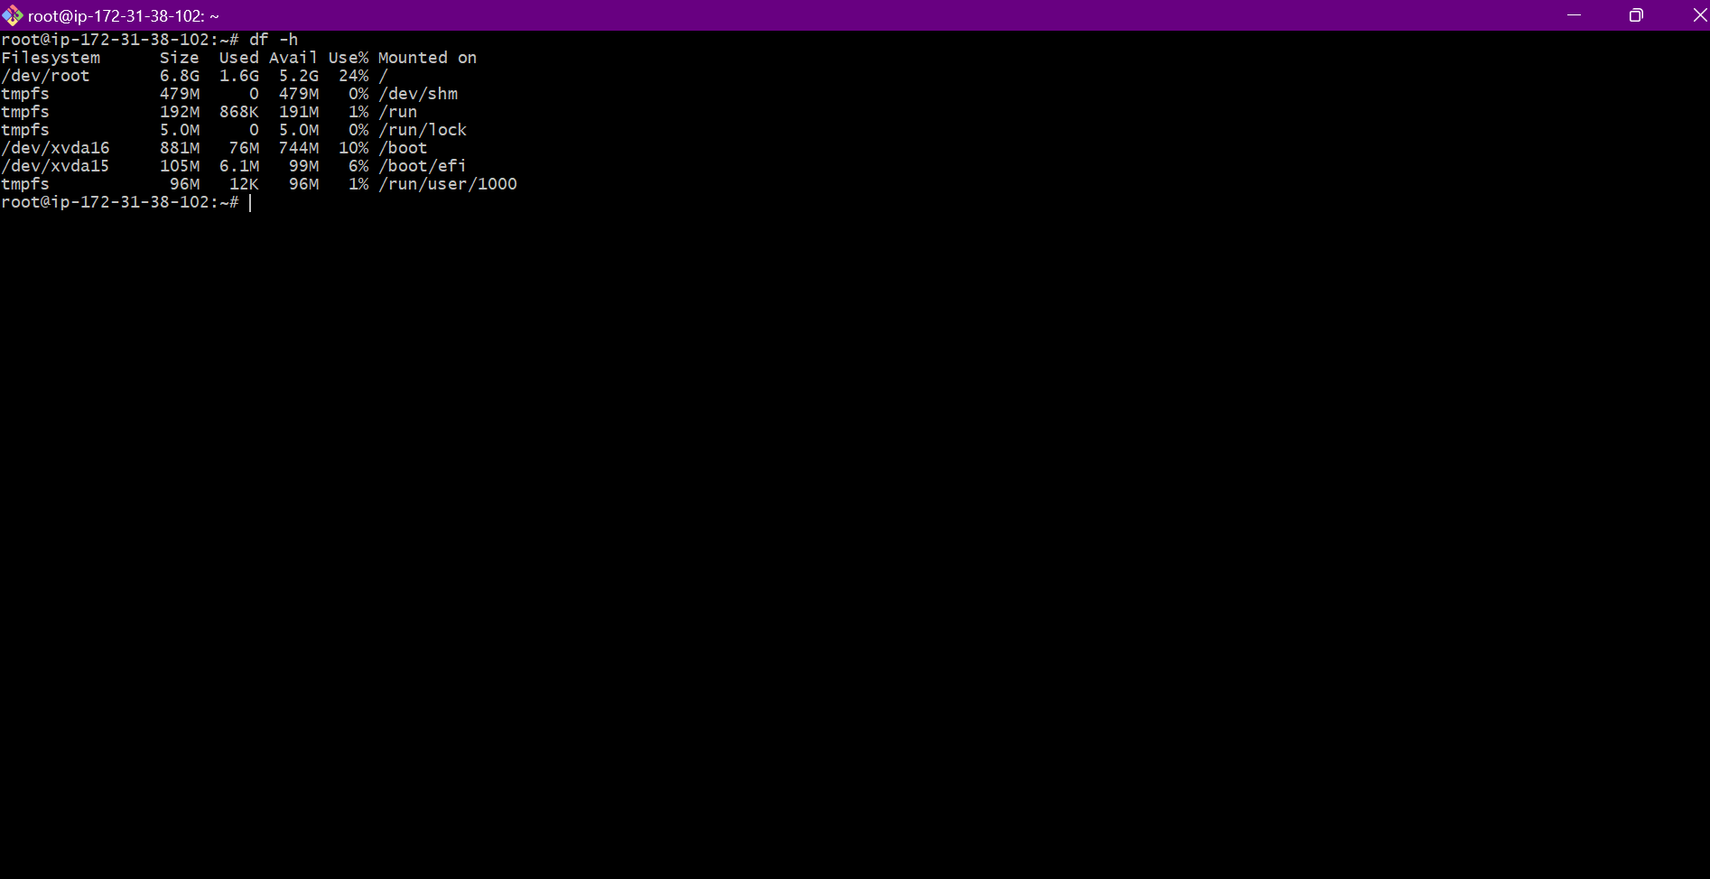
5. TO INCREASE SIZE
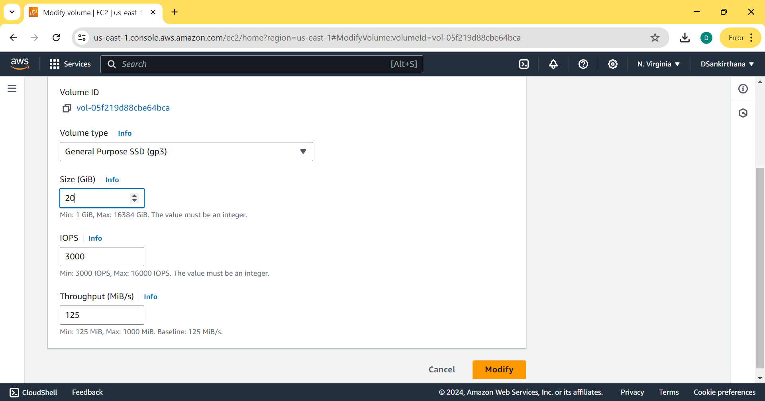
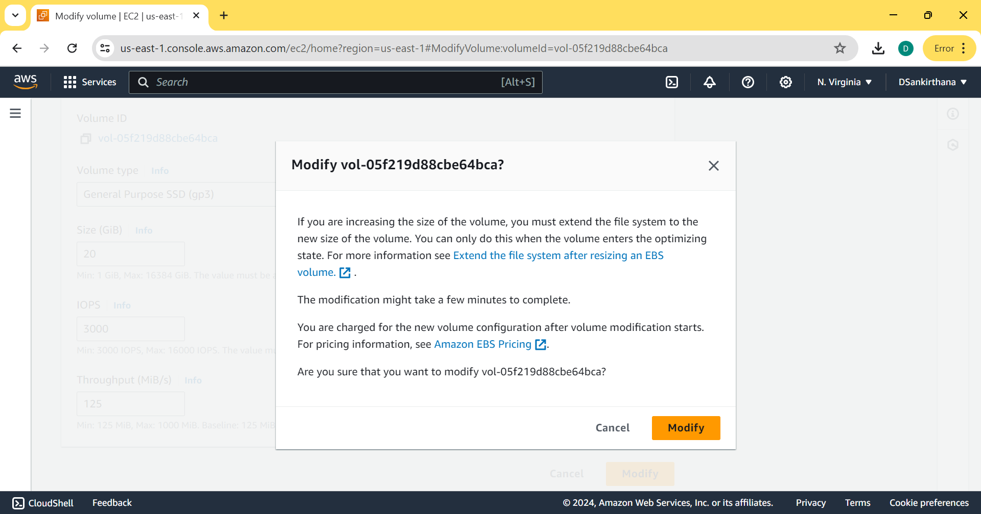
6. TO REFLECT THE UPDATED SIZE REBOOT THE INSTANCE
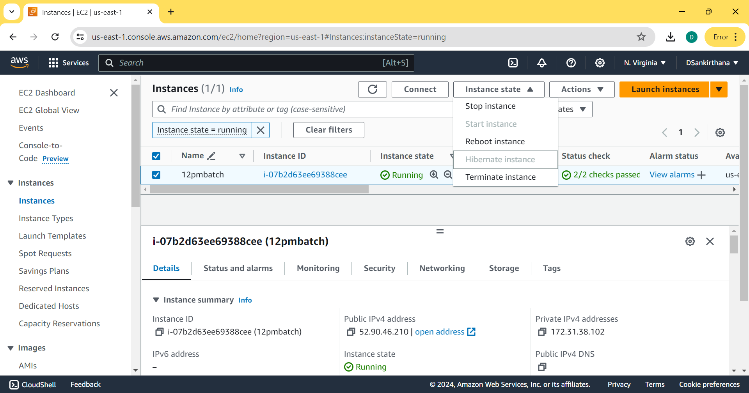
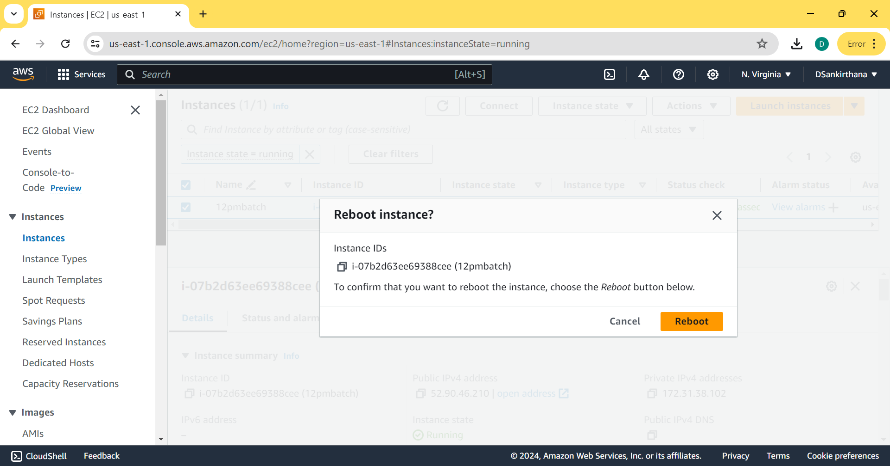
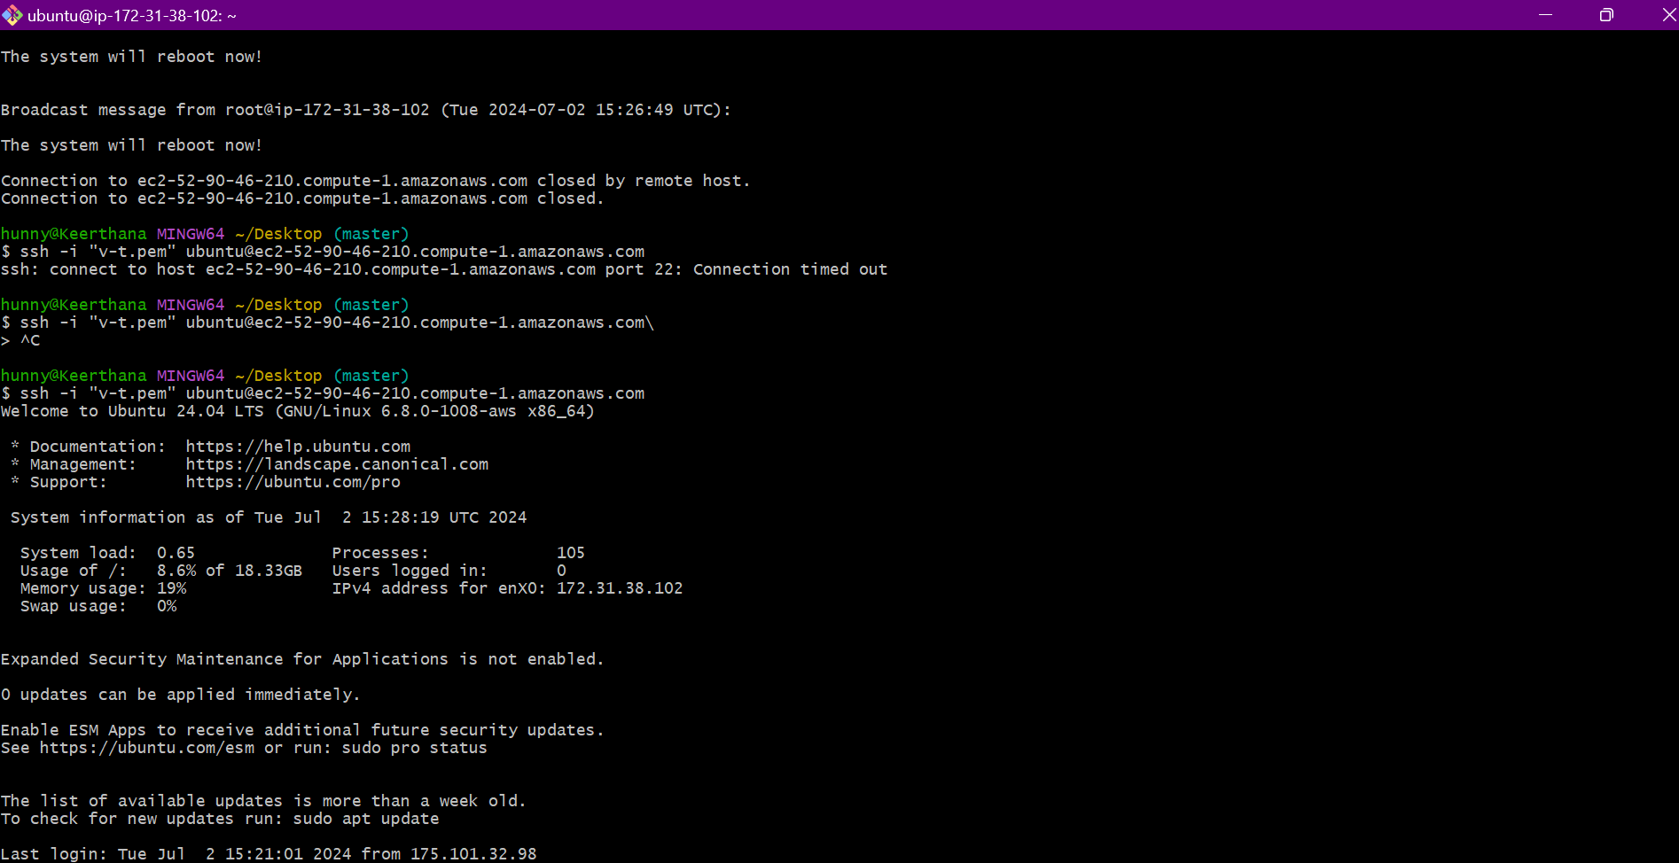
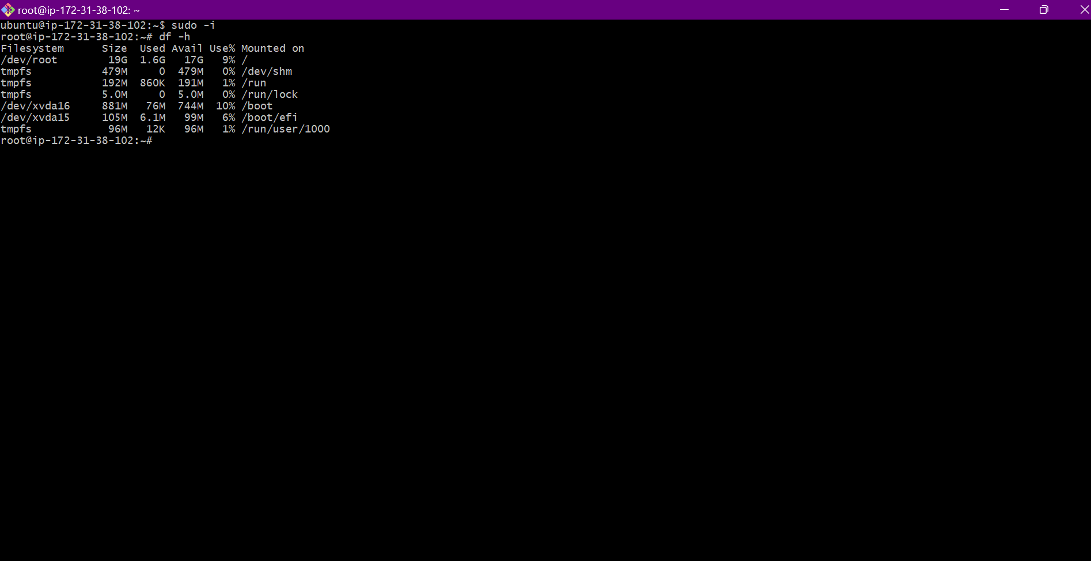
THE SIZE IS INCREASED
- TO INCREASE SIZE OF OWN DIRECTORY THE ABOVE PROCESS IS NOT SUITABLE SO WE USE MOUNT TO INCEASE THE SIZE OF OUR OWN DIRECTORY
1. PICK THE VOLUME TYPE
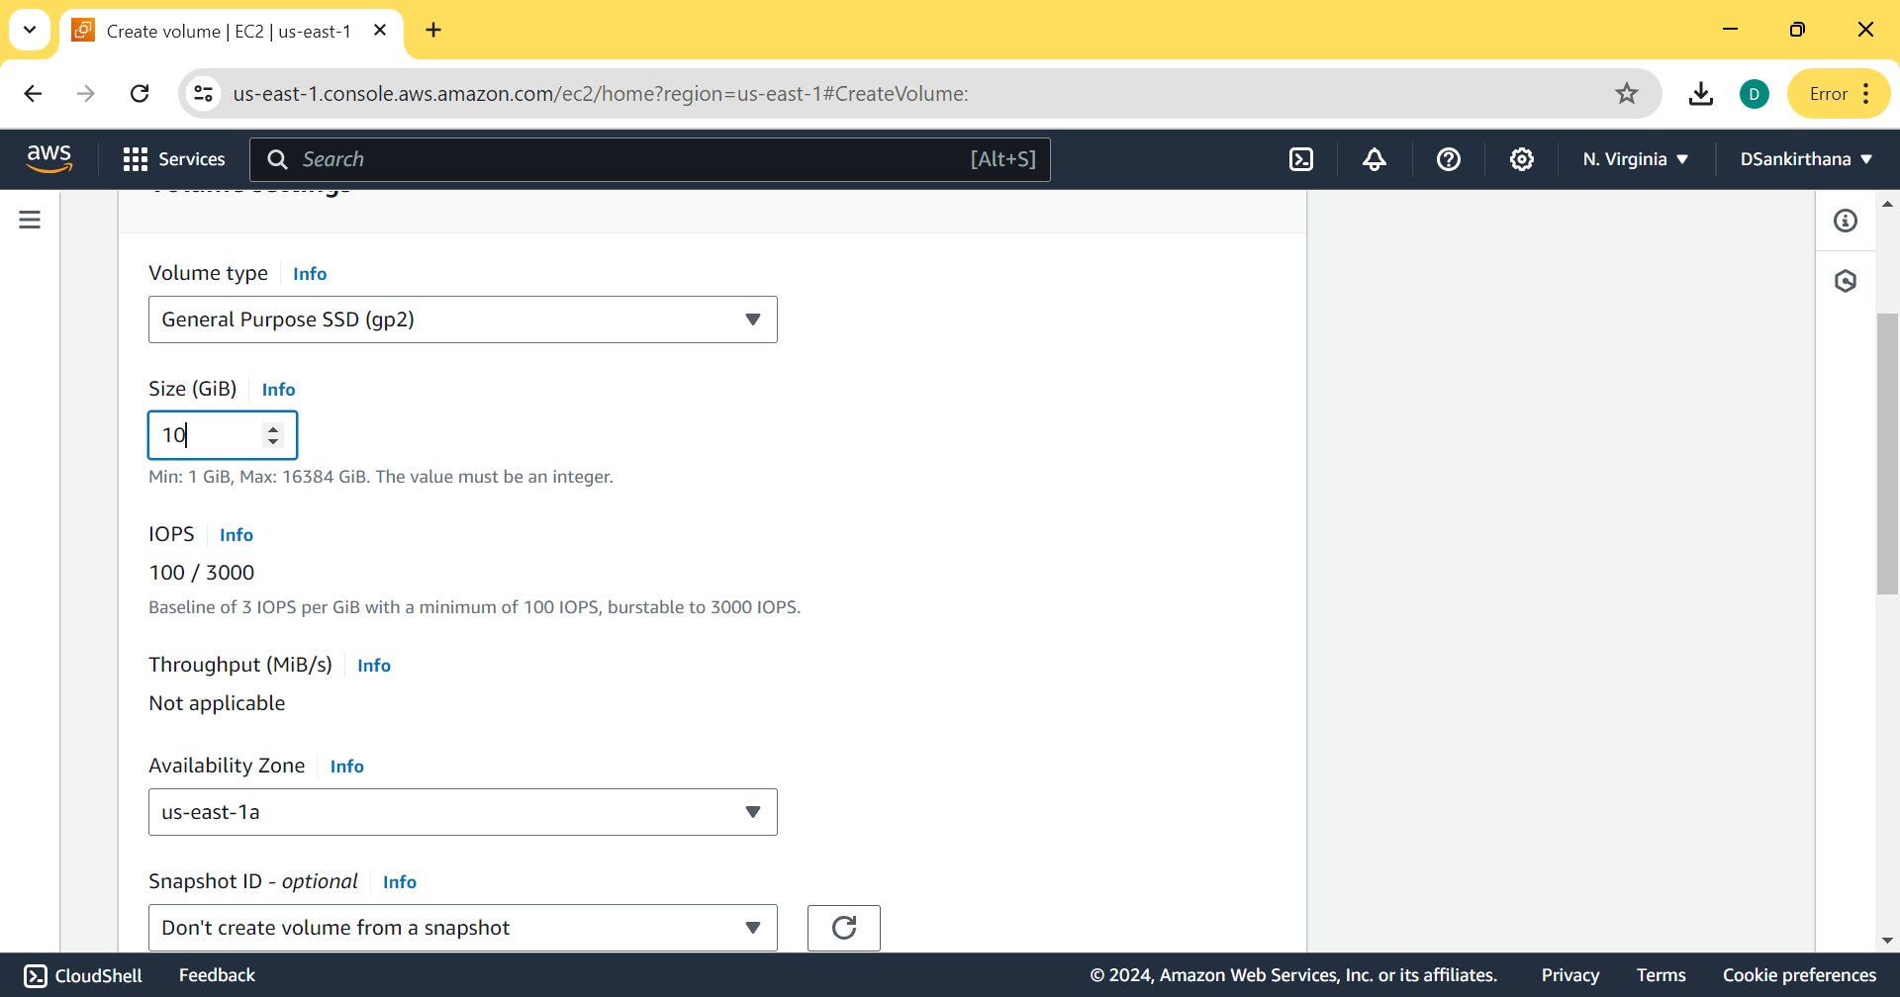
2. ATTACH THE VOLUME AND CHECK IF THE AVAILABILITY ZONES ARE IN THE SAME ZONE

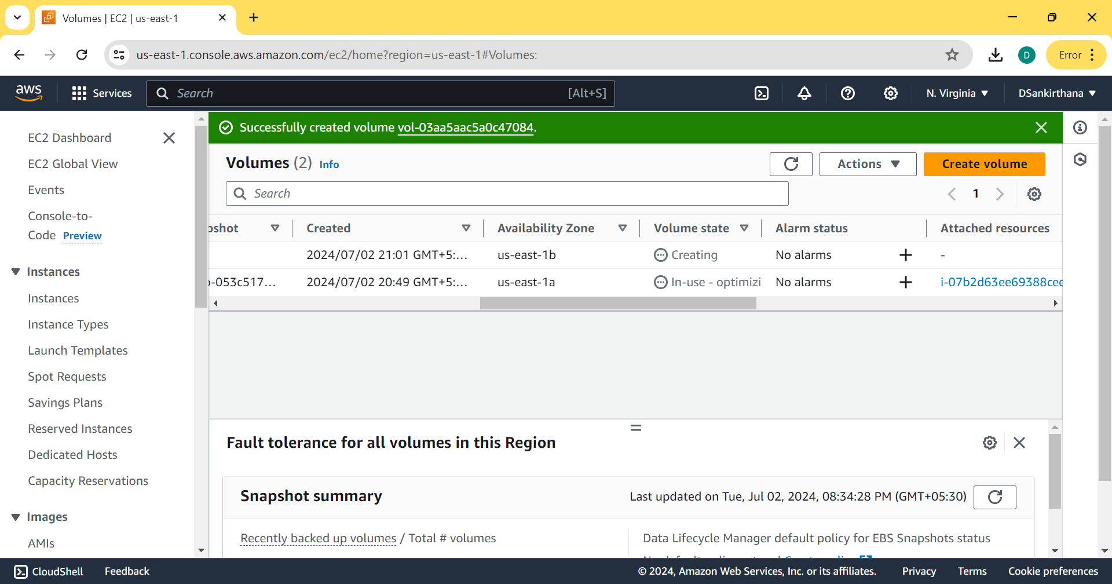
3. ATTACH THE VOLUME
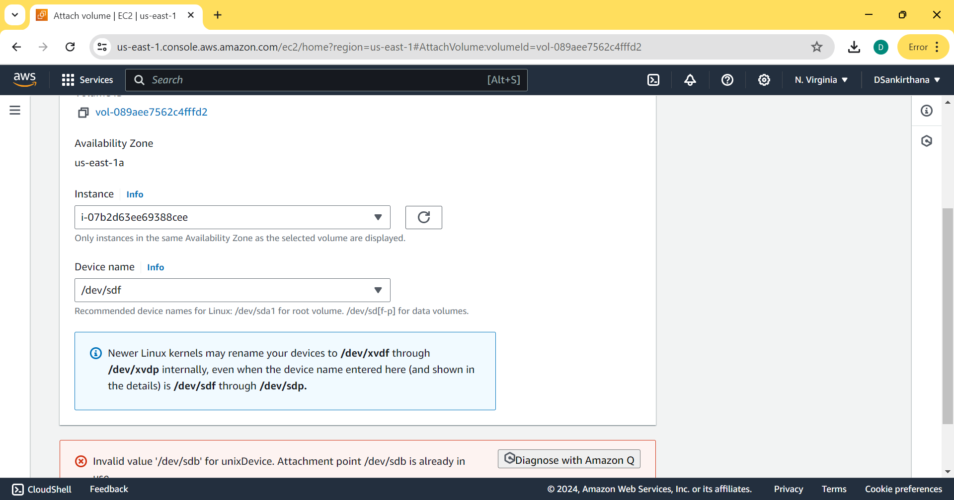
4. TO CHECK BLOCK DEVICE STORAGE
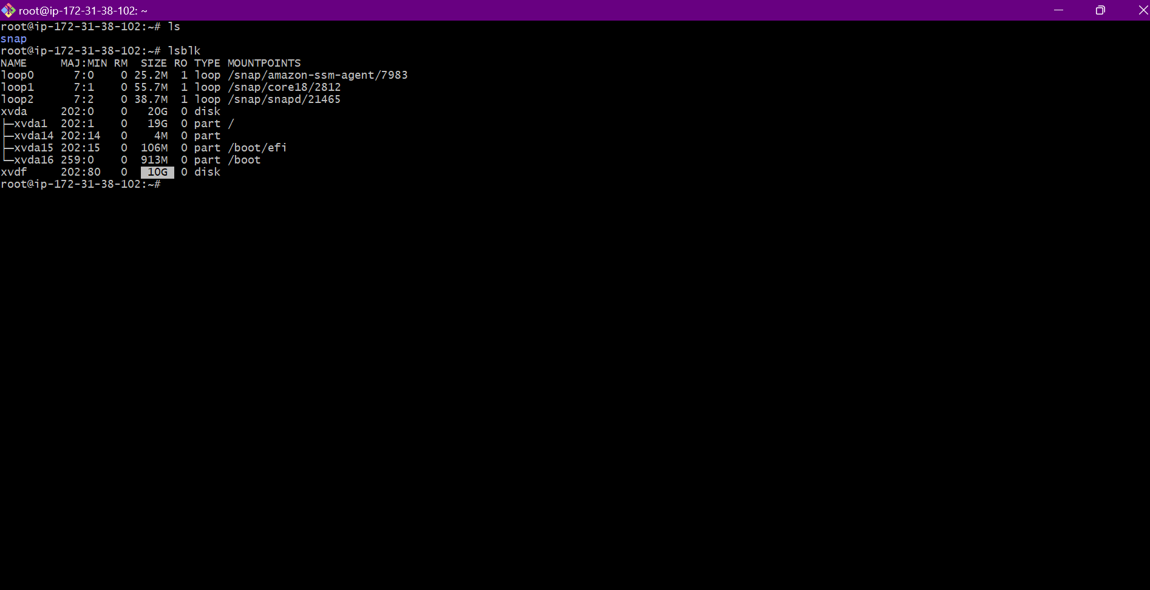
TO MAKE FILE SYSTEM
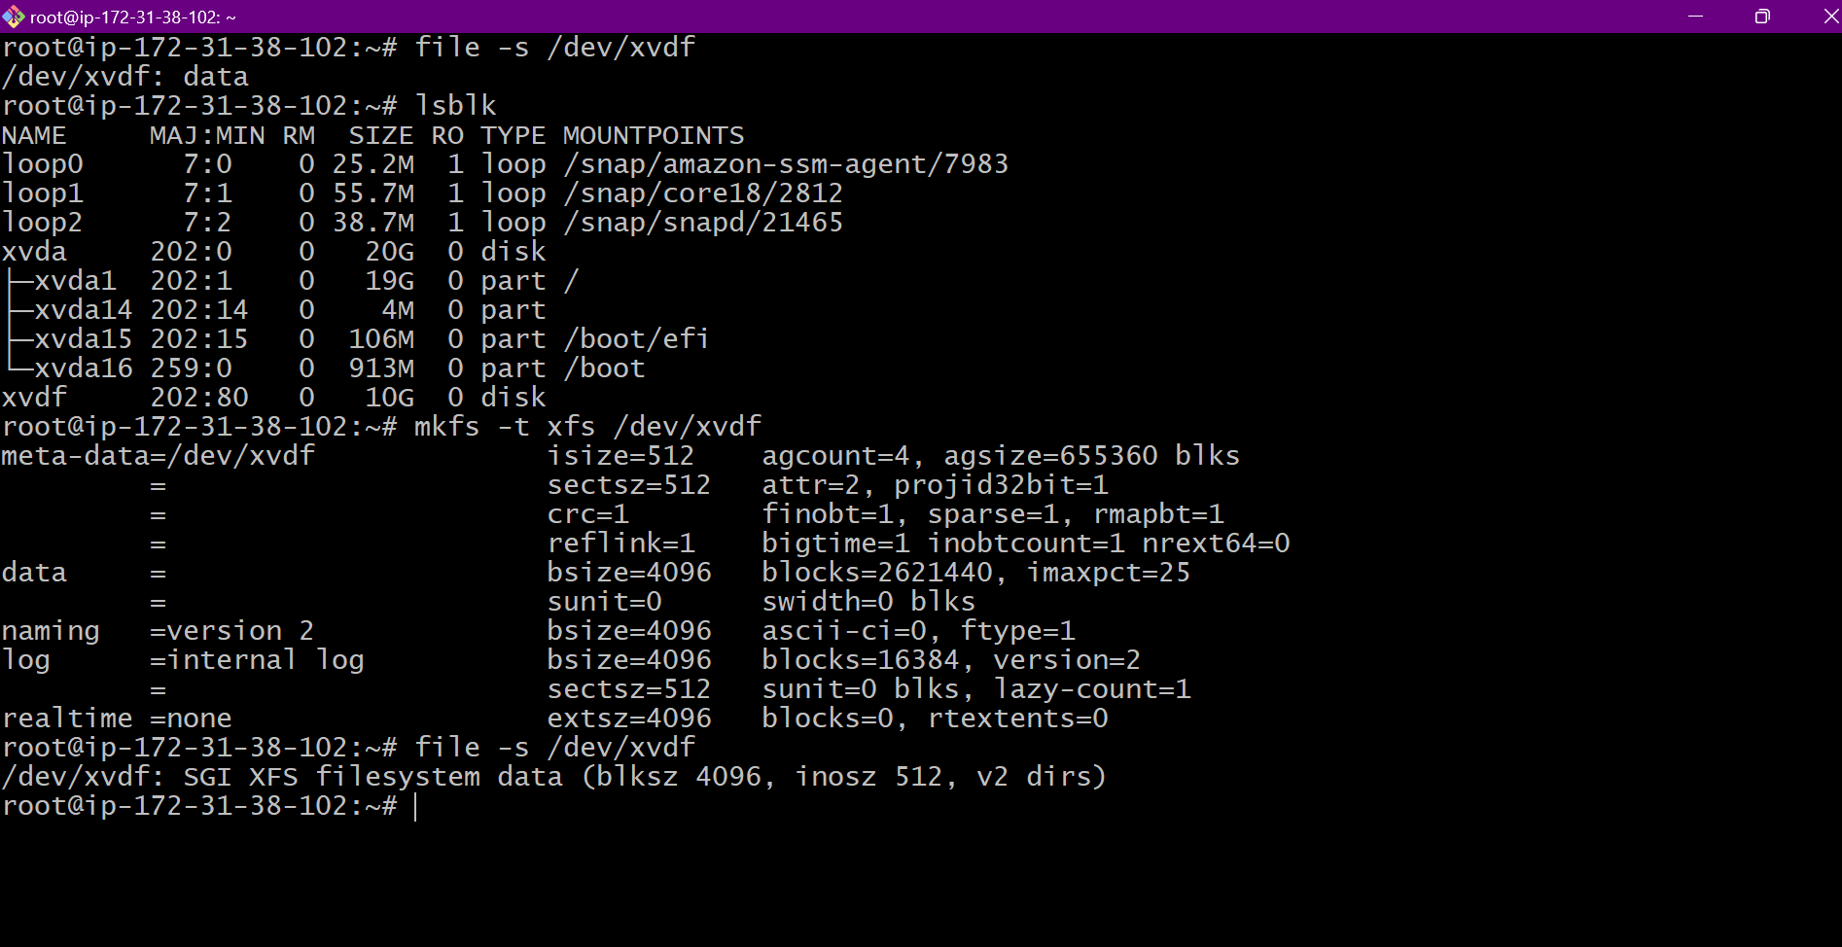
TO STORE THE DIRECTORY SIZE TO THE 10GB WE CREATED
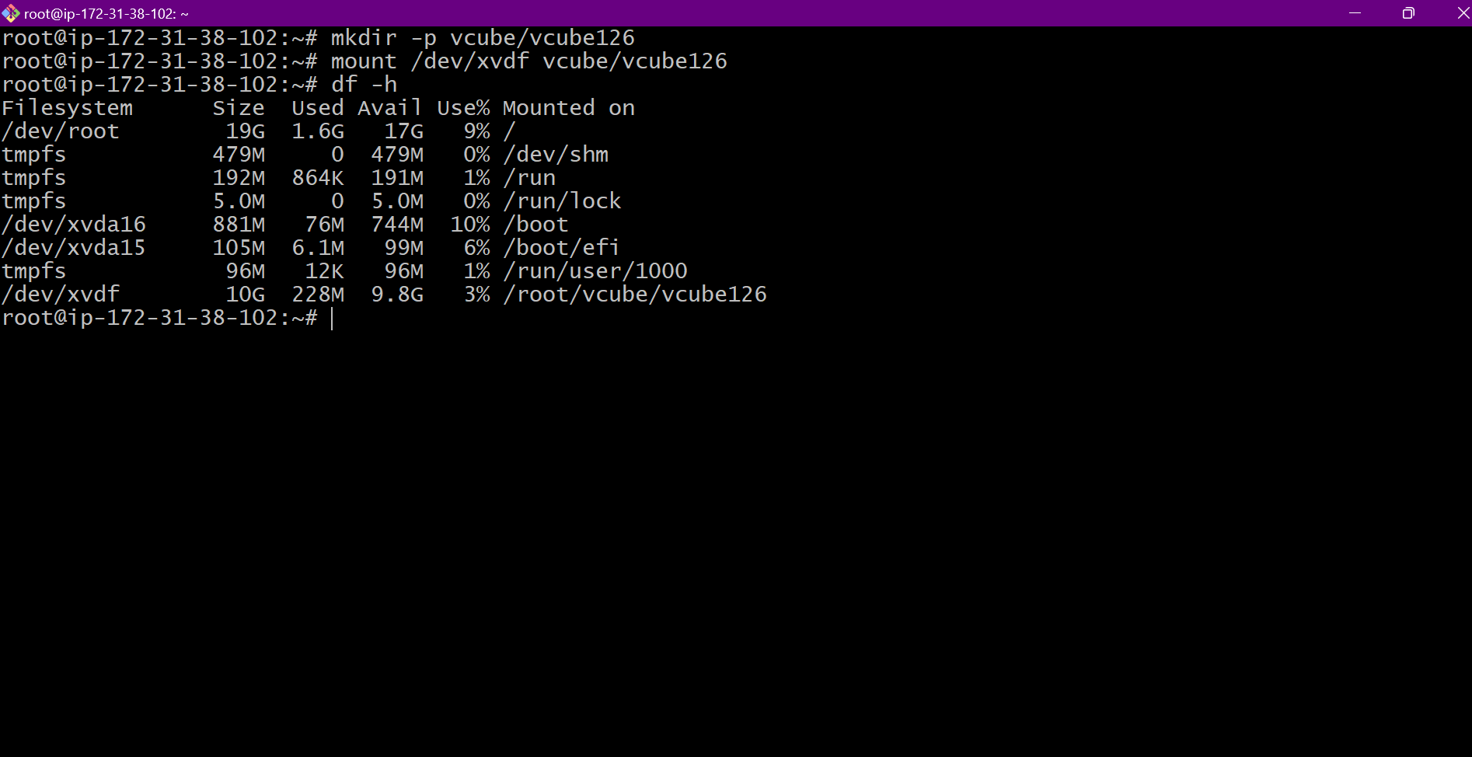
3. TO ATTACH EFS TO TWO VOLUMES
1. CREATE SECURITY GROUP
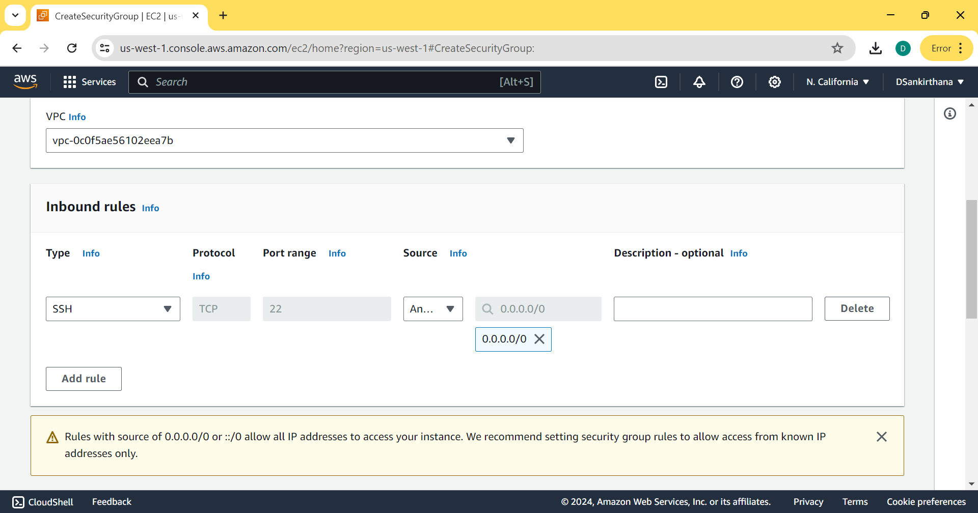
2. CREATE EFS, CREATE FILE SYSTEM
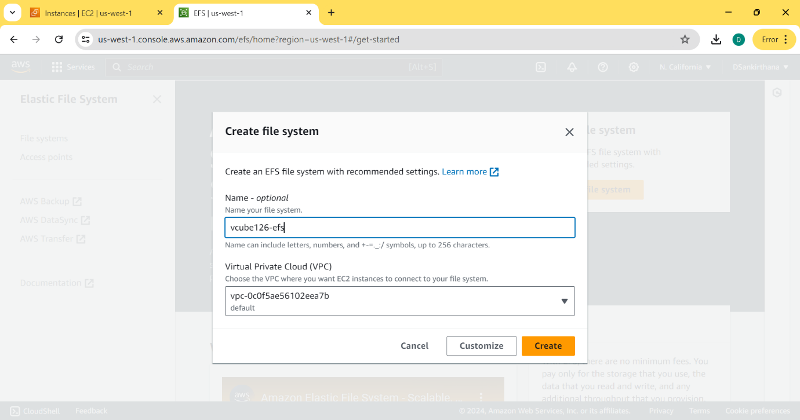
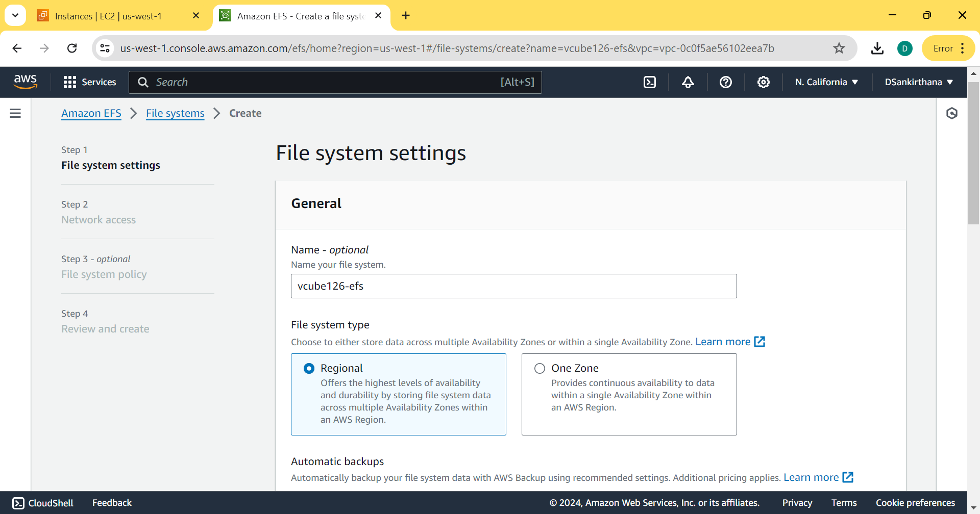
3. SELECT OWN SECURITY GROUP
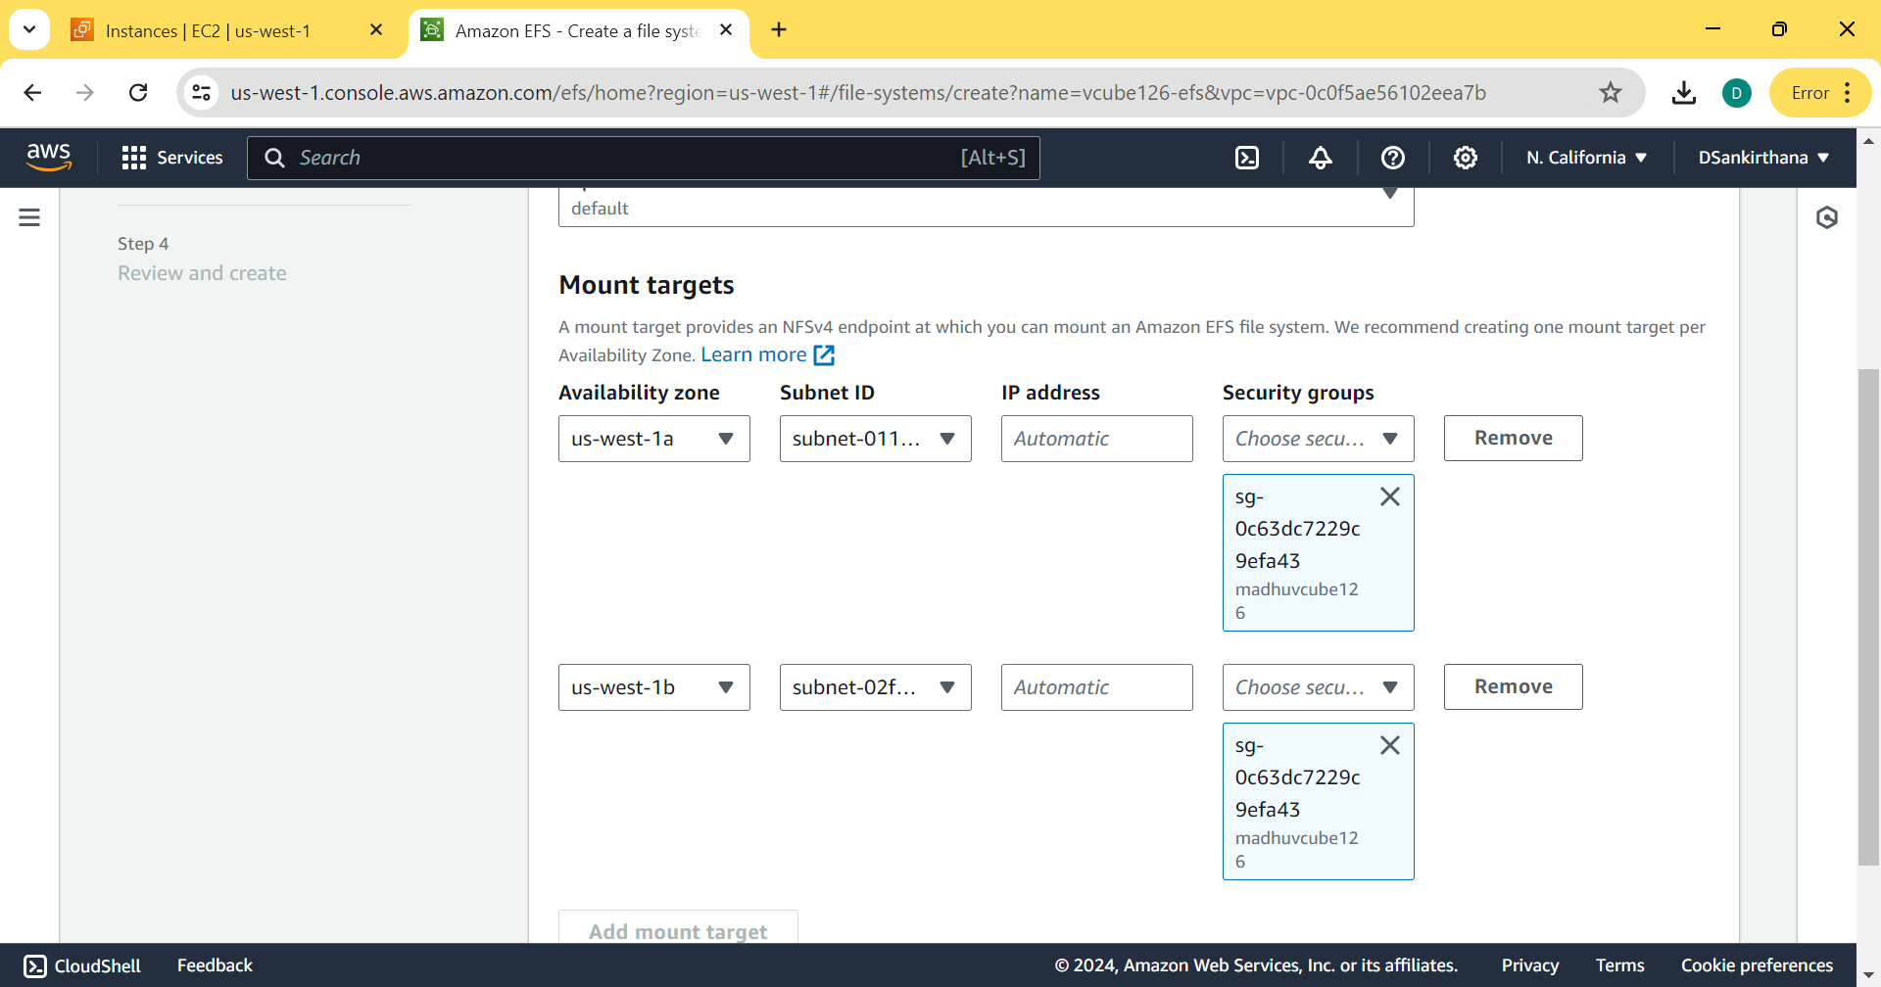
4. THE FILE SYSTEM IS CREATED
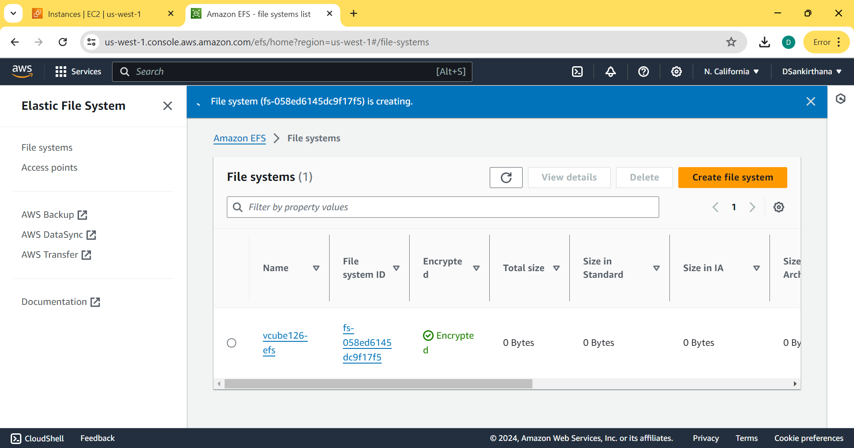
5. CREATE EC2 INSTANCE NAMED efs

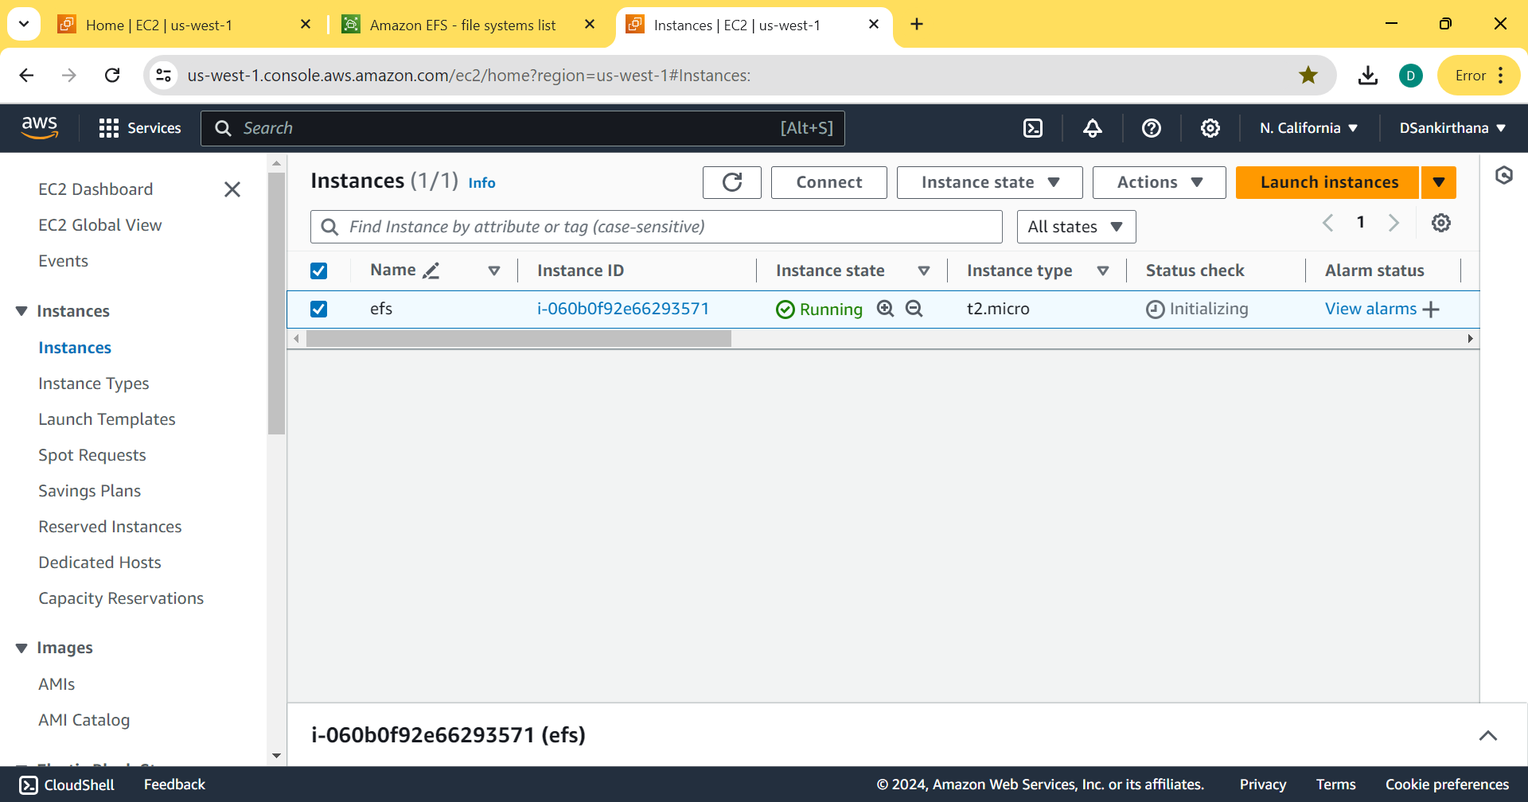
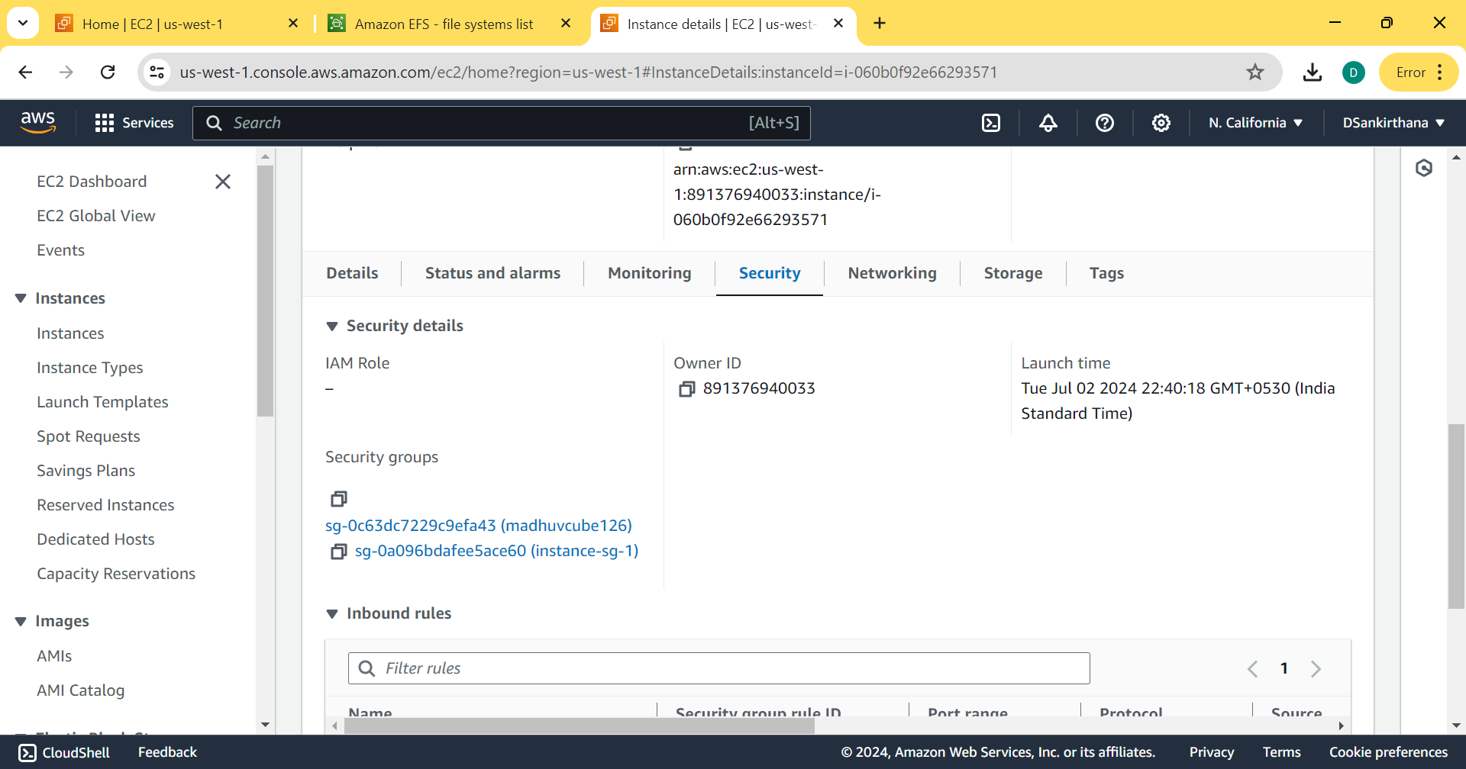
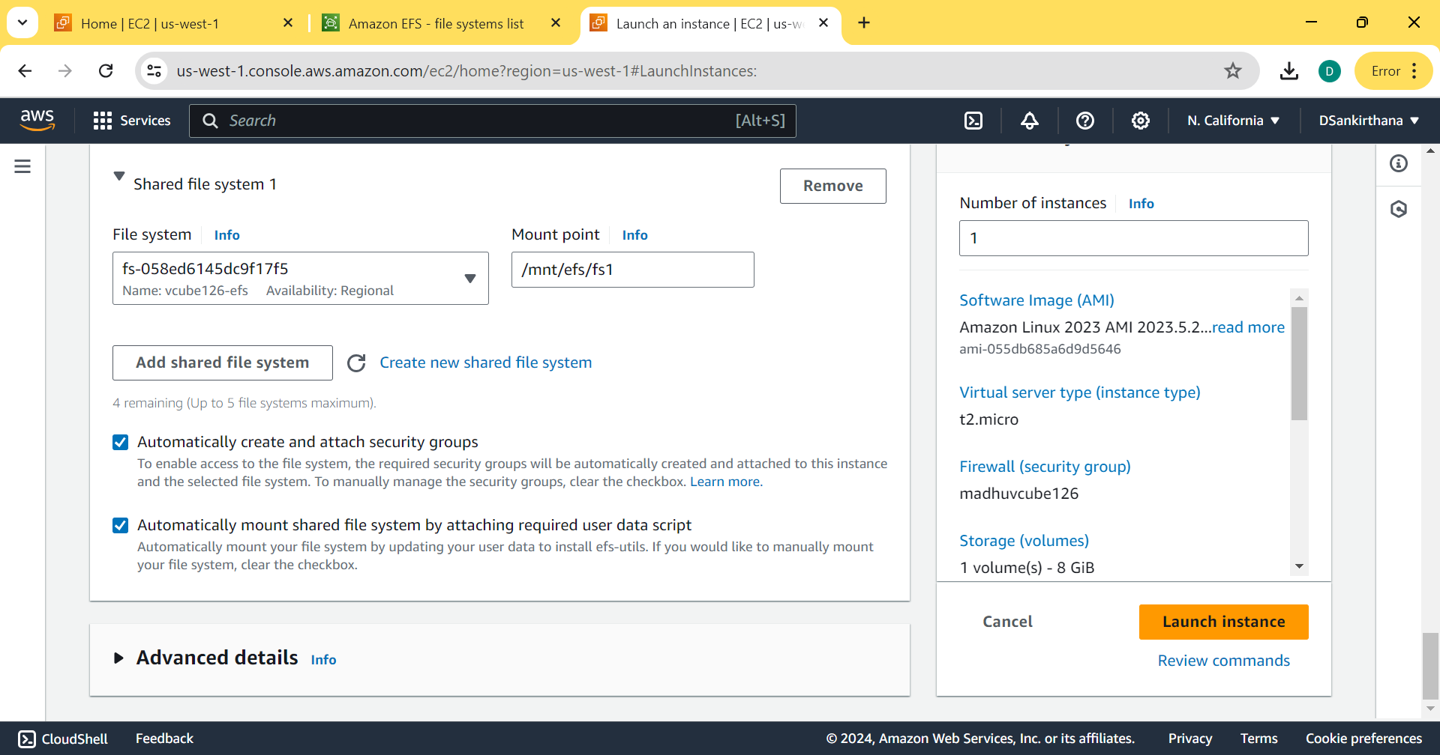
6. CREATE OTHER INSTANCE AS DID ABOVE NAMED efs-2
7. CREATING FILES IN efs WHICH IS NAMED AS file1
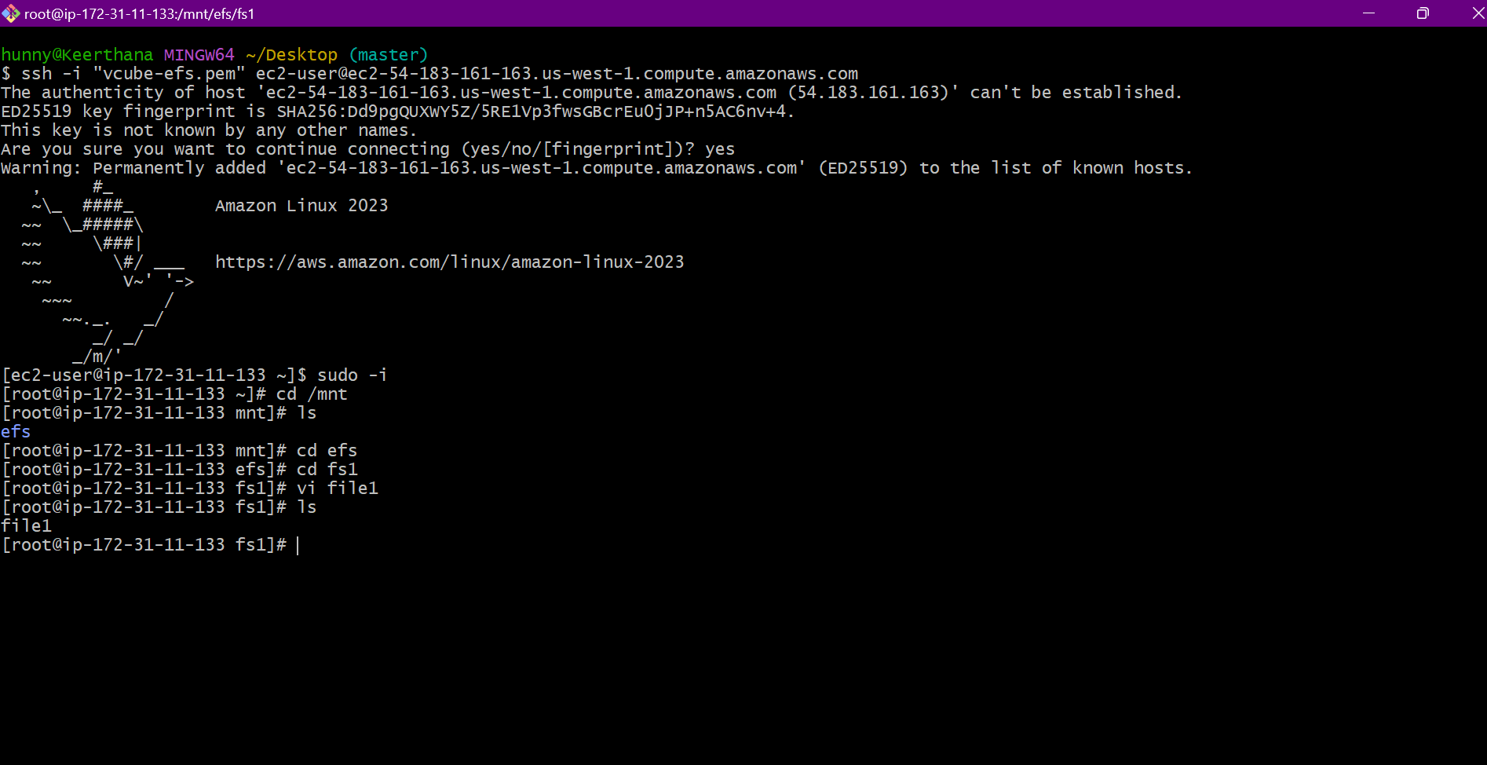
SAME WAY CREATE ONE MORE FILE IN OTHER efs-2 INSTANCE ALSO WHICH IS NAMED AS B
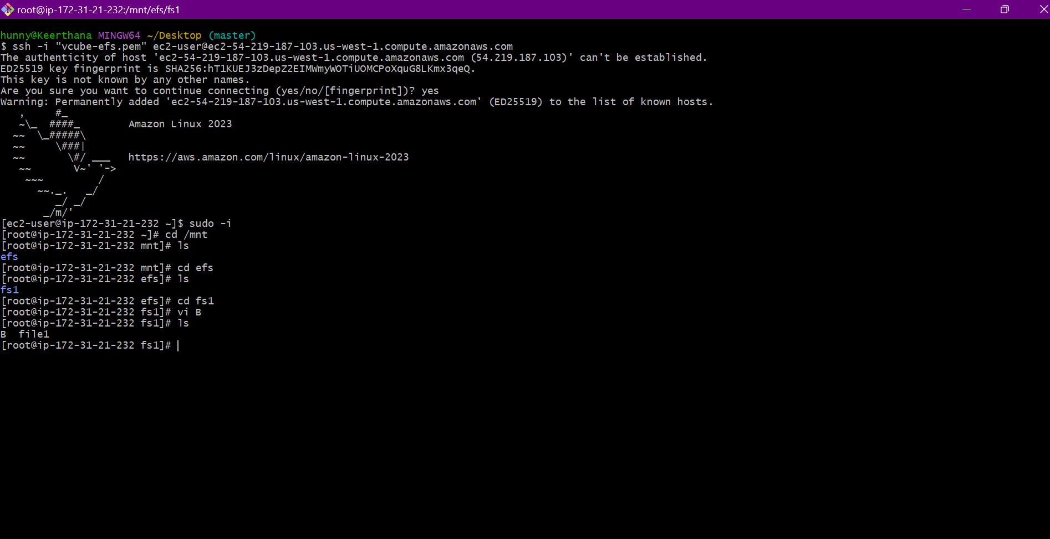

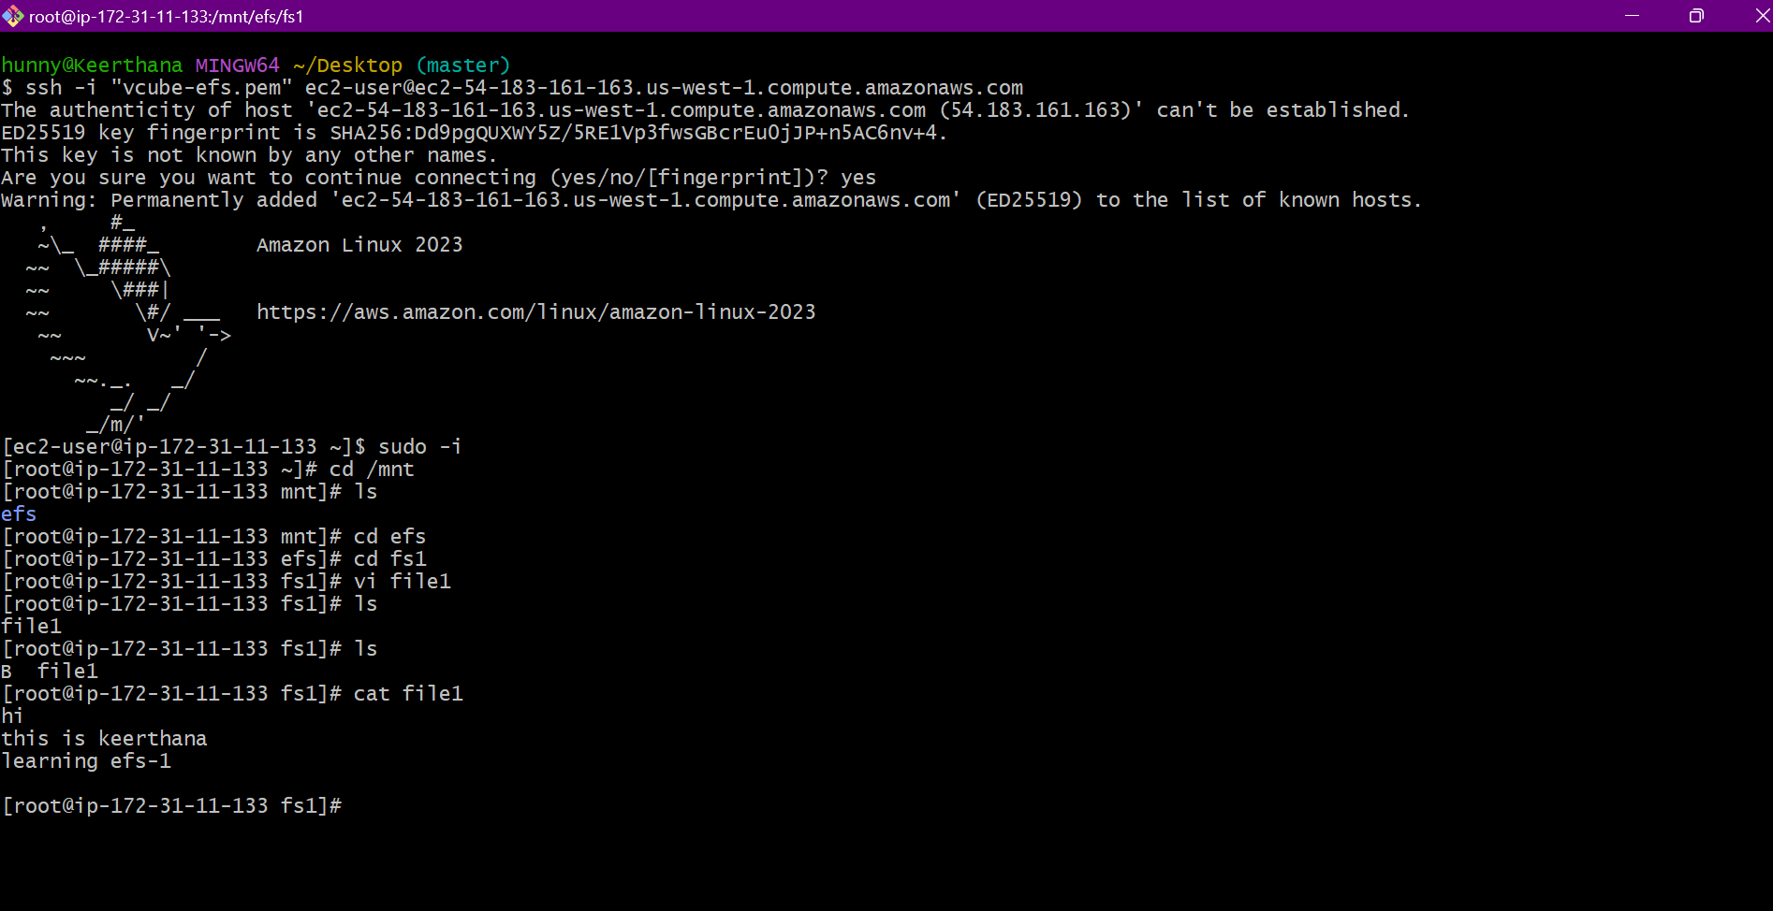
NOW WE CAN SEE FILES IN BOTH THE INSTANCES WHICH MEANS THE FILES ARE SHARED

