Project
1. Create Autoscaling using terraform
Steps:
1. Install awscli and Terraform in the gitbash
2. Create one directory and create different blocks.
2.Creating three blocks
- Terraform block
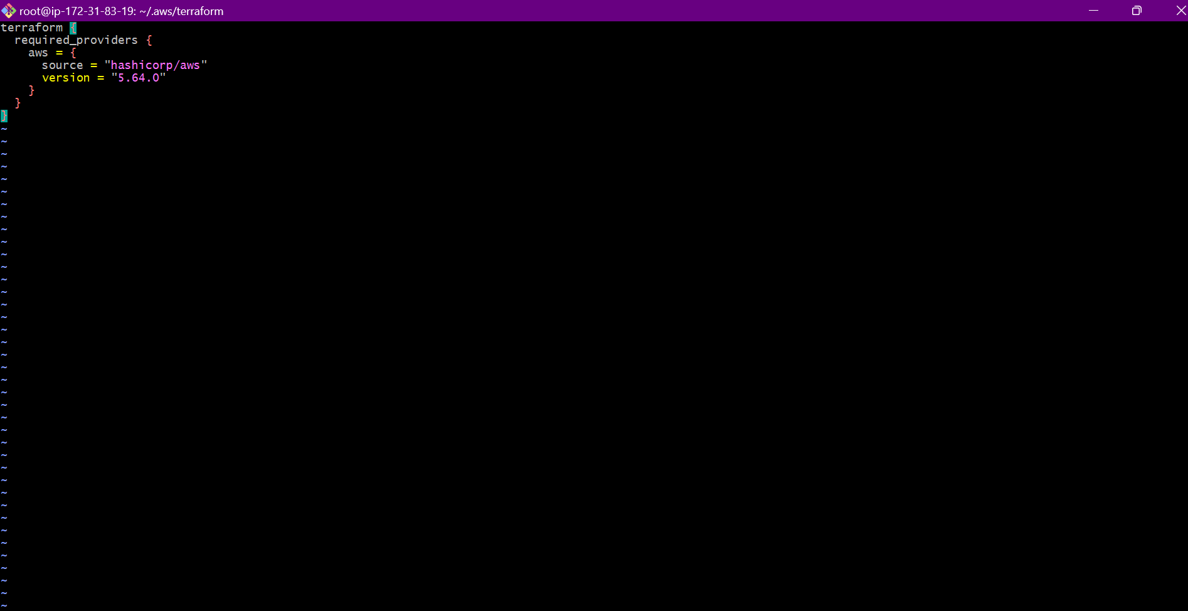
- Provider block
- 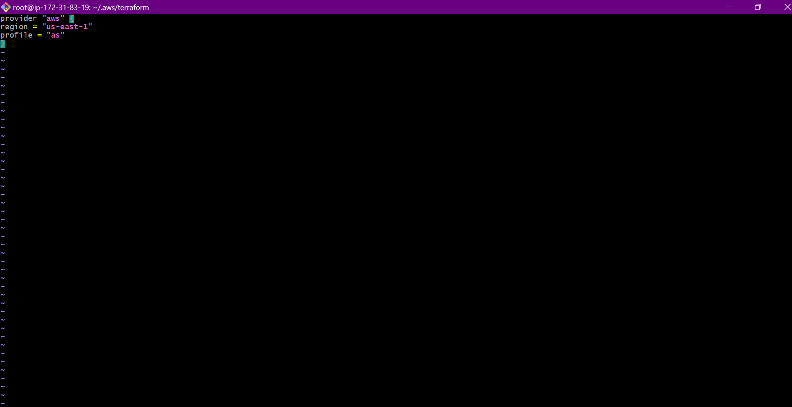

- Resource block
As we have to create autoscaling we need load balancer. The script for creating load balancer, target group, AMI, Autoscaling is given below.

# Create a VPC
resource "aws_vpc" "my_vpc" {
cidr_block = "10.0.0.0/16"
}

# Create the first Subnet
resource "aws_subnet" "my_subnet_1" {
vpc_id = aws_vpc.my_vpc.id
cidr_block = "10.0.3.0/24"
availability_zone = "us-east-1a"
}

# Create the second Subnet
resource "aws_subnet" "my_subnet_2" {
vpc_id = aws_vpc.my_vpc.id
cidr_block = "10.0.4.0/24"
availability_zone = "us-east-1b"
}

# Create an Internet Gateway
resource "aws_internet_gateway" "my_igw" {
vpc_id = aws_vpc.my_vpc.id
}

# Create a Route Table
resource "aws_route_table" "my_route_table" {
vpc_id = aws_vpc.my_vpc.id

route {
cidr_block = "0.0.0.0/0"
gateway_id = aws_internet_gateway.my_igw.id
}
}

# Associate the Route Table with the Subnets
resource "aws_route_table_association" "my_route_table_association_1" {
subnet_id = aws_subnet.my_subnet_1.id
route_table_id = aws_route_table.my_route_table.id
}

resource "aws_route_table_association" "my_route_table_association_2" {
subnet_id = aws_subnet.my_subnet_2.id
route_table_id = aws_route_table.my_route_table.id
}

# Create a Security Group
resource "aws_security_group" "my_sg" {
vpc_id = aws_vpc.my_vpc.id

ingress {
from_port = 80
to_port = 80
protocol = "tcp"
cidr_blocks = ["0.0.0.0/0"]
}

egress {
from_port = 0
to_port = 0
protocol = "-1"
cidr_blocks = ["0.0.0.0/0"]
}
}

# Create an EC2 Instance
resource "aws_instance" "as" {
ami = "ami-0e86e20dae9224db8" # Change to your preferred AMI
instance_type = "t2.micro"
subnet_id = aws_subnet.my_subnet_1.id
vpc_security_group_ids = [aws_security_group.my_sg.id]

tags = {
Name = "my-ec2-instance"
}
}

# Create a Launch Template
resource "aws_launch_template" "my_launch_template" {
name_prefix = "example-"
image_id = aws_instance.as.ami
instance_type = aws_instance.as.instance_type

network_interfaces {
associate_public_ip_address = true
security_groups = [aws_security_group.my_sg.id]
subnet_id = aws_subnet.my_subnet_1.id
}

tag_specifications {
resource_type = "instance"
tags = {
Name = "autoscaling-instance"
}
}
}

# Create an Auto Scaling Group
resource "aws_autoscaling_group" "my_asg" {
launch_template {
id = aws_launch_template.my_launch_template.id
version = "$Latest"
}

min_size = 1
max_size = 2
desired_capacity = 1

vpc_zone_identifier = [aws_subnet.my_subnet_1.id, aws_subnet.my_subnet_2.id]

target_group_arns = [aws_lb_target_group.my_target_group.arn]

tag {
key = "Name"
value = "autoscaling-instance"
propagate_at_launch = true
}
}

# Create a Load Balancer
resource "aws_lb" "my-lb" {
name = "my-lb"
internal = false
load_balancer_type = "application"
security_groups = [aws_security_group.my_sg.id]
subnets = [aws_subnet.my_subnet_1.id, aws_subnet.my_subnet_2.id]

enable_deletion_protection = false
}

# Create a Target Group
resource "aws_lb_target_group" "my_target_group" {
name = "my-target-group"
port = 80
protocol = "HTTP"
vpc_id = aws_vpc.my_vpc.id
}

# Create a Listener for the Load Balancer
resource "aws_lb_listener" "my_lb_listener" {
load_balancer_arn = aws_lb.my-lb.arn
port = "80"
protocol = "HTTP"

default_action {
type = "forward"
target_group_arn = aws_lb_target_group.my_target_group.arn
}
}

Variable block ---->>

variable "aws_region" {
description = "The AWS region to deploy to"
type = string
default = "us-east-1"
}

variable "vpc_cidr" {
description = "The CIDR block for the VPC"
type = string
default = "10.0.0.0/16"
}

variable "subnet_1_cidr" {
description = "The CIDR block for the first subnet"
type = string
default = "10.0.3.0/24"
}

variable "subnet_2_cidr" {
description = "The CIDR block for the second subnet"
type = string
default = "10.0.4.0/24"
}

variable "availability_zone_1" {
description = "The Availability Zone for the first subnet"
type = string
default = "us-east-1a"
}

variable "availability_zone_2" {
description = "The Availability Zone for the second subnet"
type = string
default = "us-east-1b"
}

variable "instance_type" {
description = "The EC2 instance type"
type = string
default = "t2.micro"
}

variable "ami_id" {
description = "The AMI ID to use for the EC2 instance"
type = string
default = "ami-0e86e20dae9224db8" # Change this to your preferred AMI ID
}

variable "min_size" {
description = "Minimum number of instances in the Auto Scaling Group"
type = number
default = 1
}

variable "max_size" {
description = "Maximum number of instances in the Auto Scaling Group"
type = number
default = 2
}

variable "desired_capacity" {
description = "Desired number of instances in the Auto Scaling Group"
type = number
default = 1
}

Output block --->>

output "vpc_id" {
description = "The ID of the VPC"
value = aws_vpc.my_vpc.id
}

output "subnet_1_id" {
description = "The ID of the first subnet"
value = aws_subnet.my_subnet_1.id
}

output "subnet_2_id" {
description = "The ID of the second subnet"
value = aws_subnet.my_subnet_2.id
}

output "security_group_id" {
description = "The ID of the Security Group"
value = aws_security_group.my_sg.id
}

output "instance_id" {
description = "The ID of the EC2 Instance"
value = aws_instance.as.id
}

output "autoscaling_group_name" {
description = "The name of the Auto Scaling Group"
value = aws_autoscaling_group.my_asg.name
}

output "load_balancer_dns" {
description = "The DNS name of the Load Balancer"
value = aws_lb.my-lb.dns_name
}

output "target_group_arn" {
description = "The ARN of the Target Group"
value = aws_lb_target_group.my_target_group.arn
}

output "launch_template_id" {
description = "The ID of the Launch Template"
value = aws_launch_template.my_launch_template.id
}
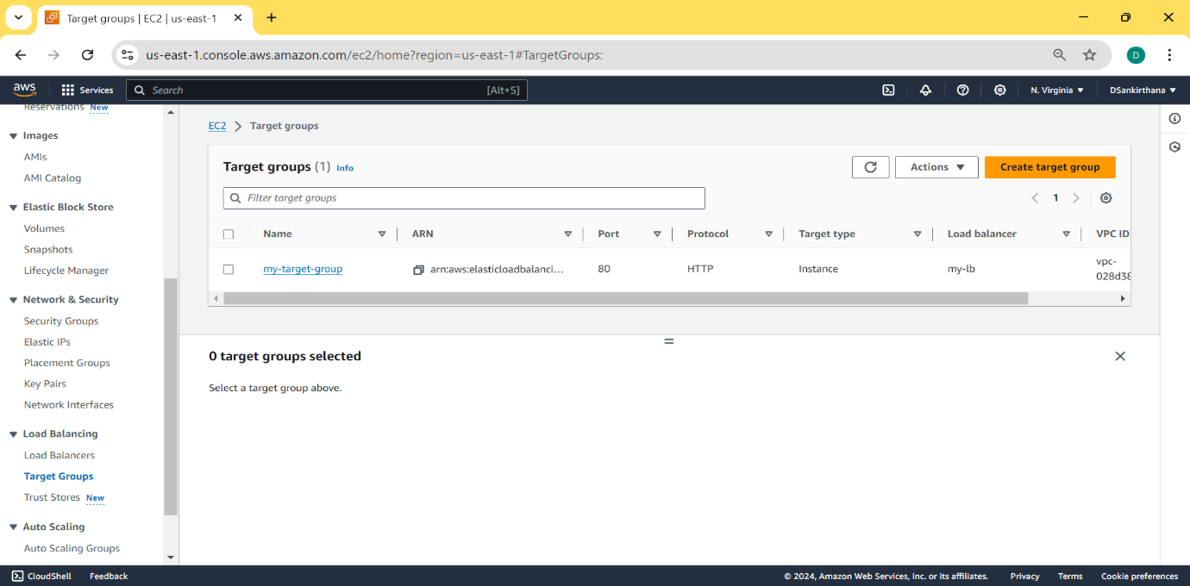
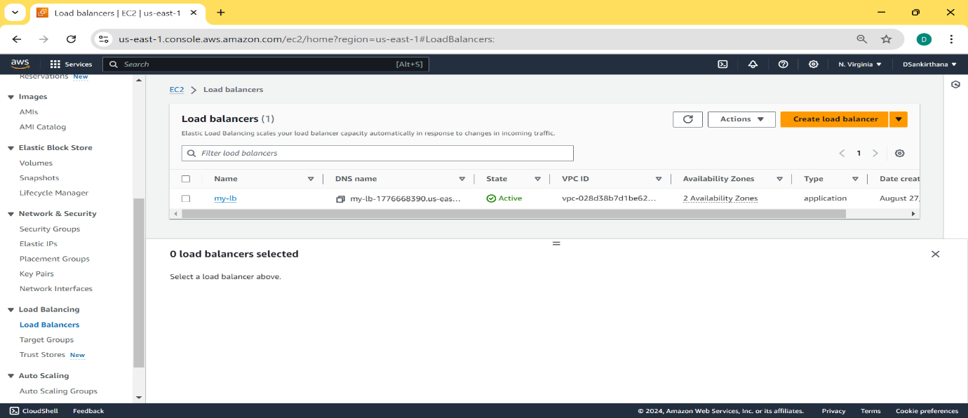
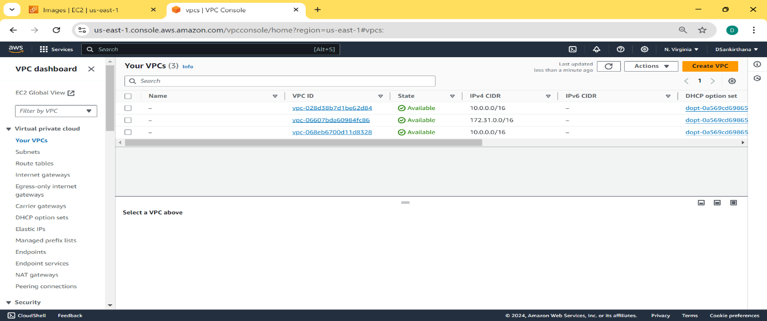
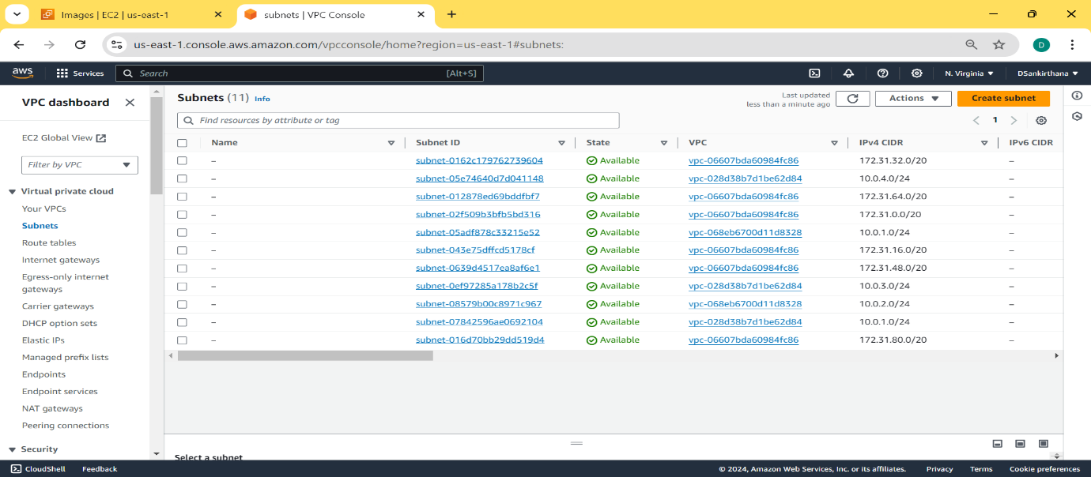
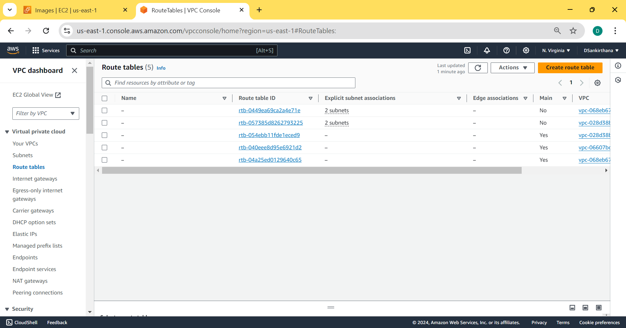
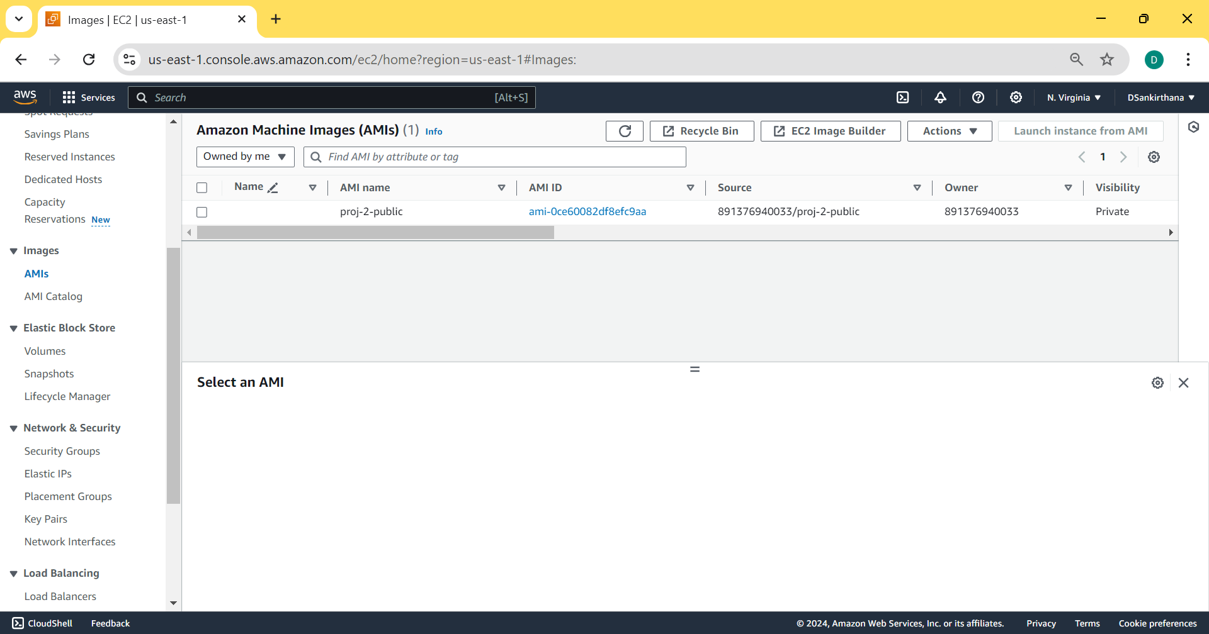
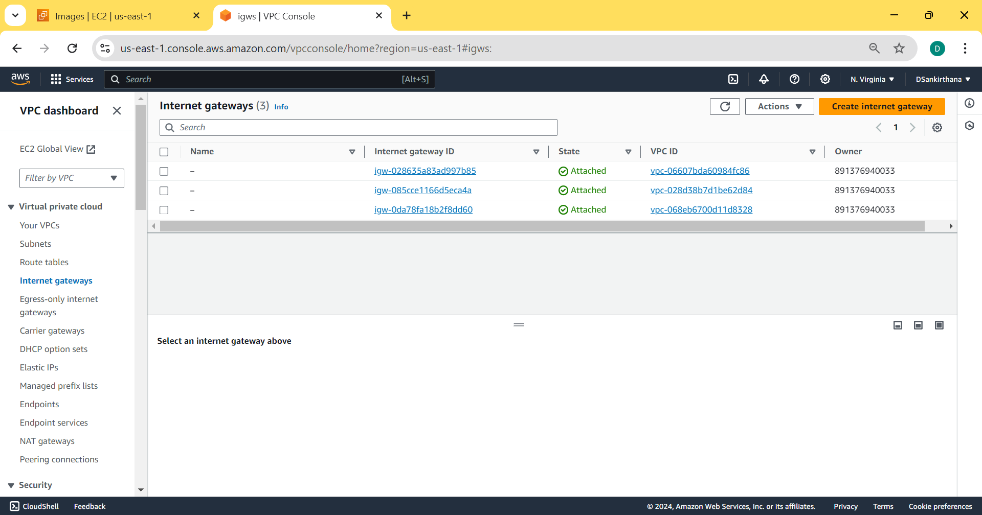
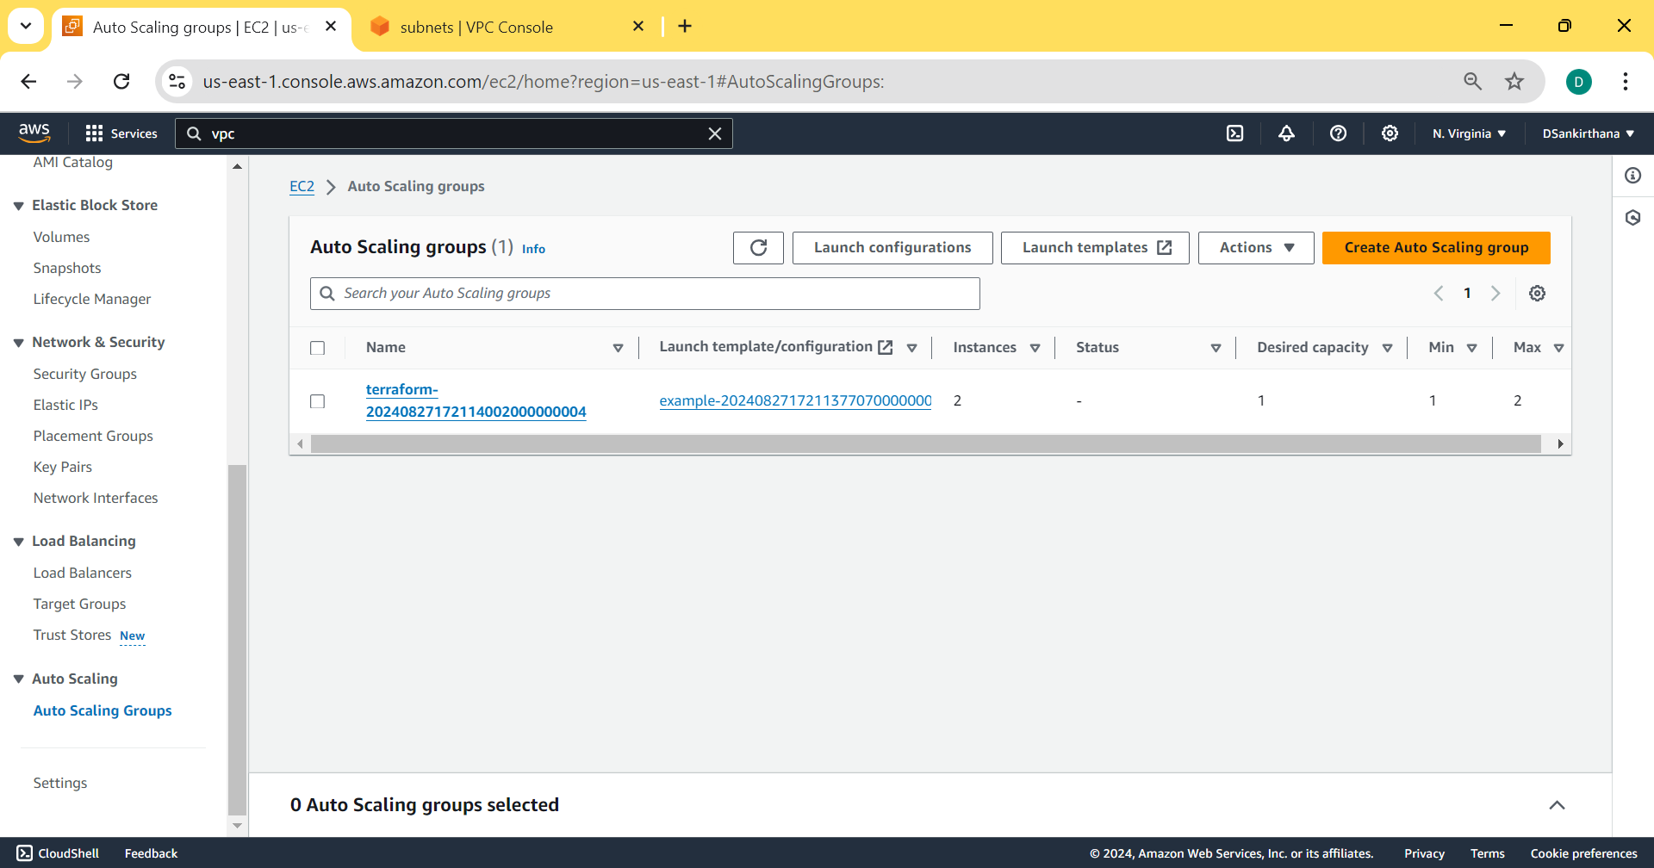
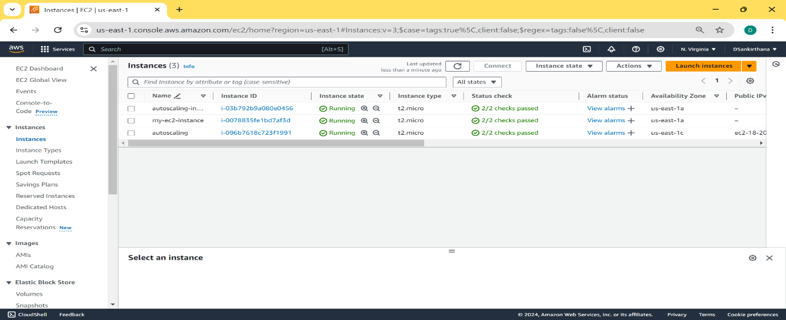

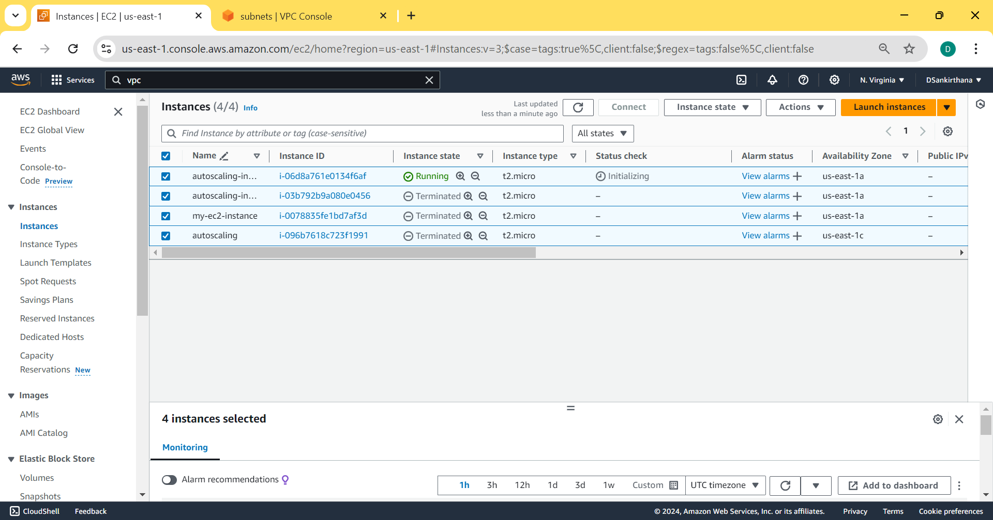
By the above screenshots, it is seen that autoscaling group is created using terraform script.

