Assignment-9.1
Name:Divya
Batch:14
RollNo:2403A51356
Task Description #1 (Documentation – Google-Style Docstrings for
Python Functions)
• Task: Use AI to add Google-style docstrings to all functions in a
given Python script.
• Instructions:
o Prompt AI to generate docstrings without providing any
input-output examples.
o Ensure each docstring includes:
▪ Function description
▪ Parameters with type hints
▪ Return values with type hints
▪ Example usage
o Review the generated docstrings for accuracy and
formatting.
• Expected Output #1:
o A Python script with all functions documented using
correctly formatted Google-style docstrings.
Prompt: AI to generate docstrings without providing any
input-output examples. Ensure each docstring includes:
▪ Function description
▪ Parameters with type hints
▪ Return values with type hints
▪ Example usage
o Review the generated docstrings for accuracy and
formatting.

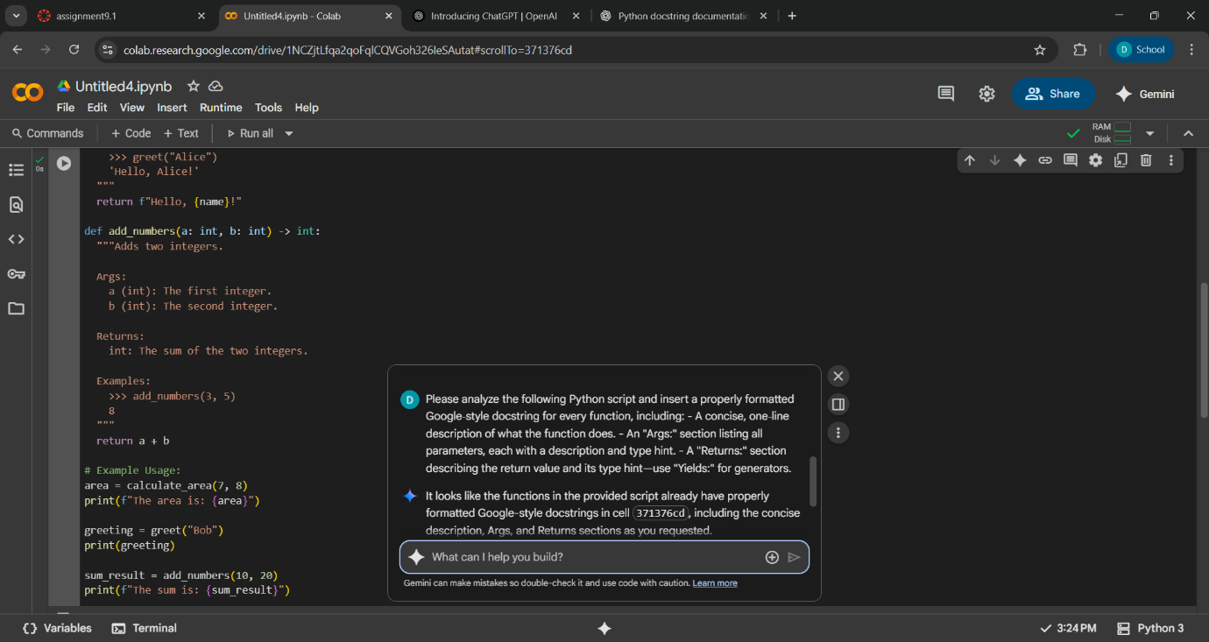
Code:

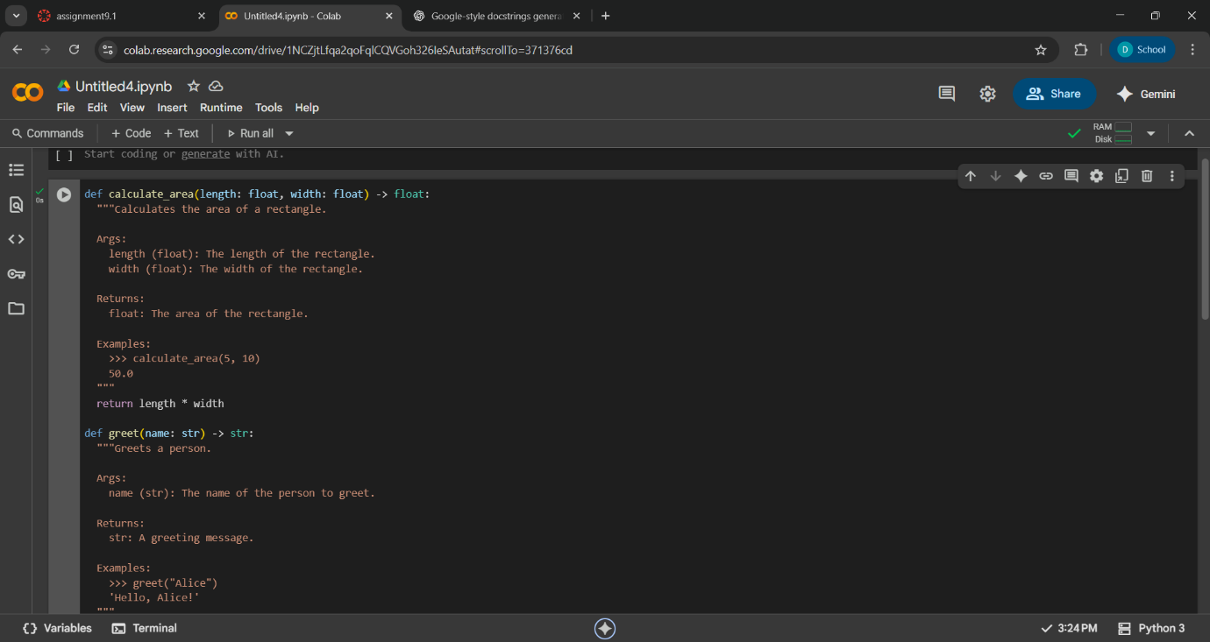

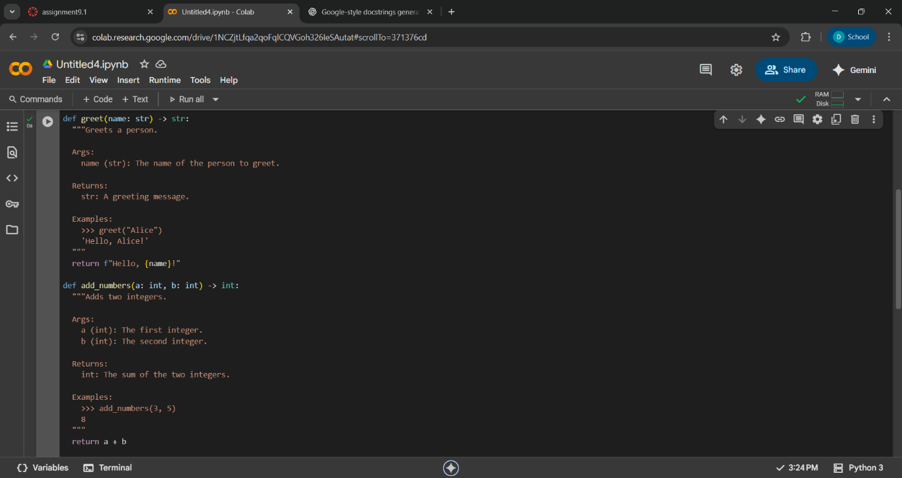
Observation:

- The code is neatly divided into three separate functions, each doing one clear task:
  - calculate_area() – for rectangle area.
  - greet() – for greeting a person.
  - add_numbers() – for adding two integers.
.It shows how each function can be used.
.It prints the results to the console.
- The logic in all three functions is basic and easy to understand.
- There are no complex conditions, loops, or advancedstructures.
- Each function is general-purpose and can be reused in other programs or situations.
Task Description #2 (Documentation – Inline Comments for Complex
Logic)
• Task: Use AI to add meaningful inline comments to a Python
program explaining only complex logic parts.
• Instructions:
o Provide a Python script without comments to the AI.
o Instruct AI to skip obvious syntax explanations and focus
only on tricky or non-intuitive code sections.
o Verify that comments improve code readability and
maintainability.
• Expected Output #2:
o Python code with concise, context-aware inline comments
for complex logic blocks
Prompt: Write a Python script that takes a filename as a command-line argument, checks if it is a Python file (ends with .py), and counts the number of non-empty, non-comment lines in the file. If the file does not exist or is not a Python file, display an appropriate error.
Code:

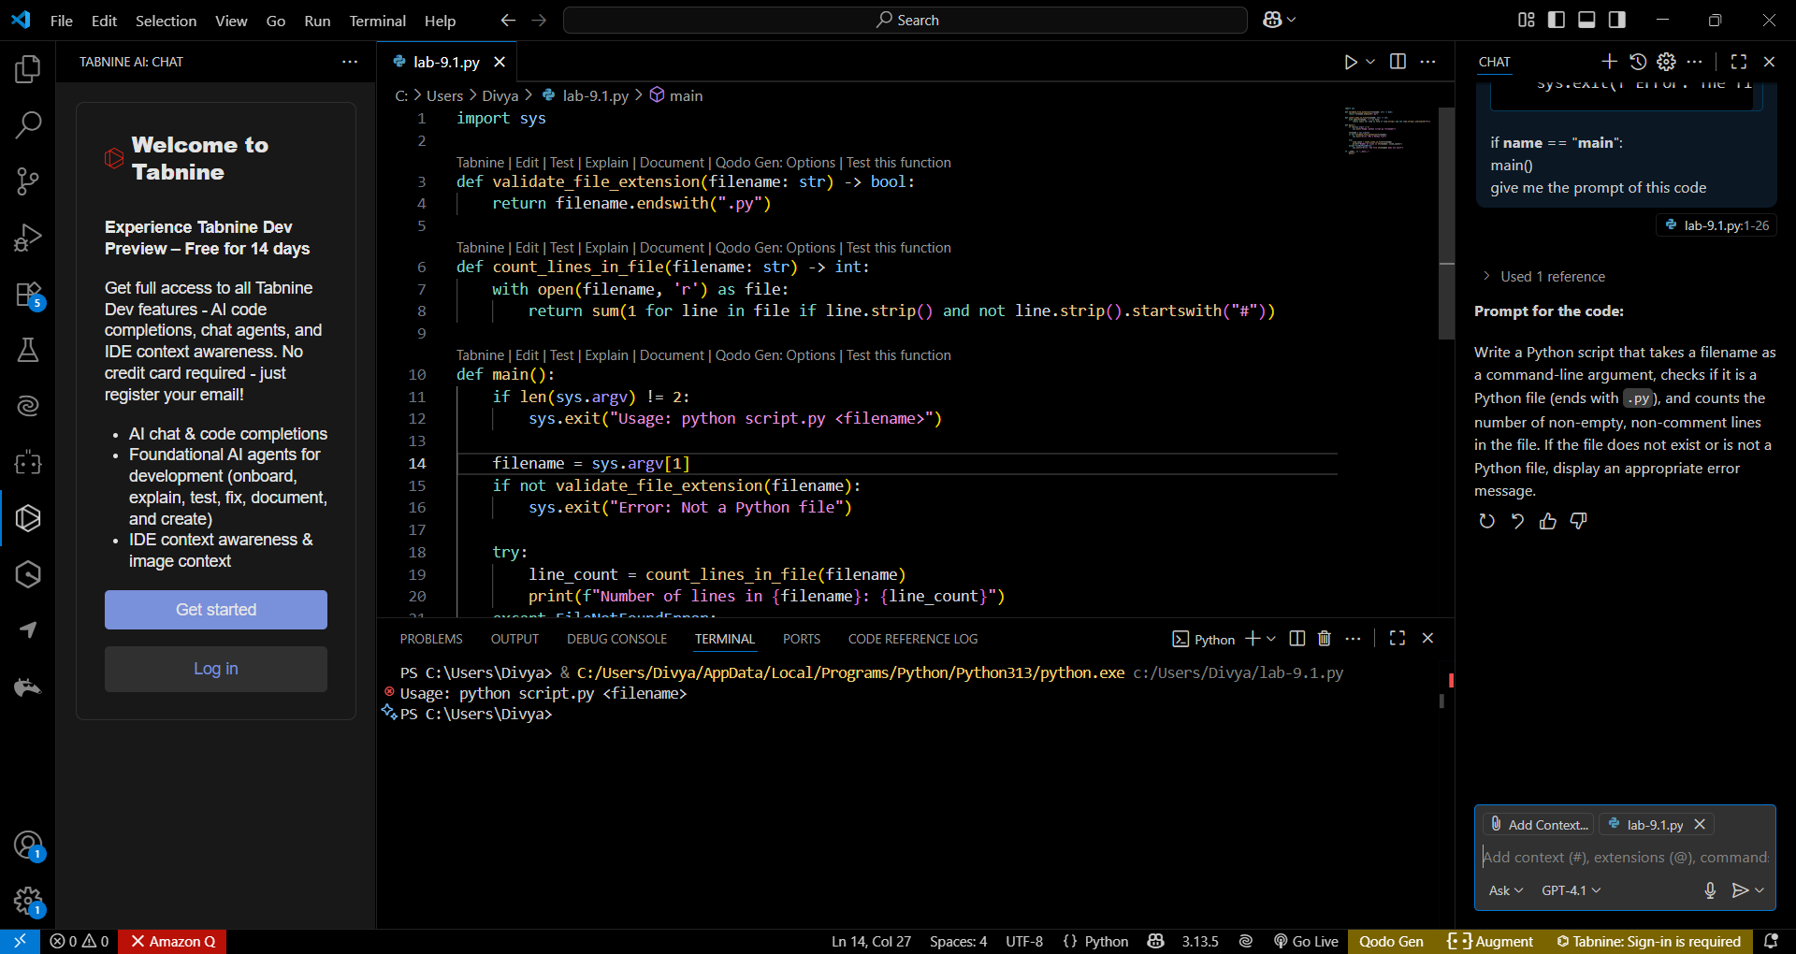

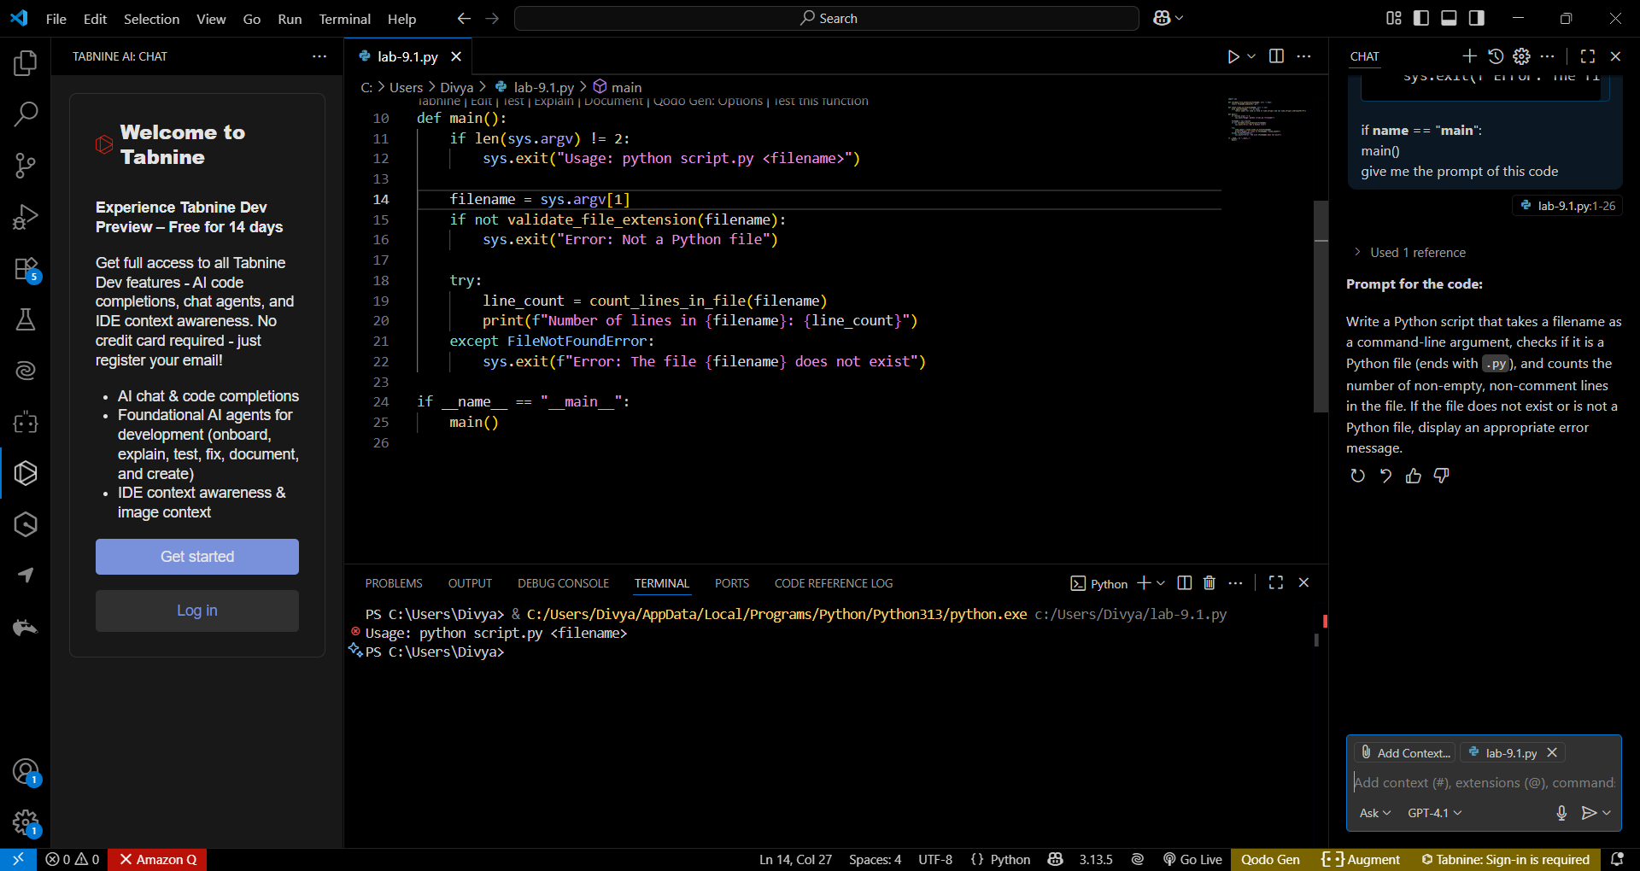
Observation:
- The script checks if a filename is provided as a command-line argument.
- It validates that the filename ends with .py to ensure it is a Python file.
- It counts the number of non-empty, non-comment lines in the specified file.
- If the file does not exist or is not a Python file, it exits with an error message.
- The code uses functions for validation and line counting, making it modular and readable.
- The script is intended to be run from the command line.
Task Description #3 (Documentation – Module-Level Documentation)
•Task: Use AI to create a module-level docstring summarizing the
purpose, dependencies, and main functions/classes of a Python
file.
• Instructions:
o Supply the entire Python file to AI.
o Instruct AI to write a single multi-line docstring at the top
of the file.
o Ensure the docstring clearly describes functionality and
usage without rewriting the entire code.
• Expected Output #3:
o A complete, clear, and concise module-level docstring at
the beginning of the file.
Prompt:

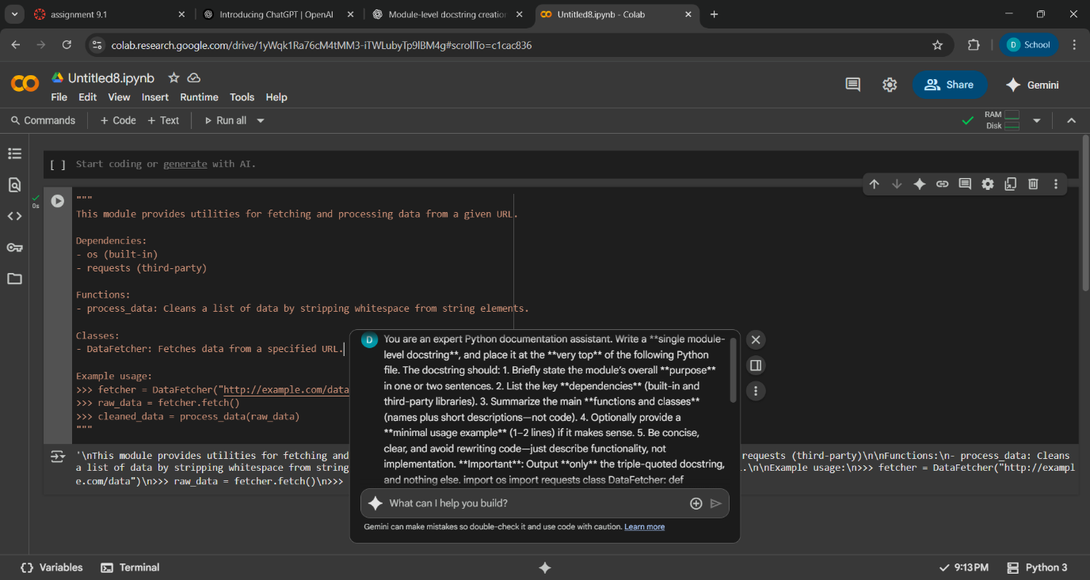
Code:

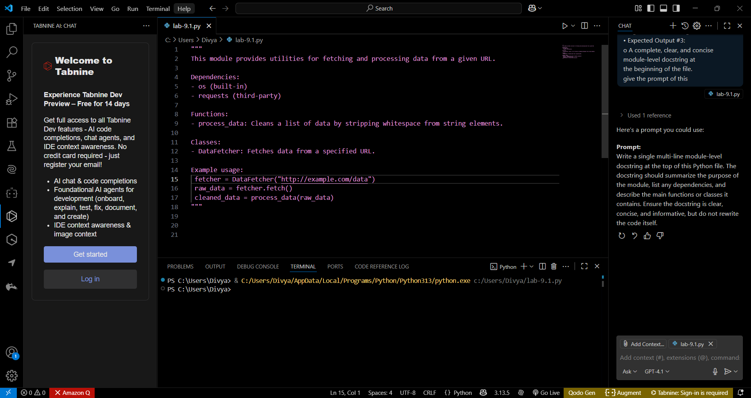

Task Description #4 (Documentation – Convert Comments to
Structured Docstrings)
• Task: Use AI to transform existing inline comments into
structured function docstrings following Google style.
• Instructions:
o Provide AI with Python code containing inline comments.
o Ask AI to move relevant details from comments into
function docstrings.
o Verify that the new docstrings keep the meaning intact
while improving structure.
• Expected Output #4:
o Python code with comments replaced by clear,
standardized docstrings.
Prompt:
Transform the inline comments in this Python code into structured function docstrings following the Google style. Move all relevant details from comments into the appropriate docstrings, ensuring the meaning is preserved and the documentation is clear and standardized.

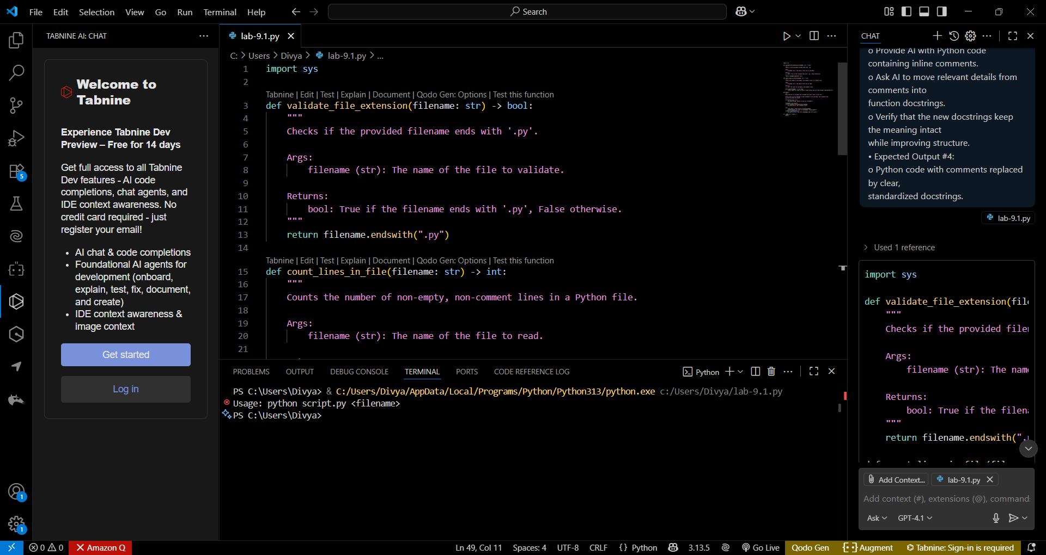

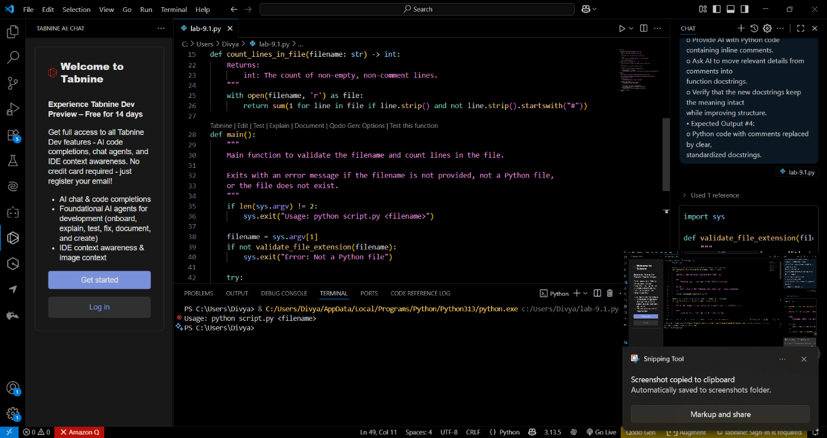

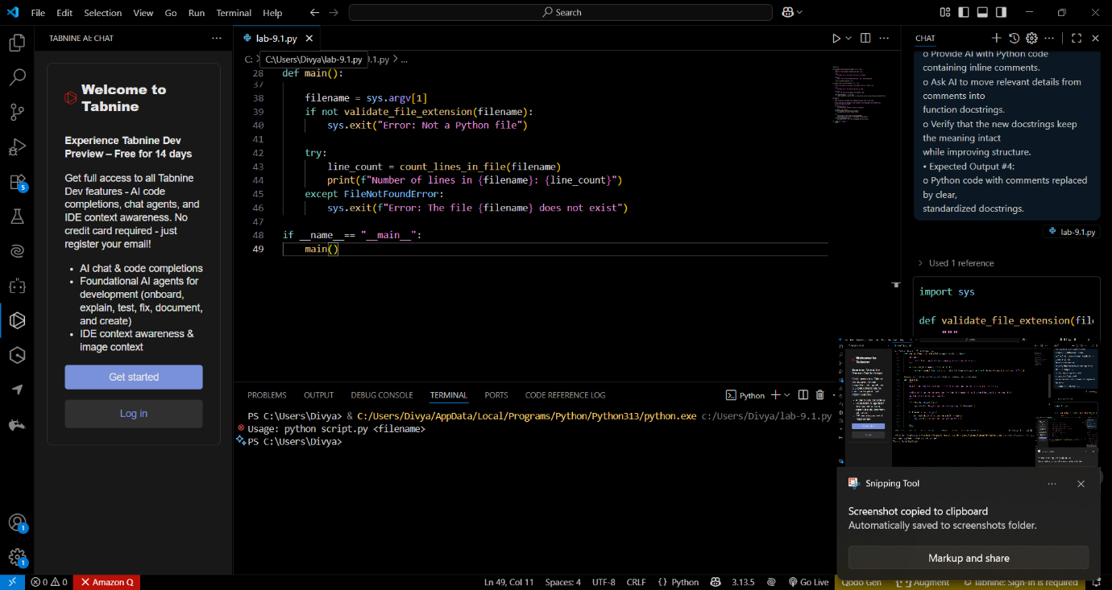
Observation:
- The code is well-structured and modular, using functions for specific tasks.
- Each function includes a Google-style docstring that clearly describes its purpose, arguments, and return values.
- The script validates the command-line argument to ensure a Python file is provided.
- It counts non-empty, non-comment lines in the specified file.
- Error handling is implemented for missing arguments, incorrect file extension, and file not found.
- The code is intended to be executed from the command line.
Task Description #5 (Documentation – Review and Correct
Docstrings)
• Task: Use AI to identify and correct inaccuracies in existing
docstrings.
• Instructions:
o Provide Python code with outdated or incorrect
docstrings.
o Instruct AI to rewrite each docstring to match the current
code behavior.
o Ensure corrections follow Google-style formatting.
• Expected Output #5:
o Python file with updated, accurate, and standardized
docstrings.
Prompt:
Review the docstrings in this Python code and correct any inaccuracies so that each docstring accurately describes the current behavior of its function. Ensure all docstrings follow Google-style formatting.
Code:

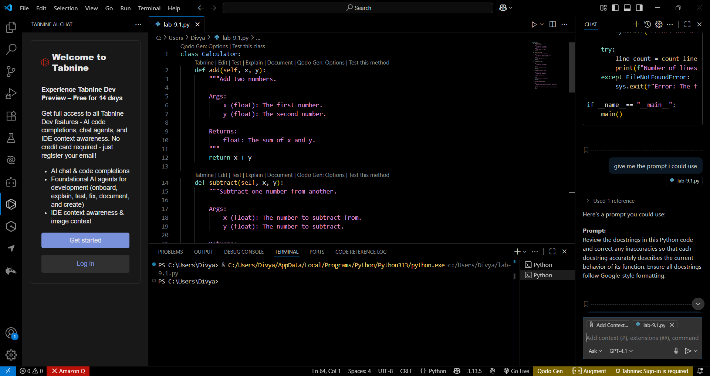

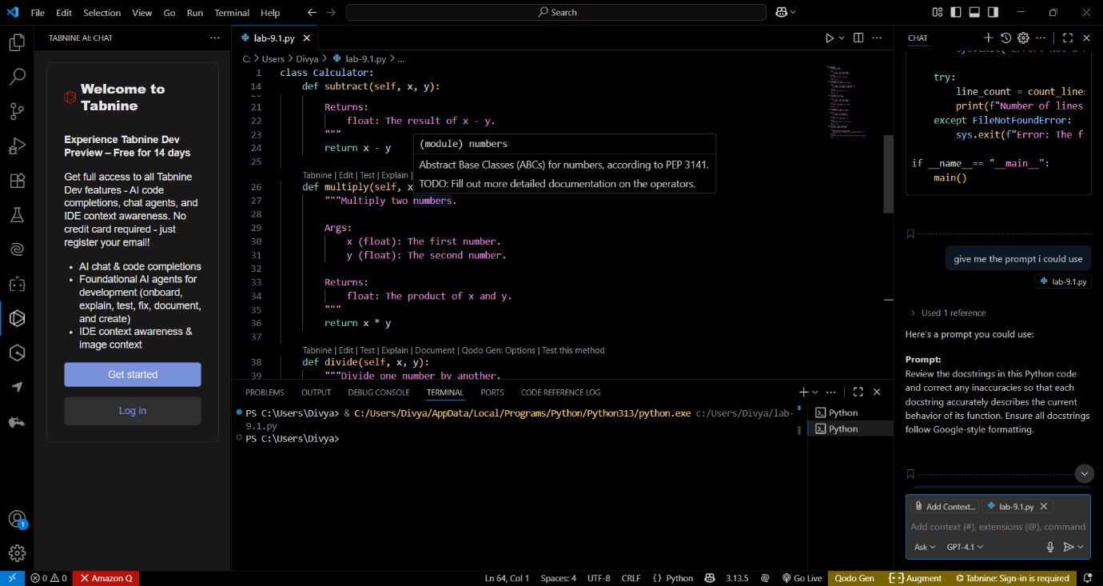

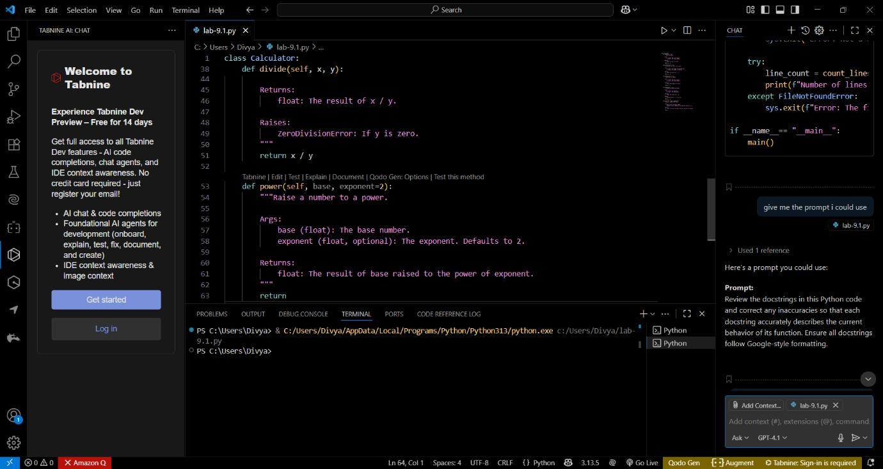

Observation:
- The Calculator class provides basic arithmetic operations: addition, subtraction, multiplication, division, and exponentiation.
- Most method docstrings are accurate and follow Google-style formatting, clearly describing arguments and return values.
- The divide method correctly documents the possibility of raising a ZeroDivisionError.
- The power method docstring is accurate, but the method implementation is incomplete (it only has return with no value).
- All methods expect numeric (float) inputs, but this is not enforced in the code.
- The class does not handle input validation or error handling beyond division by zero.
- The code is readable and modular, but the incomplete power method should be fixed for full functionality.
Task Description #6 (Documentation – Prompt Comparison
Experiment)
• Task: Compare documentation output from a vague prompt and a
detailed prompt for the same Python function.
• Instructions:
o Create two prompts: one simple (“Add comments to this
function”) and one detailed (“Add Google-style docstrings
with parameters, return types, and examples”).
o Use AI to process the same Python function with both
prompts.
o Analyze and record differences in quality, accuracy, and
completeness.
• Expected Output #6:
A comparison table showing the results from both
prompts with observations.
Prompt: Add comments to this function.
Add Google-style docstrings with parameters, return types, and examples.
Code:

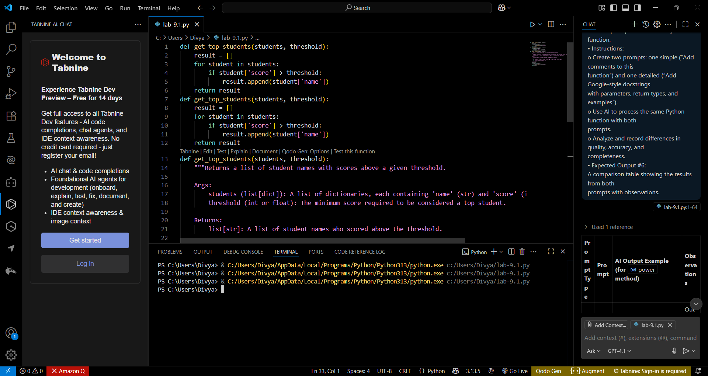

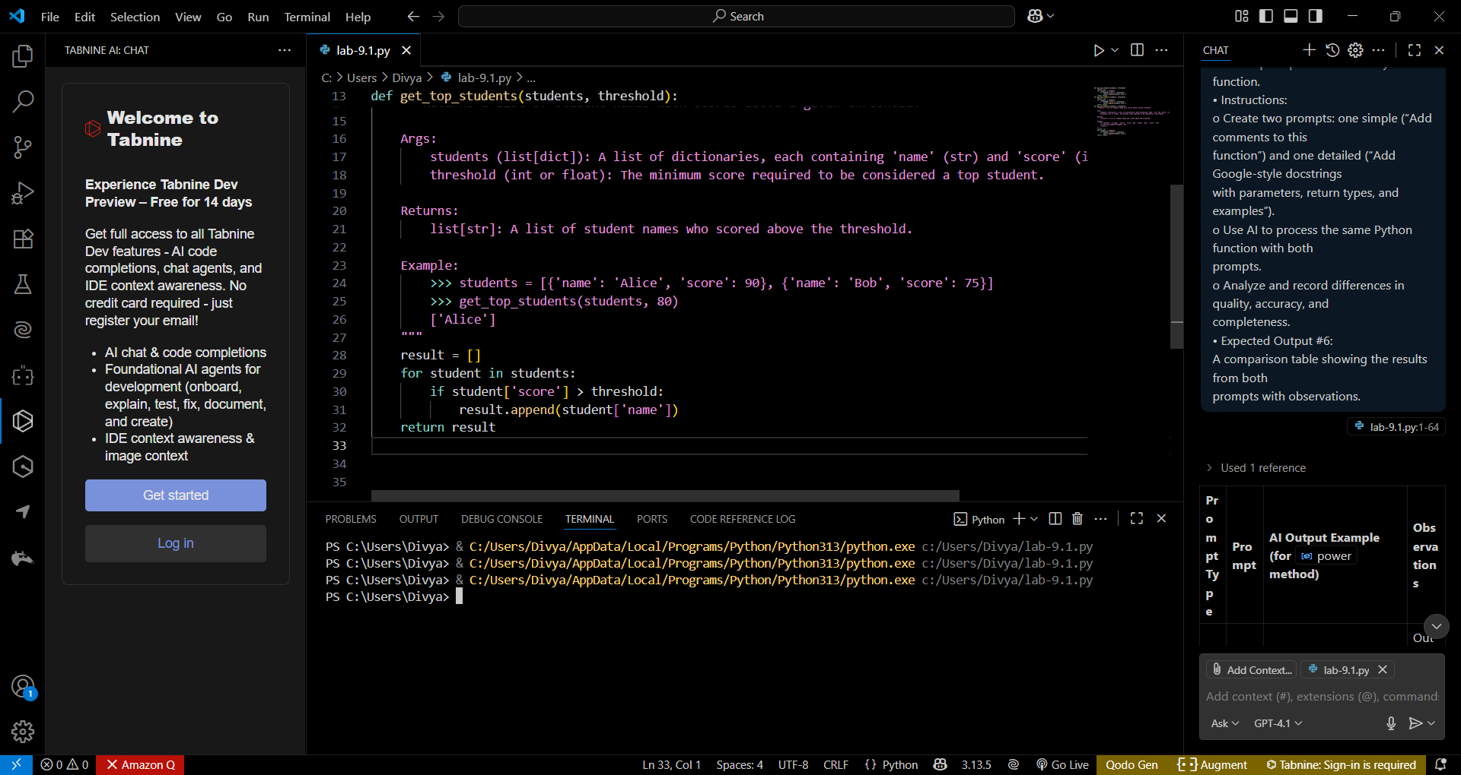
Comparision:
Criteria | Vague Prompt | Detailed Prompt | Observation
Clarity | Medium – basic comments are readable | High – explains inputs, outputs, and intent | Detailed docstring is much clearer and more informative
Accuracy | High – comments match logic | High – accurate explanation of function behavior | Both are accurate, but docstring includes more context
Completeness | Low – doesn’t explain parameters or return | High – includes parameter types, return types, and an example | Docstring provides complete developer-level documentation
Formatting | Low – informal line comments | High – follows Google-style docstring standard | Docstring is professional and standardized
Usefulness | Medium – helpful for beginners | High – suitable for documentation tools and collaborative projects | Detailed prompt yields reusable, shareable documentation

