Assignment-17.1
HALL TICKET NUMBER: 2403A51356
NAME: D.Divya
BATCH:14
Task 1 – Customer Data Cleaning
Task:
Use AI to generate a Python script for cleaning a customer dataset.
Instructions:
• Handle missing values in columns (age, income, city).
• Remove duplicate records.
• Standardize text values (e.g., city names in lowercase).
• Encode categorical variables (gender, city).
Expected Output:
• A cleaned Pandas DataFrame ready for analysis.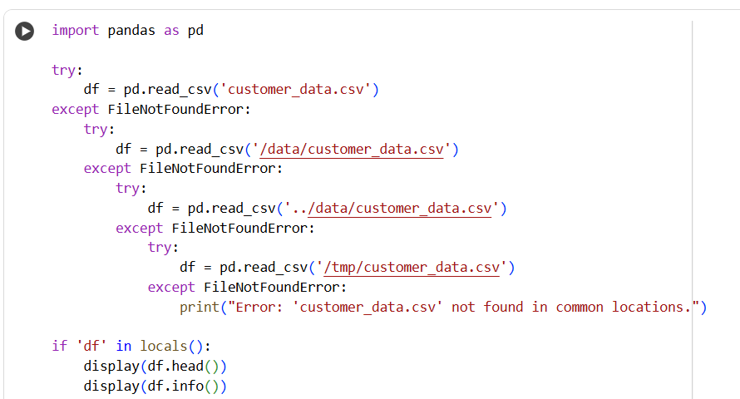
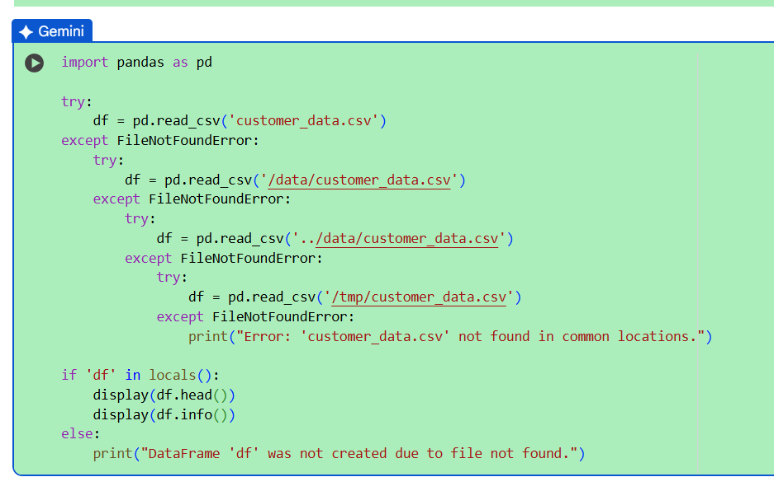
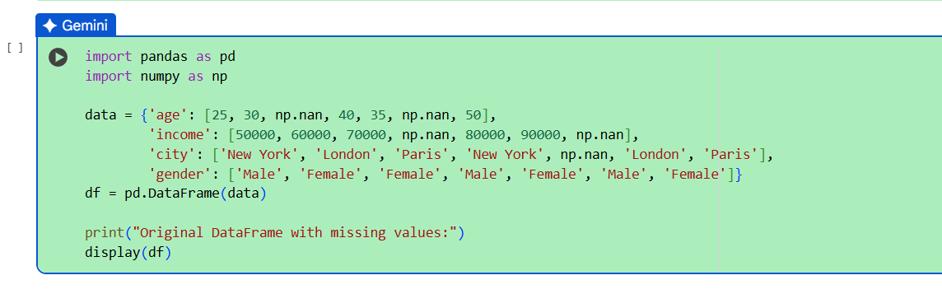
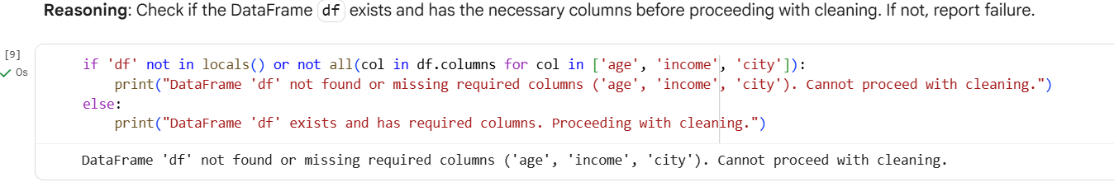
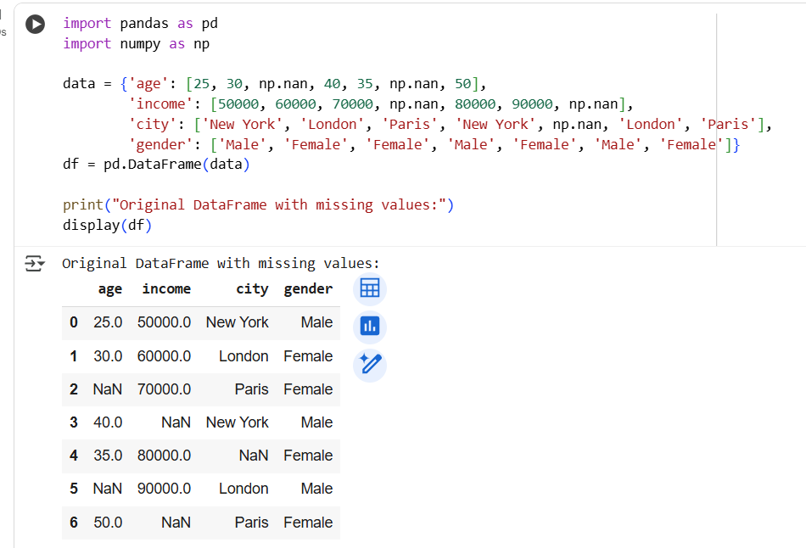
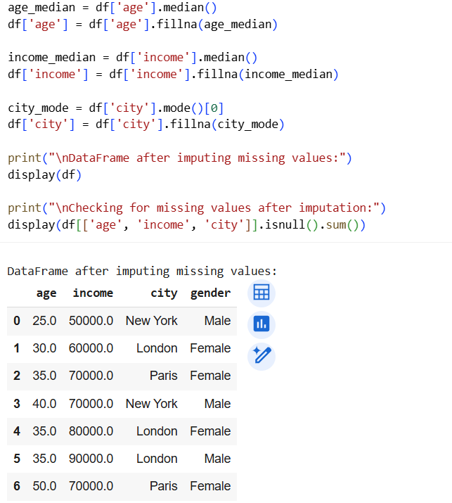
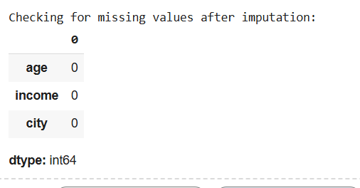
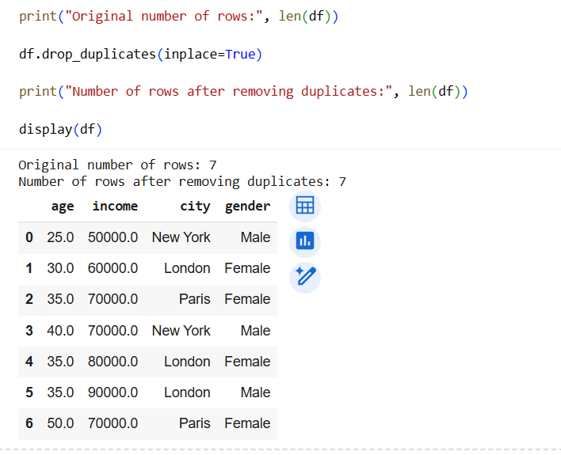
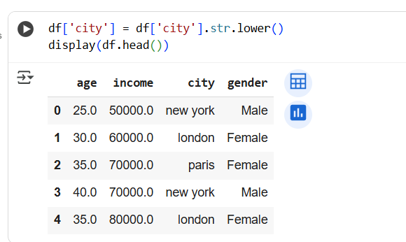
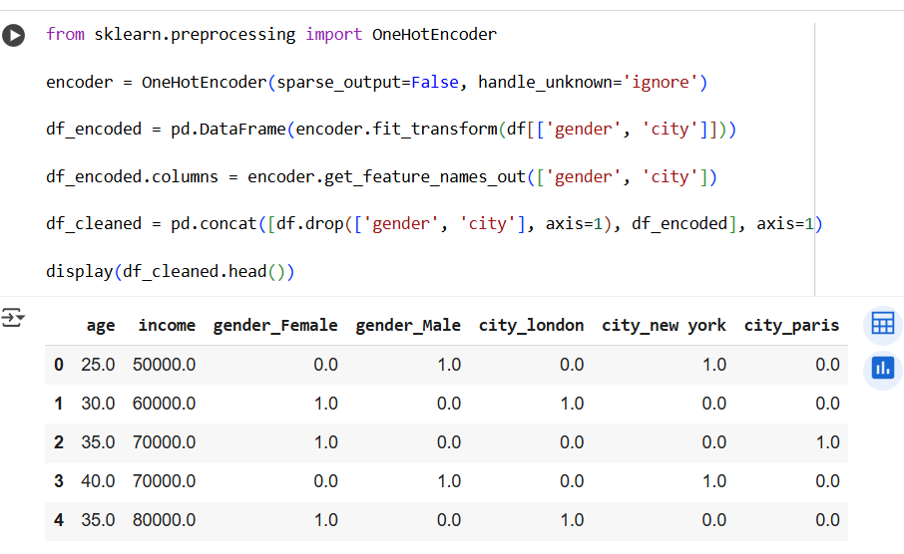

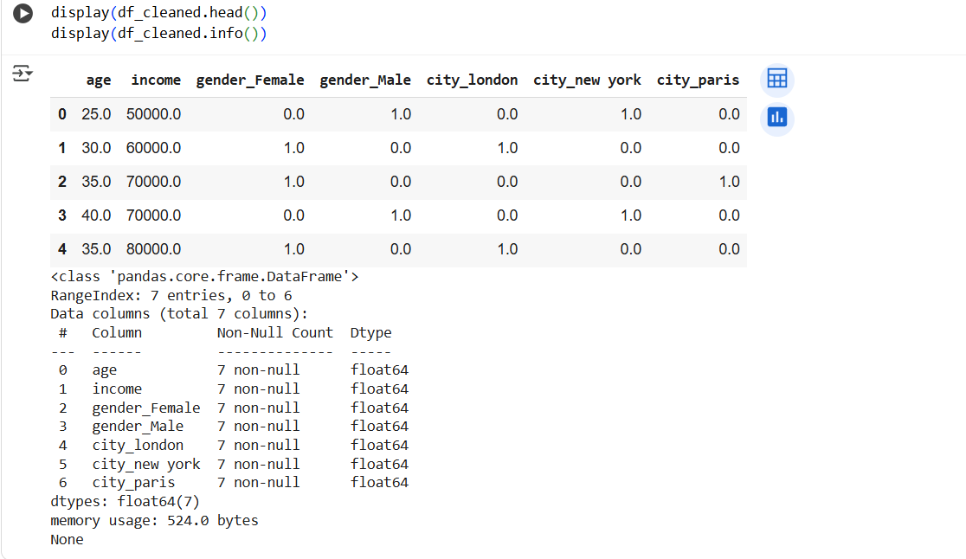

Task 2 – Sales Data Preprocessing
Task:
Preprocess sales transaction data using AI assistance.
Instructions:
• Convert date columns into datetime format.
• Create new features (month, year, day of week).
• Normalize sales amount column.
• Detect and handle outliers in transaction amounts.
Expected Output:
• A transformed dataset with time-based features and normalized
values
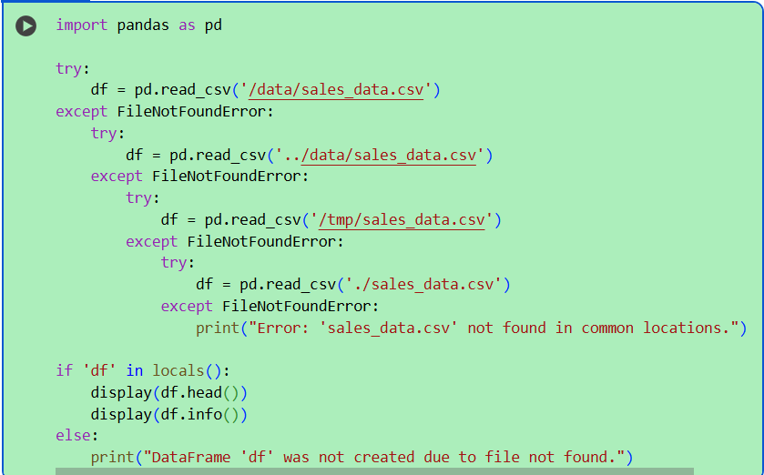
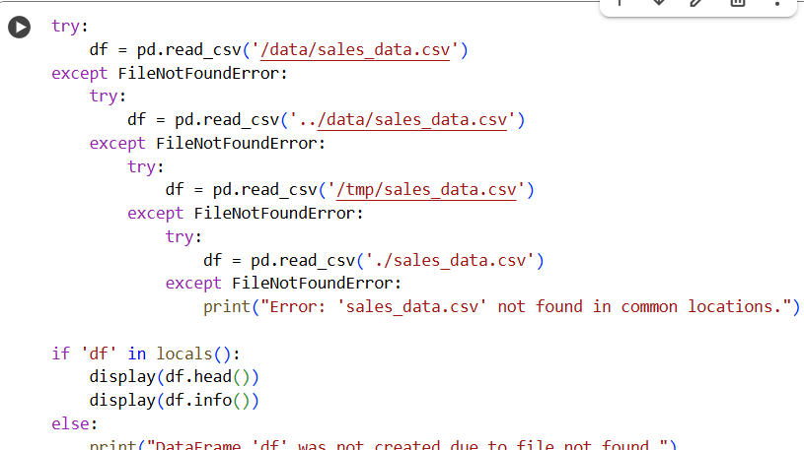
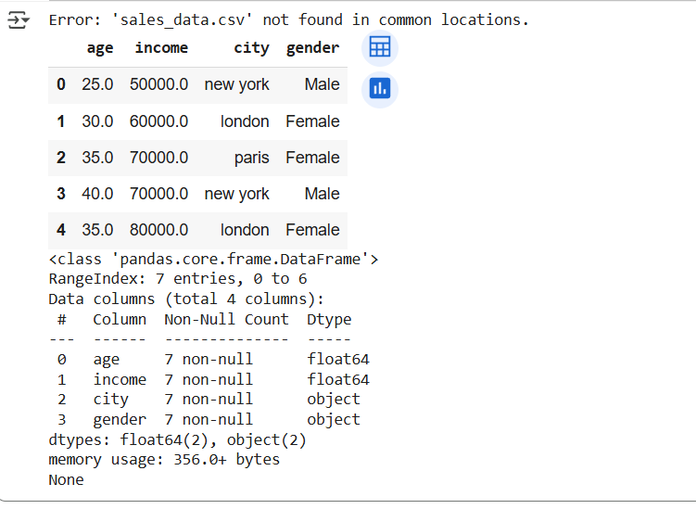
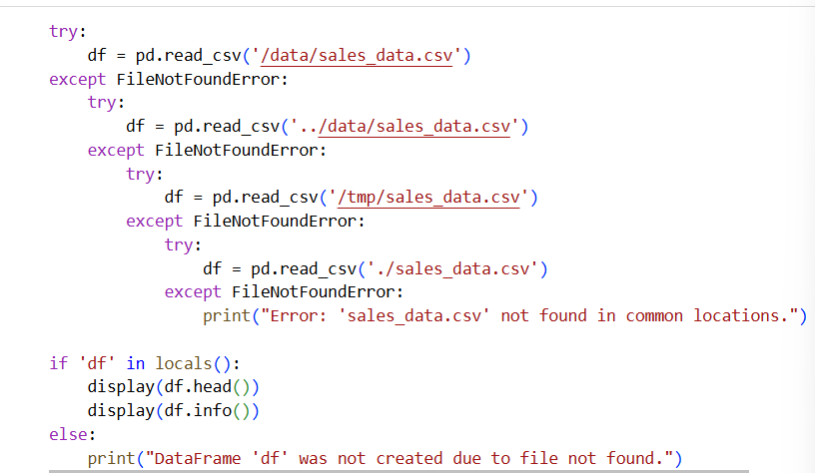
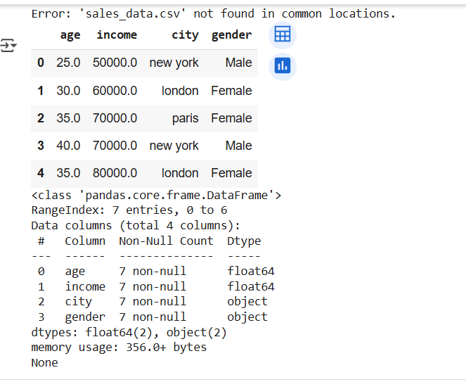
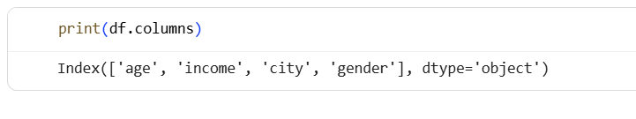
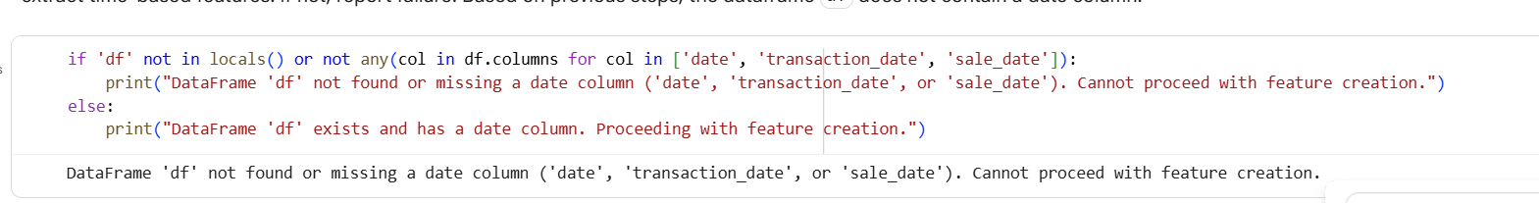
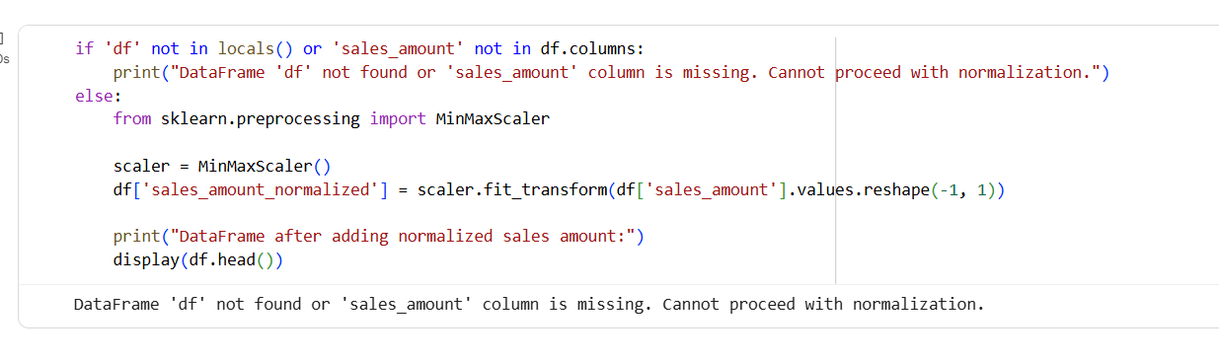
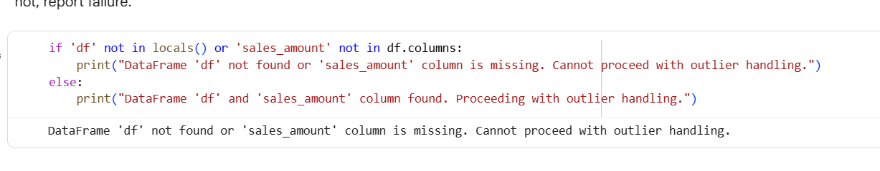
Task 3 – Healthcare Data Preparation
Task:
Clean and preprocess a healthcare dataset using AI scripts.
Instructions:
• Handle missing values in blood_pressure, cholesterol.
• Encode categorical features like disease_status (Yes/No).
• Scale numerical features (min-max or standard scaling).
• Split dataset into training and testing sets.
Expected Output:
• A preprocessed dataset ready for machine learning models
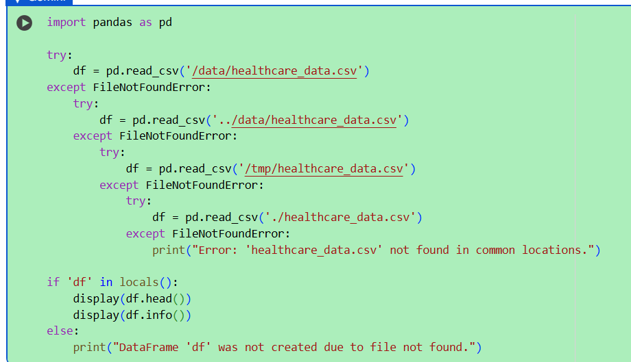
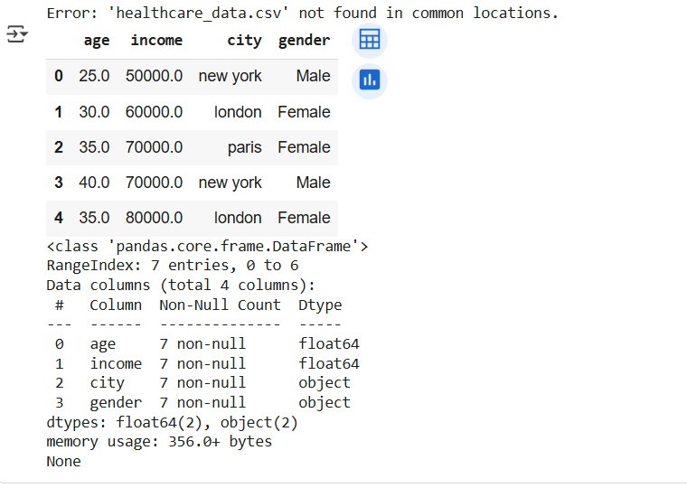
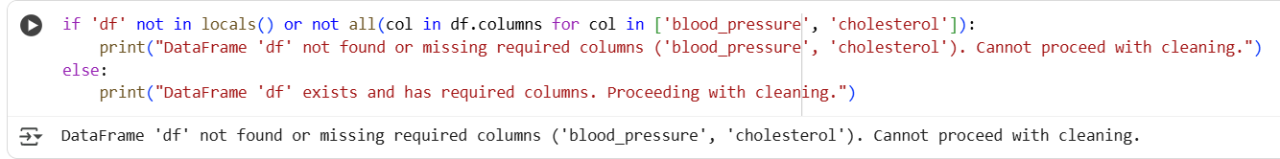
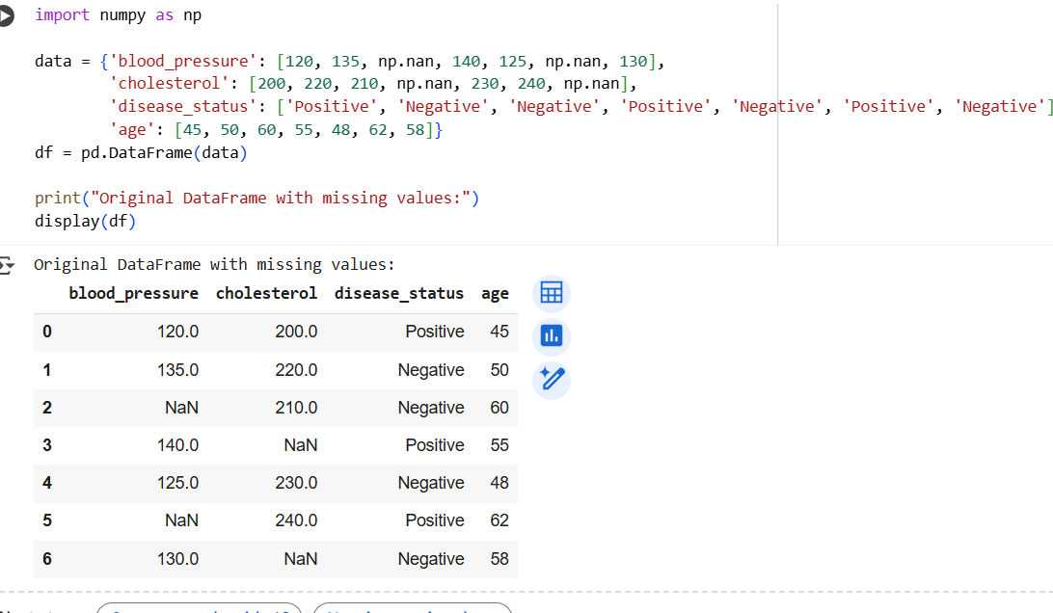
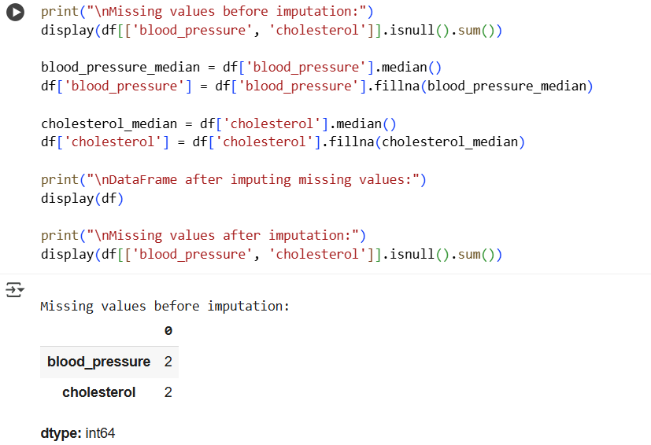
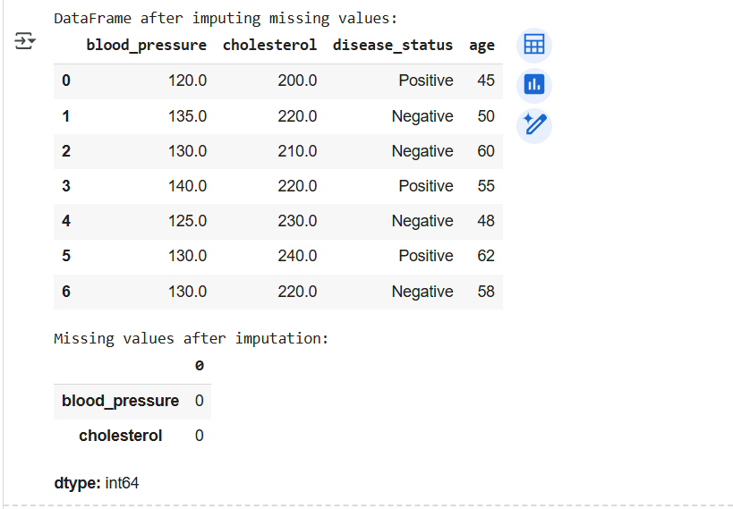
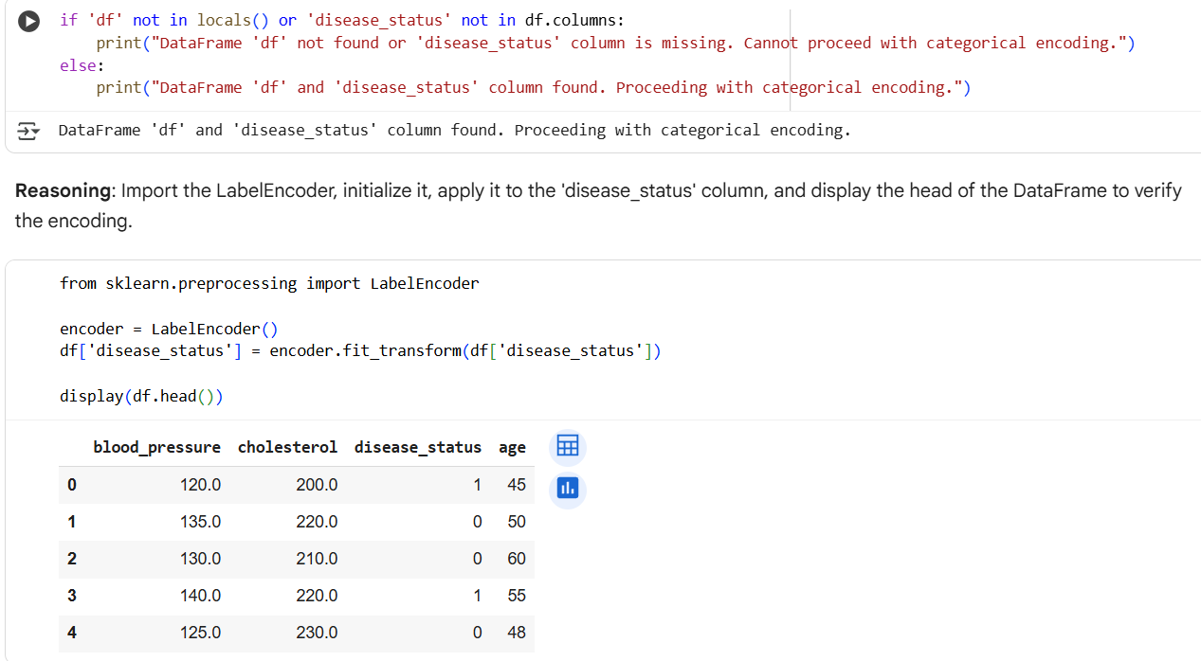
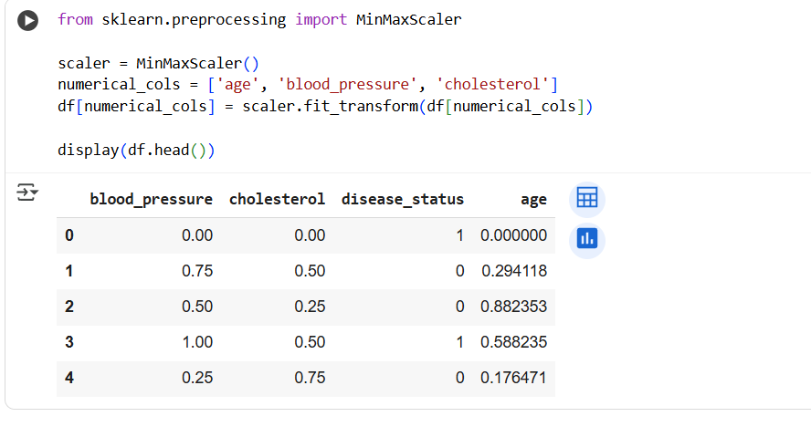
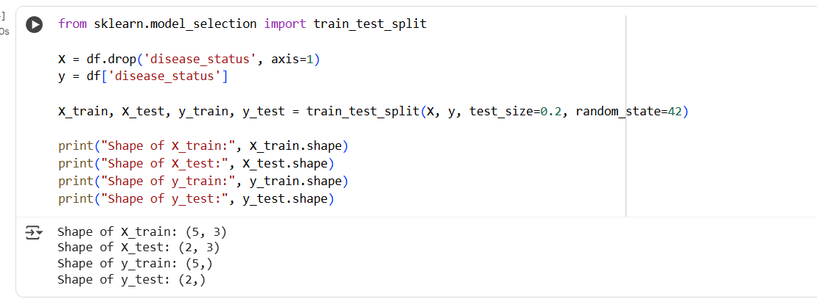
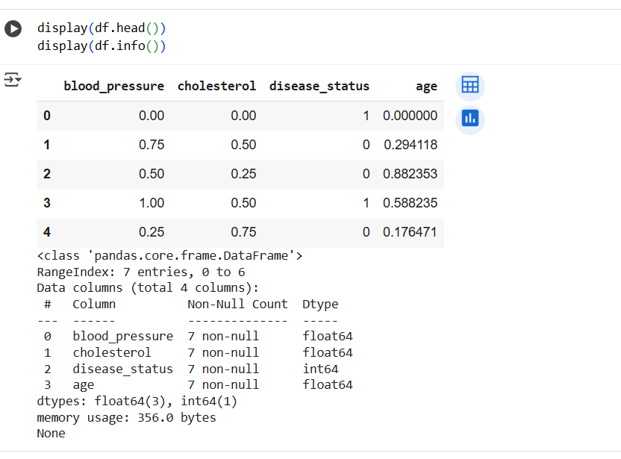
Task 4 – Real-Time Application: E-commerce Product Data
Cleaning
Scenario:
An e-commerce company has product catalog data with
inconsistencies.
Requirements:
• Standardize product names and categories.
• Fill missing prices with median values.
• Remove duplicate entries.
• Normalize product ratings (0–5 scale).
• Generate a summary report of data quality improvements (before
vs after cleaning).
Expected Output:
• A cleaned dataset with improved consistency and usability for
analytics.
