Assignment-6.4
Name:Divya
Batch:14
Rollno:2403a51356
Task Description #1:
• Start a Python class named Student with attributes name, roll_number, and marks. Prompt
GitHub Copilot to complete methods for displaying details and checking if marks are above average.
Expected Outcome #1:
• Completed class with Copilot-generated methods like display_details() and is_passed(),
demonstrating use of if-else conditions.
Prompt: Student with attributes name, roll_number, and marks. GitHub Copilot to complete methods for displaying details and checking if marks are above average.
Code with output:

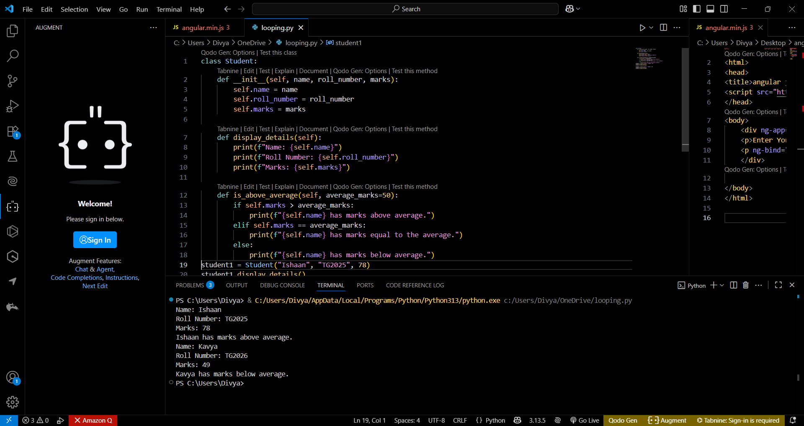

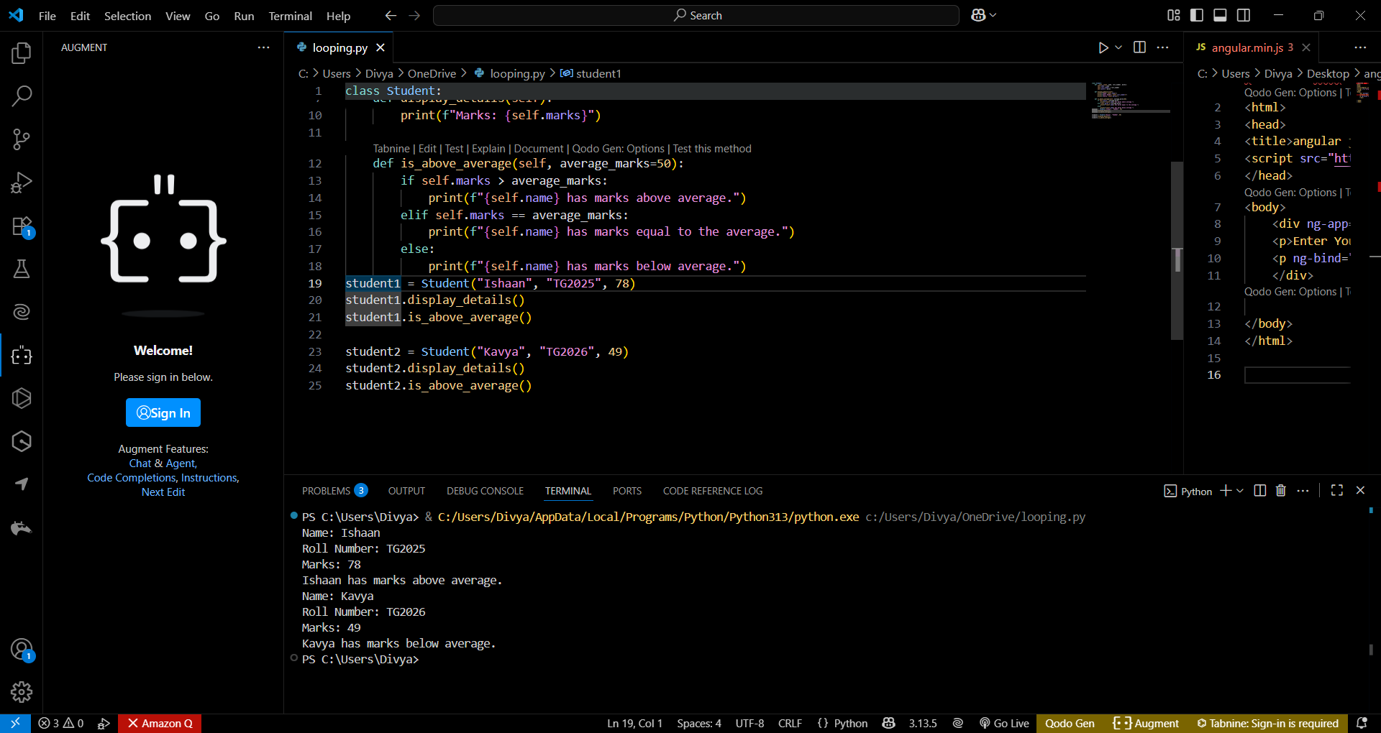
Observation:
Clear Structure: The class is well-organized with a constructor and two methods that serve distinct purposes.
Readable Output: The display_details() method uses formatted strings for clean, readable output.
The if-elif-else structure is intuitive and easy to follow.
Task Description #2:
• Write the first two lines of a for loop to iterate through a list of numbers. Use a comment
prompt to let Copilot suggest how to calculate and print the square of even numbers only.
Expected Outcome #2:
• A complete loop generated by Copilot with conditional logic (if number % 2 == 0) and
appropriate output
Prompt: the first two lines of a for loop to iterate through a list of numbers. Use a comment to let Copilot suggest how to calculate and print the square of even numbers only.
Code:

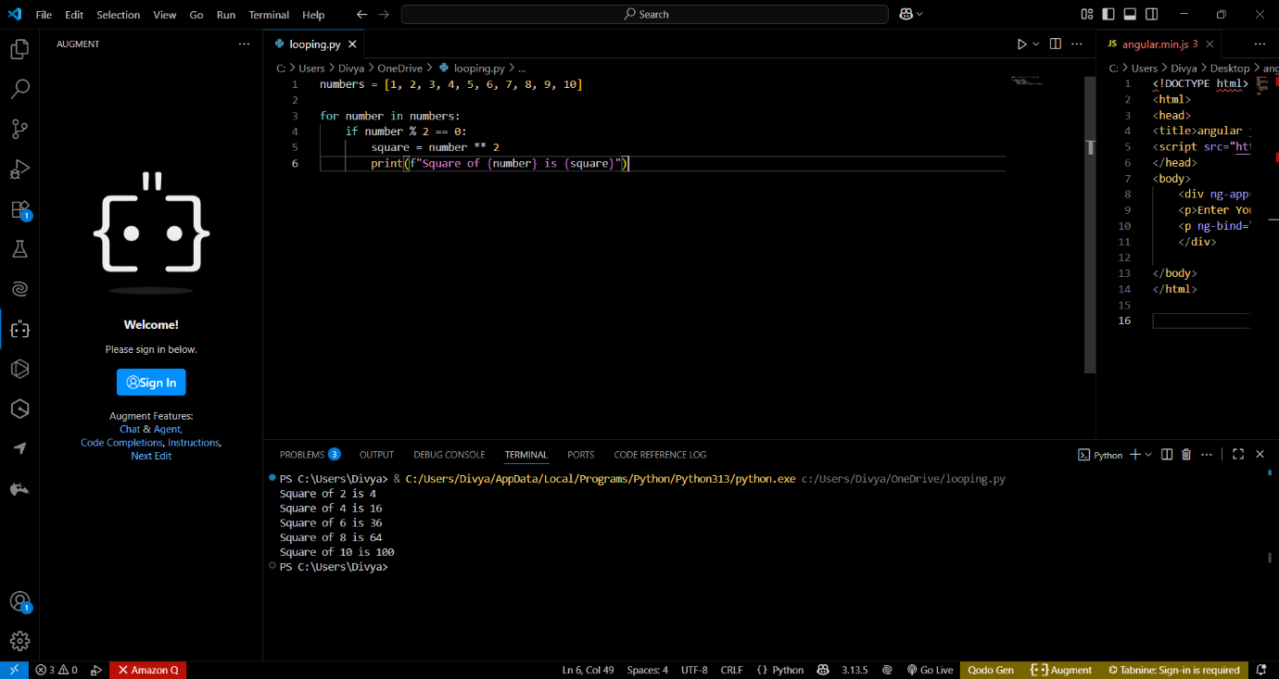
Output:


Task Description #3:
• Create a class called BankAccount with attributes account_holder and balance. Use Copilot to
complete methods for deposit(), withdraw(), and check for insufficient balance.
Expected Outcome #3:
• Functional class with complete method definitions using if conditions and self attributes. Code
should prevent overdrawing.
Prompt: Use Copilot to complete methods for deposit(), withdraw(), and check for insufficient balance. using if conditions and self attributes.
Code:

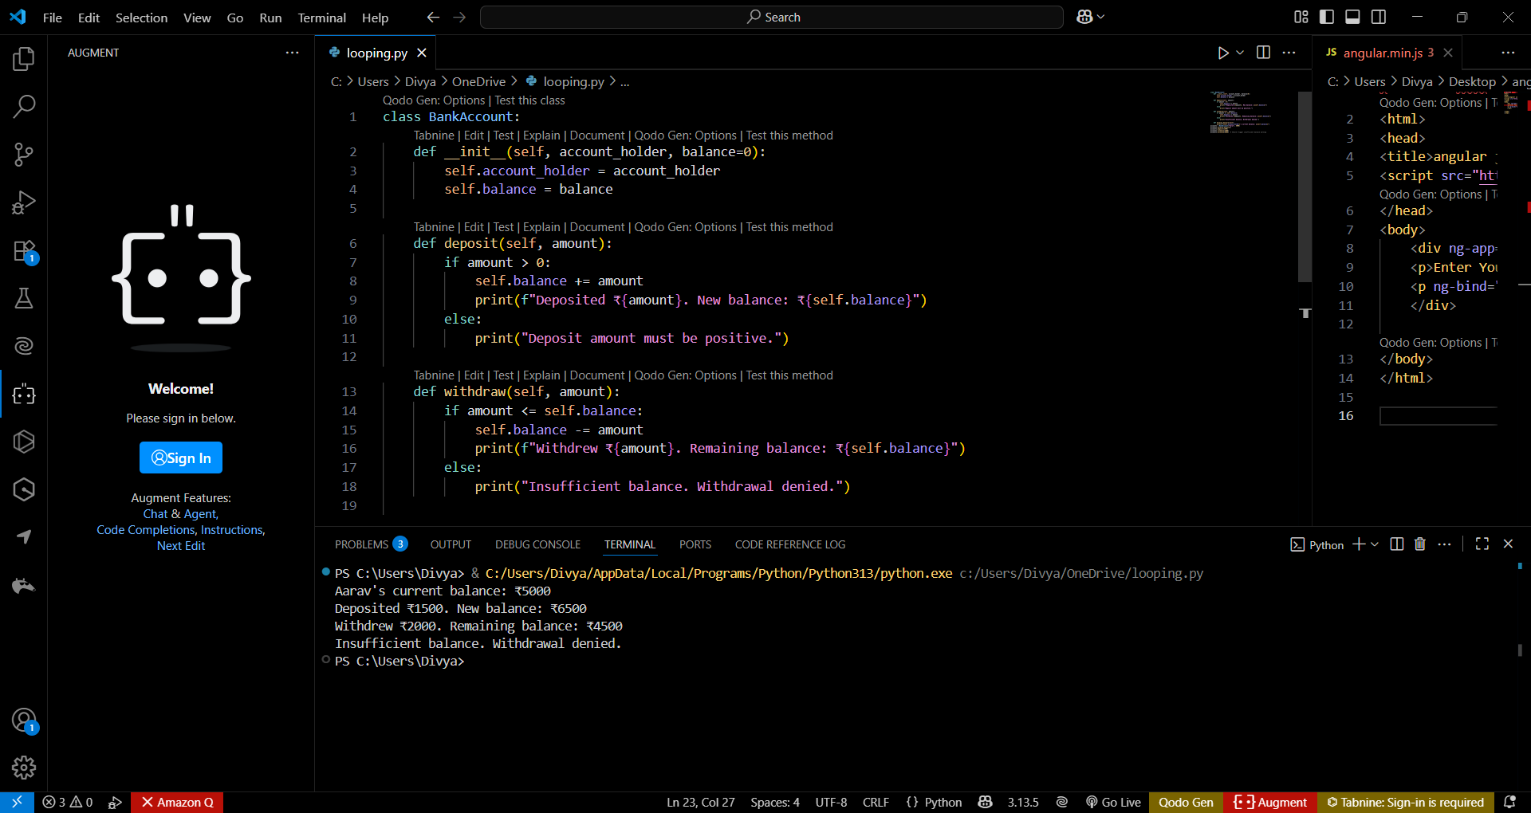

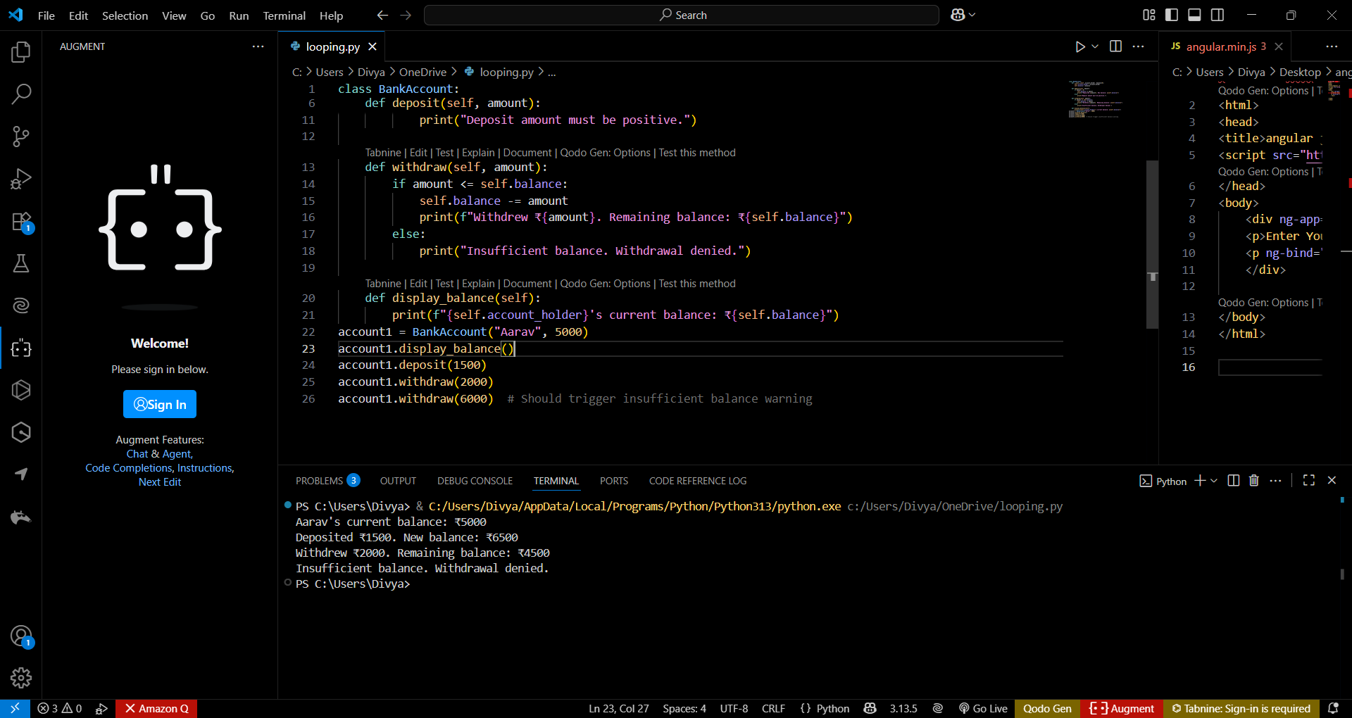
Output:


Observation:
The class neatly wraps account data and behavior, following object-oriented principles.
Use of self: Attributes like self.balance and self.account_holder are correctly used to maintain state across methods.
The constructor allows for optional initial balance, making it flexible.
Task Description #4:
• Define a list of student dictionaries with keys name and score. Ask Copilot to write a while loop to print the names of students who scored more than 75.
Expected Outcome #4:
• A complete while loop generated by Copilot with proper condition checks and formatted
output.
Prompt: write a while loop to print the names of students who scored more than 75.use proper condition and give me the code.
Code with output:

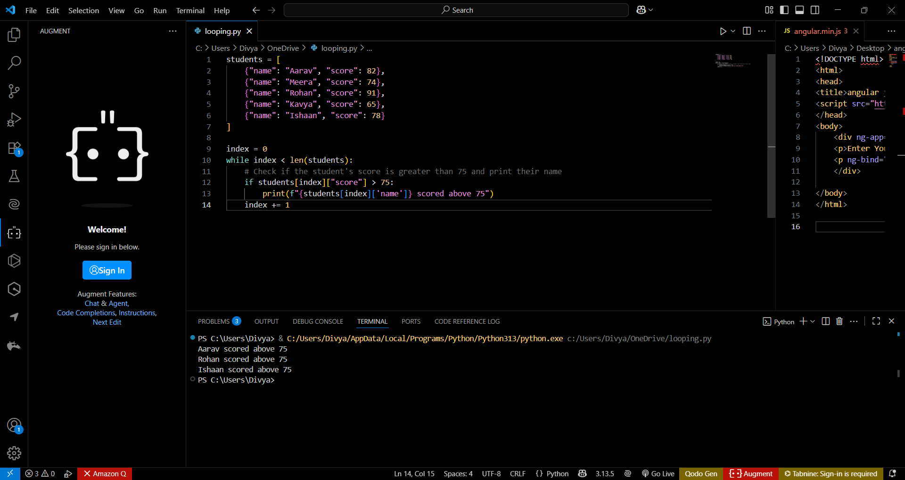
Observation:
The use of dictionaries within a list allows for organized storage of student information.
The while loop iterates through each student using an index, demonstrating manual control over iteration.
The if statement filters students based on their score, ensuring only those above 75 are printed.\
Task Description #5:
• Begin writing a class ShoppingCart with an empty items list. Prompt Copilot to generate methods to add_item, remove_item, and use a loop to calculate the total bill using conditional discounts.
Expected Outcome #5:
• A fully implemented ShoppingCart class with Copilot-generated loops and if-else statements handling item management and discount logic.
Prompt: Copilot to generate methods to add_item, remove_item, and use a loop to calculate the total bill using conditional discounts.
using if else statements and give me the correct code.
Code:

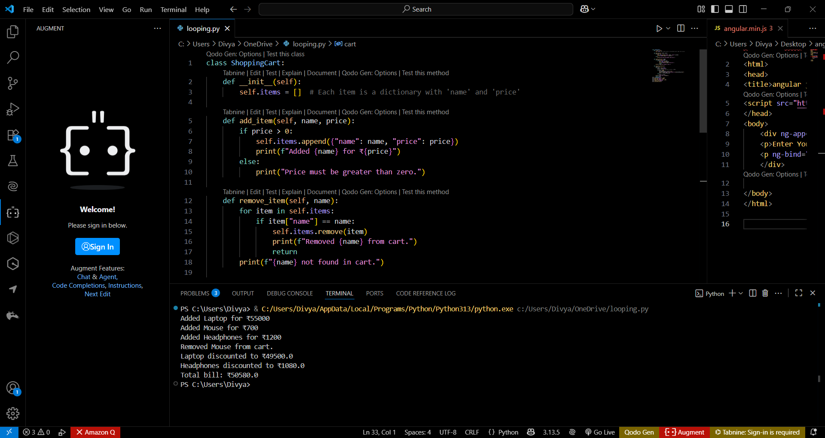

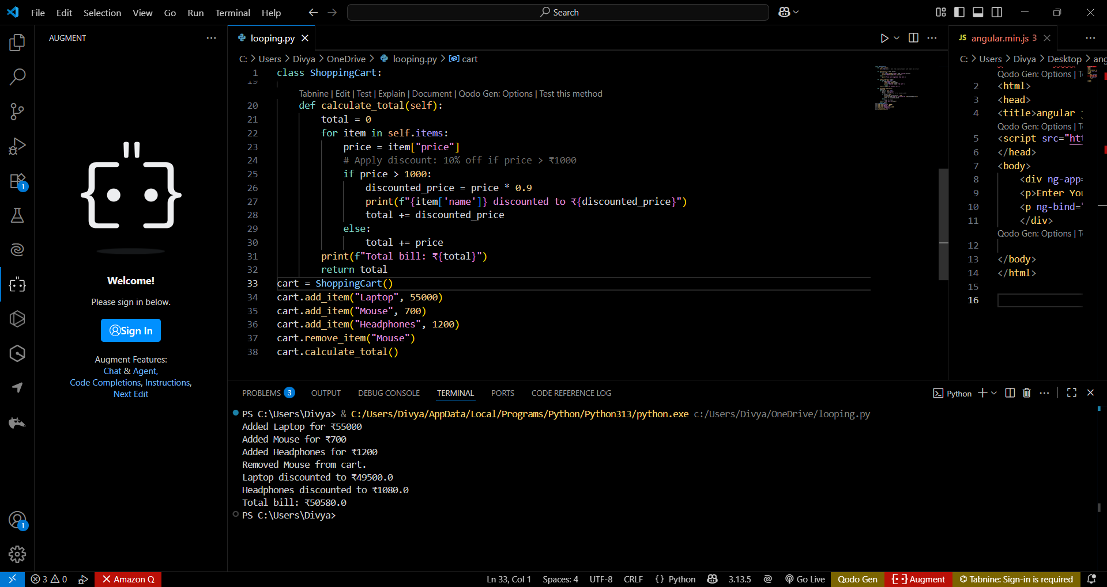
Output:


Observation:
Use of self: Attributes and methods correctly reference instance data, maintaining state.
Add_item() checks for positive pricing, preventing invalid entires. remove_item() uses a loop and conditional logic to find and delete items.Print statements provide clear, step-by-step updates for each action.

