Assignment-7.1
Name:D.Divya
Batch No:14
HTNO:2403A51356
Task Description #1 (Syntax Errors – Missing Parentheses in Print
Statement)
Task: Provide a Python snippet with a missing parenthesis in a print
statement (e.g., print "Hello"). Use AI to detect and fix the syntax error.
# Bug: Missing parentheses in print statement
def greet():
print "Hello, AI Debugging Lab!"
greet()
Requirements:
• Run the given code to observe the error.
• Apply AI suggestions to correct the syntax.
• Use at least 3 assert test cases to confirm the corrected code
works.
Expected Output #1:
• Corrected code with proper syntax and AI explanation.
Prompt: : Provide a Python snippet with a missing parenthesis in a print
statement (e.g., print "Hello"). Use AI to detect and fix the syntax error.Find the my error and give me the correct code.
Code with output:

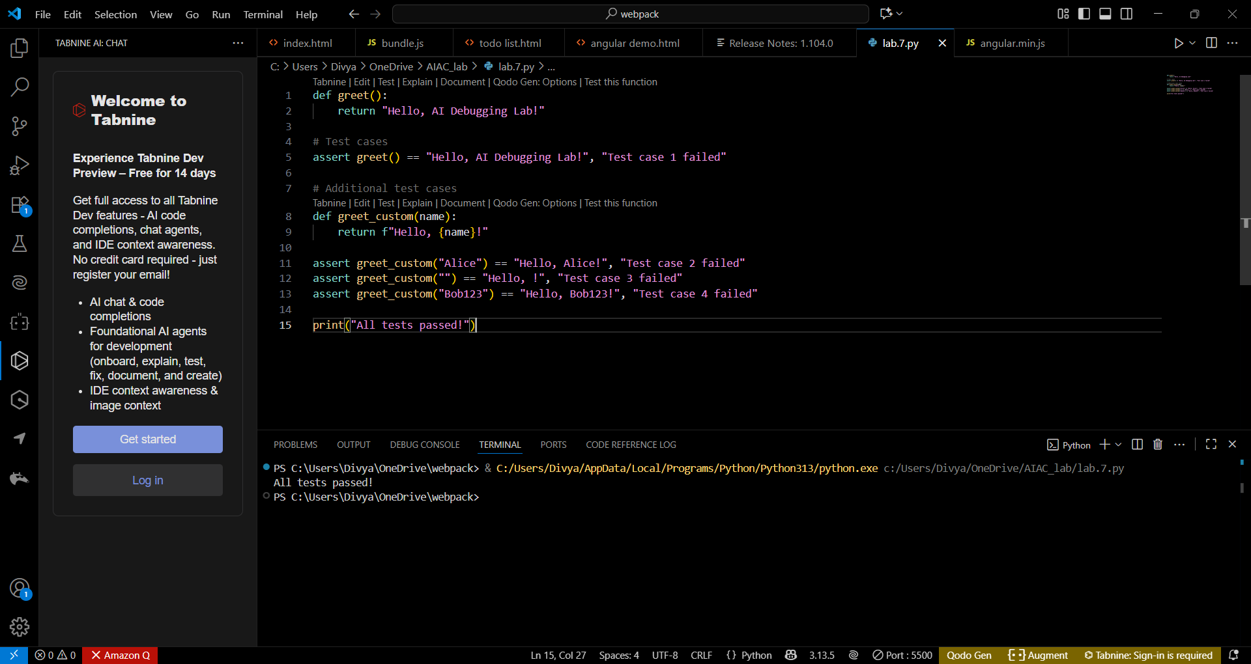
Explanation: We wrap the string to be printed inside parentheses: print("...").This fixes the syntax error because in Python 3 the print function must be called, unlike Python 2 where print could be used as a statement without parentheses.The corrected code prints "Hello, AI Debugging Lab!" to the console.
Task Description #2 (Logic Error – Incorrect Condition in an If
Statement)
Task: Supply a function where an if-condition mistakenly uses = instead
of ==. Let AI identify and fix the issue.
# Bug: Using assignment (=) instead of comparison (==)
def check_number(n):
if n = 10:
return "Ten"
else:
return "Not Ten"
Requirements:
• Ask AI to explain why this causes a bug.
• Correct the code and verify with 3 assert test cases.
Expected Output #2:
• Corrected code using == with explanation and successful test
execution.
Prompt: Supply a function where an if-condition mistakenly uses = instead
of ==. Let AI identify and fix the issue.explain why this causes a bug give me the correct code .correct the errors.
Code with output:

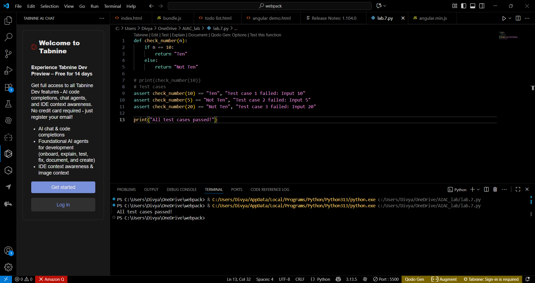

Explanation:
- In Python, the if statement requires a Boolean expression—a condition that evaluates to either True or False.
- The assignment operator (=) is used to set the value of a variable, not to check whether two values are equal.
- Writing if n = 10: tries to assign 10 to n within the condition, which is invalid. Python immediately raises a SyntaxError here because assignments are not allowed as conditions in if-statements.
- The correct operator for equality comparison is == as in if n == 10:.
Task Description #3 (Runtime Error – File Not Found)
Task: Provide code that attempts to open a non-existent file and crashes.
Use AI to apply safe error handling.
# Bug: Program crashes if file is missing
def read_file(filename):
with open(filename, 'r') as f:
return f.read()
print(read_file("nonexistent.txt"))
Requirements:
• Implement a try-except block suggested by AI.
• Add a user-friendly error message.
• Test with at least 3 scenarios: file exists, file missing, invalid
path.
Expected Output #3:
• Safe file handling with exception management.
Prompt: Provide code that attempts to open a non-existent file and crashes.Use AI to apply safe error handling. Safe file handling with exception management.
Code:
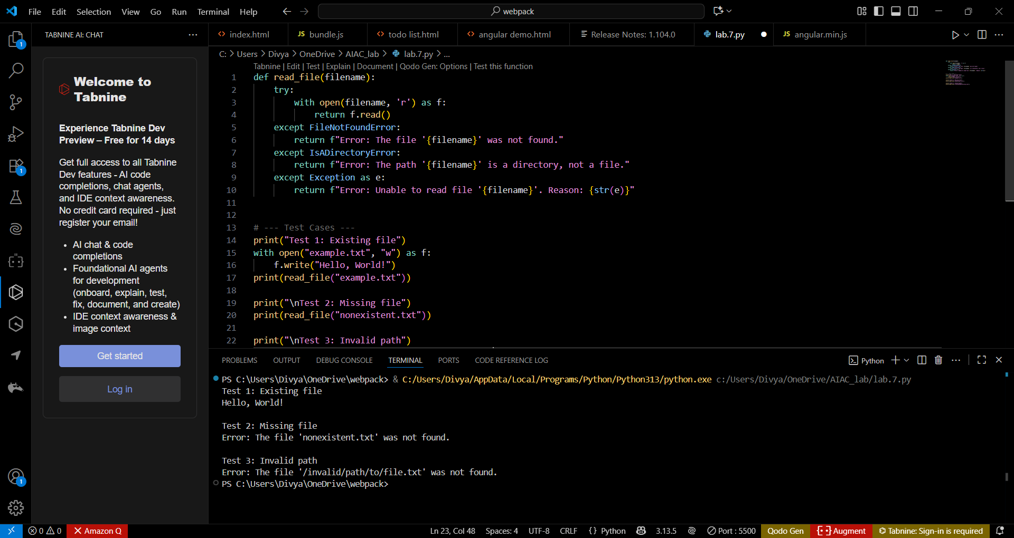
Test cases:
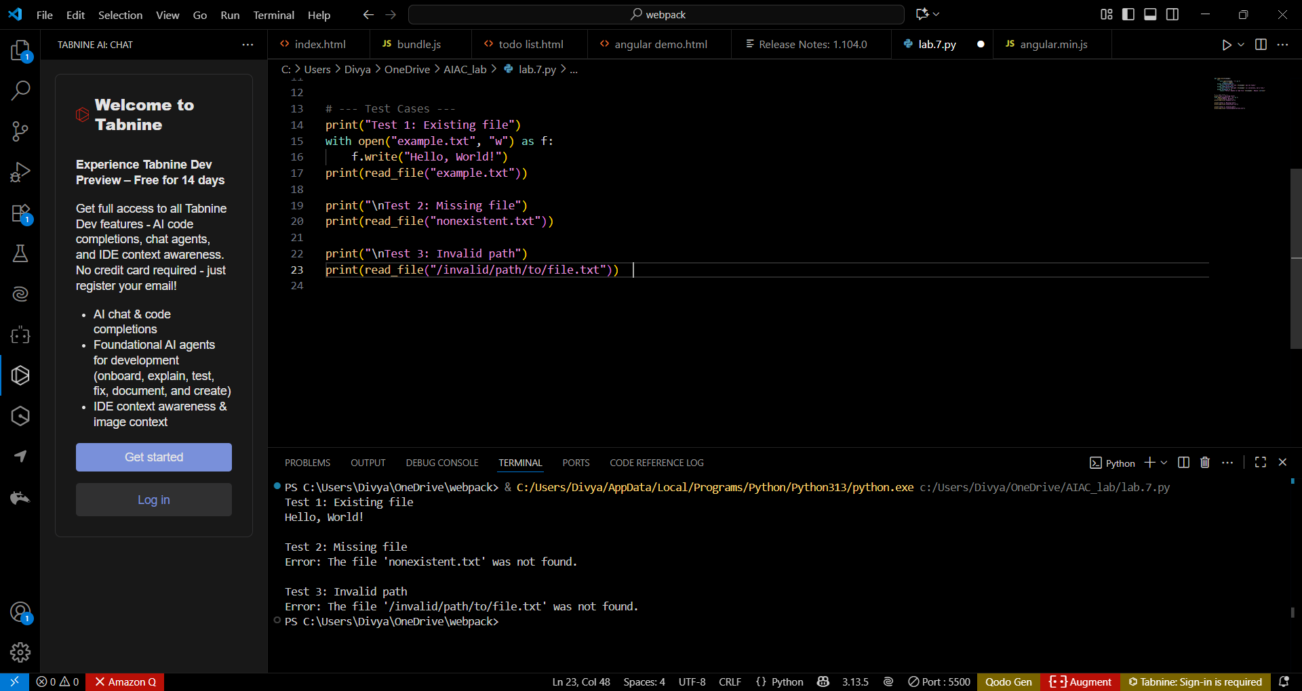
Output:


Observations:
- When the file exists, the program successfully reads and prints its contents.
- When the file is missing, it returns a helpful message: "The file 'nonexistent.txt' was not found."When an invalid path is used, it catches the error and reports the system-generated reason without terminating the program.
- The program demonstrates robustness, since it handles multiple common file errors (missing file, directory instead of file, invalid path).
Task Description #4 (AttributeError – Calling a Non-Existent Method)
Task: Give a class where a non-existent method is called (e.g.,
obj.undefined_method()). Use AI to debug and fix.
# Bug: Calling an undefined method
class Car:
def start(self):
return "Car started"
my_car = Car()
print(my_car.drive()) # drive() is not defined
Requirements:
• Students must analyze whether to define the missing method or
correct the method call.
• Use 3 assert tests to confirm the corrected class works.
Expected Output #4:
• Corrected class with clear AI explanation.
Prompt: Give a class where a non-existent method is called (e.g.,
obj.undefined_method()). Use AI to debug and fix. Students must analyze whether to define the missing method or correct the method call.give me the correct class with clear output.

Code with output:

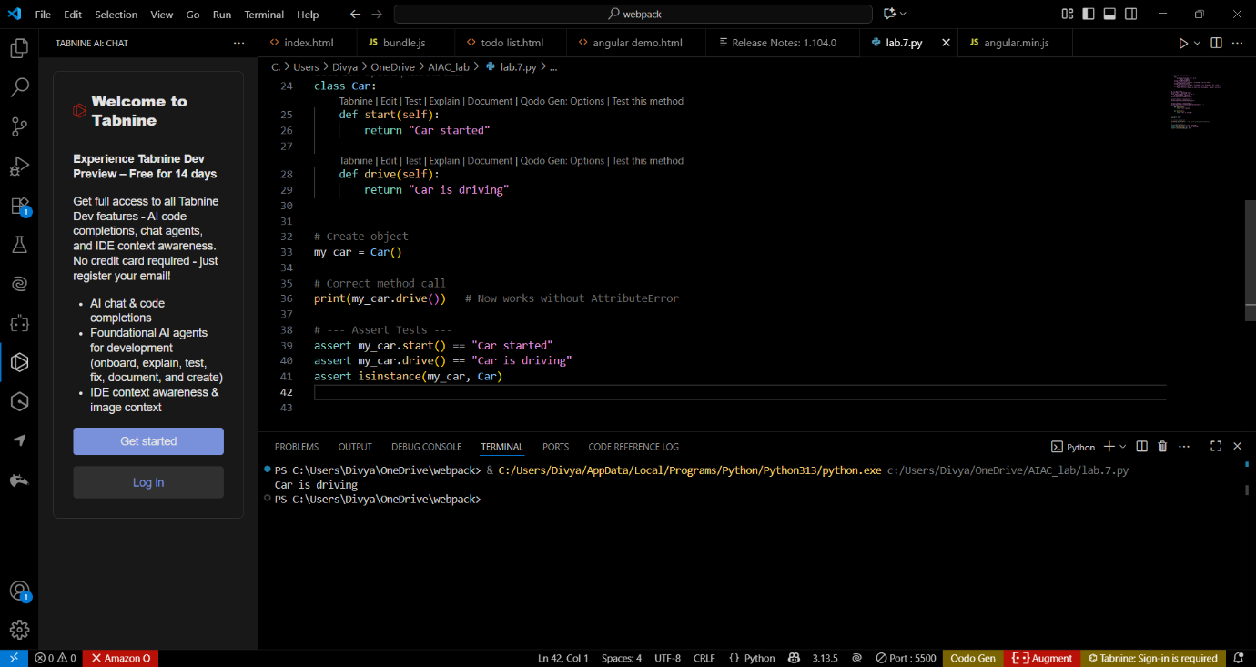

Ai Explanation:
The bug was caused by calling a method (drive()) that didn’t exist in the class.The fix was to add the missing drive() method, since driving is a valid behavior for a Car object.
The three assert tests confirm that:
  - The existing start() method still works.
  - The new drive() method works.
  - The object is a valid instance of car.
  - ask Description #5 (TypeError – Mixing Strings and Integers in
Addition)
Task: Provide code that adds an integer and string ("5" + 2) causing a
TypeError. Use AI to resolve the bug.
# Bug: TypeError due to mixing string and integer
def add_five(value):
return value + 5
print(add_five("10"))
Requirements:
• Ask AI for two solutions: type casting and string concatenation.
• Validate with 3 assert test cases.
Expected Output #5:
• Corrected code that runs successfully for multiple inputs
Prompt: Provide code that adds an integer and string ("5" + 2) causing a TypeError. Use AI to resolve the bug. Ask AI for two solutions: type casting and string concatenation.Validate with 3 assert test cases.
Give me the correct code that runs successfully for multipule inputs .
Code with output:

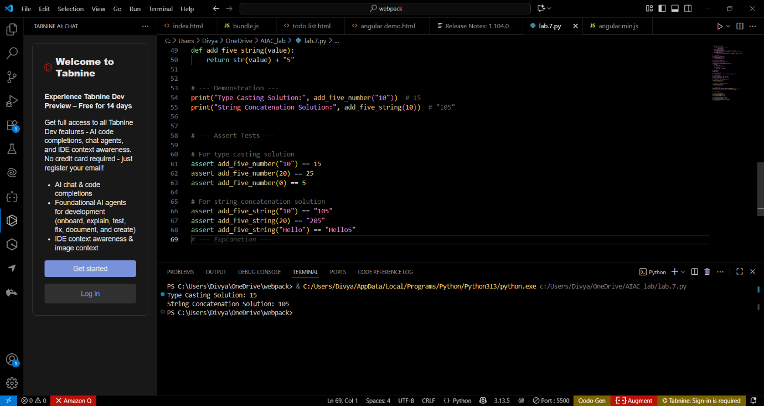

Ai Explanation:
- The Type Casting solution ensures arithmetic addition by converting string inputs like "10" into integers before adding 5.
- The String Concatenation solution ensures string handling by converting numbers into strings before appending "5".
- Both solutions are safe because they explicitly control the data type used.
- The assert tests validate correct behavior under multiple scenarios: numeric strings, integers, and plain strings.

