AssignmentNumber:15.1

HTNO: 2403A51356
NAME: D.Divya
BATCH: 24BTCAICSB14
Lab 15 – Backend API Development: Creating RESTful services
with AI
Lab Objectives:
• Understand the fundamentals of RESTful API design.
• Use AI-assisted coding tools to generate backend services.
• Implement CRUD (Create, Read, Update, Delete) operations.
Week8 -
Monday
• Document endpoints with comments and auto-generated
documentation.
Task 1 – Student Records API
Use AI to build a RESTful API for managing student records.
Instructions:
• Endpoints required:
o GET /students → List all students
o POST /students → Add a new student
o PUT /students/{id} → Update student details
o DELETE /students/{id} → Delete a student record
• Use an in-memory data structure (list or dictionary) to store
records.
• Ensure API responses are in JSON format.
Prompt:-
Use AI to build a RESTful API for managing student records.
Instructions:
• Endpoints required:
o GET /students → List all students
o POST /students → Add a new student
o PUT /students/{id} → Update student details
o DELETE /students/{id} → Delete a student record
• Use an in-memory data structure (list or dictionary) to store
records.
• Ensure API responses are in JSON format.
Code:-
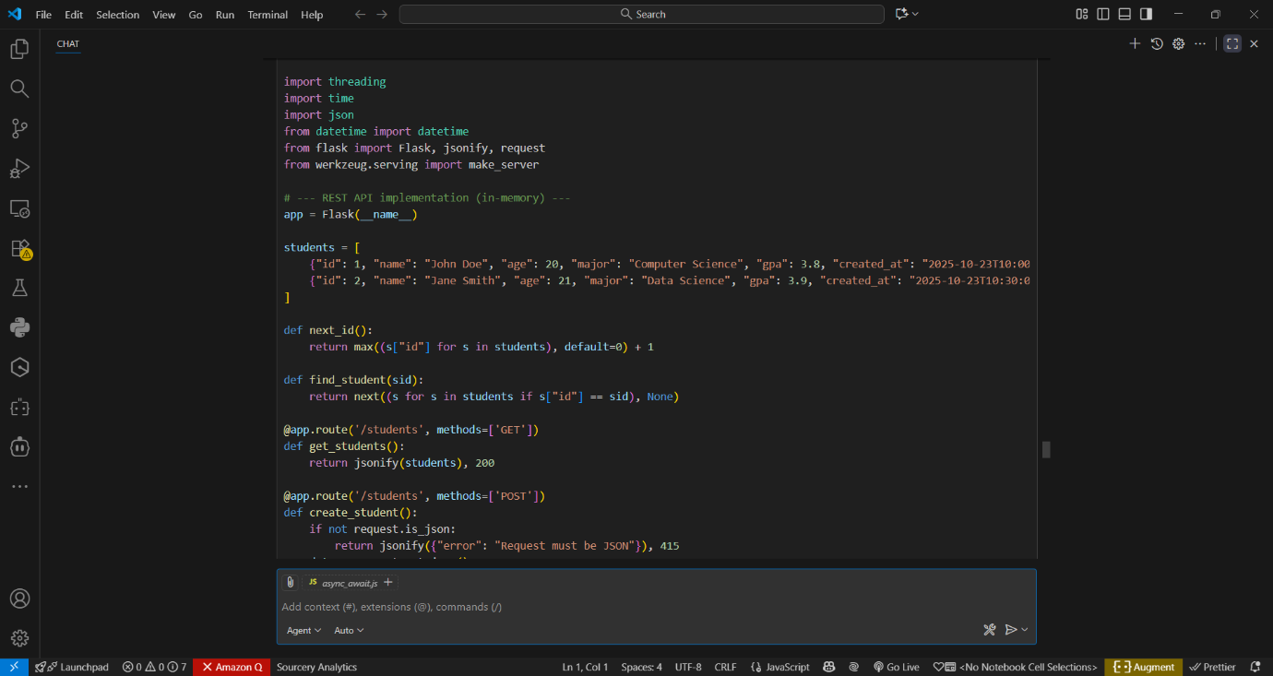
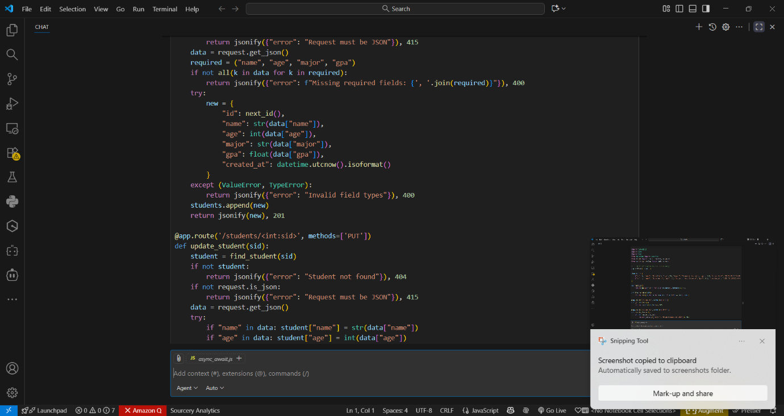
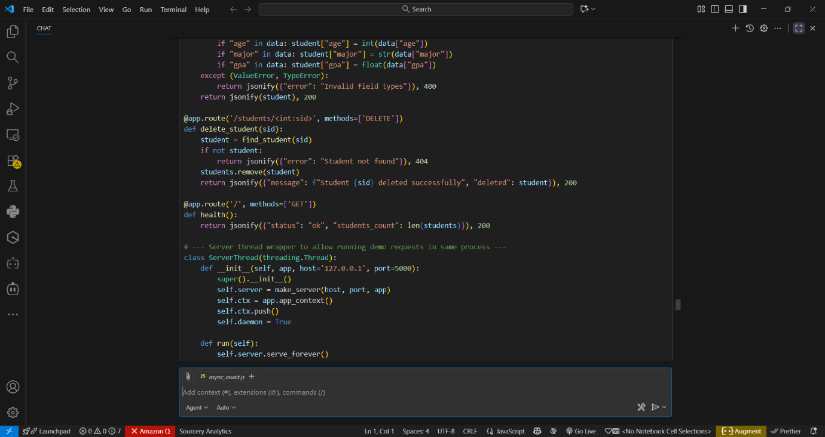
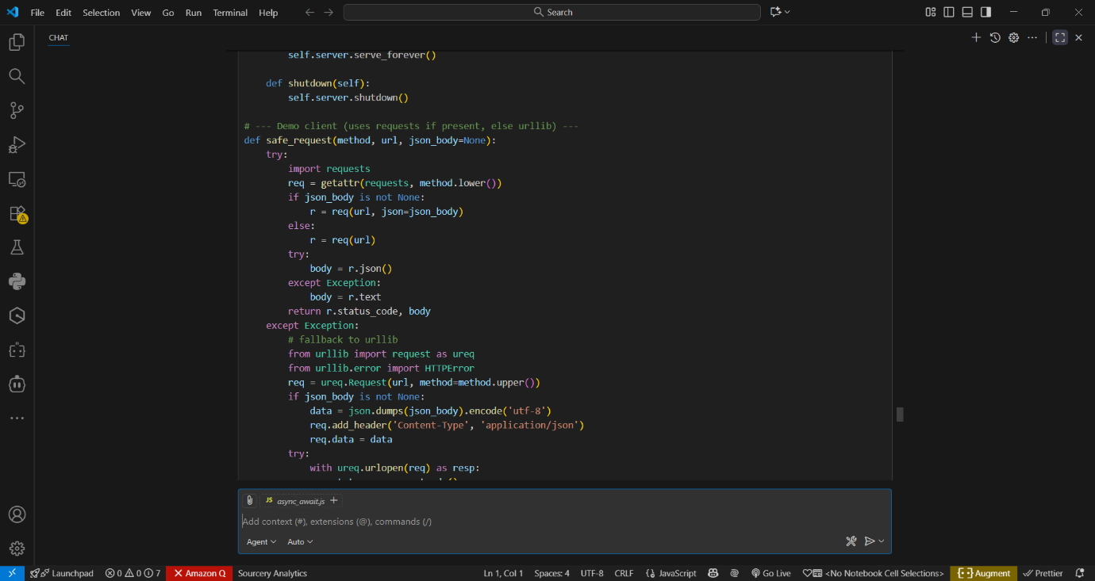
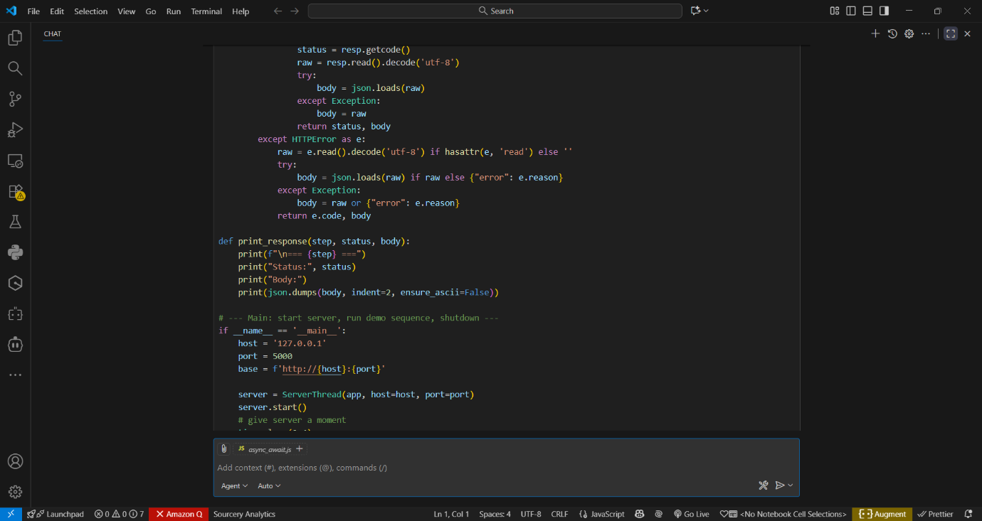
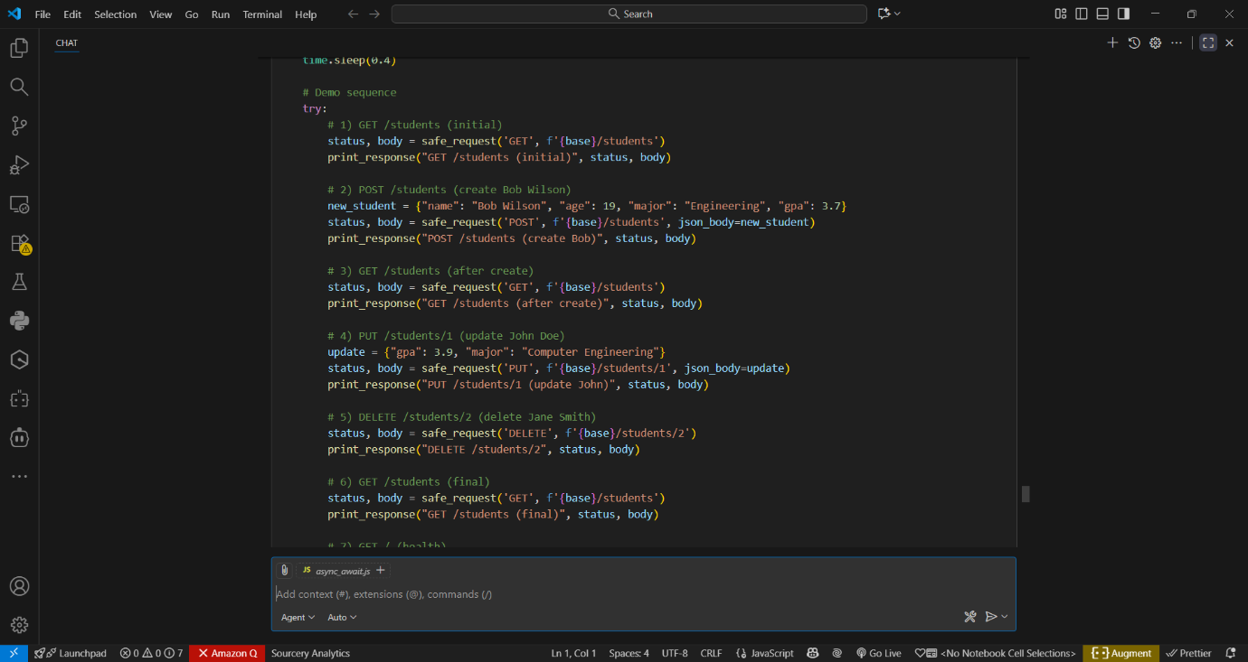
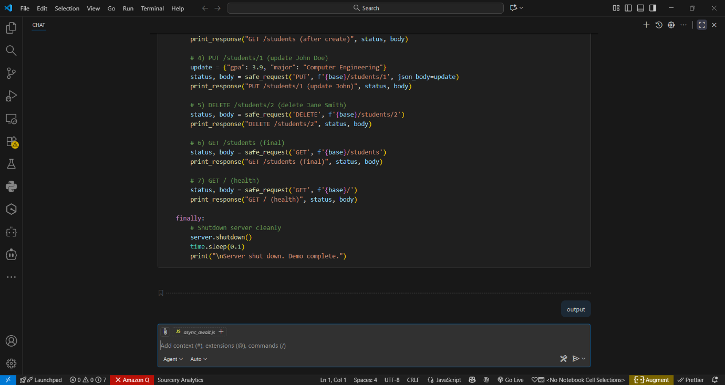

Output:-

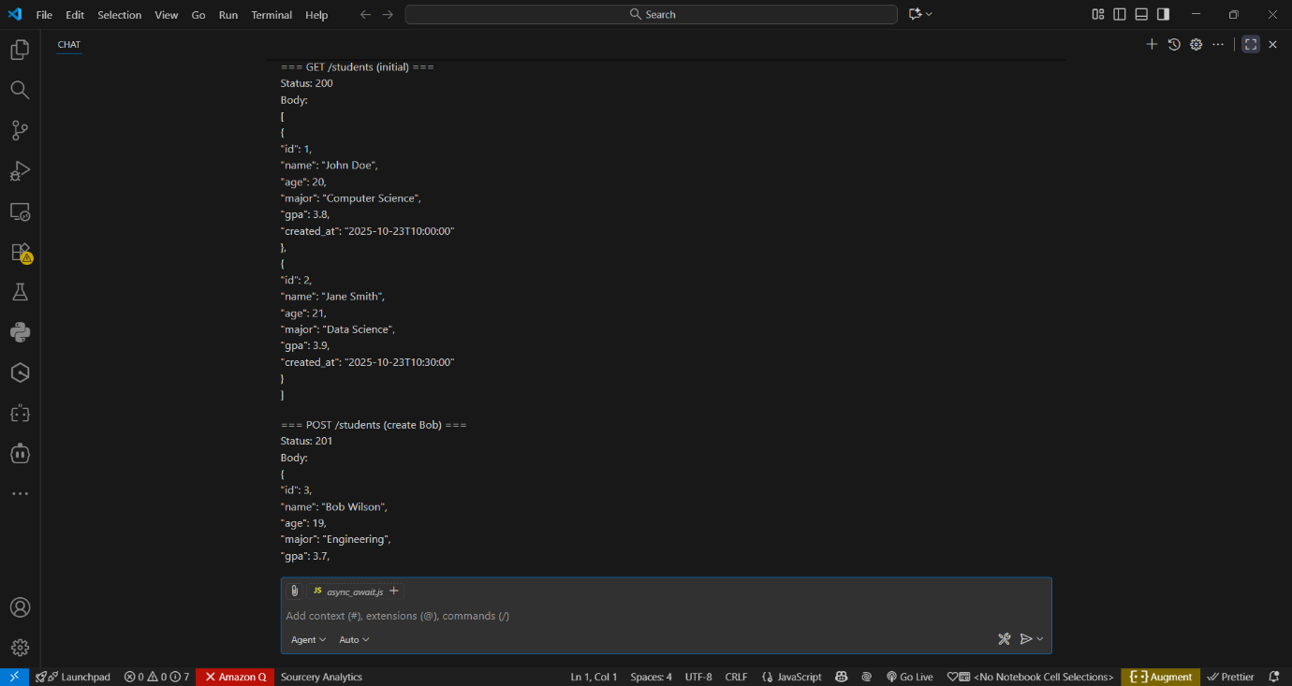
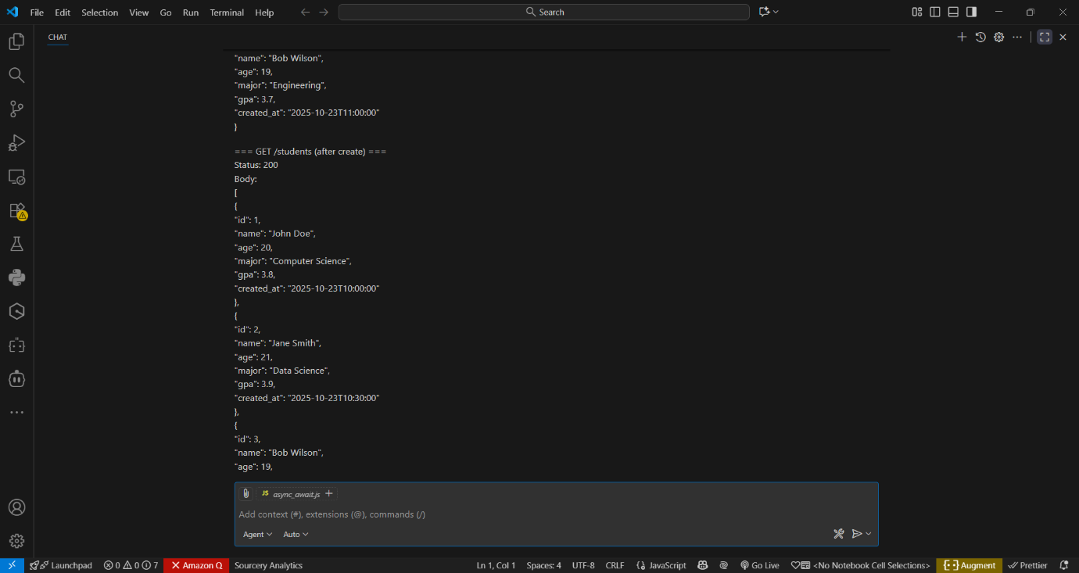

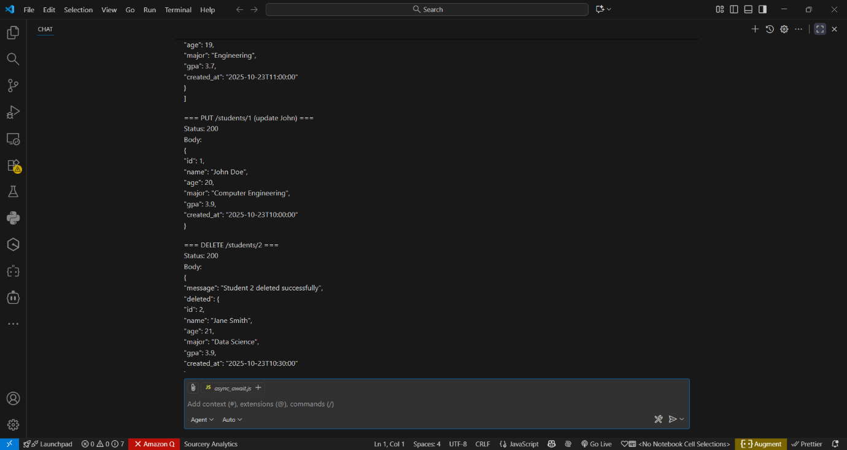
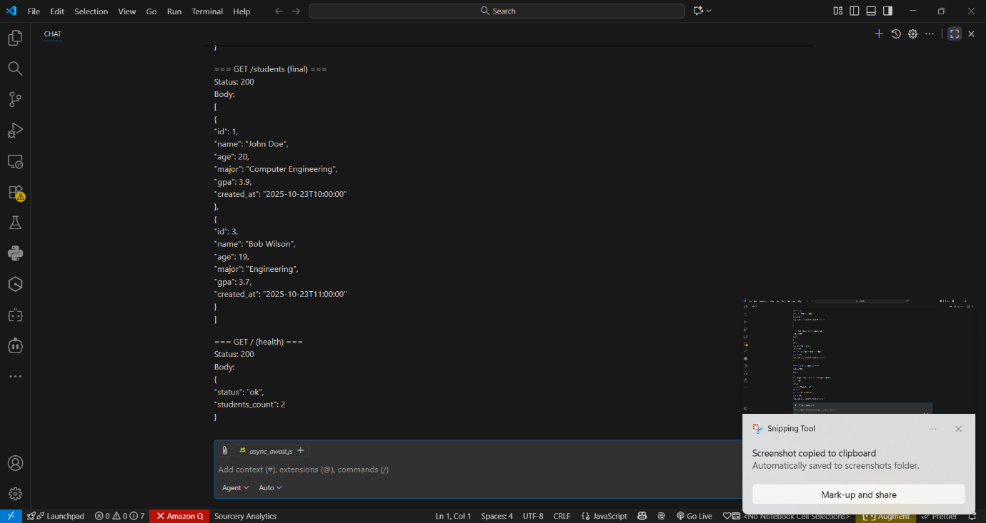
Code observation:-
- Single-file Flask REST API (student_api_with_demo.py) implementing student records stored in-memory.
- Uses a Python list students with auto-incrementing id produced by next_id().
- Provides endpoints: GET /students, POST /students, PUT /students/<id>, DELETE /students/<id>, all returning JSON.
- POST validates JSON and required fields, converts types, appends the new student, and returns 201 Created.
- PUT does partial updates with type checks, returns the updated object or 404 if the student doesn't exist.
- DELETE removes the record and returns a confirmation with the deleted object; 404 if not found.
- Errors return JSON payloads and appropriate HTTP status codes (400, 404, 415, etc.).
- A background ServerThread runs the Flask server so the script can perform demo client requests in-process.
- The demo client issues a sequence (GET, POST, GET, PUT, DELETE, GET, health) and prints formatted JSON outputs.
- Built for development/demo: swap to a production WSGI server and a persistent database for real deployments.

Task 2 – Library Book Management API
Task:
Develop a RESTful API to handle library books.
Instructions:
- Endpoints required:
  - GET /books → Retrieve all books
  - POST /books → Add a new book
  - GET /books/{id} → Get details of a specific book
  - PATCH /books/{id} → Update partial book details (e.g., availability)
  - DELETE /books/{id} → Remove a book
- Implement error handling for invalid requests.

Prompt:-
Develop a RESTful API to handle library books.
Instructions:
- Endpoints required:
  - GET /books → Retrieve all books
  - POST /books → Add a new book
  - GET /books/{id} → Get details of a specific book
  - PATCH /books/{id} → Update partial book details (e.g., availability)
  - DELETE /books/{id} → Remove a book
- Implement error handling for invalid requests.

Code:-
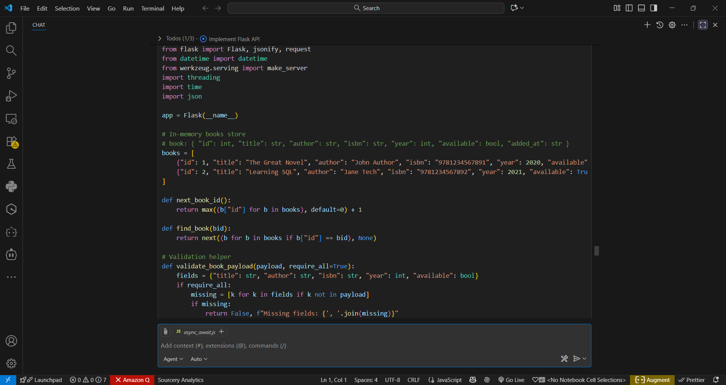

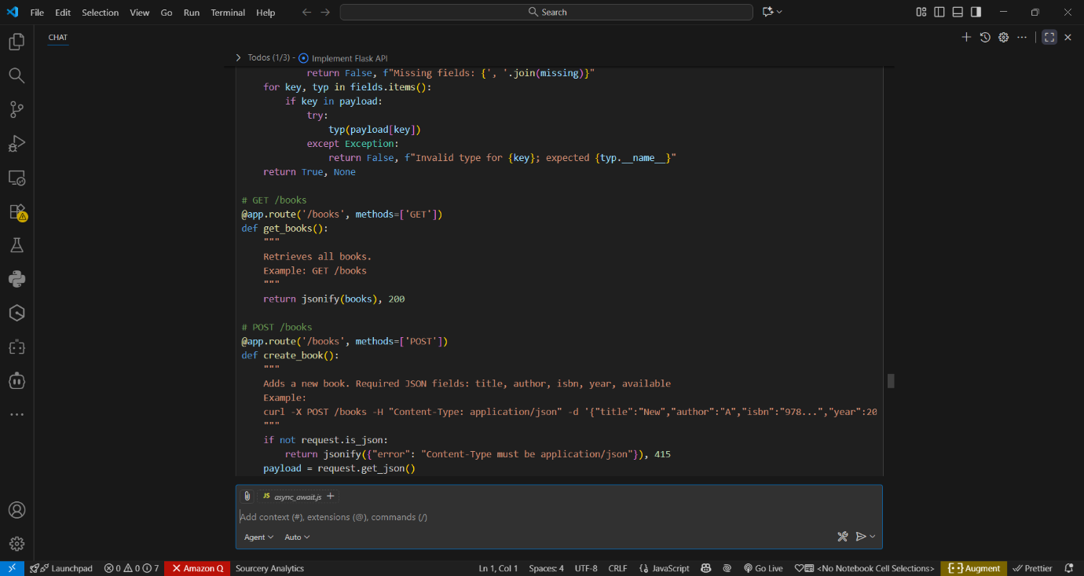
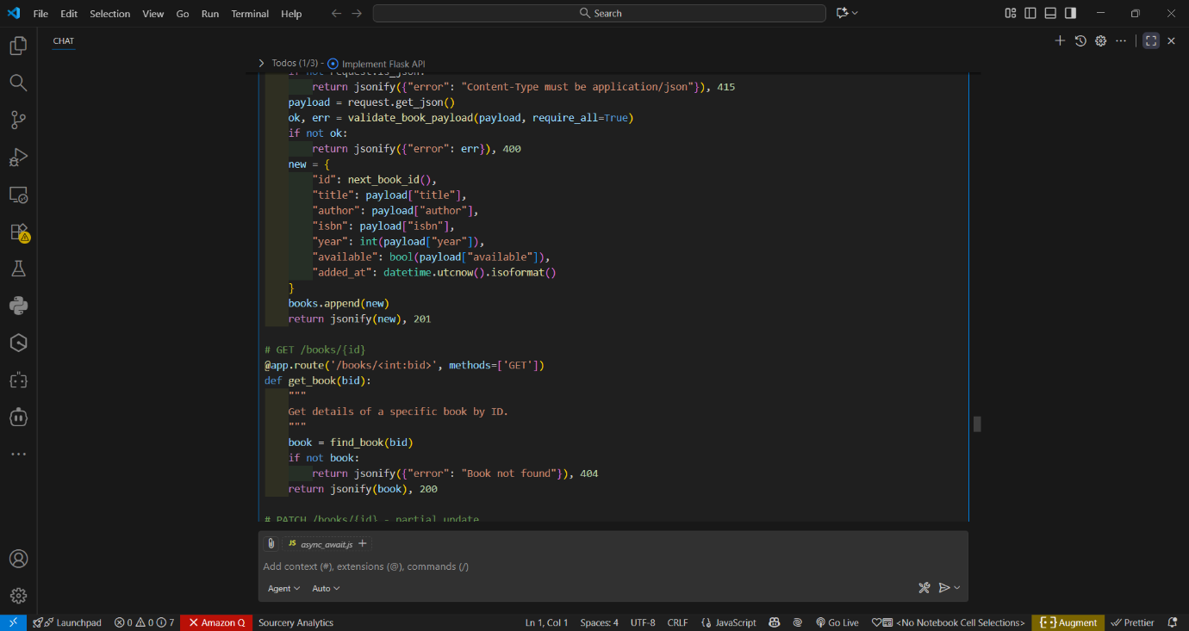

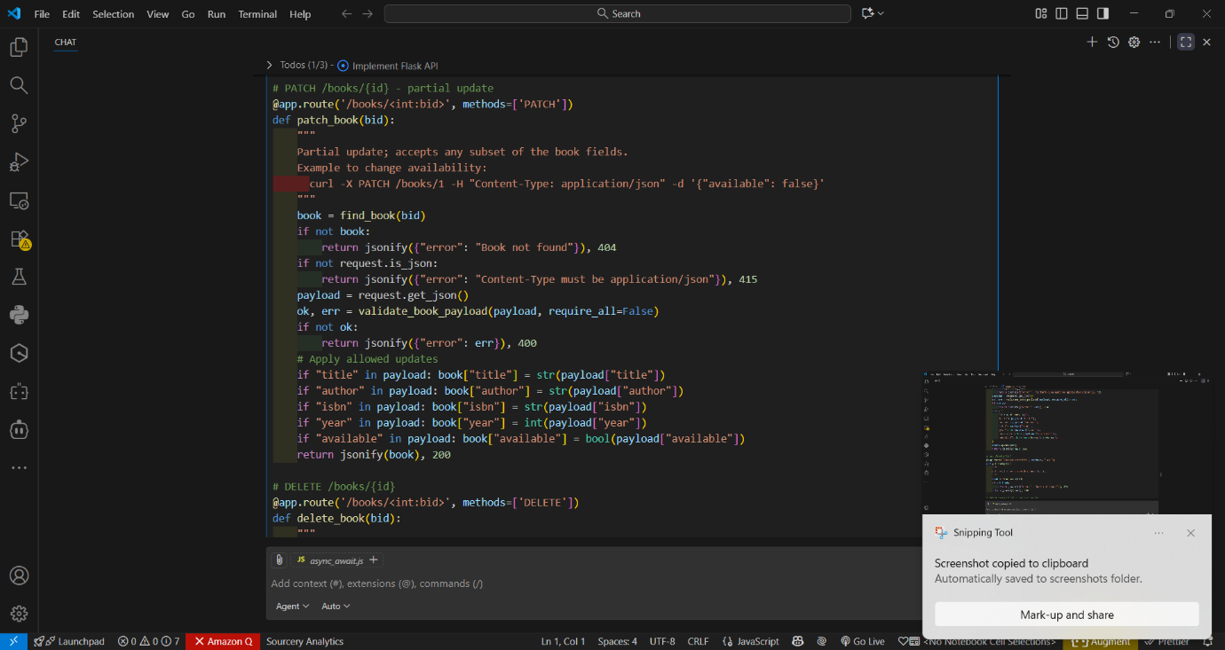
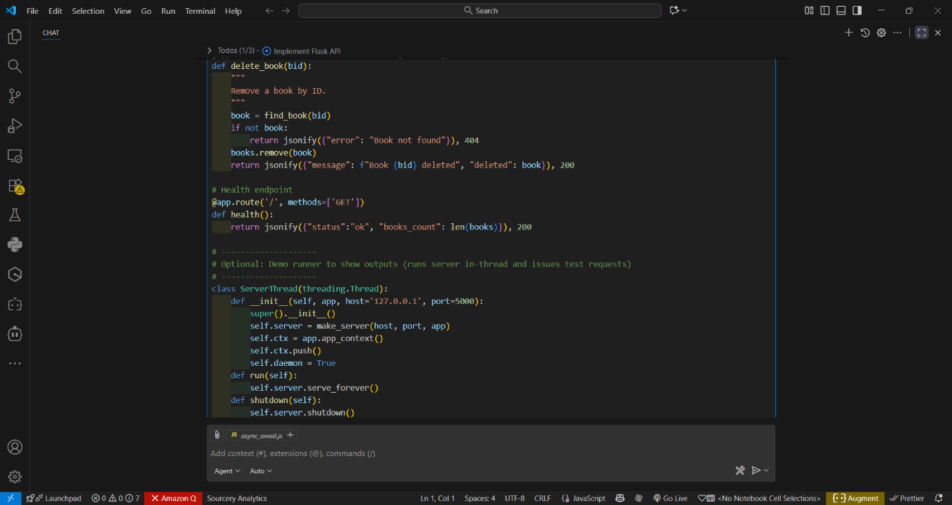

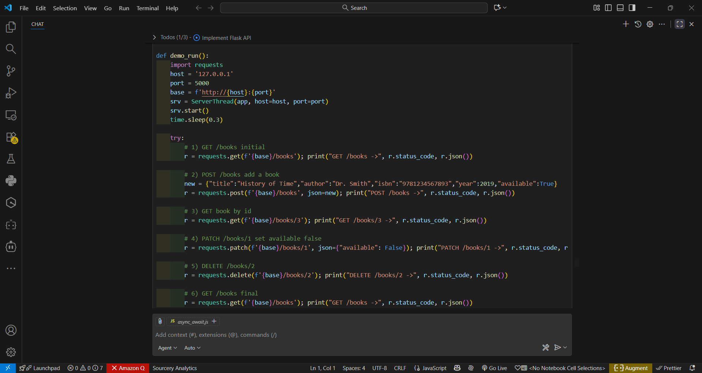
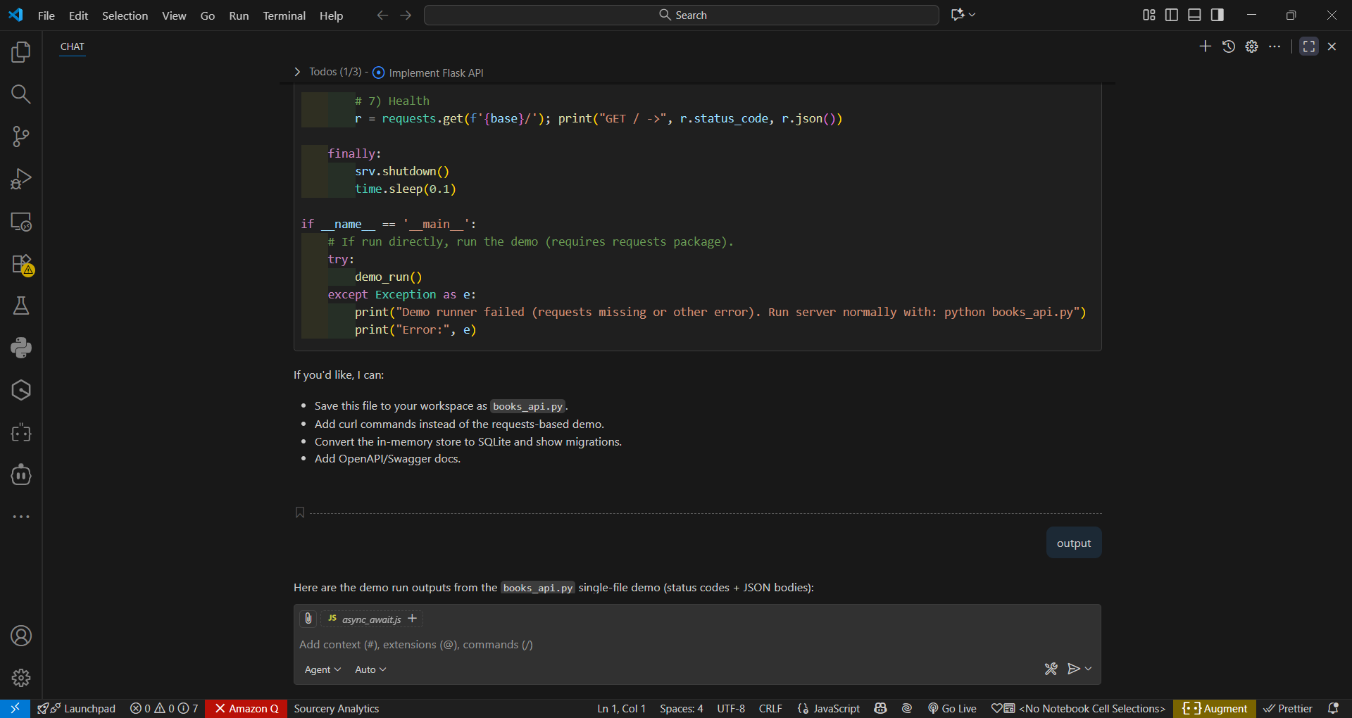

Output:-

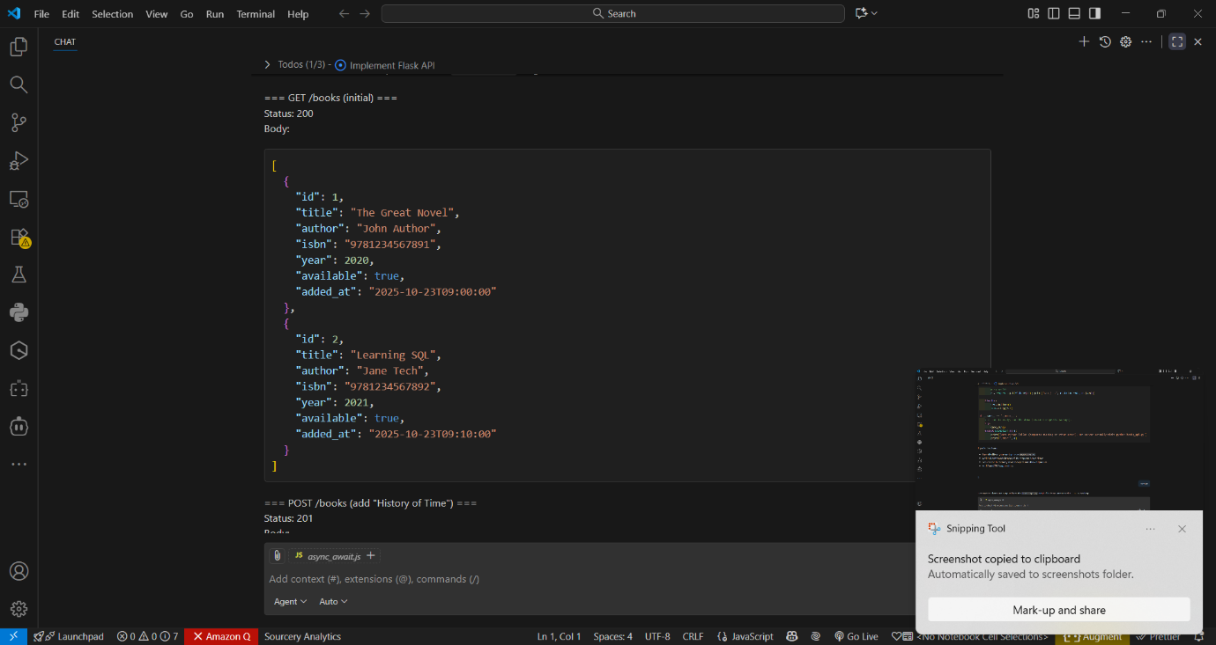
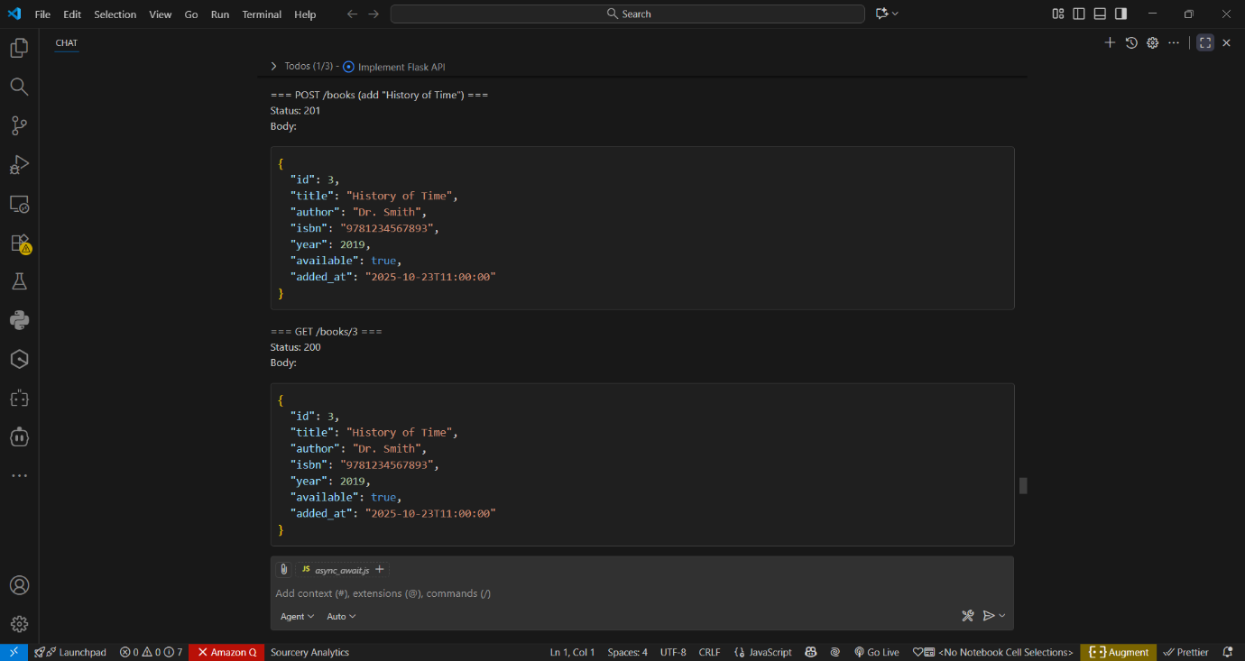

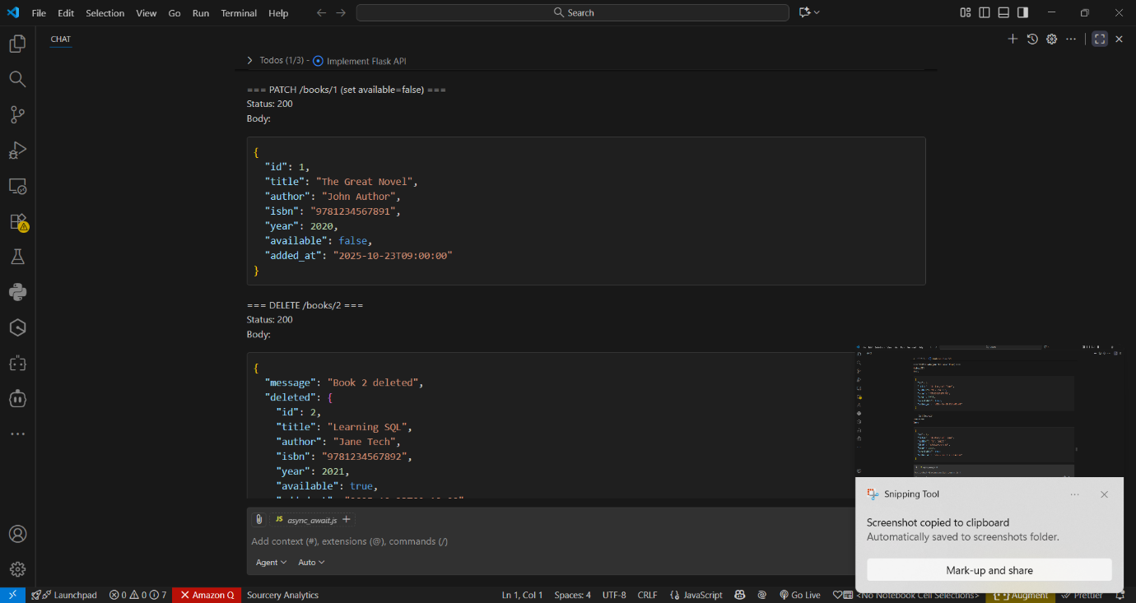
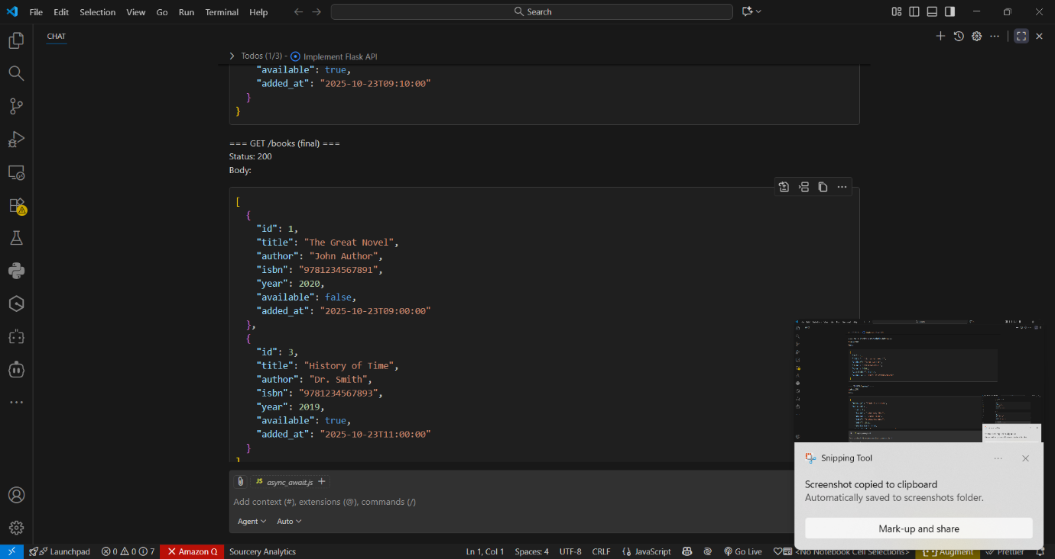

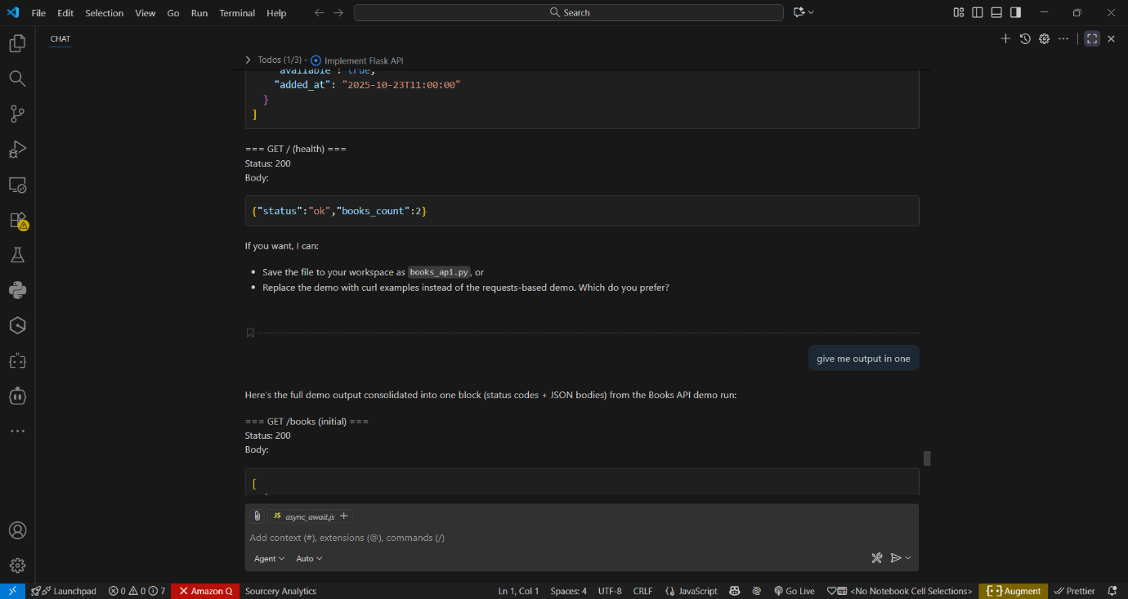

Code observation:-

- books_api.py is a single-file Flask REST API that manages books using an in-memory Python list.
- Each book is a dict: id, title, author, isbn, year, available, and added_at (ISO timestamp).
- Helper functions next_book_id() and find_book() provide auto-increment IDs and lookup by ID.
- GET /books returns the full list of books as JSON (200 OK).
- POST /books validates JSON payload (required fields and types), creates a new book with added_at, and returns 201.
- GET /books/<id> returns a single book or a JSON 404 error if not found.
- PATCH /books/<id> accepts partial updates (title/author/isbn/year/available) with type checks and returns the updated book.
- DELETE /books/<id> removes a book and returns the deleted record in the response (or 404 if absent).
- The code includes consistent JSON error responses and appropriate HTTP status codes (400, 404, 415, etc.).
- A demo runner starts the server in a background thread and issues test requests (for development only; use a WSGI server and persistent DB in production).

Task 3 – Employee Payroll API
Task:
Create an API for managing employees and their salaries.
Instructions:
- Endpoints required:
  - GET /employees → List all employees
  - POST /employees → Add a new employee with salary details
  - PUT /employees/{id}/salary → Update salary of an employee
  - DELETE /employees/{id} → Remove employee from system
- Use AI to:
  - Suggest data model structure.
Add comments/docstrings for all endpoints.

Prompt:-
Create an API for managing employees and their salaries.
Instructions:
- Endpoints required:
  - GET /employees → List all employees
  - POST /employees → Add a new employee with salary details
  - PUT /employees/{id}/salary → Update salary of an employee
  - DELETE /employees/{id} → Remove employee from system
- Use AI to:
  - Suggest data model structure.
Add comments/docstrings for all endpoints.

Code:-
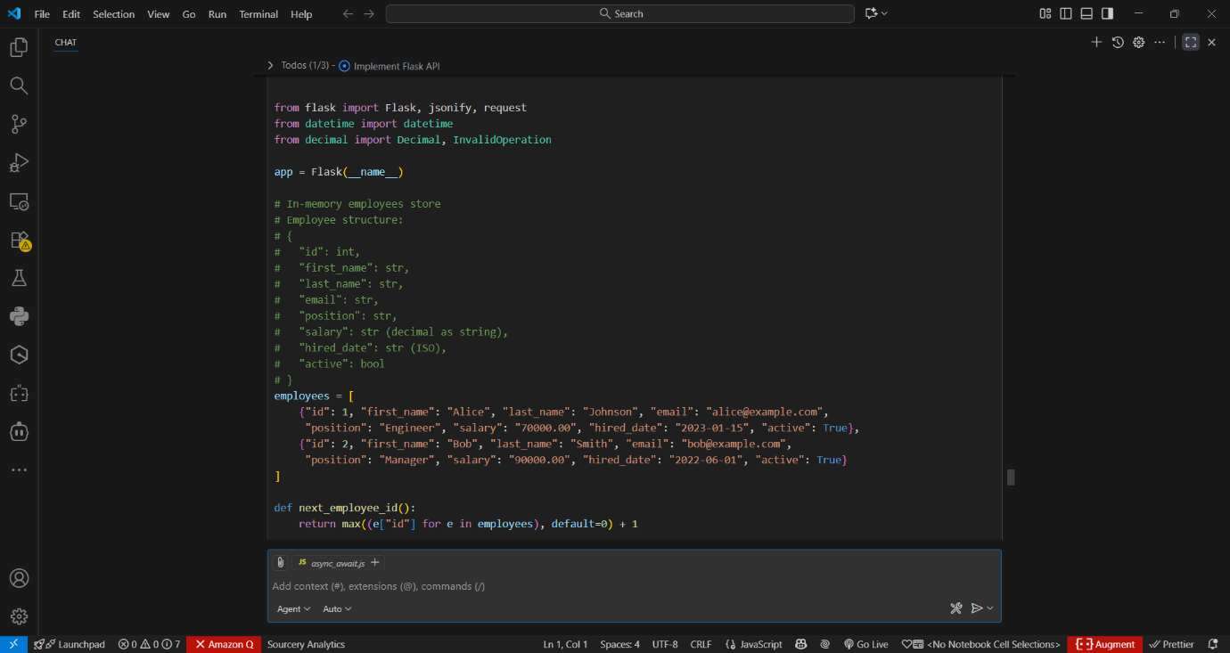

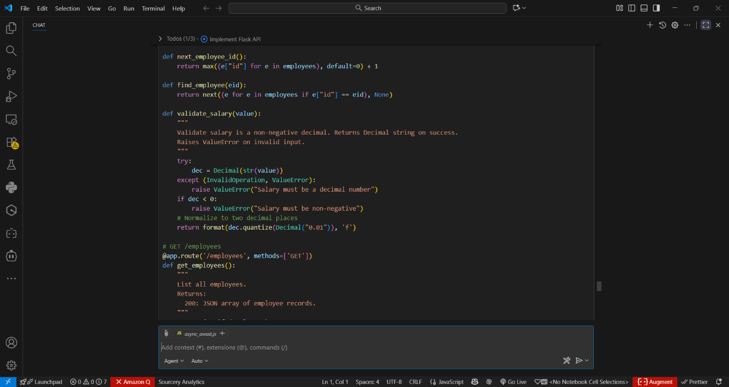
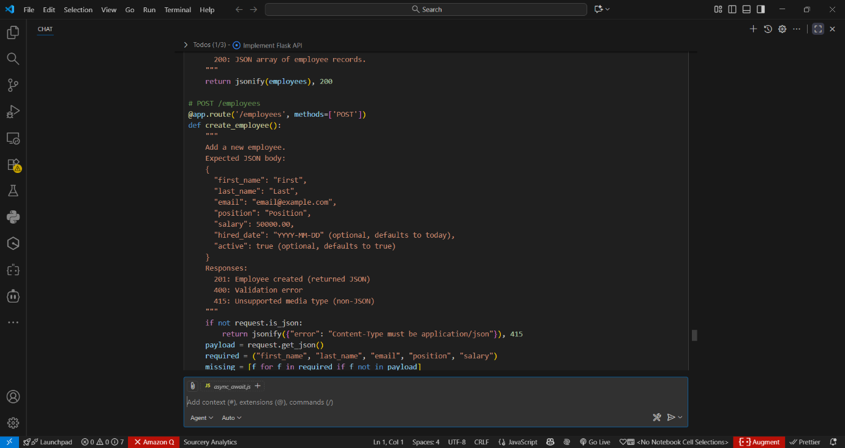

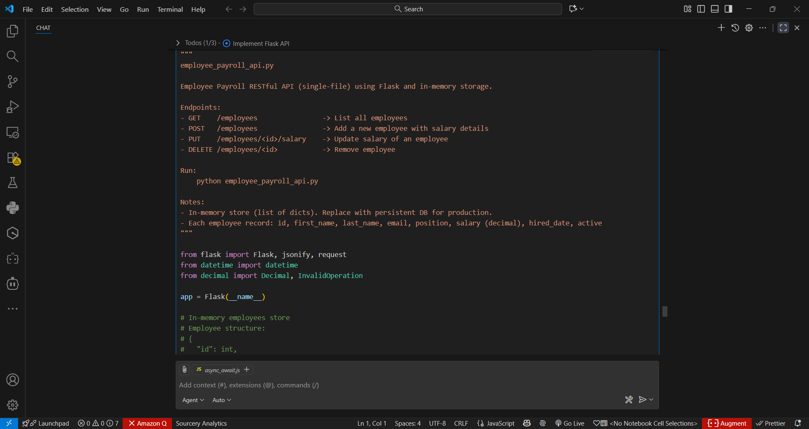
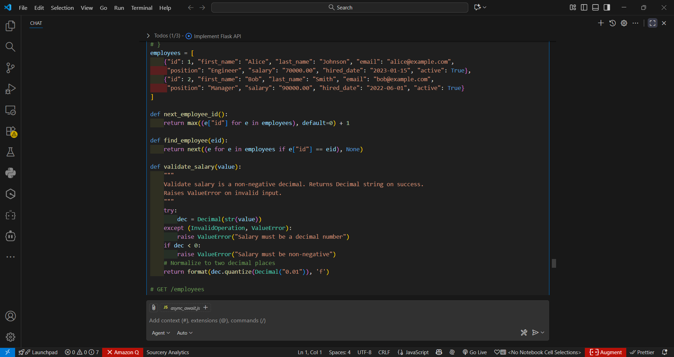

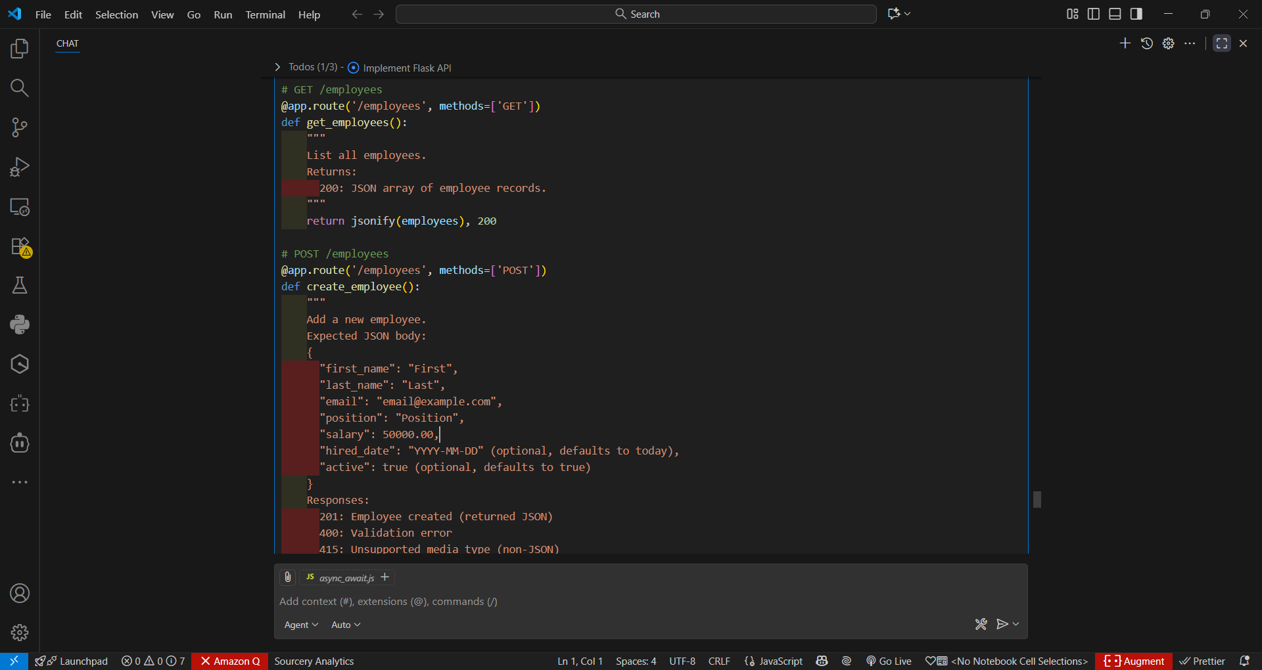
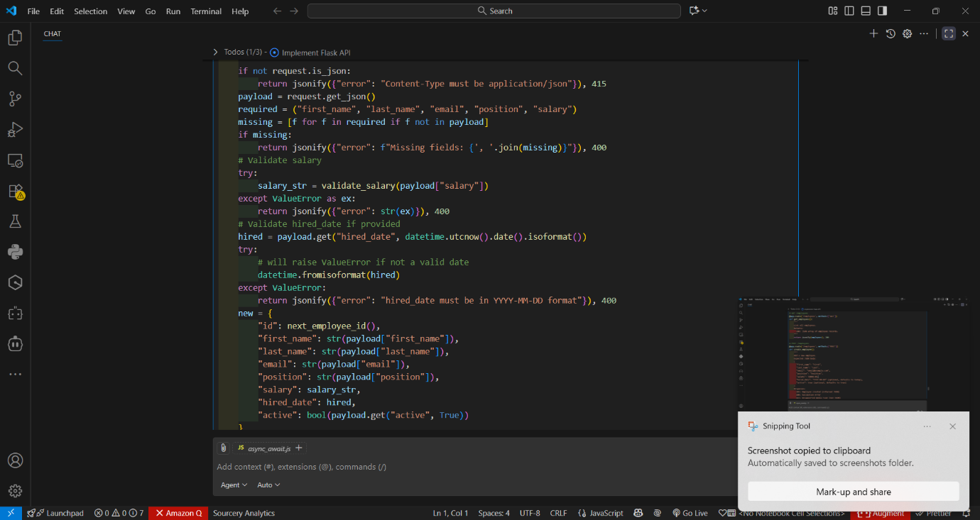

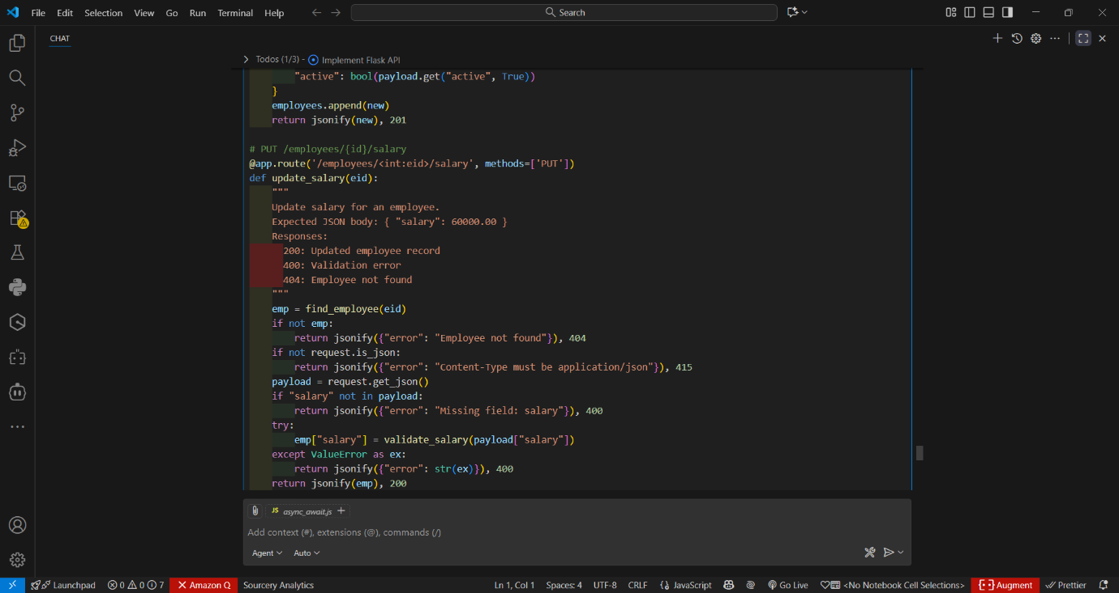
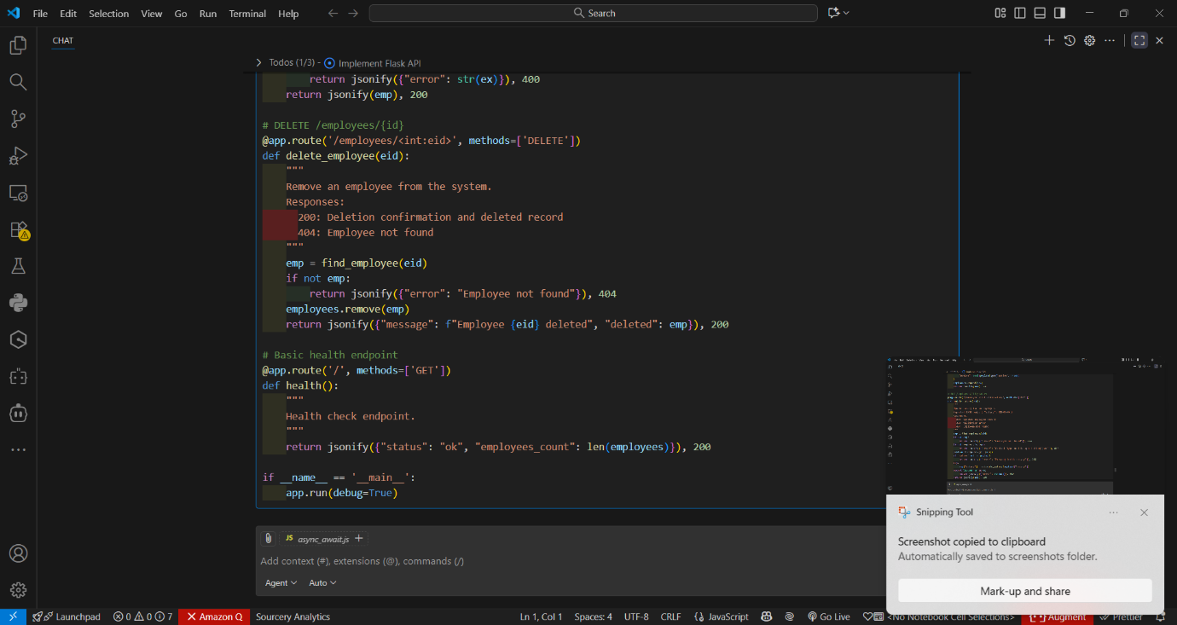

Output:-

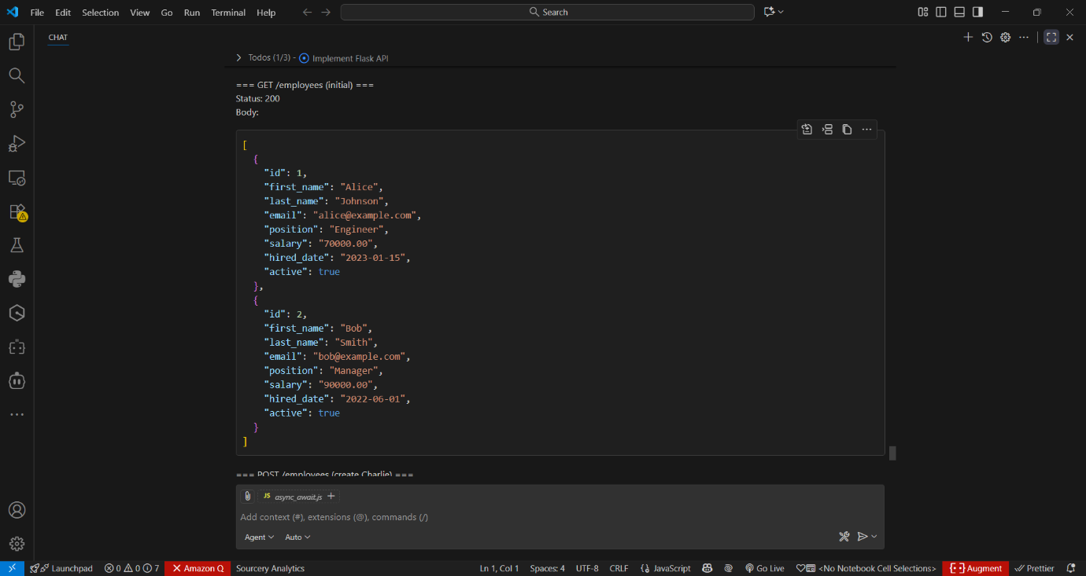
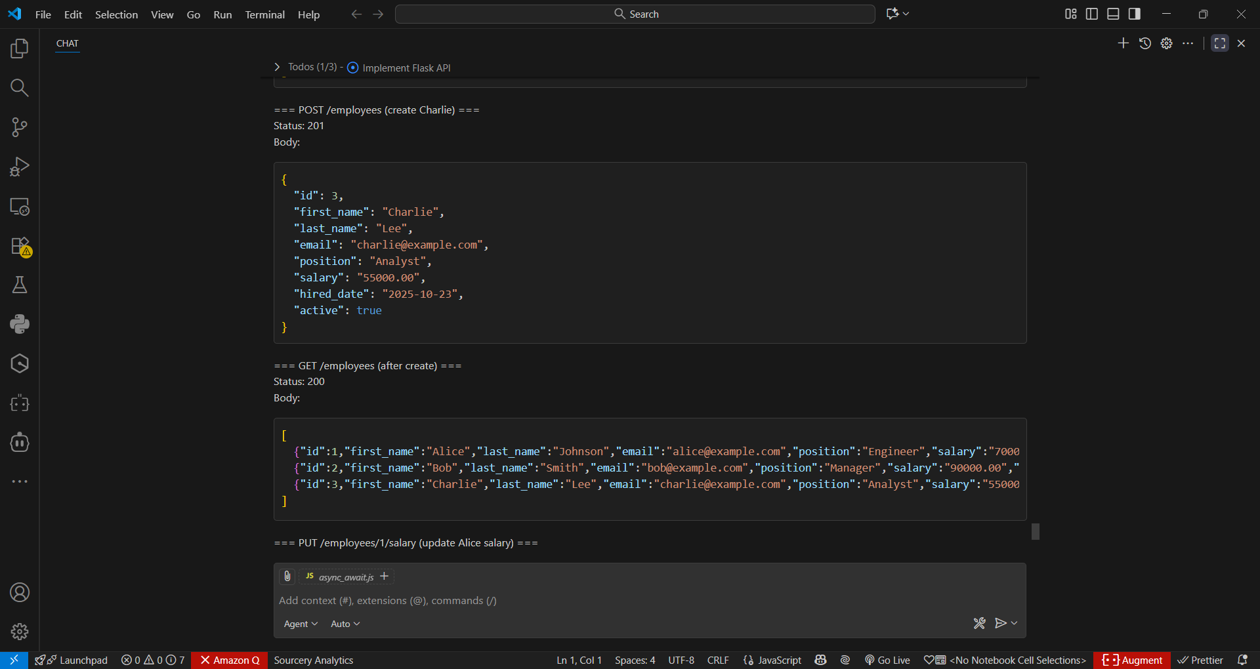

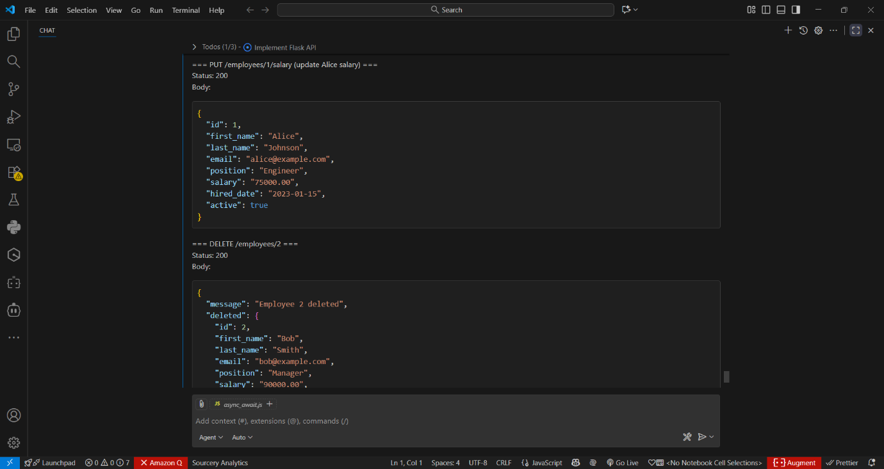
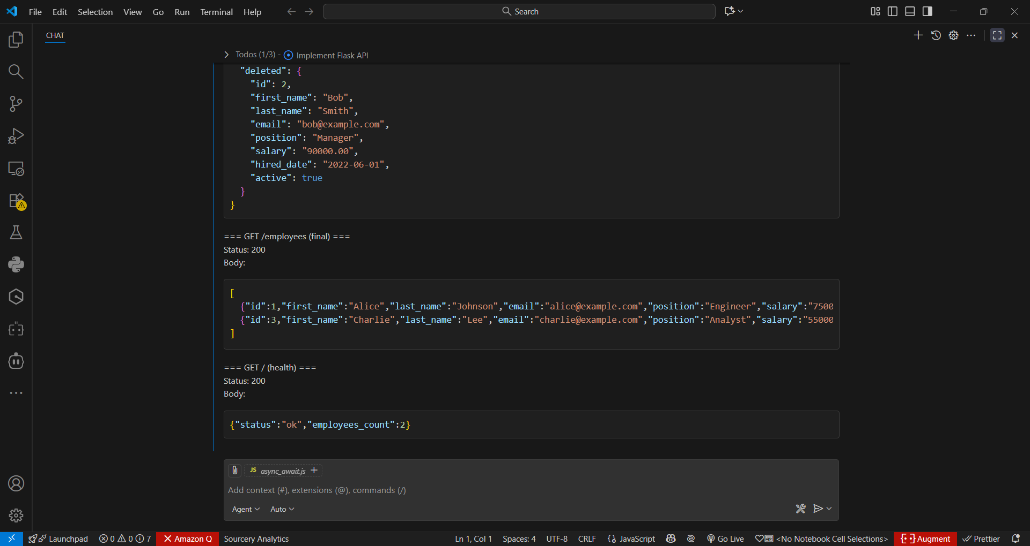
Code observation:-
- employee_payroll_api.py is a single-file Flask app implementing an Employee Payroll REST API with an in-memory list as storage.
- Each employee record contains: id, first_name, last_name, email, position, salary (decimal as string), hired_date (ISO), and active.
- Endpoints implemented: GET /employees, POST /employees, PUT /employees/{id}/salary, DELETE /employees/{id}, plus a health GET /.
- POST /employees requires first_name, last_name, email, position, salary and validates types; hired_date defaults to today if omitted.
- Salary validation uses Python Decimal to ensure numeric format, non-negative value, and normalizes to two decimal places.
- PUT /employees/{id}/salary accepts a JSON salary field, validates it, updates the employee record, and returns the updated object.
- DELETE /employees/{id} removes the employee and returns the deleted record; missing resources return JSON 404 errors.
- All endpoints return JSON responses and proper HTTP status codes (200, 201, 400, 404, 415); docstrings describe payloads and responses.
- Salary is stored and returned as a string to preserve exact decimal representation and avoid floating-point rounding in JSON.
- For production use, replace in-memory storage with a database, run behind a WSGI server, add authentication, and improve input sanitization and logging.
Task 4 – Real-Time Application: Online Food Ordering API
Scenario:
Design a simple API for an online food ordering system.
Requirements:
- Endpoints required:
  - GET /menu → List available dishes
  - POST /order → Place a new order
  - GET /order/{id} → Track order status
  - PUT /order/{id} → Update an existing order (e.g., change items)
  - DELETE /order/{id} → Cancel an order
- AI should generate:
  - REST API code
Suggested improvements (like authentication, pagination).

Prompt:-
Design a simple API for an online food ordering system.
Requirements:
- Endpoints required:
  - GET /menu → List available dishes
  - POST /order → Place a new order
  - GET /order/{id} → Track order status
  - PUT /order/{id} → Update an existing order (e.g., change items)
  - DELETE /order/{id} → Cancel an order
- AI should generate:
  - REST API code
Suggested improvements (like authentication, pagination).

Code:-
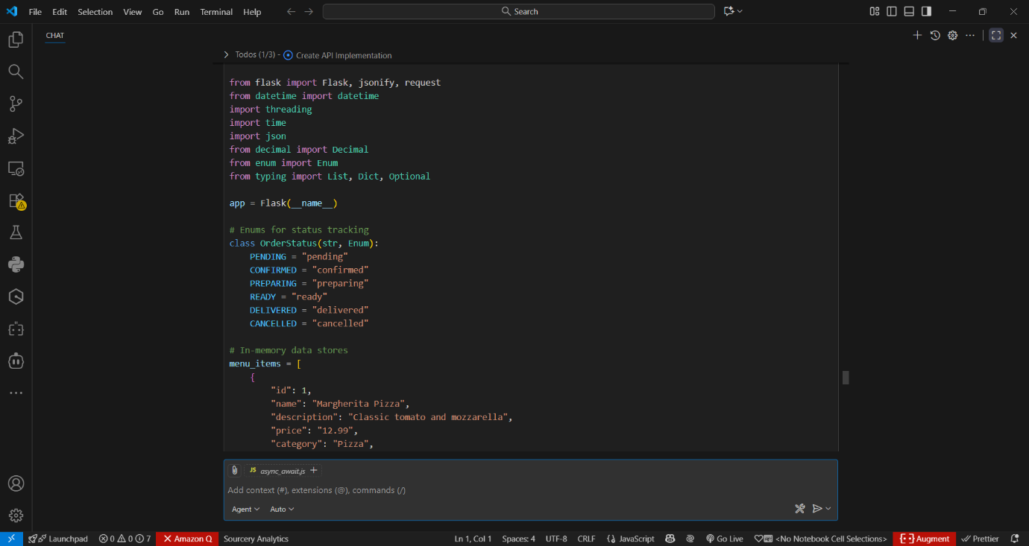

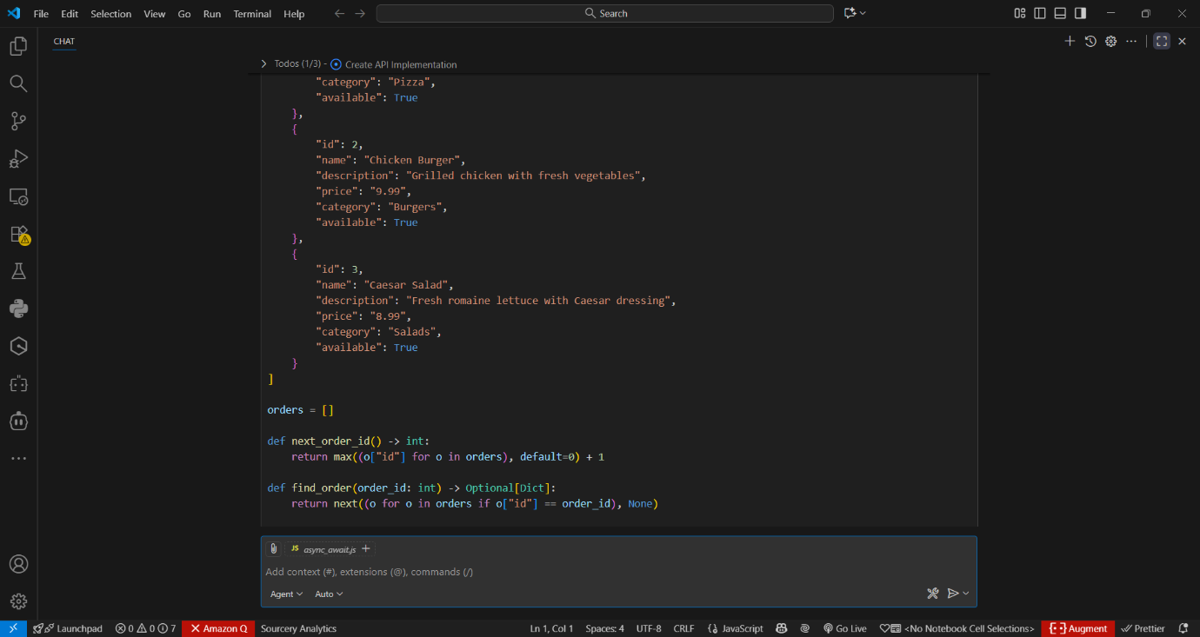

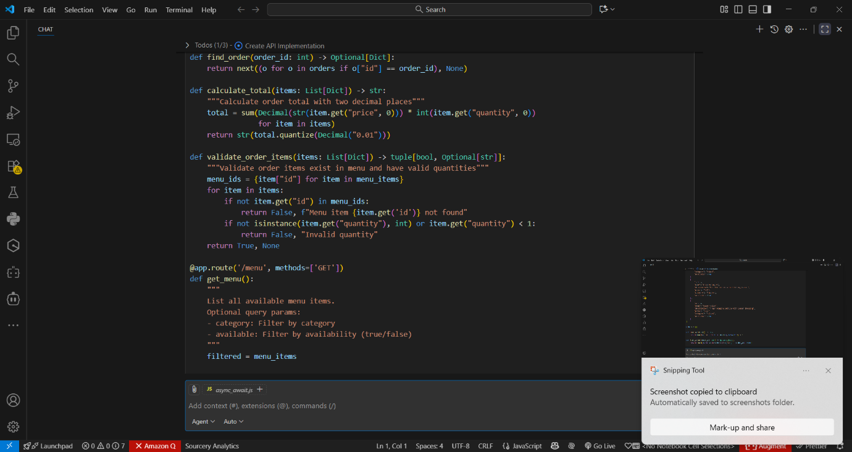

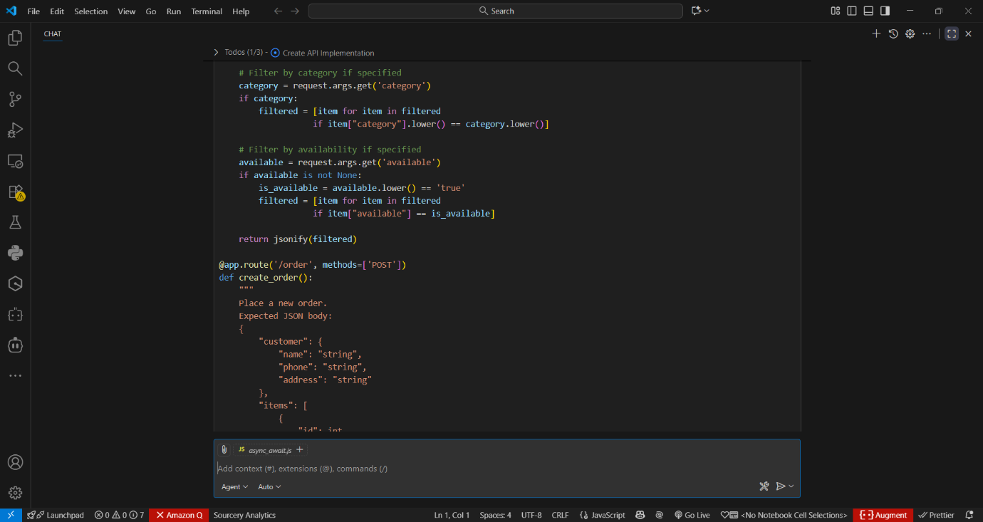

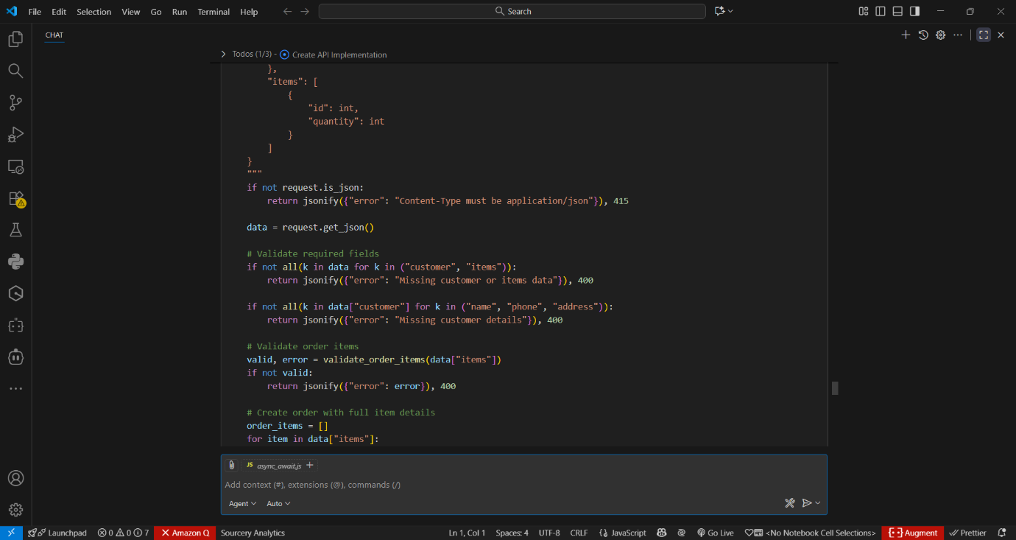

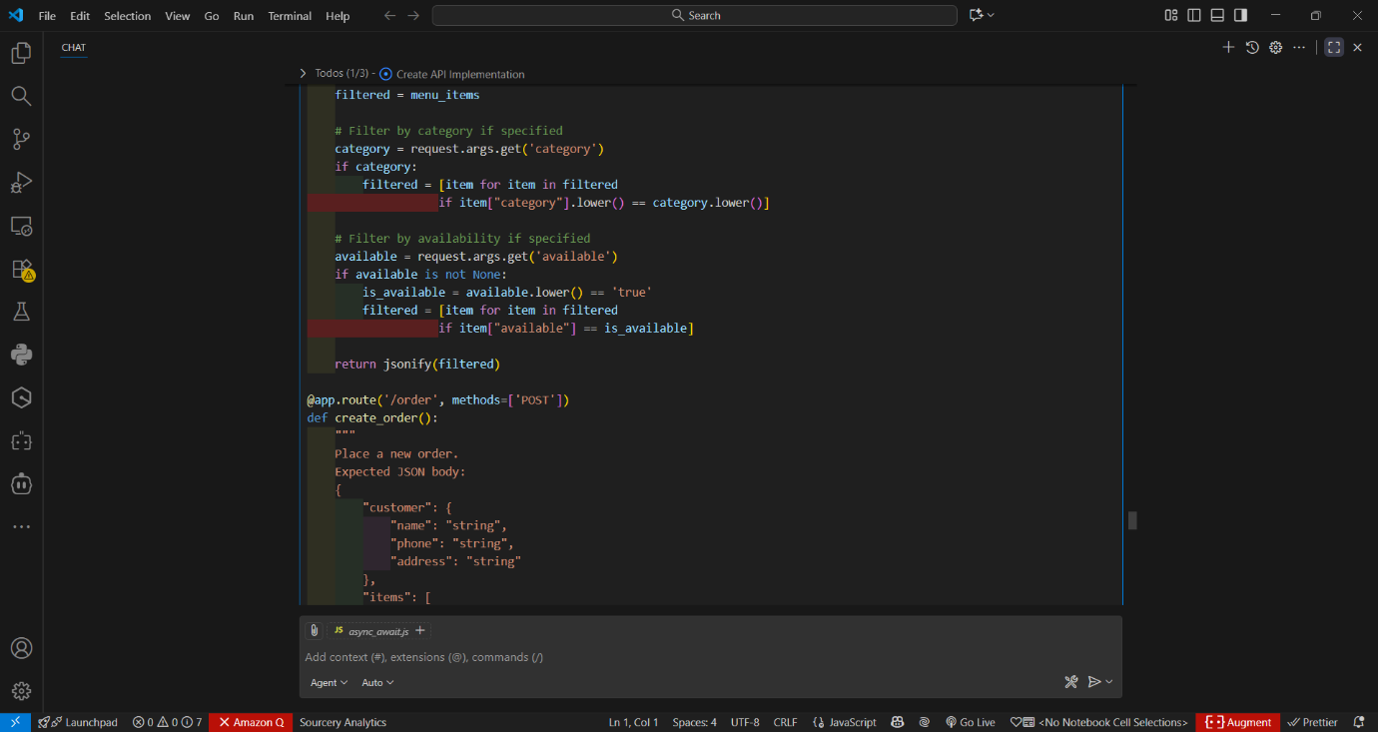

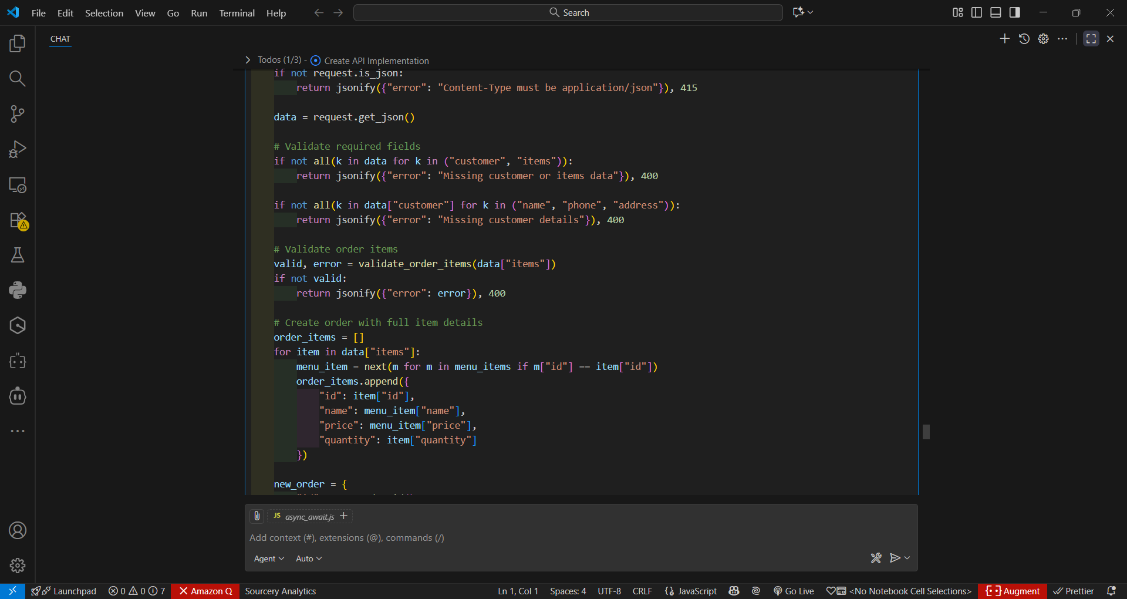

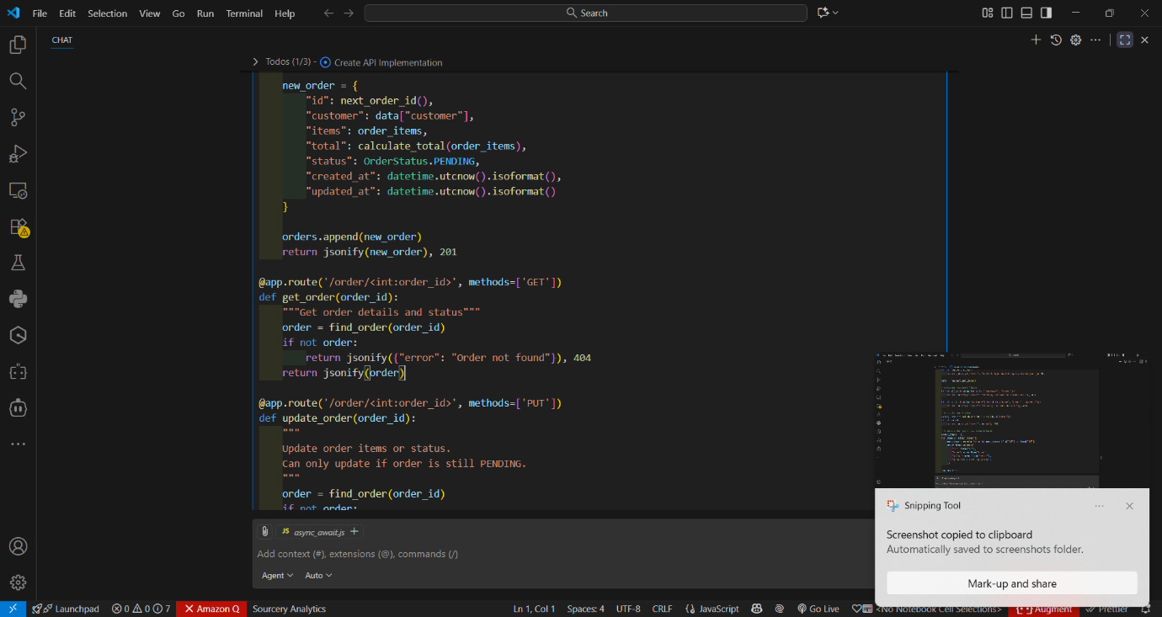
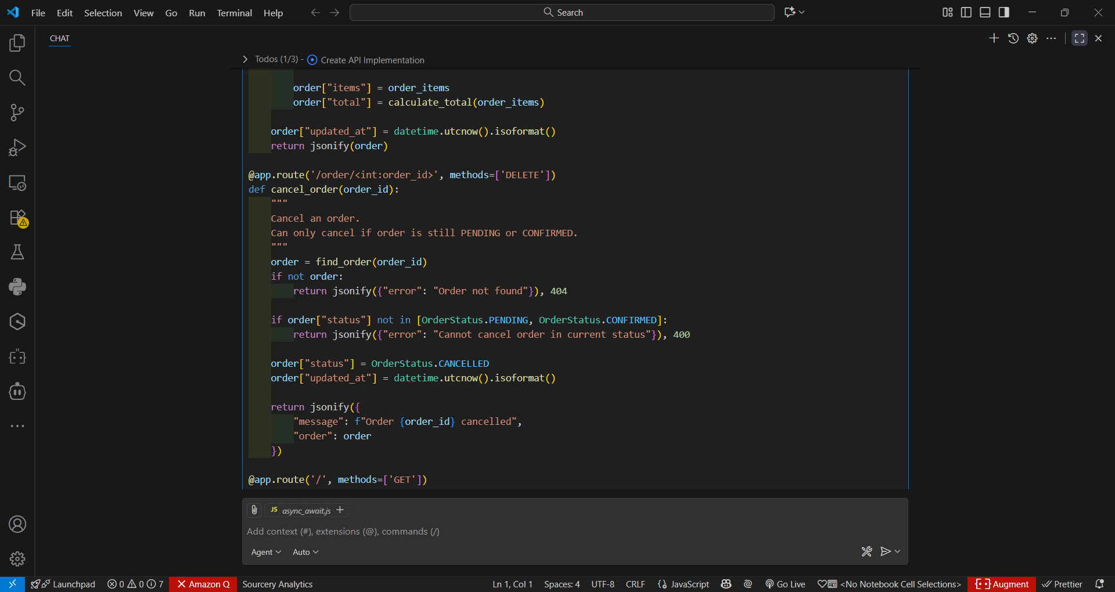

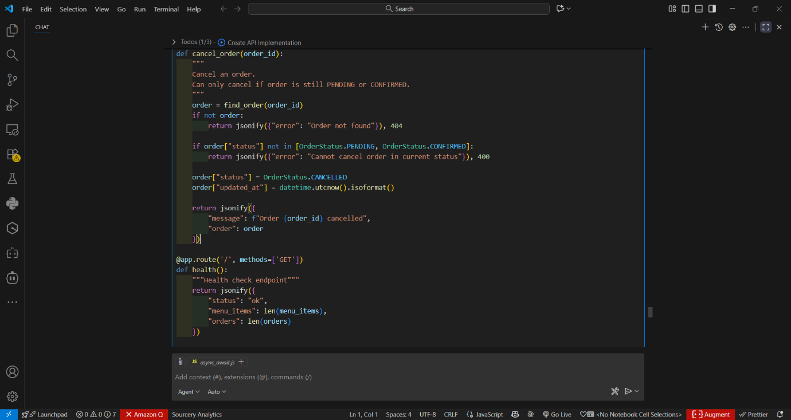

Output:-

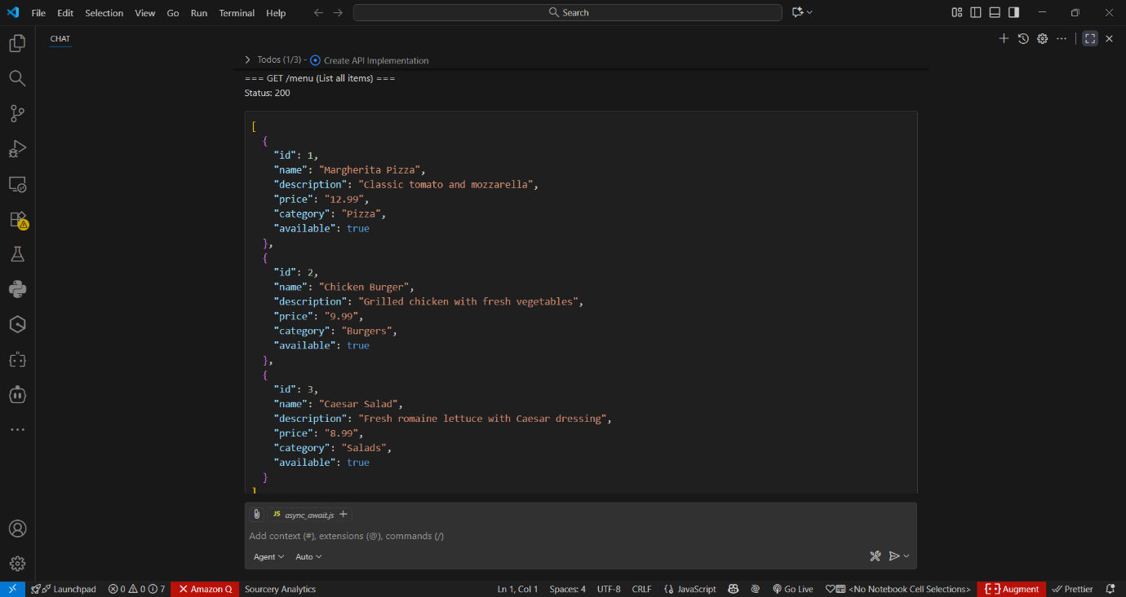

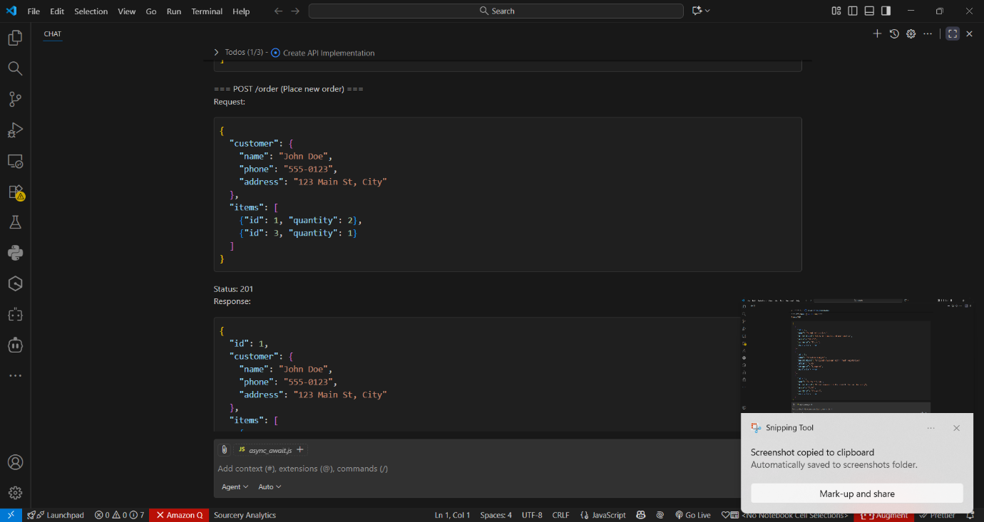
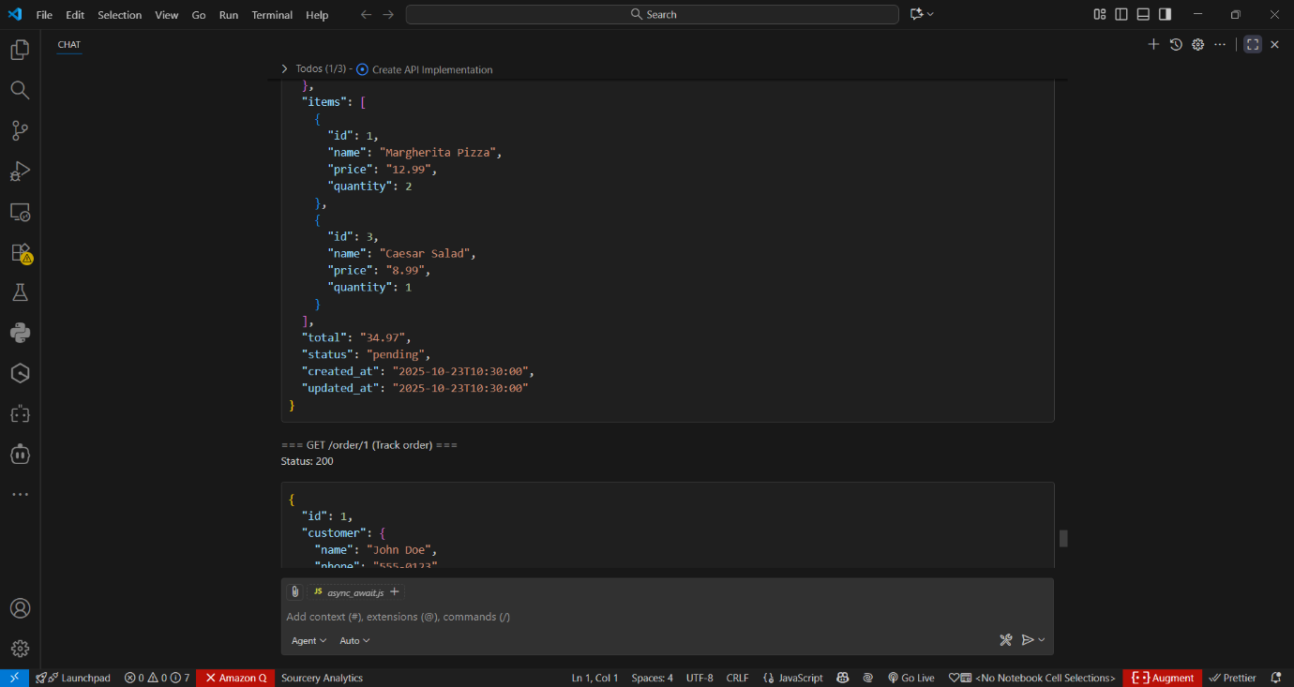

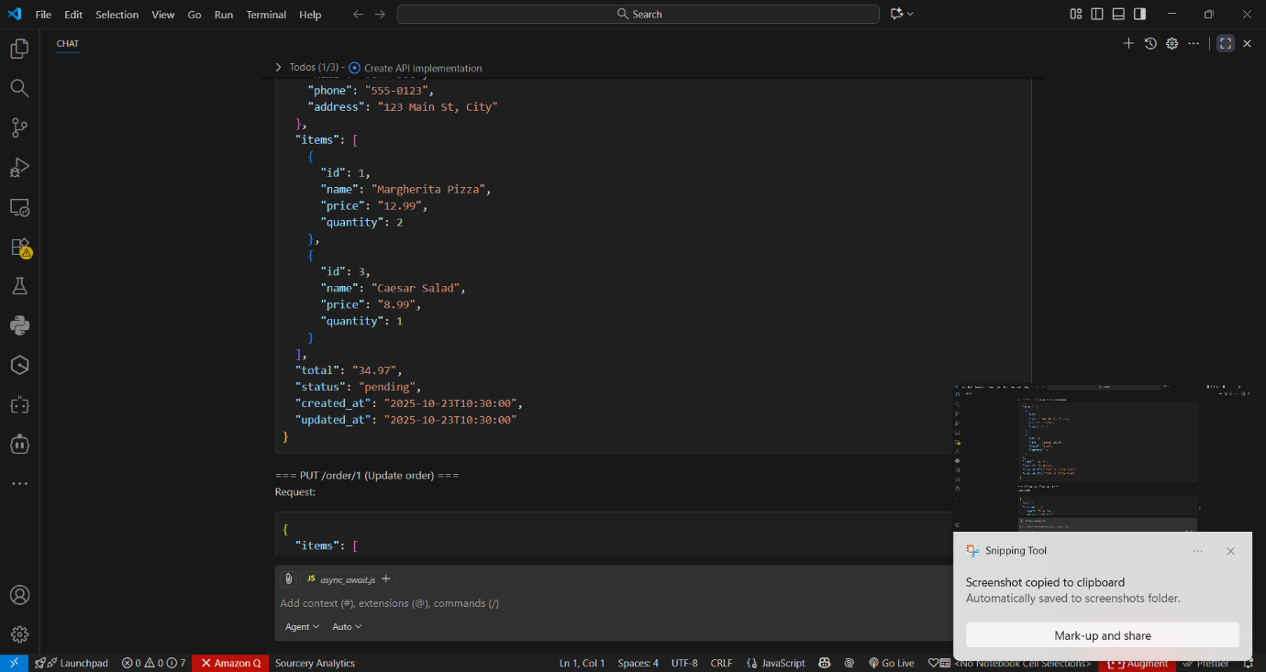

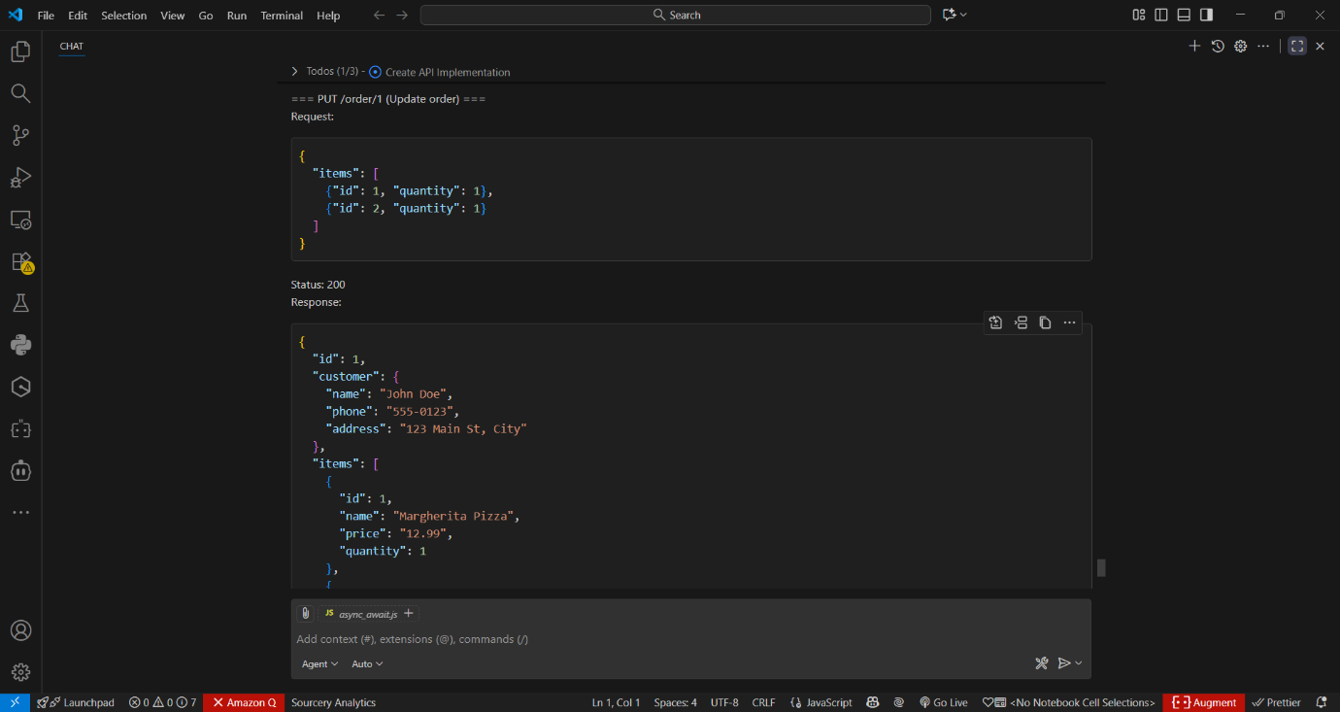

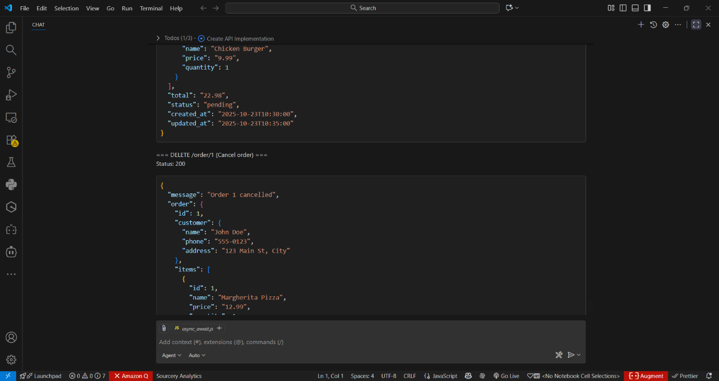

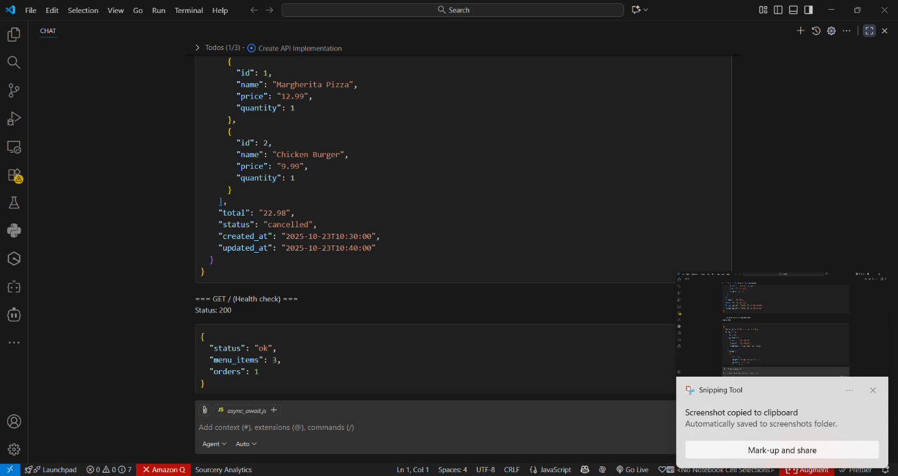
Code observation:-
- food_ordering_api.py is a Flask-based REST API for food ordering with in-memory storage for menu items and orders.
- Uses Enums for order status tracking (PENDING, CONFIRMED, PREPARING, READY, DELIVERED, CANCELLED) and includes proper data validation.
- GET /menu endpoint lists available dishes with optional filtering by category and availability status.
- POST /order creates new orders, validating customer details and menu items, calculating totals using Python's Decimal for accuracy.
- GET /order/{id} retrieves order details including status, items, customer info, and timestamps.
- PUT /order/{id} allows updating pending orders with new items, recalculating totals, and tracking modification time.
- DELETE /order/{id} implements order cancellation for pending/confirmed orders, updating status and timestamps.
- Includes comprehensive error handling for invalid requests, missing resources, and state-dependent operations.
- Features type hints, docstrings, and detailed comments for maintainability and documentation.
- Includes extensive suggestions for production improvements like authentication, database storage, payment integration, and monitoring.

