## .OUTPUTS

To run project install python 3.7 and then install DJANGO server and deploy code on that server and run from browser to get below screen



In above screen click on ‘New User Signup Here’ link to get below screen

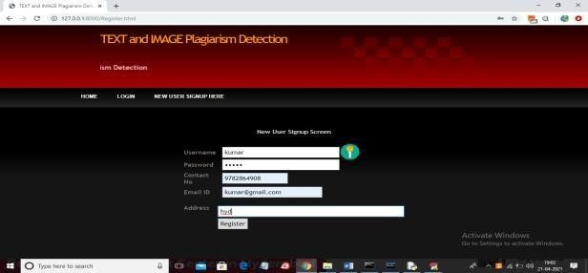

In above screen user signup details entered and then click on Register button to get below In above screen user signup process completed and now clicks on ‘Login’ link to get below screen In above screen user is login and then click on button to get below screen In above screen click on ‘Upload Source Files’ link to load all files from corpus folder

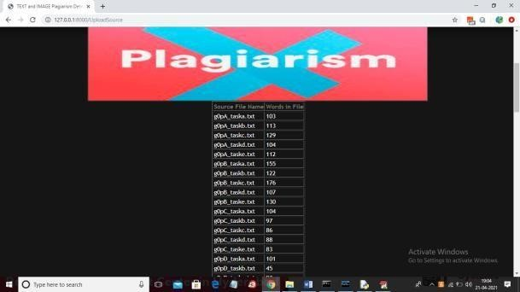

In above screen all files are loaded now click on ‘Upload Suspicious File’ button to load suspicious file and get result

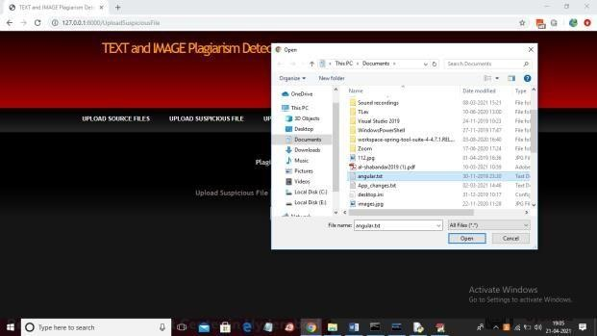

In above screen I am selecting and uploading ‘angular.txt’ file and then click on ‘Open’ button to get below result and then click on ‘Check Plagiarism’ button to get result

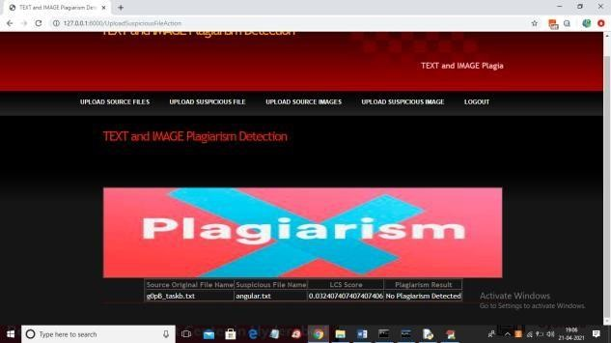

In above screen LCS score is 1.0 which means 100% matched with corpus file so plagiarism detected and similarly not only this u may enter any text file and get result. Now click on

‘Upload Source Images’ link to upload all images from ‘images’ folder

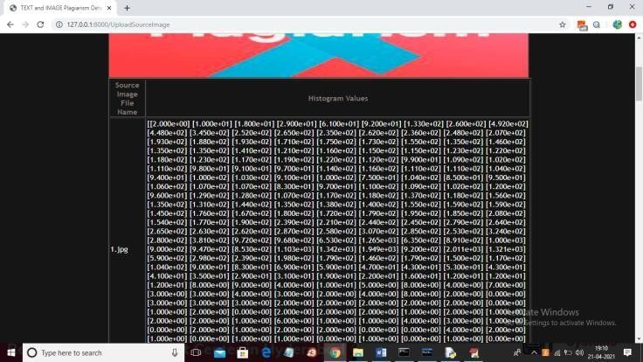

In above screen from all database images histogram will be calculated and store in array and whenever we upload new test image then both histogram will get matched and now click on

‘Upload Suspicious Image’ link to upload some image

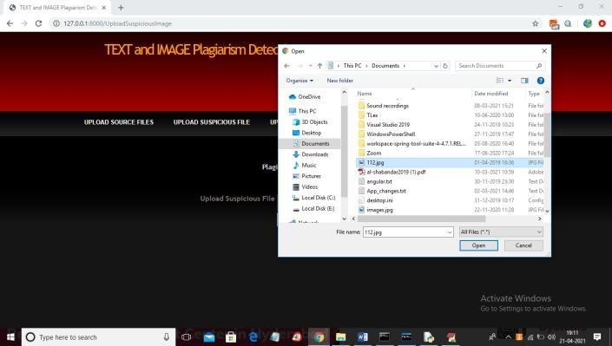

In above screen we can see for database image and uploaded image we generated histogram and we can see there is no match in histogram so no plagiarism will be detected and now close above graph to get below result

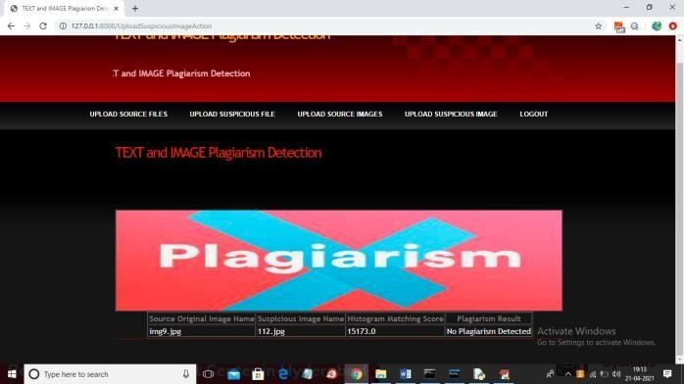

In above screen histogram pixel matching score is 15173 out of 40000 pixels so image is not plagiarized and now upload image from “images” folder and see result

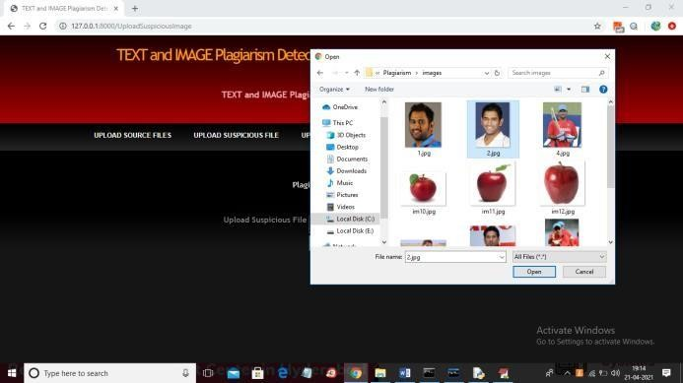

In above screen I am selecting and uploading ‘2.jpg’ file from “images” database folder and below. In above screen we can both original and uploaded image histogram is matching 100% so plagiarism is detected and now close above graph to get below result



In above screen histogram matching score is 40000 which means all pixels matched so plagiarism is detected in above result. Similarly u can upload any text file and image and test the application.