Contents

Overview 2

Tools Used 2

Solution For Perfect Numbers 2

REST API Result 3

Check Perfect Number 3

Perfect Number List 3

JUnit Testing 4

# Overview

In [number theory](https://en.wikipedia.org/wiki/Number_theory), a perfect number is a [positive integer](https://en.wikipedia.org/wiki/Positive_integer) that is equal to the sum of its positive [divisors](https://en.wikipedia.org/wiki/Divisor), excluding the number itself. For instance, 6 has divisors 1, 2 and 3 (excluding itself), and 1 + 2 + 3 = 6, so 6 is a perfect number.

Program has been written to compute check perfect number and provide list of perfect numbers. These methods are exposed as REST API’s

# Tools Used

* Java 8
* Tomcat v9.0
* Junit 4
* Postman

# Solution For Perfect Numbers

Following classes have been created to achieve the complete solution

* PerfectNumberResource : Class has been created with 2 functions:

**public** **boolean** checkPerfectNumber(**long** number):

This method is used to check if provided number is perfect or not. Logic has been written to find the divisors of provided number , sum all the divisor values, check this value against the input number.

**public** List<PerfectNumber> getListOfPerfectNumbers(**long** number1, **long** number2):

This method is used to provide the list of perfect numbers within given range of input numbers. Both numbers in the range are included in computing perfect number list.

* PerfectNumbersService : Class has been created to expose the above methods as REST API’s.

@GET

@Produces(MediaType.***TEXT_PLAIN***)

@Path("/{number}")

**public** String checkNumber(@PathParam("number") **long** number)

@GET

@Produces(MediaType.***APPLICATION_JSON***)

@Path("/{number1}/{number2}")

**public** List<PerfectNumber> getListOfPerfectNumbers (@PathParam("number1") **long** number1,@PathParam("number2") **long** number2)

* PerfectNumber : POJO class for perfect number object.
* PerfectNumberTest: Class has been created for Junit testing of perfect number functionality.

# REST API Result

## Check Perfect Number

URL : [http://localhost:8080/PerfectNumbers/{number}](http://localhost:8080/PerfectNumbers/%7bnumber%7d)

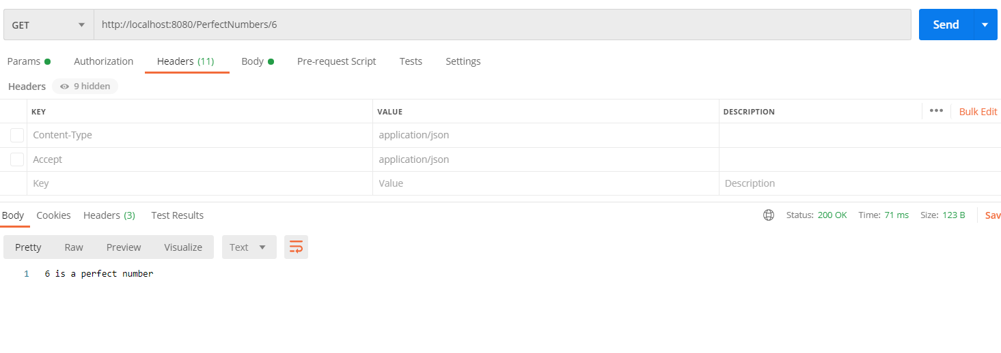

## Perfect Number List

URL: [http://localhost:8080/PerfectNumbers/{number1}/{number2}](http://localhost:8080/PerfectNumbers/%7bnumber1%7d/%7bnumber2%7d)

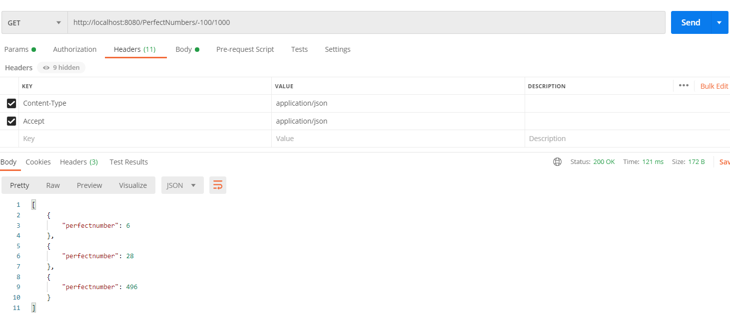

# JUnit Testing

