East-Central Europe

Summary

Presentation

Matrix of direct influences

Matrix of Direct Influences (MDI)

MDI characteristics

Stability from MDI

Sums of rows and columns of MDI

View of direct influences / dependencies

Matrix of potential direct influences

Matrix of Potential Direct Influences (MPDI)

MPDI characteristics

mmc_midp_stability

Sums of rows and columns of MPDI

View of potential direct influences / dependencies

Matrix of indirect influences

Sums of rows and columns of MII

View of indirect influences / dependencies

Matrix of potential indirect influences

Sums of rows and columns of MPII

View of potential indirect influences / dependencies

Variable ranking

Variable ranking by influences

Variable ranking by dependencies

Synthesis

# Presentation

See the importance of different variables

# Matrix of direct influences

## Matrix of Direct Influences (MDI)

|  |  |  |  |  |  |  |  |  |  |  |  |  |  |  |  |  |  |  |  |  |  |  |  |  |  |  |  |  |  |  |
| --- | --- | --- | --- | --- | --- | --- | --- | --- | --- | --- | --- | --- | --- | --- | --- | --- | --- | --- | --- | --- | --- | --- | --- | --- | --- | --- | --- | --- | --- | --- |
|  | rusb | usab | euob | turb | turi | eece | milbeceia | milboa | coopece | coopglob | baldga | instreg | migpres | ukstab | kurdst | enerece | wmdprofgl | chnbeh | demiaece | ecostab | ethnbalia | natconcia | demoaece | demglob | econiaece | econoaece | econglobt | labforia | edueceia | opeffiaece |
| RUSB | 0 | 2 | 2 | 3 | 1 | P3 | P3 | 3 | 2 | 3 | 3 | P3 | 2 | 0 | 3 | 3 | P3 | 2 | 0 | 2 | 0 | P2 | P1 | P1 | 2 | 1 | 1 | 0 | 0 | 0 |
| USAB | 3 | 0 | 3 | 3 | 2 | 3 | 3 | 3 | 3 | 3 | 3 | 2 | 3 | 2 | 2 | 1 | P3 | 3 | P2 | 2 | P2 | P3 | P1 | 1 | 3 | 2 | 3 | P3 | P3 | P3 |
| EUOB | 2 | 1 | 0 | 2 | 1 | 2 | 1 | 1 | 2 | 2 | 1 | 1 | 2 | P3 | 1 | 1 | P2 | P2 | P2 | 2 | 1 | 1 | P2 | P2 | 3 | 1 | 2 | 2 | 2 | 2 |
| TURB | 1 | 1 | 1 | 0 | 0 | 2 | 2 | 1 | 2 | P1 | 0 | 3 | 3 | 0 | 3 | 2 | P3 | P1 | P3 | 1 | 2 | 2 | P1 | P1 | 2 | P2 | P1 | 0 | 0 | 0 |
| TURI | 1 | 1 | 1 | 3 | 0 | P3 | P2 | P1 | 2 | 0 | 0 | 3 | 3 | 0 | 2 | 1 | P3 | 0 | 0 | 0 | P3 | P3 | 0 | 0 | P3 | 0 | P1 | 0 | 0 | 0 |
| EECE | 2 | 2 | 3 | 3 | 2 | 0 | 3 | 2 | 3 | 2 | P2 | P3 | P2 | P1 | P2 | 2 | P2 | P1 | P3 | P2 | P3 | P3 | 0 | P1 | 3 | 1 | 0 | P2 | P2 | P2 |
| MILBECEIA | P2 | P1 | 1 | 2 | 2 | P3 | 0 | P2 | P3 | P1 | 0 | 2 | 2 | 0 | 0 | 1 | P2 | 0 | 0 | 0 | 0 | P1 | 0 | 0 | 1 | 1 | 0 | P1 | 0 | 0 |
| MILBOA | 3 | 2 | 2 | 2 | 1 | P3 | 2 | 0 | P3 | P3 | P2 | P2 | P1 | 0 | P1 | 0 | P2 | 2 | 0 | 0 | 0 | 0 | 0 | 0 | P2 | 2 | 1 | 0 | 0 | 0 |
| COOPECE | P3 | P3 | P3 | P3 | P2 | 3 | 2 | 1 | 0 | 1 | P2 | 2 | 2 | P1 | P1 | P3 | P1 | P1 | P1 | P1 | P1 | P2 | 0 | 0 | 3 | 2 | 1 | P1 | P1 | P1 |
| COOPGLOB | 3 | 3 | 3 | 3 | P1 | 3 | 3 | 2 | 3 | 0 | 3 | 2 | 2 | 1 | 2 | 2 | 2 | 3 | P1 | P3 | 0 | P1 | P1 | 1 | 2 | 2 | 2 | P2 | P2 | P2 |
| BALDGA | 3 | 2 | 3 | 3 | 2 | 3 | 2 | 2 | 2 | 2 | 0 | 2 | 3 | 1 | 3 | 3 | 1 | 3 | P1 | P3 | 0 | 0 | P2 | P2 | 2 | 2 | 2 | 0 | 0 | 0 |
| INSTREG | 1 | 1 | 2 | 3 | 2 | 2 | 3 | 1 | 3 | 1 | P1 | 0 | 3 | 0 | 2 | 2 | 3 | P1 | P1 | P1 | P2 | P2 | P1 | P1 | 2 | 1 | P1 | P1 | 0 | P1 |
| MIGPRES | 1 | 1 | 3 | 3 | 1 | P1 | P3 | P2 | P3 | P1 | 0 | P3 | 0 | P1 | 1 | 0 | 0 | 0 | P1 | 0 | P2 | P2 | P1 | 0 | P1 | P1 | 0 | P1 | 0 | P1 |
| UKSTAB | 2 | 3 | 3 | P1 | 0 | P1 | 0 | P1 | 0 | P1 | 1 | 1 | 0 | 0 | P1 | 0 | P1 | P1 | 0 | 0 | 0 | P1 | 0 | 0 | P1 | P2 | P1 | 0 | 0 | 0 |
| KURDST | 1 | 1 | 1 | 3 | 3 | P2 | P3 | P1 | P3 | 0 | P1 | 3 | 3 | 0 | 0 | 0 | P1 | 0 | 0 | 0 | P1 | P3 | 0 | 0 | P1 | 0 | 0 | 0 | 0 | 0 |
| ENERECE | 2 | 1 | 3 | 1 | 0 | P3 | 1 | 1 | P3 | 0 | 0 | P1 | 0 | 0 | 0 | 0 | 0 | 0 | P1 | 1 | 0 | 0 | 0 | 0 | 3 | 1 | P1 | 0 | 0 | 3 |
| WMDPROFGL | 1 | 2 | 3 | 2 | P2 | P3 | 1 | 2 | P3 | P3 | P1 | 2 | P2 | 0 | 0 | P2 | 0 | P2 | 0 | P3 | 0 | 0 | 0 | P1 | P2 | P1 | P1 | 0 | 0 | 0 |
| CHNBEH | 2 | 2 | 2 | P3 | P1 | P1 | P1 | P3 | P1 | 2 | 2 | 1 | P3 | 0 | P1 | 0 | 2 | 0 | 0 | 2 | 0 | 0 | P2 | 2 | P3 | 2 | 2 | P1 | 0 | P1 |
| DEMIAECE | 1 | 1 | 1 | 1 | 0 | 1 | 1 | P1 | P2 | 0 | 0 | P1 | 0 | 0 | 0 | 0 | 0 | 0 | 0 | P1 | 2 | 1 | 0 | 0 | 2 | 1 | 0 | 3 | 0 | P2 |
| ECOSTAB | P3 | P3 | P3 | P3 | P2 | P2 | P3 | P3 | P3 | 1 | P1 | P2 | P3 | 0 | 0 | P1 | P1 | 1 | P3 | 0 | 0 | 0 | P3 | P3 | P3 | P3 | P3 | P2 | P2 | P2 |
| ETHNBALIA | 2 | 2 | 2 | 3 | P1 | 2 | 3 | P1 | 1 | 0 | P1 | 1 | 0 | 0 | 0 | 0 | 0 | 0 | 2 | 0 | 0 | 2 | 0 | 0 | 3 | P1 | 0 | 3 | 2 | 2 |
| NATCONCIA | 1 | 1 | 1 | 2 | P1 | P3 | P3 | P2 | P2 | 0 | P1 | P3 | 0 | 0 | 0 | P1 | 0 | 0 | P2 | 0 | P1 | 0 | P1 | 0 | 2 | P1 | 0 | P2 | P2 | P1 |
| DEMOAECE | 2 | 2 | 2 | 2 | 1 | P2 | P1 | 2 | P3 | P3 | 2 | P1 | 0 | P1 | 0 | P1 | 0 | 2 | P1 | P3 | 0 | 0 | 0 | 2 | P2 | 3 | 3 | P1 | 0 | 0 |
| DEMGLOB | 1 | 1 | 1 | 1 | 0 | P1 | P2 | 2 | P1 | P3 | 1 | P1 | 2 | 0 | 0 | P1 | P1 | 1 | P1 | 3 | 0 | P1 | 2 | 0 | P2 | 2 | 2 | P2 | 0 | P1 |
| ECONIAECE | P1 | P1 | 1 | 1 | 0 | P1 | 2 | P1 | 1 | 0 | 0 | P1 | 1 | 0 | 0 | P2 | 0 | 0 | 2 | P1 | P1 | P1 | 0 | 0 | 0 | P1 | 0 | 2 | 3 | 2 |
| ECONOAECE | 2 | 2 | 3 | 3 | P1 | P1 | P1 | 2 | P1 | P2 | 1 | P1 | 0 | P1 | 0 | 1 | 0 | 2 | P1 | 1 | 0 | 0 | 1 | P1 | 2 | 0 | 2 | P2 | P2 | P2 |
| ECONGLOBT | 2 | 2 | 2 | 2 | 3 | 3 | 2 | 2 | 2 | 1 | P1 | P2 | 2 | P1 | 0 | P1 | 0 | 2 | P2 | P1 | 0 | P1 | P2 | 2 | 2 | 2 | 0 | P2 | P3 | P2 |
| LABFORIA | 0 | 0 | 1 | 1 | 0 | 1 | 2 | 0 | 0 | 0 | 0 | 0 | P1 | 0 | 0 | 0 | 0 | 0 | P1 | 0 | 0 | 0 | 0 | 0 | 3 | 1 | 0 | 0 | 0 | 3 |
| EDUECEIA | 0 | 0 | 1 | 1 | 0 | P2 | 1 | 0 | 2 | 0 | 0 | 0 | 0 | 0 | 0 | P1 | P1 | 0 | 1 | 3 | 1 | 2 | 0 | 0 | 3 | P2 | 0 | 3 | 0 | 3 |
| OPEFFIAECE | P1 | P1 | 2 | 2 | 0 | 1 | 2 | P1 | 1 | 0 | 0 | P1 | P1 | 0 | 0 | 2 | 0 | 0 | 1 | 1 | 0 | 1 | 0 | 0 | 3 | 1 | P1 | 1 | 2 | 0 |

Note : you could export the matrix in CSV format by clicking on the "Export CSV" button on the matrix interface

## MDI characteristics

|  |  |
| --- | --- |
| **Indicator** | **Value** |
| Matrix size | 30 |
| Number of iterations | 2 |
| Number of zeros | 263 |
| Number of ones | 109 |
| Number of twos | 149 |
| Number of threes | 88 |
| Number of P1s | 144 |
| Number of P2s | 76 |
| Number of P3s | 71 |
| Total | 637 |
| Filling ratio | 70.778% |

## Stability from MDI

|  |  |  |
| --- | --- | --- |
| **Iteration** | **Influence | Influences** | **Dependency | Dependencies** |
| 2 | 102.16 | 99.68 |
| 3 | 99.65 | 100.32 |

## Sums of rows and columns of MDI

|  |  |  |
| --- | --- | --- |
| **Variable** | **Total of lines** | **Total of columns** |
| Russian federation - behaviour | 35 | 39 |
| USA - beahviour | 53 | 36 |
| EU(outer participants) - behaviour | 36 | 53 |
| Republic of Turkey - behaviour | 28 | 55 |
| Republic of Turkey - internal affairs | 17 | 21 |
| Level of enmity within ECE | 28 | 26 |
| Military budgets - ECE (Internal actors) | 12 | 36 |
| Military budgets - outer actors | 17 | 27 |
| Level of cooperation - ECE | 17 | 29 |
| Level of cooperation - global | 47 | 18 |
| Balance between DGA | 46 | 17 |
| Instability from the actions of regional powers | 32 | 25 |
| Migration pressure | 10 | 33 |
| Political stability of UK | 10 | 4 |
| Creation of Kurds state | 15 | 19 |
| Security of the energy supplies to ECE | 17 | 21 |
| Proliferation of WMD - global | 13 | 8 |
| People's Republic of China - behaviour | 21 | 21 |
| Demographics - ECE (internal actors) | 15 | 6 |
| Stability of the ecosystem | 2 | 18 |
| Changes in the ethnic balance within ECE - IA | 30 | 6 |
| Stability of the concept of nation in ECE - IA | 7 | 9 |
| Demographics ECE - outer actors | 23 | 3 |
| Demographic tendencies - global | 19 | 8 |
| Economic level ECE - IA | 15 | 46 |
| Economic level of ECE - OA | 22 | 28 |
| Economic tendencies - global | 31 | 21 |
| Quality/quantity of the labor force in ECE - IA | 12 | 14 |
| Effectivness/efficiency of the educational systems in ECE - IA | 21 | 9 |
| Operational efficiency in ECE - IA | 20 | 15 |

## View of direct influences / dependencies

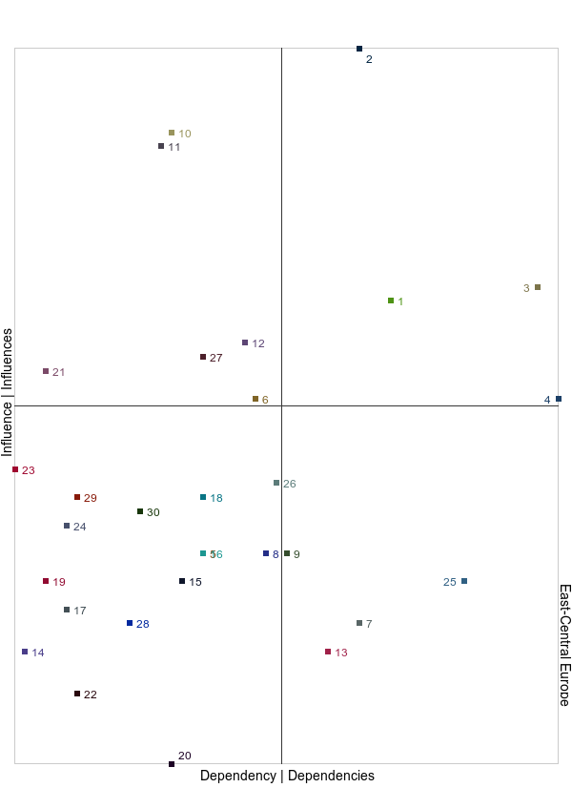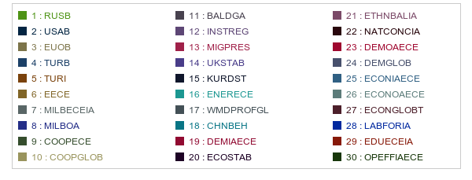

# Matrix of potential direct influences

## Matrix of Potential Direct Influences (MPDI)

|  |  |  |  |  |  |  |  |  |  |  |  |  |  |  |  |  |  |  |  |  |  |  |  |  |  |  |  |  |  |  |
| --- | --- | --- | --- | --- | --- | --- | --- | --- | --- | --- | --- | --- | --- | --- | --- | --- | --- | --- | --- | --- | --- | --- | --- | --- | --- | --- | --- | --- | --- | --- |
|  | rusb | usab | euob | turb | turi | eece | milbeceia | milboa | coopece | coopglob | baldga | instreg | migpres | ukstab | kurdst | enerece | wmdprofgl | chnbeh | demiaece | ecostab | ethnbalia | natconcia | demoaece | demglob | econiaece | econoaece | econglobt | labforia | edueceia | opeffiaece |
| RUSB | 0 | 2 | 2 | 3 | 1 | 3 | 3 | 3 | 2 | 3 | 3 | 3 | 2 | 0 | 3 | 3 | 3 | 2 | 0 | 2 | 0 | 3 | 3 | 3 | 2 | 1 | 1 | 0 | 0 | 0 |
| USAB | 3 | 0 | 3 | 3 | 2 | 3 | 3 | 3 | 3 | 3 | 3 | 2 | 3 | 2 | 2 | 1 | 3 | 3 | 3 | 2 | 3 | 3 | 3 | 1 | 3 | 2 | 3 | 3 | 3 | 3 |
| EUOB | 2 | 1 | 0 | 2 | 1 | 2 | 1 | 1 | 2 | 2 | 1 | 1 | 2 | 3 | 1 | 1 | 3 | 3 | 3 | 2 | 1 | 1 | 3 | 3 | 3 | 1 | 2 | 2 | 2 | 2 |
| TURB | 1 | 1 | 1 | 0 | 0 | 2 | 2 | 1 | 2 | 3 | 0 | 3 | 3 | 0 | 3 | 2 | 3 | 3 | 3 | 1 | 2 | 2 | 3 | 3 | 2 | 3 | 3 | 0 | 0 | 0 |
| TURI | 1 | 1 | 1 | 3 | 0 | 3 | 3 | 3 | 2 | 0 | 0 | 3 | 3 | 0 | 2 | 1 | 3 | 0 | 0 | 0 | 3 | 3 | 0 | 0 | 3 | 0 | 3 | 0 | 0 | 0 |
| EECE | 2 | 2 | 3 | 3 | 2 | 0 | 3 | 2 | 3 | 2 | 3 | 3 | 3 | 3 | 3 | 2 | 3 | 3 | 3 | 3 | 3 | 3 | 0 | 3 | 3 | 1 | 0 | 3 | 3 | 3 |
| MILBECEIA | 3 | 3 | 1 | 2 | 2 | 3 | 0 | 3 | 3 | 3 | 0 | 2 | 2 | 0 | 0 | 1 | 3 | 0 | 0 | 0 | 0 | 3 | 0 | 0 | 1 | 1 | 0 | 3 | 0 | 0 |
| MILBOA | 3 | 2 | 2 | 2 | 1 | 3 | 2 | 0 | 3 | 3 | 3 | 3 | 3 | 0 | 3 | 0 | 3 | 2 | 0 | 0 | 0 | 0 | 0 | 0 | 3 | 2 | 1 | 0 | 0 | 0 |
| COOPECE | 3 | 3 | 3 | 3 | 3 | 3 | 2 | 1 | 0 | 1 | 3 | 2 | 2 | 3 | 3 | 3 | 3 | 3 | 3 | 3 | 3 | 3 | 0 | 0 | 3 | 2 | 1 | 3 | 3 | 3 |
| COOPGLOB | 3 | 3 | 3 | 3 | 3 | 3 | 3 | 2 | 3 | 0 | 3 | 2 | 2 | 1 | 2 | 2 | 2 | 3 | 3 | 3 | 0 | 3 | 3 | 1 | 2 | 2 | 2 | 3 | 3 | 3 |
| BALDGA | 3 | 2 | 3 | 3 | 2 | 3 | 2 | 2 | 2 | 2 | 0 | 2 | 3 | 1 | 3 | 3 | 1 | 3 | 3 | 3 | 0 | 0 | 3 | 3 | 2 | 2 | 2 | 0 | 0 | 0 |
| INSTREG | 1 | 1 | 2 | 3 | 2 | 2 | 3 | 1 | 3 | 1 | 3 | 0 | 3 | 0 | 2 | 2 | 3 | 3 | 3 | 3 | 3 | 3 | 3 | 3 | 2 | 1 | 3 | 3 | 0 | 3 |
| MIGPRES | 1 | 1 | 3 | 3 | 1 | 3 | 3 | 3 | 3 | 3 | 0 | 3 | 0 | 3 | 1 | 0 | 0 | 0 | 3 | 0 | 3 | 3 | 3 | 0 | 3 | 3 | 0 | 3 | 0 | 3 |
| UKSTAB | 2 | 3 | 3 | 3 | 0 | 3 | 0 | 3 | 0 | 3 | 1 | 1 | 0 | 0 | 3 | 0 | 3 | 3 | 0 | 0 | 0 | 3 | 0 | 0 | 3 | 3 | 3 | 0 | 0 | 0 |
| KURDST | 1 | 1 | 1 | 3 | 3 | 3 | 3 | 3 | 3 | 0 | 3 | 3 | 3 | 0 | 0 | 0 | 3 | 0 | 0 | 0 | 3 | 3 | 0 | 0 | 3 | 0 | 0 | 0 | 0 | 0 |
| ENERECE | 2 | 1 | 3 | 1 | 0 | 3 | 1 | 1 | 3 | 0 | 0 | 3 | 0 | 0 | 0 | 0 | 0 | 0 | 3 | 1 | 0 | 0 | 0 | 0 | 3 | 1 | 3 | 0 | 0 | 3 |
| WMDPROFGL | 1 | 2 | 3 | 2 | 3 | 3 | 1 | 2 | 3 | 3 | 3 | 2 | 3 | 0 | 0 | 3 | 0 | 3 | 0 | 3 | 0 | 0 | 0 | 3 | 3 | 3 | 3 | 0 | 0 | 0 |
| CHNBEH | 2 | 2 | 2 | 3 | 3 | 3 | 3 | 3 | 3 | 2 | 2 | 1 | 3 | 0 | 3 | 0 | 2 | 0 | 0 | 2 | 0 | 0 | 3 | 2 | 3 | 2 | 2 | 3 | 0 | 3 |
| DEMIAECE | 1 | 1 | 1 | 1 | 0 | 1 | 1 | 3 | 3 | 0 | 0 | 3 | 0 | 0 | 0 | 0 | 0 | 0 | 0 | 3 | 2 | 1 | 0 | 0 | 2 | 1 | 0 | 3 | 0 | 3 |
| ECOSTAB | 3 | 3 | 3 | 3 | 3 | 3 | 3 | 3 | 3 | 1 | 3 | 3 | 3 | 0 | 0 | 3 | 3 | 1 | 3 | 0 | 0 | 0 | 3 | 3 | 3 | 3 | 3 | 3 | 3 | 3 |
| ETHNBALIA | 2 | 2 | 2 | 3 | 3 | 2 | 3 | 3 | 1 | 0 | 3 | 1 | 0 | 0 | 0 | 0 | 0 | 0 | 2 | 0 | 0 | 2 | 0 | 0 | 3 | 3 | 0 | 3 | 2 | 2 |
| NATCONCIA | 1 | 1 | 1 | 2 | 3 | 3 | 3 | 3 | 3 | 0 | 3 | 3 | 0 | 0 | 0 | 3 | 0 | 0 | 3 | 0 | 3 | 0 | 3 | 0 | 2 | 3 | 0 | 3 | 3 | 3 |
| DEMOAECE | 2 | 2 | 2 | 2 | 1 | 3 | 3 | 2 | 3 | 3 | 2 | 3 | 0 | 3 | 0 | 3 | 0 | 2 | 3 | 3 | 0 | 0 | 0 | 2 | 3 | 3 | 3 | 3 | 0 | 0 |
| DEMGLOB | 1 | 1 | 1 | 1 | 0 | 3 | 3 | 2 | 3 | 3 | 1 | 3 | 2 | 0 | 0 | 3 | 3 | 1 | 3 | 3 | 0 | 3 | 2 | 0 | 3 | 2 | 2 | 3 | 0 | 3 |
| ECONIAECE | 3 | 3 | 1 | 1 | 0 | 3 | 2 | 3 | 1 | 0 | 0 | 3 | 1 | 0 | 0 | 3 | 0 | 0 | 2 | 3 | 3 | 3 | 0 | 0 | 0 | 3 | 0 | 2 | 3 | 2 |
| ECONOAECE | 2 | 2 | 3 | 3 | 3 | 3 | 3 | 2 | 3 | 3 | 1 | 3 | 0 | 3 | 0 | 1 | 0 | 2 | 3 | 1 | 0 | 0 | 1 | 3 | 2 | 0 | 2 | 3 | 3 | 3 |
| ECONGLOBT | 2 | 2 | 2 | 2 | 3 | 3 | 2 | 2 | 2 | 1 | 3 | 3 | 2 | 3 | 0 | 3 | 0 | 2 | 3 | 3 | 0 | 3 | 3 | 2 | 2 | 2 | 0 | 3 | 3 | 3 |
| LABFORIA | 0 | 0 | 1 | 1 | 0 | 1 | 2 | 0 | 0 | 0 | 0 | 0 | 3 | 0 | 0 | 0 | 0 | 0 | 3 | 0 | 0 | 0 | 0 | 0 | 3 | 1 | 0 | 0 | 0 | 3 |
| EDUECEIA | 0 | 0 | 1 | 1 | 0 | 3 | 1 | 0 | 2 | 0 | 0 | 0 | 0 | 0 | 0 | 3 | 3 | 0 | 1 | 3 | 1 | 2 | 0 | 0 | 3 | 3 | 0 | 3 | 0 | 3 |
| OPEFFIAECE | 3 | 3 | 2 | 2 | 0 | 1 | 2 | 3 | 1 | 0 | 0 | 3 | 3 | 0 | 0 | 2 | 0 | 0 | 1 | 1 | 0 | 1 | 0 | 0 | 3 | 1 | 3 | 1 | 2 | 0 |

Note : you could export the matrix in CSV format by clicking on the "Export CSV" button on the matrix interface

## MPDI characteristics

|  |  |
| --- | --- |
| **Indicator** | **Value** |
| Matrix size | 30 |
| Number of iterations | 2 |
| Number of zeros | 263 |
| Number of ones | 109 |
| Number of twos | 149 |
| Number of threes | 379 |
| Number of P1s | 0 |
| Number of P2s | 0 |
| Number of P3s | 0 |
| Total | 637 |
| Filling ratio | 70.778% |

## mmc_midp_stability

|  |  |  |
| --- | --- | --- |
| **Iteration** | **Influence | Influences** | **Dependency | Dependencies** |
| 2 | 100.36 | 100 |
| 3 | 100 | 100.38 |

## Sums of rows and columns of MPDI

|  |  |  |
| --- | --- | --- |
| **Variable** | **Total of lines** | **Total of columns** |
| Russian federation - behaviour | 56 | 54 |
| USA - beahviour | 77 | 51 |
| EU(outer participants) - behaviour | 54 | 59 |
| Republic of Turkey - behaviour | 52 | 67 |
| Republic of Turkey - internal affairs | 41 | 45 |
| Level of enmity within ECE | 73 | 77 |
| Military budgets - ECE (Internal actors) | 39 | 66 |
| Military budgets - outer actors | 44 | 63 |
| Level of cooperation - ECE | 71 | 68 |
| Level of cooperation - global | 71 | 45 |
| Balance between DGA | 58 | 47 |
| Instability from the actions of regional powers | 65 | 67 |
| Migration pressure | 55 | 54 |
| Political stability of UK | 43 | 25 |
| Creation of Kurds state | 42 | 34 |
| Security of the energy supplies to ECE | 32 | 48 |
| Proliferation of WMD - global | 52 | 50 |
| People's Republic of China - behaviour | 57 | 42 |
| Demographics - ECE (internal actors) | 30 | 57 |
| Stability of the ecosystem | 71 | 48 |
| Changes in the ethnic balance within ECE - IA | 42 | 33 |
| Stability of the concept of nation in ECE - IA | 52 | 51 |
| Demographics ECE - outer actors | 56 | 39 |
| Demographic tendencies - global | 55 | 35 |
| Economic level ECE - IA | 45 | 76 |
| Economic level of ECE - OA | 58 | 55 |
| Economic tendencies - global | 64 | 45 |
| Quality/quantity of the labor force in ECE - IA | 18 | 56 |
| Effectivness/efficiency of the educational systems in ECE - IA | 33 | 33 |
| Operational efficiency in ECE - IA | 38 | 54 |

## View of potential direct influences / dependencies

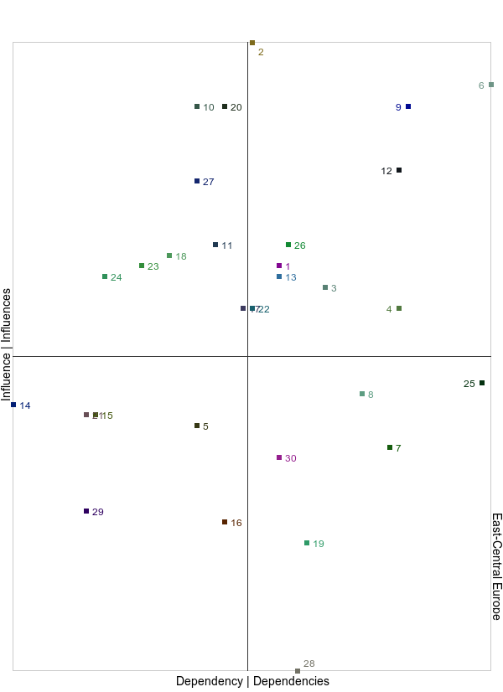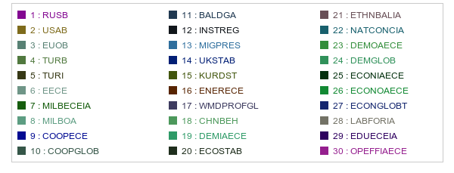

# Matrix of indirect influences

## Sums of rows and columns of MII

|  |  |  |
| --- | --- | --- |
| **Variable** | **Total of lines** | **Total of columns** |
| Russian federation - behaviour | 21834 | 20382 |
| USA - beahviour | 31262 | 17407 |
| EU(outer participants) - behaviour | 18990 | 27351 |
| Republic of Turkey - behaviour | 13504 | 30763 |
| Republic of Turkey - internal affairs | 9547 | 13678 |
| Level of enmity within ECE | 16861 | 16134 |
| Military budgets - ECE (Internal actors) | 6054 | 21383 |
| Military budgets - outer actors | 12171 | 15319 |
| Level of cooperation - ECE | 9160 | 19342 |
| Level of cooperation - global | 29475 | 12457 |
| Balance between DGA | 27717 | 9309 |
| Instability from the actions of regional powers | 16314 | 16234 |
| Migration pressure | 7092 | 23416 |
| Political stability of UK | 9793 | 2388 |
| Creation of Kurds state | 8853 | 14575 |
| Security of the energy supplies to ECE | 9445 | 14599 |
| Proliferation of WMD - global | 9585 | 4445 |
| People's Republic of China - behaviour | 15818 | 10960 |
| Demographics - ECE (internal actors) | 7979 | 3194 |
| Stability of the ecosystem | 1841 | 10376 |
| Changes in the ethnic balance within ECE - IA | 14943 | 4156 |
| Stability of the concept of nation in ECE - IA | 4640 | 5024 |
| Demographics ECE - outer actors | 16977 | 886 |
| Demographic tendencies - global | 11235 | 3302 |
| Economic level ECE - IA | 5477 | 26254 |
| Economic level of ECE - OA | 15053 | 14221 |
| Economic tendencies - global | 18492 | 11176 |
| Quality/quantity of the labor force in ECE - IA | 5195 | 6554 |
| Effectivness/efficiency of the educational systems in ECE - IA | 6721 | 6569 |
| Operational efficiency in ECE - IA | 8158 | 8332 |

## View of indirect influences / dependencies

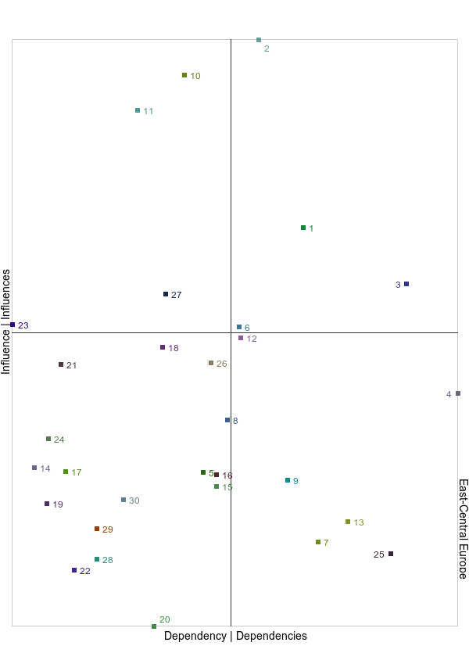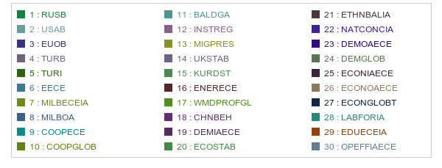

# Matrix of potential indirect influences

## Sums of rows and columns of MPII

|  |  |  |
| --- | --- | --- |
| **Variable** | **Total of lines** | **Total of columns** |
| Russian federation - behaviour | 161922 | 148086 |
| USA - beahviour | 203513 | 138658 |
| EU(outer participants) - behaviour | 144792 | 157266 |
| Republic of Turkey - behaviour | 146377 | 177157 |
| Republic of Turkey - internal affairs | 113752 | 119704 |
| Level of enmity within ECE | 188785 | 200379 |
| Military budgets - ECE (Internal actors) | 111759 | 176717 |
| Military budgets - outer actors | 132528 | 165490 |
| Level of cooperation - ECE | 183193 | 182797 |
| Level of cooperation - global | 189552 | 122083 |
| Balance between DGA | 164412 | 124839 |
| Instability from the actions of regional powers | 171984 | 182422 |
| Migration pressure | 143289 | 151279 |
| Political stability of UK | 128155 | 70986 |
| Creation of Kurds state | 117315 | 96064 |
| Security of the energy supplies to ECE | 91072 | 131119 |
| Proliferation of WMD - global | 154650 | 135296 |
| People's Republic of China - behaviour | 157691 | 116590 |
| Demographics - ECE (internal actors) | 79892 | 157727 |
| Stability of the ecosystem | 189494 | 132290 |
| Changes in the ethnic balance within ECE - IA | 105702 | 98929 |
| Stability of the concept of nation in ECE - IA | 128675 | 138818 |
| Demographics ECE - outer actors | 155364 | 105139 |
| Demographic tendencies - global | 149028 | 98852 |
| Economic level ECE - IA | 117806 | 197986 |
| Economic level of ECE - OA | 153800 | 144166 |
| Economic tendencies - global | 167853 | 116350 |
| Quality/quantity of the labor force in ECE - IA | 42356 | 152645 |
| Effectivness/efficiency of the educational systems in ECE - IA | 83527 | 94622 |
| Operational efficiency in ECE - IA | 104278 | 148060 |

## View of potential indirect influences / dependencies

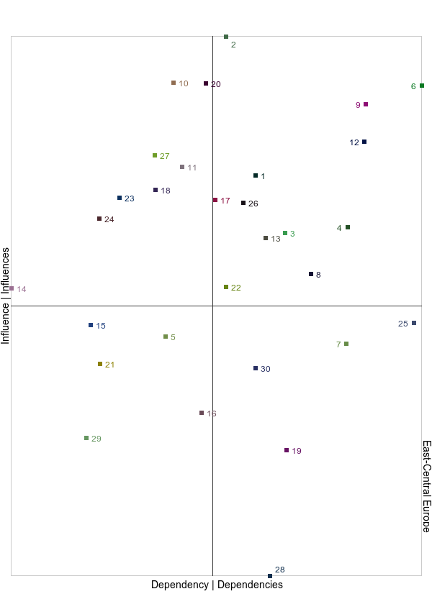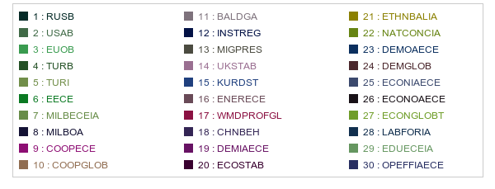

# Variable ranking

## Variable ranking by influences

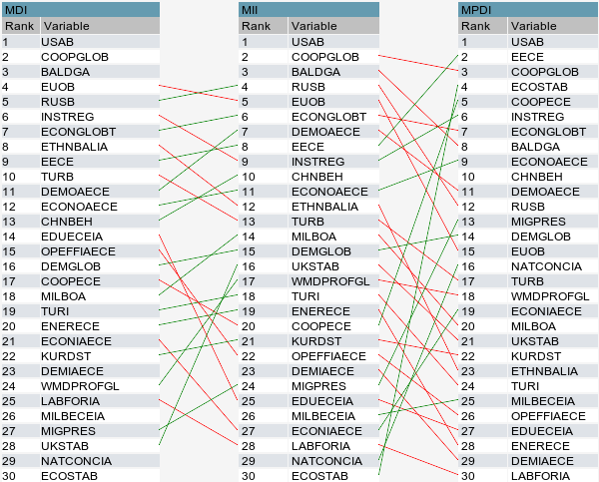

## Variable ranking by dependencies

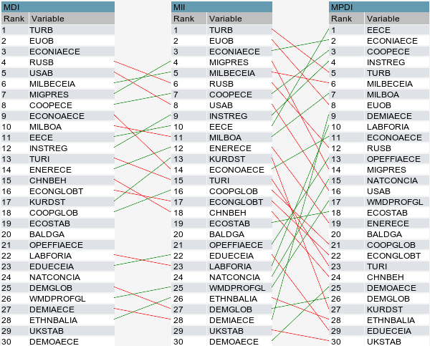

# Synthesis