Dynamic Service Conformance tool
For up-to-date information about the tool: http://groupspaces.com/dashif/wiki/DynamicConformance

Brief Description:
Dynamic service conformance tool is a JavaScript based tool basically intended to run at or close to the server providing the live service (to minimize clock skew and RTT issues). Nevertheless it can provide useful information even by running remotely, with the basic RTT and clock skew adjustments provided. Following is a screen shot.
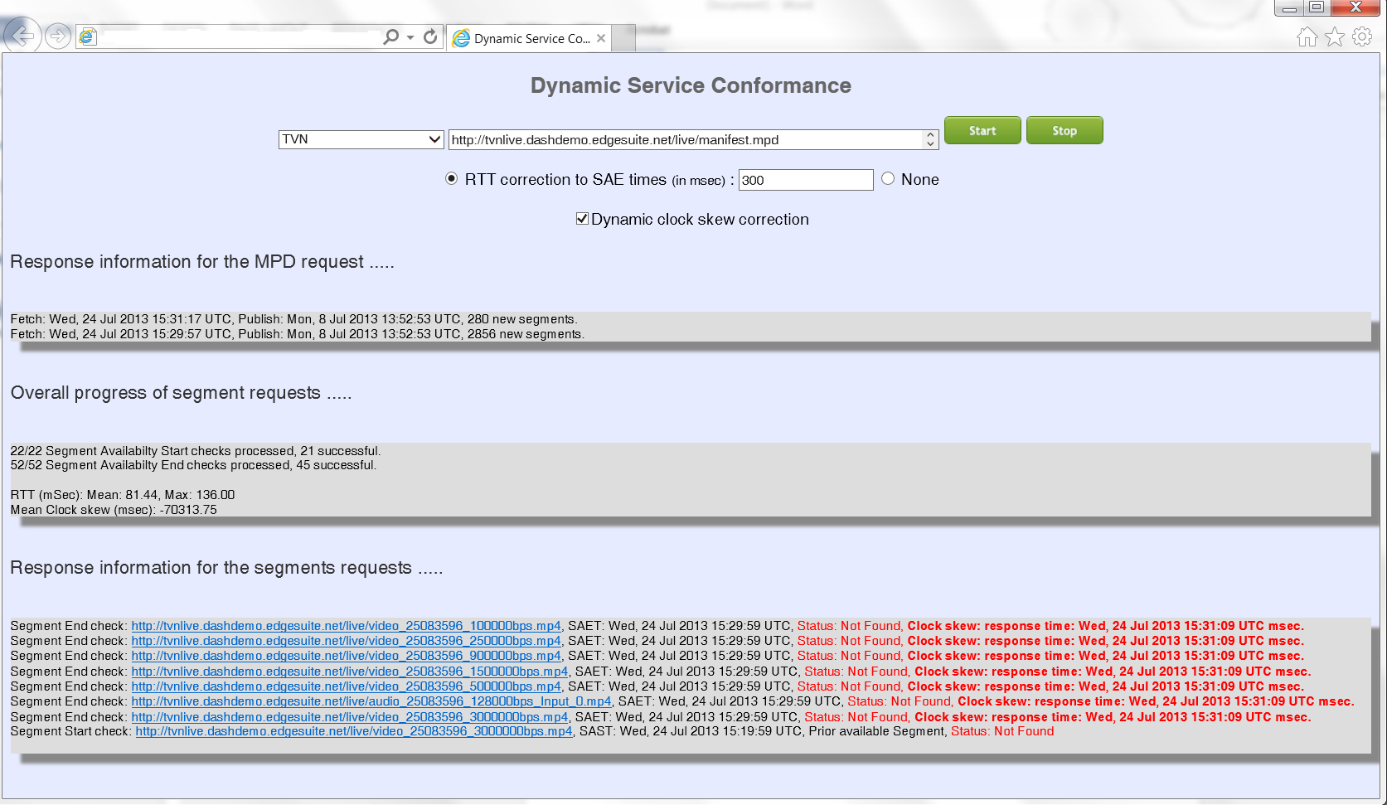

Features supported
- Dynamic services with or without MPD updates.
- Segment template with either number based addressing or Segment timeline.
- RTT calculations and correction.
- Clock-skew calculations and dynamic corrections (cross-domain allowance required).

Usage guide
The user interface is quite self-explanatory.

Controls

MPD input via UI
The MPD URL can be selected from a set of known live services or can be manually entered in the text box. Hitting start initiates the processing.

MPD input via URL
The main page (index.html) can be accessed with the desired MPD URL as a query string with key “mpdurl”. This MPD URL will automatically appear in the box for MPD URL ready to be tested. An example syntax is: http://dasher.eu5.org/Dynamic/index.html?mpdurl=MY_URL

Outputs
The main outputs are:

MPD status
Last 5 instances of MPD updates with relevant data such as the number of new segment URLs provided.

Segment request progress
- A summary of processed and successful segment requests. Successful means a 200 code was received in reply for a segment request.
- A moving average of RTT for requests (last 10 values).
- A moving average of observed clock skew based on http response, with a deadzone of 0.5 seconds. Cross-domain requests must be enabled for this to work. For information only: if the server does not allow this, cross domain access can be enabled in IE (Internet options -> Security -> Custom level -> Miscellaneous -> Allow data sources across domains). This value is also used to adjust for clock skew if available.

Response information
A detailed, access-by-access error log is provided with relevant information.

Advanced Controls

RTT correction
A fixed offset can optionally be applied to segment availability end (SAE) checks so that the request is initiated a bit earlier on to compensate for the delay. It should be more than half the maximum reported RTT in the statistics. Dynamic corrections are not provided because of the typical high variance of this value.

Dynamic clock skew correction
If cross-domain requests are allowed (above), average clock skew is applied to dynamically correct the local clock. An internal, duplicate and corrected clock is maintained for this purpose (system clock is not altered). As an example of operations, in the snapshot, the system is lagging by more than 70 seconds in spite of periodic NTP sync. Soon after launch after 7 errors, the system becomes stable by dynamic corrections and no further errors are reported. Another browser launched in parallel as control with no clock skew correction showed none of the SAE requests were successful, and the client had no information that the reason is clock skew.

Availability
The up-to-date version of this tool is available via the same SVN access as the rest of the conformance software: http://groupspaces.com/dashif/wiki/Conformance-Software . Occasionally, a snapshot is reflected on http://dasher.eu5.org/Dynamic/

