How to Use the Church Scheduling Toolset

*Note: This documentation assumes some familiarity with Microsoft Excel as well as executing programs from a command line. This document is a walkthrough manual describing from beginning to end how the scheduling process currently works.*

**Summary**

The spreadsheet consists of two pages. The first page is the scheduling page, where people are assigned roles and dates for helping by whoever is doing the scheduling. The second page shows what dates everyone is scheduled for in a user friendly format for printing and distribution.

A macro formula has been setup to pull people who have been scheduled from the first page to the user friendly display on the second page. Sometimes Excel will complain about the fact that there’s a macro in the spreadsheet; you need to make sure to enable macros on the spreadsheet to use this functionality.

To execute the macro, use the shortcut Ctrl+Alt+F9. This will force Excel to recalculate everything on the second page. This can take some time to finish depending on the speed of the processors in your machine. Excel will show a status in the bottom right corner while it is processing the macro.

Sometimes you may need to add an extra week or two to the second page of the spreadsheet depending upon how many Sundays a particular scheduling period has. If this is required, copy and paste pre-existing rows from another defined Sunday on the spreadsheet. Excel should automatically copy the required formulas to the new rows. If not, you can always drag the existing formula from other cells to the new cells.

Here is an example of what the formula looks like on the second sheet of the spreadsheet:

=GetData(FindRoleTypeCell(C$3), AddCellVerticalOffset($B3, 1), C4, FindRange('JunSept2014Worship Schedule'!$F$3:$F$116, FindDateCell($A4)))

The section ‘!$F$3:$F$116’ defines which rows in the first sheet of the spreadsheet the formula will use. You may need to update this spread to include any new rows that have been added. E.g. If the last row for a person on the first spread sheet was ‘118,’ you would need to update this formula in one of the cells on the second spread sheet, then drag that formula to all of the other cells on that sheet.

**Note:** If you wish to see or alter the macro used for these calculations, you will need to customize your Microsoft Excel Ribbon to show the ‘Developer’ tab (File -> Options -> Customize Ribbon), then click on ‘Visual Basic’ while in the ‘Developer’ tab.

**Spreadsheet Layout**

The second sheet of the spreadsheet is fairly obvious; it simply shows which dates people have been scheduled for. The first sheet, however, is more complicated.

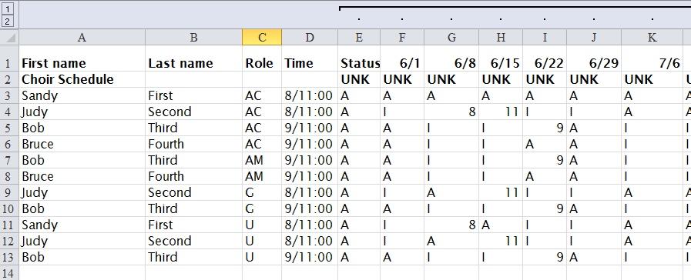

The top row contains columns for data we use for the scheduling.

**Role -** There are four role types that are scheduled – AC (Acolyte), AM (Assisting Minister), G (Greeter), and U (Usher).

**Time -** Next to the role types is a column with the preferred worship times for each participant. It’s best to schedule someone for the time they asked to be scheduled.

**Status –** Is the participant A (Active) or I (Inactive)?

**Date Scheduling –** Each column contains a Sunday we’re scheduling the worship assistants for. I (Inavailable), A (Active), 8 (Eight o’ clock service), 9 (Nine o’ clock service), and 11 (Eleven o’ clock service) are valid variables for each scheduling square. The macro interprets the contents of these columns for display on the second sheet in the spreadsheet. **Note:** If more than one person is scheduled for the same date, the macro will choose the first one it finds! It’s much easier to figure out errors like this during the QC step (explained later).

**Email Addresses –** There is a column for ‘email address 1’ and ‘email address 2’ (alternate email). See the ‘Getting an Email List’ section for instructions on how to retrieve a de-duplicated email list from this data.

There is other data that can be stored in the spreadsheet, but currently nothing else is required for scheduling purposes. The most important fields are names, role, preferred time, email addresses, and the dates the participants are scheduled.

**Choir Row –** Used a placeholder for defining when the choir will sing. None of the toolset reads directly off this row, so it is safe to set it to whatever value you need to keep track of which services the choir sings at. By default it is set to UNK (Unknown).

By default the spreadsheet is setup with a vertical split. This makes it easier to see the dates you’re scheduling for in the top pane while scheduling people in the bottom pane. It’s setup there by default for ease of use when you’re doing the scheduling.

**Setting up the Spreadsheet**

Your first step in setting up the spread sheet is to adjust it to match the new scheduling period. On the first spreadsheet, change the date in the ‘F’ column to match the first date of the scheduling period. E.g. 8/5 if you were starting in October of 2014. The rest of the columns will automatically calculate their dates by adding 7 to the preceding date. If you need to add more dates to the spread sheet due to a different length scheduling period, feel free to copy/paste an existing column.

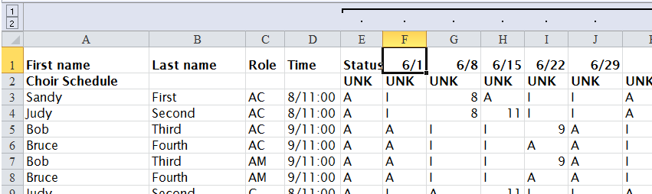

Do the same in the second sheet of the spreadsheet. These dates aren’t linked, so you need to make sure they’re synched up manually.

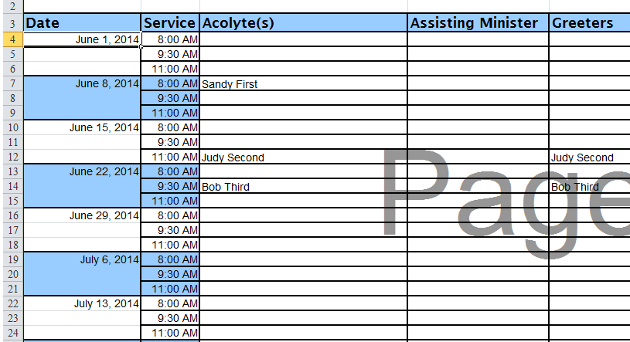

At this time it’s also a good idea to update the title on the second sheet of the spreadsheet (E.g. ‘Holy Spirit Assistant Schedule For X date-Y date). Also feel free to update the names of the tabs on the spreadsheet, but it’s just cosmetic.

Now that the basic dates are setup, you want to set the availability for everyone on the first sheet to ‘available.’ To this, simply set all of the squares corresponding to dates to the letter ‘A’ for ‘available.’

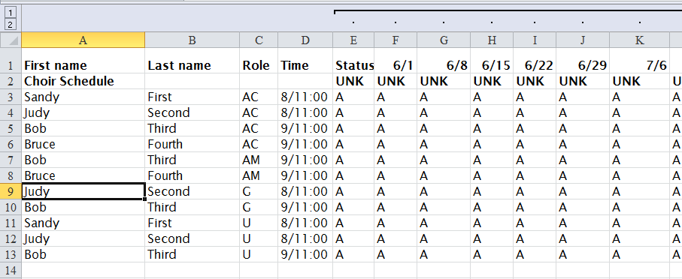

Now you’re ready to start scheduling, but before you do that, you need to email everyone and ask for which Sundays they are available to be scheduled.

**Getting an Email List**

There are two ways to get an email list to send to people:

1. Use Excel (Technically Harder).
2. Use the included ‘ChurchScheduler.exe’ program to generate the list for you (Technically Easier – also, this describes how to get the CSV file which will be useful later in the process).

**Using Excel**

1. Copy all emails from the ‘email address 1’ column of the first sheet in the spreadsheet.
2. Create a new blank workbook and copy in the email addresses.
3. Go back to the original spread sheet and copy the ‘email address 2’ column.
4. Paste the emails from the ‘email address 2’ column below the emails you already copied in the same column.
5. Select the column where you pasted the emails (usually ‘column A’).
6. Click on the ‘Data’ tab on the ribbon.
7. Click on the ‘Remove Duplicates’ button and follow the prompts to remove any duplicate emails.
8. Click on the ‘A-Z’ sort button to sort the emails in alphabetical order.
9. Copy the cells out to a text editing program, such as Notepad++.
10. Replace the line breaks with commas to produce a comma delimited list of email addresses. With newer versions of Notepad++ you can use their Find/Replace dialog by setting the search mode to ‘Extended,’ searching for ‘\r\n’ and replacing that with a comma ‘,’.

**Using ChurchScheduler.exe**

To use the program, we first need a CSV (Comma Separated Value) version of the first sheet in the spreadsheet.

1. When on the first sheet, do a save as -> CSV (Comma Delimited) file. There are several CSV formats, but we want the plain version.
2. When you hit the save button, Excel will complain about formats:

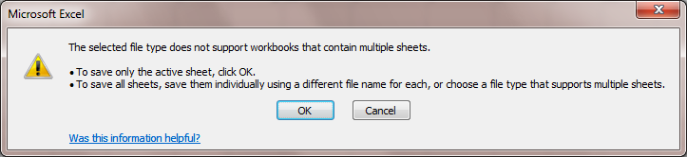

1. Click on the ‘Ok’ button. Then, this dialog will appear: 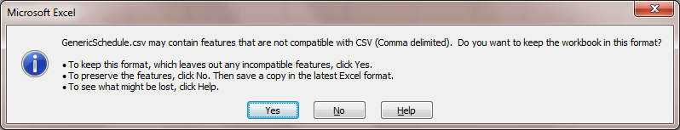
2. Click on ‘No.’ Finally, the save file dialog will appear again. Click on ‘Cancel.’

The end result should be a CSV file named the same as your XSLM file saved in the same folder. Once you have the CSV file, you simply need to execute the command line tool like this:

ChurchScheduler.exe -a "C:\FilePath\GenericSchedule.csv" > Emails.txt

This will ask the tool to read the CSV file, get all of the emails, and ‘pipe’ a comma delimited list of those emails into the ‘Emails.txt’ file. Once the tool has run, simply open the ‘Emails.txt’ file to get your list of email addresses. Alternately, you can copy/paste directly from the console window, but that’s trickier to do due to line breaks.

Once you have your email list, simply email everyone asking them which dates they will be unable to assist with helping out at the church services.

**Recording Availability**

**Creating a Schedule**

**Using the ChurchScheduler.exe program for QC**

ChurchScheduler.exe -qc -date 6/1/2014 "C:\FilePath\CSVFileName.csv" > Output.txt

**Creating Drafts**

**Finishing the Schedule**