### Solving analytical queries on Redshift Cluster

Here, you have to write the query used for solving the question and the screenshots of the table which is outputted after the query is run on the AWS Redshift Query editor UI.

1. **Top 10 ATMs where most transactions are in the ’inactive’ state**

select f.atm_id, a.atm_number, count(f.trans_id) as total_trans_count, l.location

from spar_nord_bank_atm_data.fact_atm_trans f

inner join spar_nord_bank_atm_data.dim_atm a on a.atm_id = f.atm_id

inner join spar_nord_bank_atm_data.dim_location l on a.atm_location_id = l.location_id

group by f.atm_id, a.atm_number, l.location, f.atm_status

having f.atm_status = 'Inactive'

order by total_trans_count DESC

Limit 10;

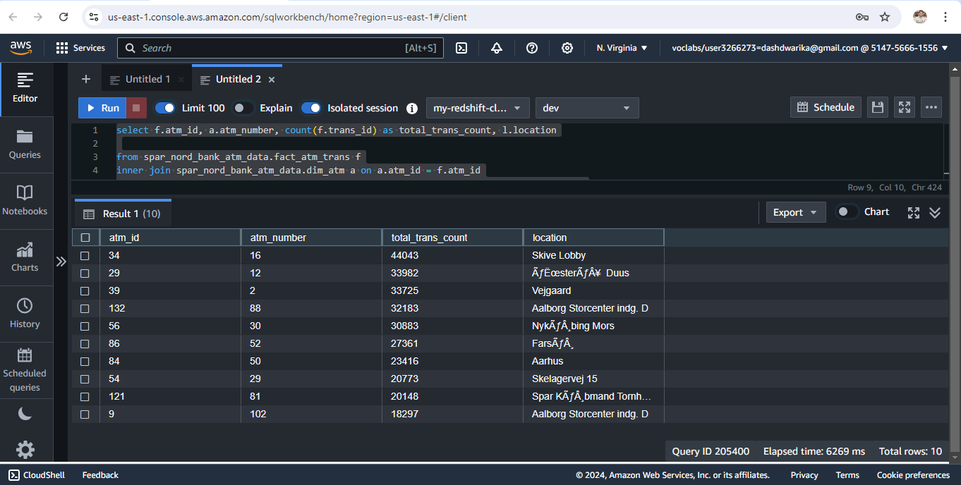

1. **Number of ATM failures corresponding to the different weather conditions recorded at the time of the transactions**

WITH weather_atm_failure AS (

select weather_main, count(trans_id) as total_trans_count, sum(case when atm_status = 'Inactive'then 1 else 0 end) as atm_status_inactive_count

from spar_nord_bank_atm_data.fact_atm_trans

where weather_main != ''

group by weather_main

)

select *, round(((CAST(atm_status_inactive_count as numeric) / total_trans_count) * 100), 2) AS atm_status_inactive_count_percentage

from weather_atm_failure

order by atm_status_inactive_count_percentage DESC;

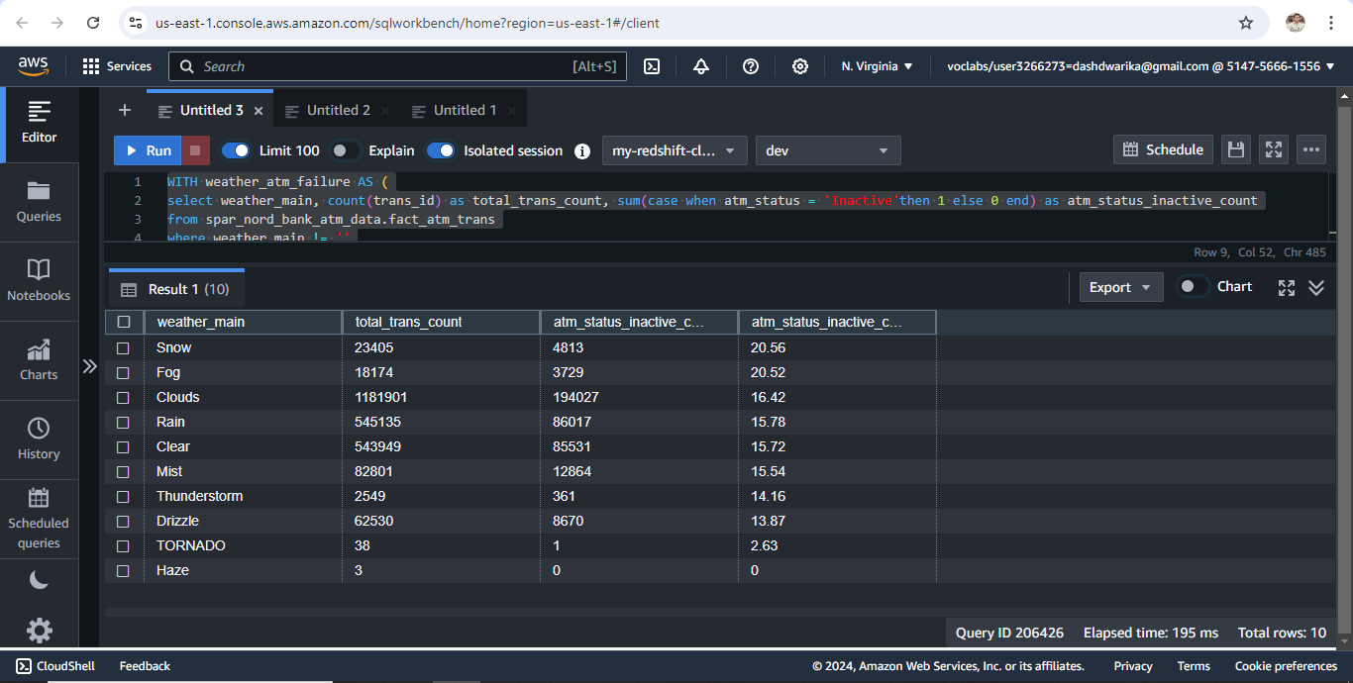

1. **Top 10 ATMs with the most number of transactions throughout the year**

select f.atm_id, a.atm_number, a.atm_manufacturer, l.location, count(f.trans_id) as total_trans_count

from spar_nord_bank_atm_data.fact_atm_trans f

inner join spar_nord_bank_atm_data.dim_atm a on a.atm_id = f.atm_id

inner join spar_nord_bank_atm_data.dim_location l on a.atm_location_id = l.location_id

group by f.atm_id, a.atm_number, a.atm_manufacturer, l.location, f.atm_status

order by total_trans_count DESC

Limit 10;

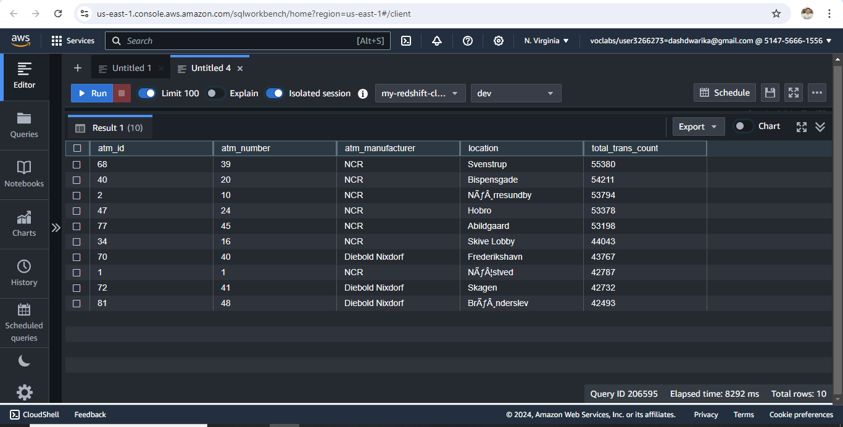

1. **Number of overall ATM transactions going inactive per month for each month**

WITH inactive_count_month_wise AS (

select d.month, count(f.trans_id) as total_trans_count, sum(case when f.atm_status = 'Inactive'then 1 else 0 end) as atm_status_inactive_count

from spar_nord_bank_atm_data.fact_atm_trans f

inner join spar_nord_bank_atm_data.dim_date d on d.date_id = f.date_id

group by d.month

)

select *, round(cast(atm_status_inactive_count as NUMERIC) / total_trans_count * 100, 2)  as atm_status_inactive_count_percent

from inactive_count_month_wise

order by to_date(month, 'Month');

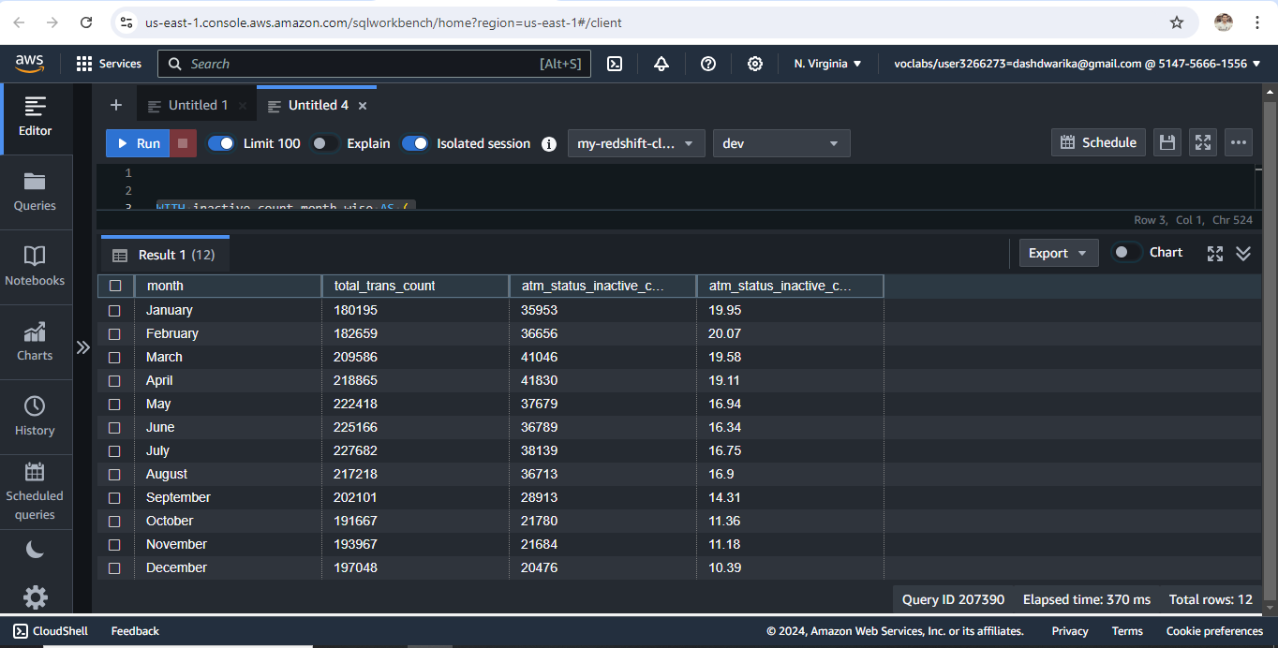

1. **Top 10 ATMs with the highest total withdrawn amount throughout the year**

select f.atm_id, a.atm_number, a.atm_manufacturer, l.location, sum(f.transaction_amount) as total_trans_amount

from spar_nord_bank_atm_data.fact_atm_trans f

inner join spar_nord_bank_atm_data.dim_atm a on a.atm_id = f.atm_id

inner join spar_nord_bank_atm_data.dim_location l on a.atm_location_id = l.location_id

group by f.atm_id, a.atm_number, a.atm_manufacturer, l.location

order by total_trans_amount DESC

Limit 10;

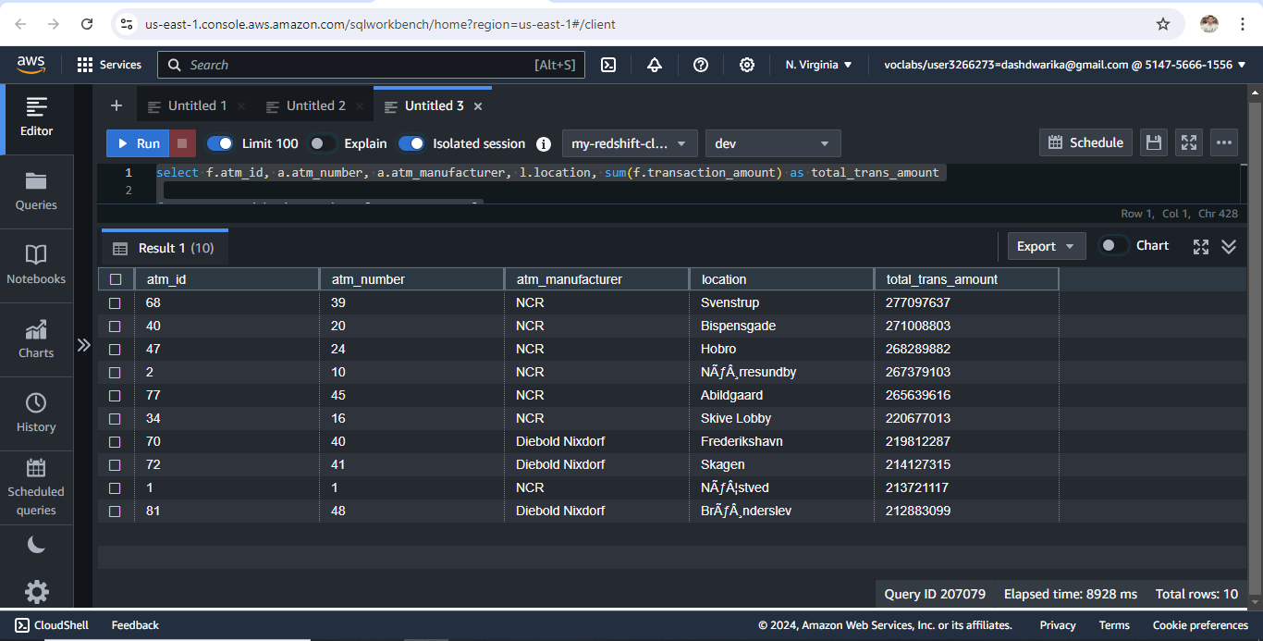

1. **Number of failed ATM transactions across various card types**

WITH inactive_count_card_wise AS (

select c.card_type, count(f.trans_id) as total_trans_count, sum(case when f.atm_status = 'Inactive'then 1 else 0 end) as atm_status_inactive_count

from spar_nord_bank_atm_data.fact_atm_trans f

inner join spar_nord_bank_atm_data.dim_card_type c on c.card_type_id = f.card_type_id

group by c.card_type

)

select *, round(cast(atm_status_inactive_count as NUMERIC) / total_trans_count * 100, 2) as atm_status_inactive_count_percent

from inactive_count_card_wise

order by atm_status_inactive_count_percent DESC;

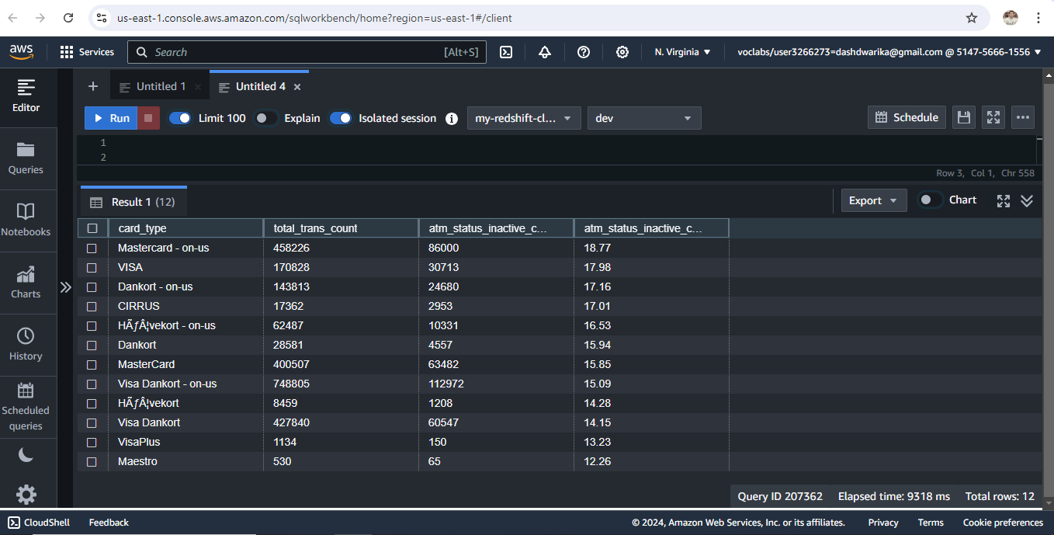

1. **Number of transactions happening on an ATM on weekdays and on weekends throughout the year. Order this by the ATM_number, ATM_manufacturer, location, weekend_flag and then total_transaction_count**

select a.atm_number, a.atm_manufacturer, l.location, (case when d.weekday in ('Saturday', 'Sunday') then 1 else 0 end) as weekend_flag, count(f.trans_id) as total_trans_id

from spar_nord_bank_atm_data.fact_atm_trans f

inner join spar_nord_bank_atm_data.dim_atm a on a.atm_id = f.atm_id

inner join spar_nord_bank_atm_data.dim_location l on l.location_id = a.atm_location_id

inner join spar_nord_bank_atm_data.dim_date d on d.date_id = f.date_id

group by a.atm_number, a.atm_manufacturer, l.location, weekend_flag

order by a.atm_number, a.atm_manufacturer, l.location, weekend_flag, total_trans_id DESC

LIMIT 10;

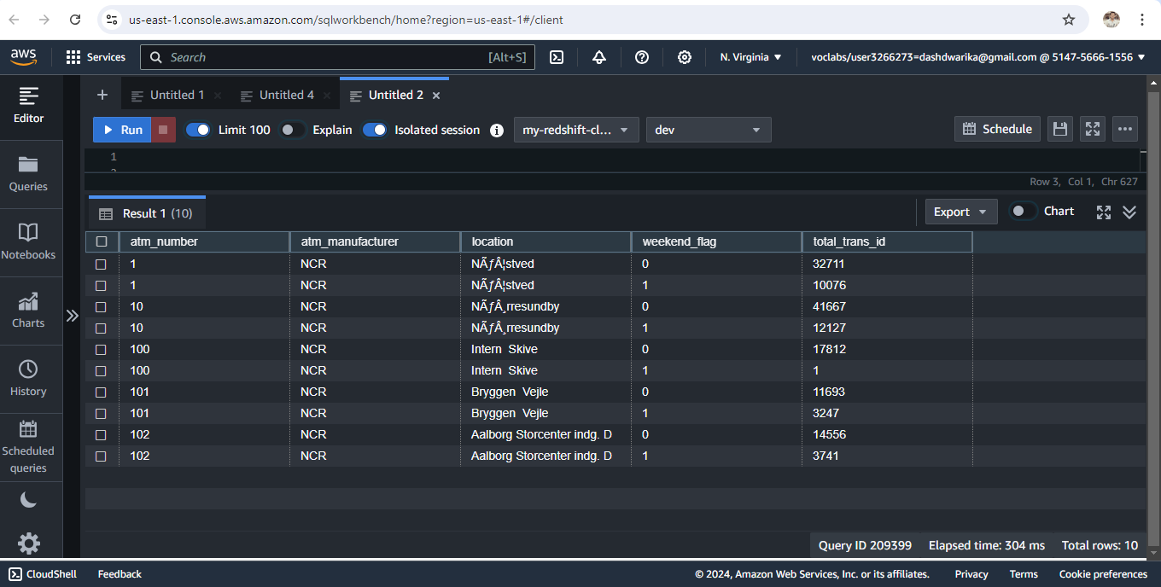

1. **Most active day in each ATMs from location "Vejgaard"**

WITH vejgaard_atm_trans_data AS (

select a.atm_id, a.atm_number, a.atm_manufacturer, l.location, count(f.trans_id) as total_trans_id, d.weekday

from spar_nord_bank_atm_data.fact_atm_trans f

inner join spar_nord_bank_atm_data.dim_atm a on a.atm_id = f.atm_id

inner join spar_nord_bank_atm_data.dim_location l on l.location_id = a.atm_location_id

inner join spar_nord_bank_atm_data.dim_date d on d.date_id = f.date_id

where l.location = 'Vejgaard'

group by a.atm_id, a.atm_number, a.atm_manufacturer, l.location, d.weekday

order by total_trans_id DESC

)

select * from vejgaard_atm_trans_data v1

where v1.total_trans_id = (select max(total_trans_id) from vejgaard_atm_trans_data v2 where v1.atm_id = v2.atm_id);

