### Creation of a Redshift Cluster

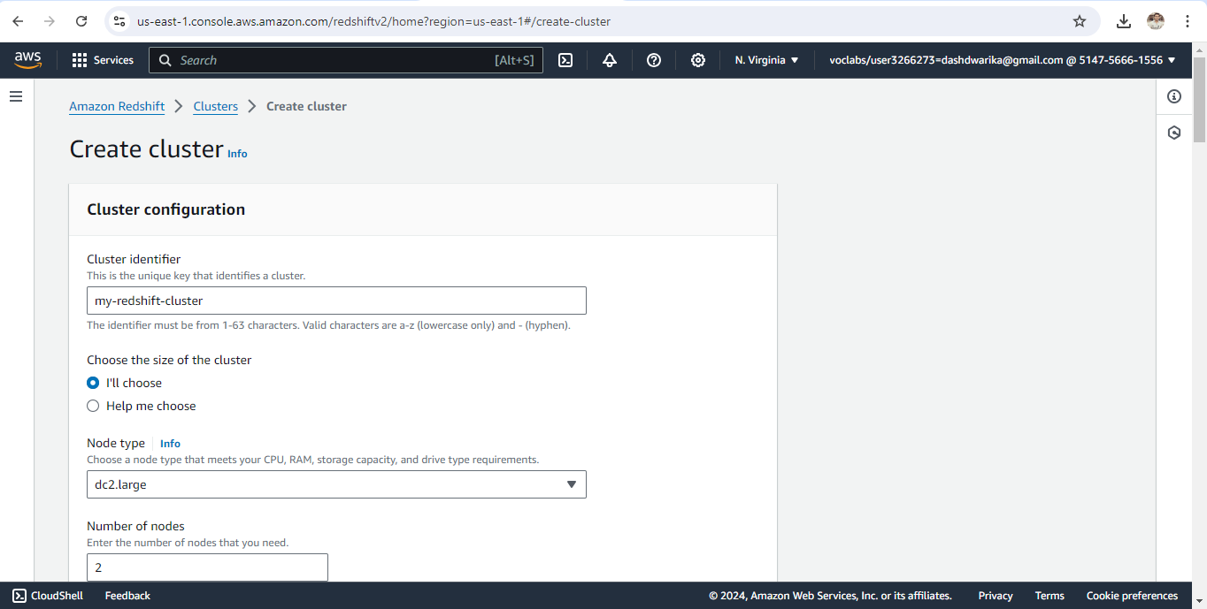

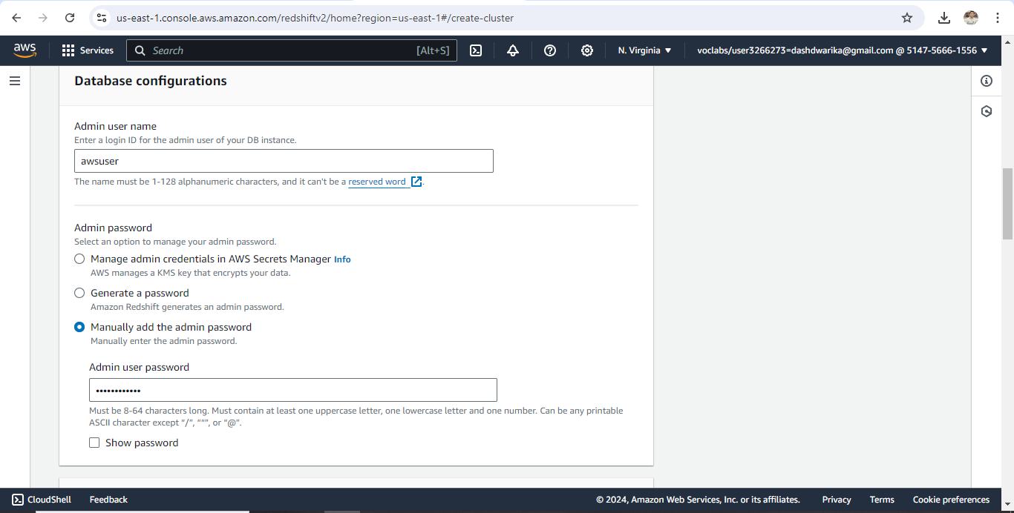

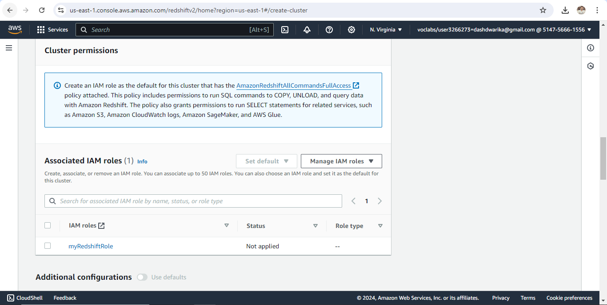

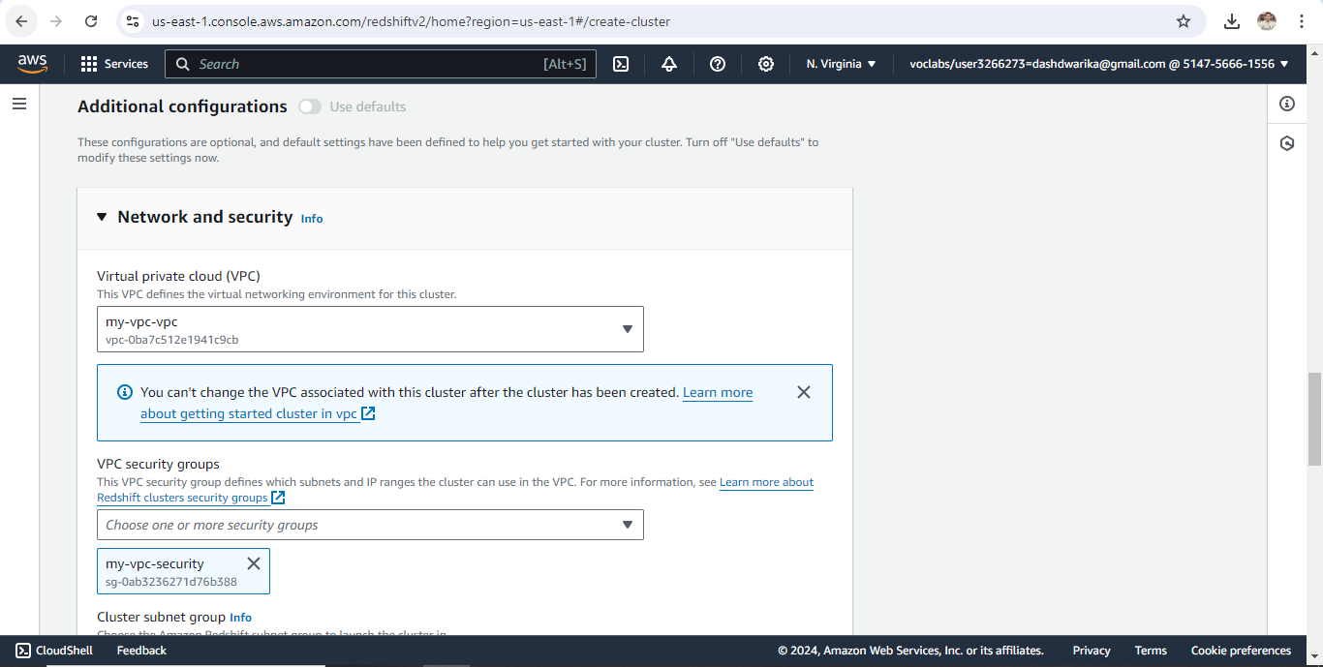

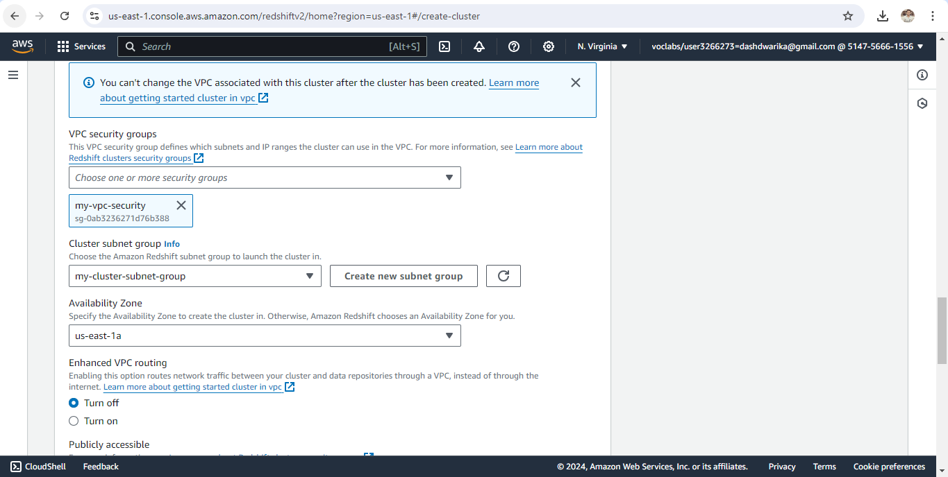

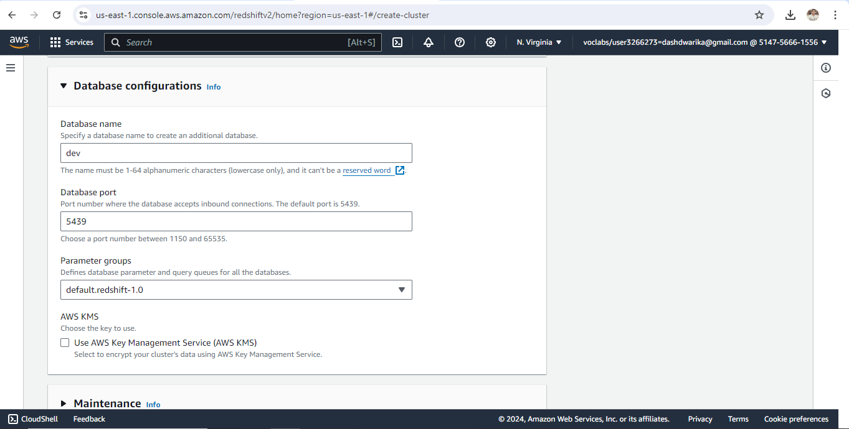

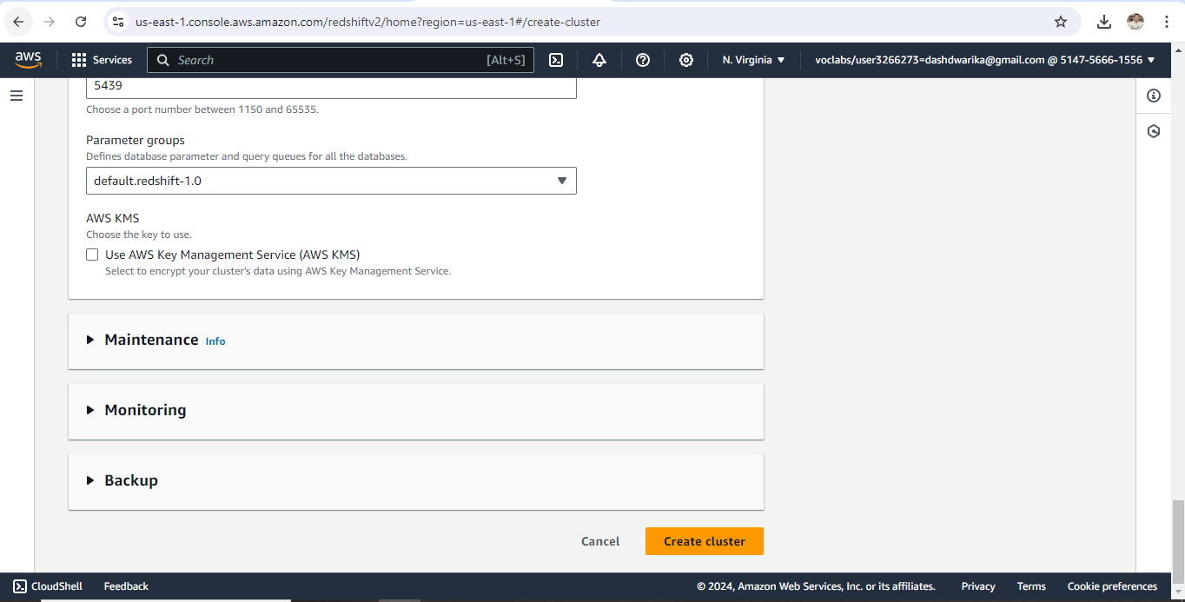

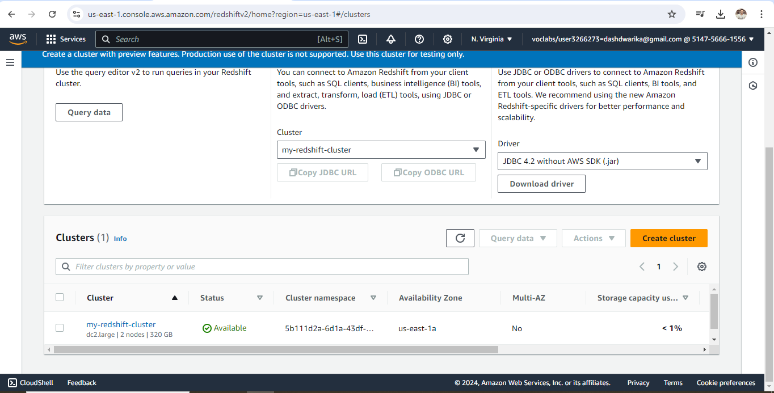

### 

### 

### S3 bucket containing files:

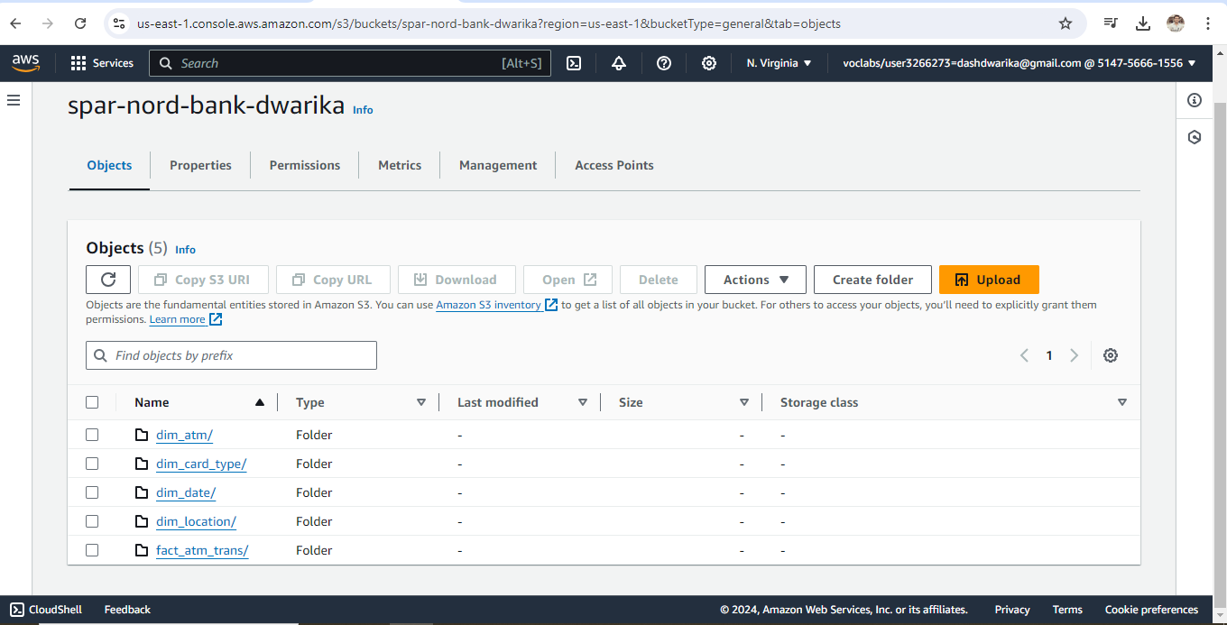

### Setting up a database in the Redshift cluster and running queries to create the dimension and fact tables

**Queries to create the various dimension and fact tables with appropriate primary and foreign keys:**

create schema spar_nord_bank_atm_data;

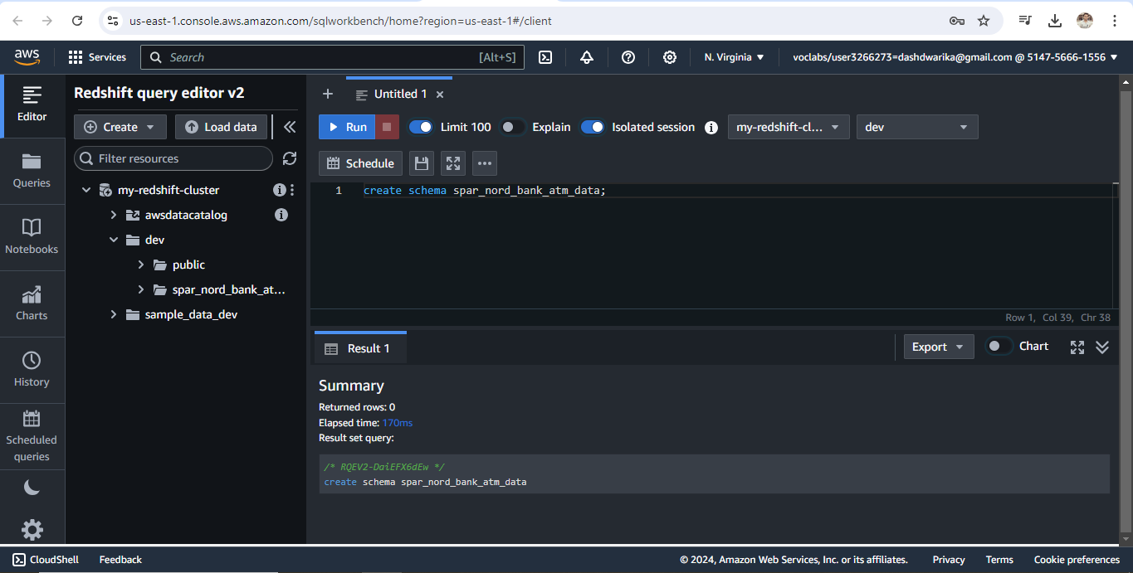

create table spar_nord_bank_atm_data.DIM_LOCATION

(

location_id int not null DISTKEY SORTKEY,

location varchar(50),

streetname varchar(255),

street_number int,

zipcode int,

lat decimal(10,3),

lon decimal(10,3),

PRIMARY KEY(location_id)

);

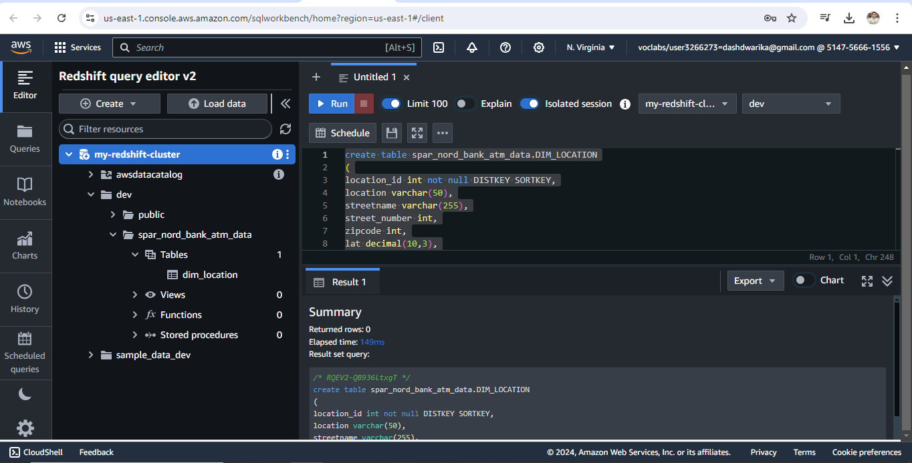

create table spar_nord_bank_atm_data.DIM_ATM

(

atm_id int not null DISTKEY SORTKEY,

atm_number varchar(20),

atm_manufacturer varchar(50),

atm_location_id int,

PRIMARY KEY(atm_id),

FOREIGN KEY(atm_location_id) references spar_nord_bank_atm_data.DIM_LOCATION(location_id)

);

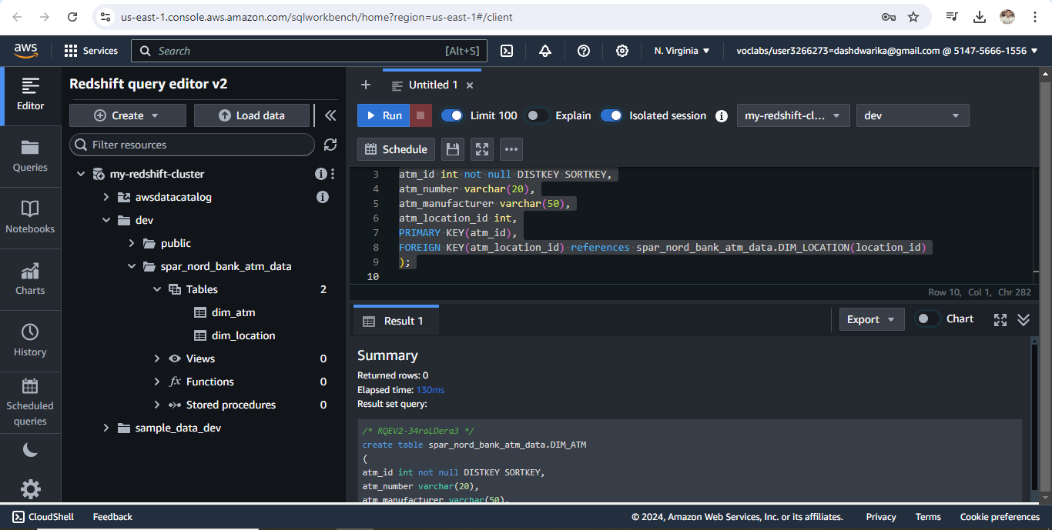

create table spar_nord_bank_atm_data.DIM_DATE

(

date_id int not null DISTKEY SORTKEY,

full_date_time timestamp,

year int,

month varchar(20),

day int,

hour int,

weekday varchar(20),

PRIMARY KEY(date_id)

);

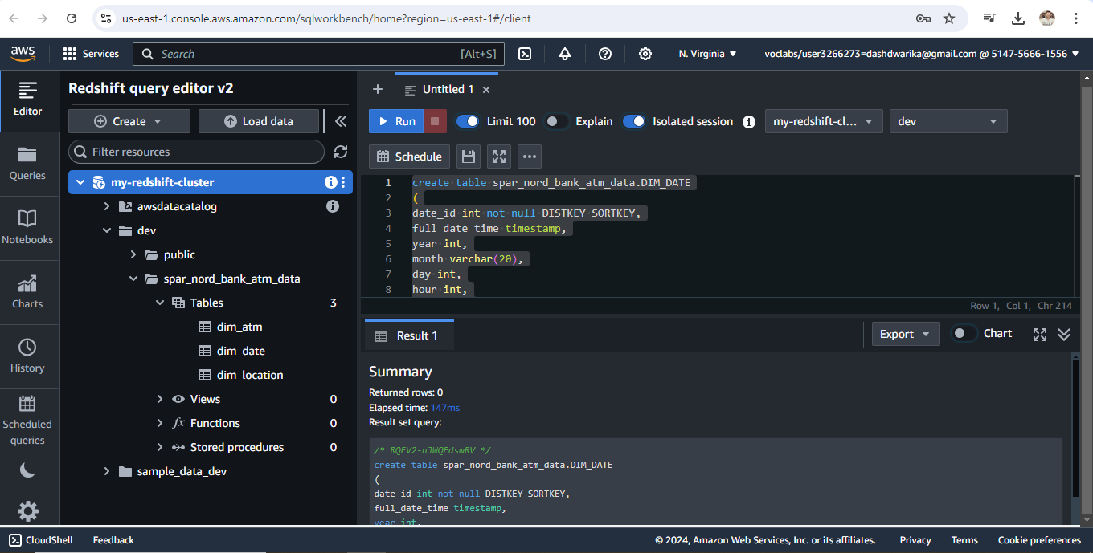

create table spar_nord_bank_atm_data.DIM_CARD_TYPE

(

card_type_id int not null DISTKEY SORTKEY,

card_type varchar(30),

PRIMARY KEY(card_type_id)

);

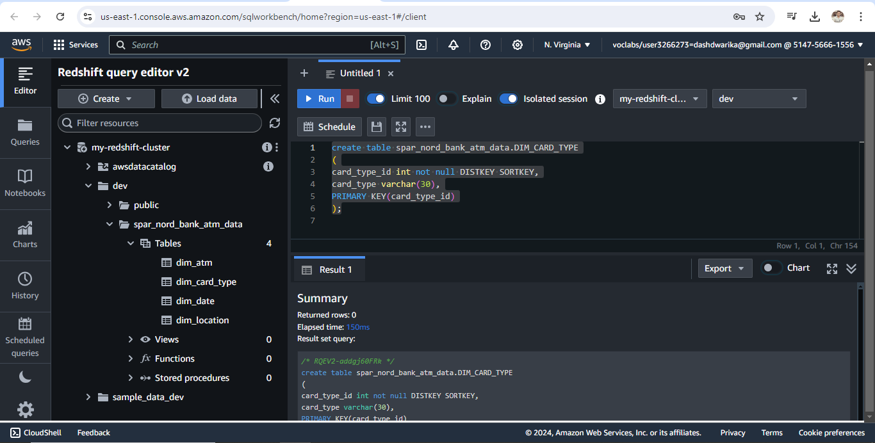

create table spar_nord_bank_atm_data.FACT_ATM_TRANS

(

trans_id bigint not null DISTKEY SORTKEY,

atm_id int,

weather_loc_id int,

date_id int,

card_type_id int,

atm_status varchar(20),

currency varchar(10),

service varchar(20),

transaction_amount int,

message_code varchar(225),

message_text varchar(225),

rain_3h decimal(10,3),

clouds_all int,

weather_id int,

weather_main varchar(50),

weather_description varchar(255),

PRIMARY KEY(trans_id),

FOREIGN KEY(weather_loc_id) references spar_nord_bank_atm_data.DIM_LOCATION(location_id),

FOREIGN KEY(atm_id) references spar_nord_bank_atm_data.DIM_ATM(atm_id),

FOREIGN KEY(date_id) references spar_nord_bank_atm_data.DIM_DATE(date_id),

FOREIGN KEY(card_type_id) references spar_nord_bank_atm_data.DIM_CARD_TYPE(card_type_id)

);

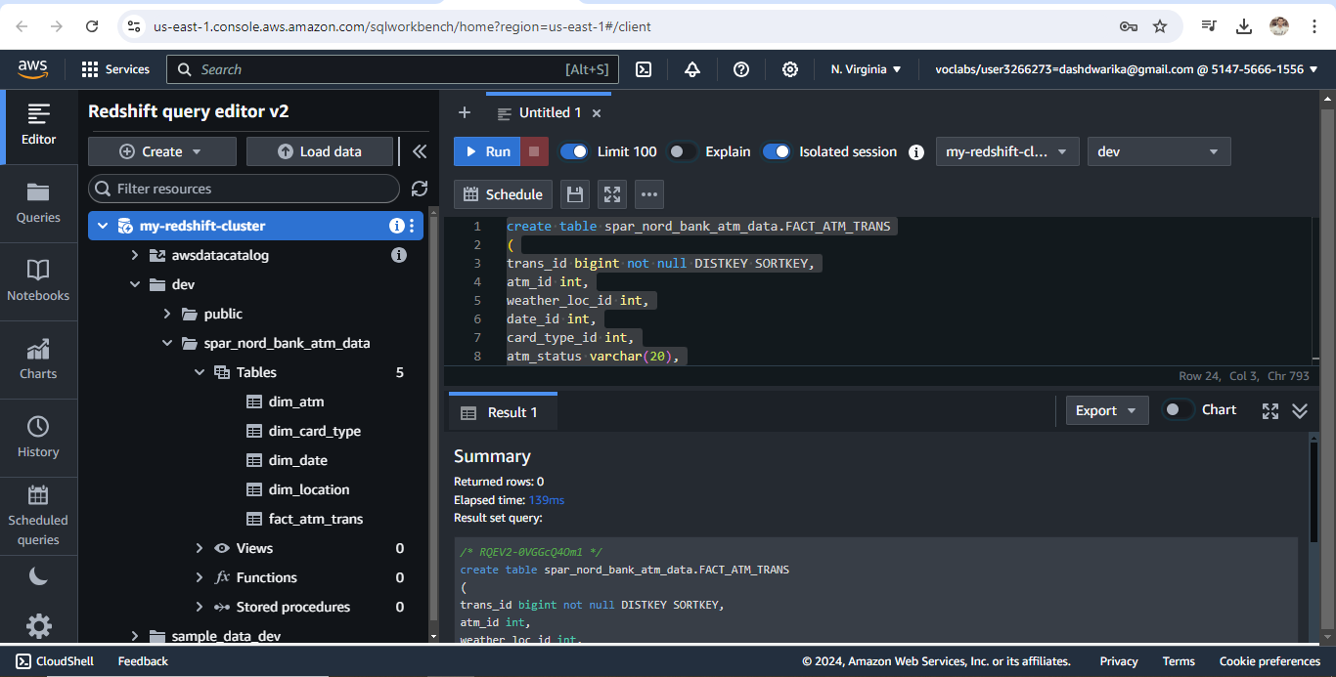

### Loading data into a Redshift cluster from Amazon S3 bucket

**Queries to copy the data from S3 buckets to the Redshift cluster in the appropriate tables**

copy spar_nord_bank_atm_data.dim_location from

's3://spar-nord-bank-dwarika/dim_location/part-00000-ac62de17-c2e5-420d-9660-e51262671580-c000.csv'

iam_role 'arn:aws:iam::514756661556:role/myRedshiftRole'

delimiter ',' region 'us-east-1'

CSV;

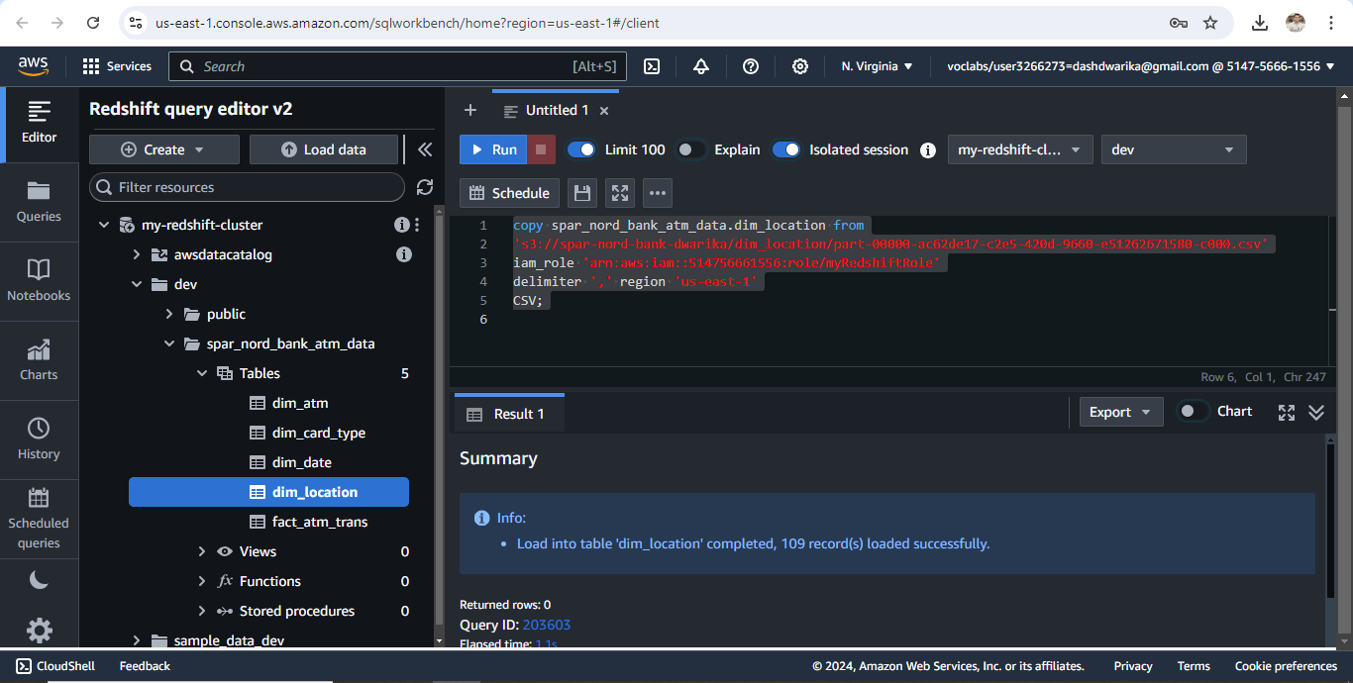

copy spar_nord_bank_atm_data.dim_atm from

's3://spar-nord-bank-dwarika/dim_atm/part-00000-60834aa1-b834-44b3-b5e1-9978aad04197-c000.csv'

iam_role 'arn:aws:iam::514756661556:role/myRedshiftRole'

delimiter ',' region 'us-east-1'

CSV;

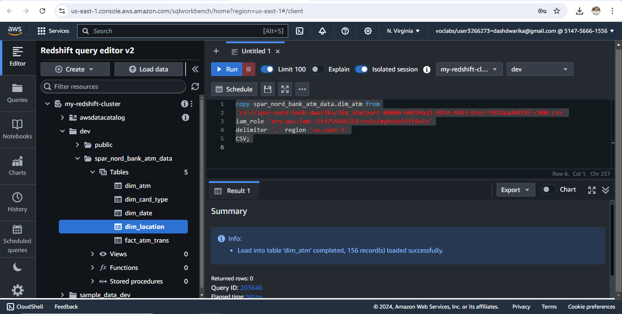

copy spar_nord_bank_atm_data.dim_card_type from

's3://spar-nord-bank-dwarika/dim_card_type/part-00000-8e1eb017-3e00-4ae8-9b30-b14c67a39d6b-c000.csv'

iam_role 'arn:aws:iam::514756661556:role/myRedshiftRole'

delimiter ',' region 'us-east-1'

CSV;

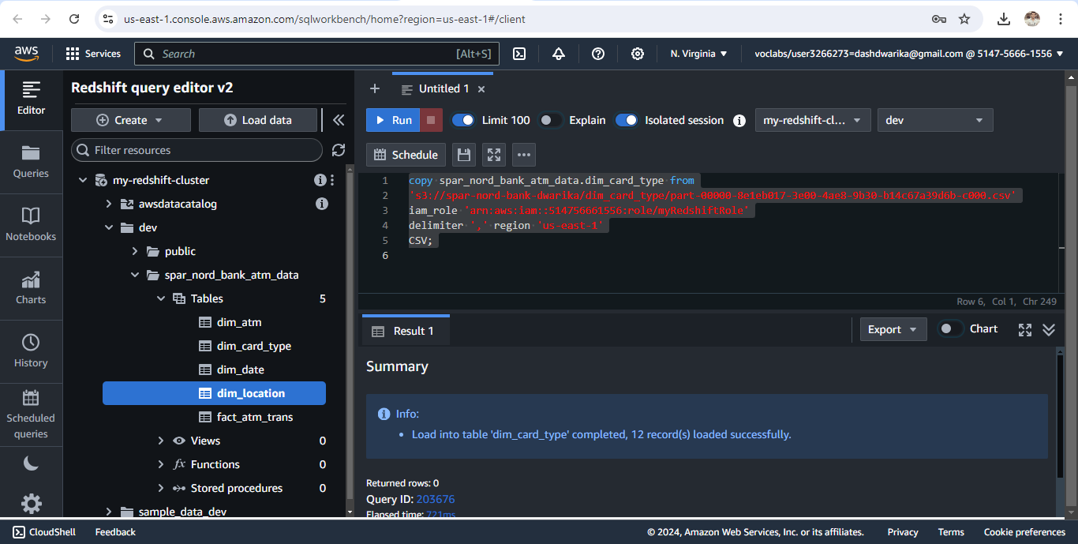

copy spar_nord_bank_atm_data.dim_date from

's3://spar-nord-bank-dwarika/dim_date/part-00000-799dc8fe-288e-4c19-b2c2-b8e1ef221cc2-c000.csv'

iam_role 'arn:aws:iam::514756661556:role/myRedshiftRole'

delimiter ',' region 'us-east-1'

CSV

TIMEFORMAT 'auto';

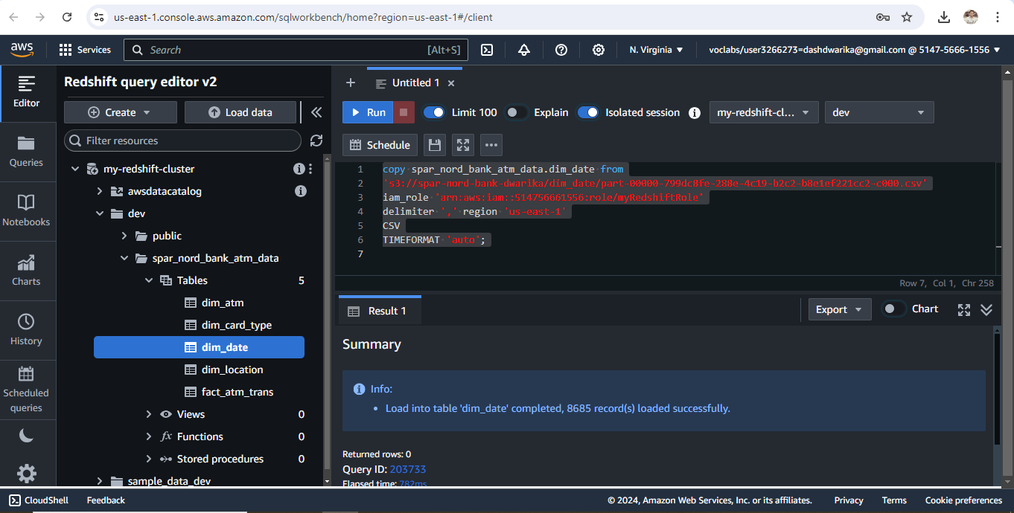

copy spar_nord_bank_atm_data.fact_atm_trans from

's3://spar-nord-bank-dwarika/fact_atm_trans/part-00000-fd716829-86aa-4836-b5c6-49443a3cd2f7-c000.csv'

iam_role 'arn:aws:iam::514756661556:role/myRedshiftRole'

delimiter ',' region 'us-east-1'

CSV;

