### Data Ingestion from the RDS to HDFS using Sqoop

**Sqoop Import command used for importing table from RDS to HDFS:**

sqoop import \

--connect jdbc:mysql://upgraddetest.cyaielc9bmnf.us-east-1.rds.amazonaws.com/testdatabase \

--username student -password STUDENT123 \

--table SRC_ATM_TRANS \

--target-dir /user/root/SRC_ATM_TRANS \

-m 1

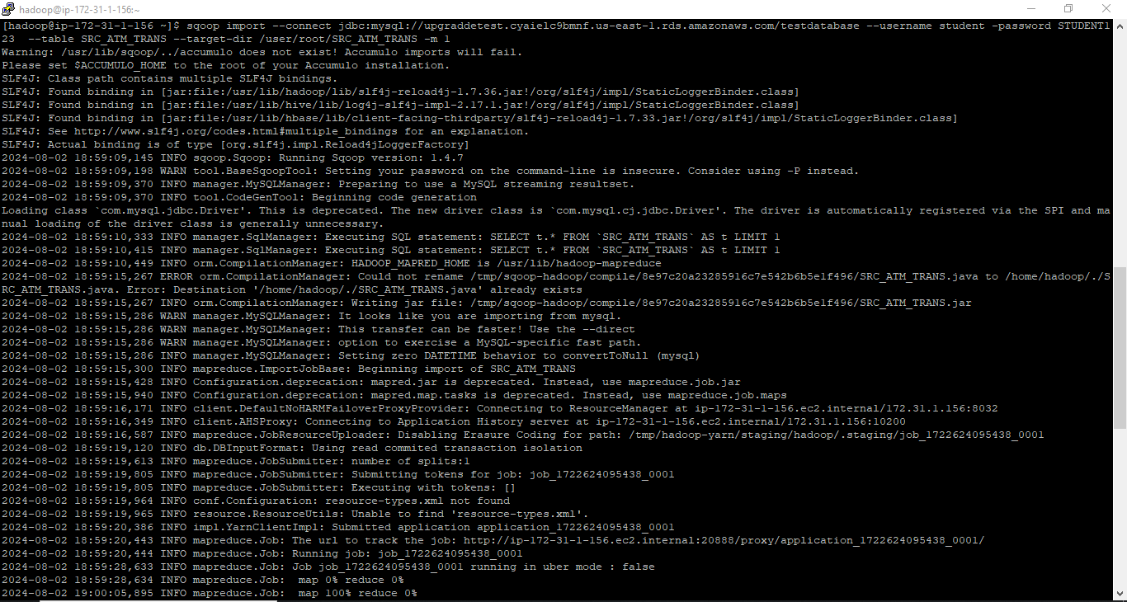

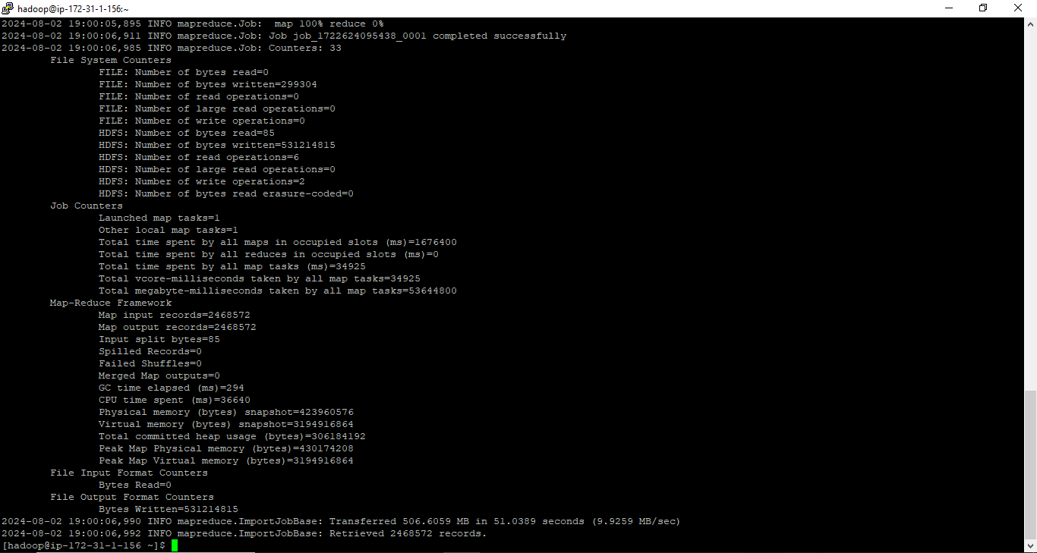

2024-08-02 19:00:06,990 INFO mapreduce.ImportJobBase: Transferred 506.6059 MB in 51.0389 seconds (9.9259 MB/sec)

2024-08-02 19:00:06,992 INFO mapreduce.ImportJobBase: Retrieved 2468572 records.

**Command used to see the list of imported data in HDFS:**

hadoop fs –ls /user/root/SRC_ATM_TRANS

hadoop fs –cat /user/root/SRC_ATM_TRANS/part-m-00000

**Screenshot of the imported data:**



